# Gases transport

To support metabolism of each cell there must be delivered oxygen. And carbon dioxide must be transported out of the body. Both called blood gases transport are critical for life. It starts by lungs ventilation to reach optimal alveolar partial pressures of oxygen and carbon dioxide. These pressures play roles in gases dissolving in blood, but here is the total amount of transported gases dependent also on blood flow, binding properties of hemoglobin, temperature and hydrogen ion activity. In tissue microcirculation is blood delivered so close to cells that no other active delivery is needed and only diffusion take place here.

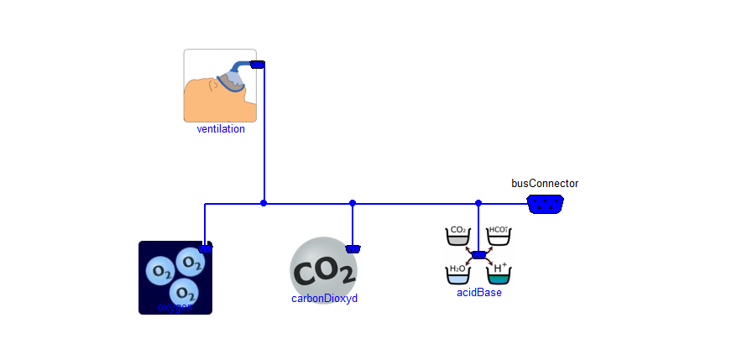

The submodels of gases transport are: ventilation, where is calculated the air flow, water vapor dilution, temperatures and pressures effect; oxygen transport; carbon dioxide transport; and acid-base as hydrogen ion activity calculations.

## Ventilation

Natural ventilation depends on many factors and are driven by neural reflexes. Their sensors are central chemoreceptors, which answer to change of intracellular pH; peripheral chemoreceptors located in arterial sinus and aorta detecting changes of arterial blood pH and pO2 and receptors of skeletal muscle metaboreflex. Whole afferent path of respiratory reflexes are in the model summarized into one normalized value called TotalDrive, from which is in efferent part calculated the respiratory rate (typical 11 per minute) and normalized respiratory center motoric nerve activity.

From the lungs properties are then calculated current tidal volume (450 ml) and current dead space volume (150ml). Because the temperature and humidity in lungs differs from surrounding air environment, the alveolar ventilation is recalculated to the inspired air conditions.

