# Vasopressin

Arginine vasopressin known as antidiuretic hormone (ADH) has molecular weight of 1084 Dalton and one international unit of ADH was measured to be 2.5ug. ADH as a hypothalamic neurohormone is synthesized in the cell bodies of magnocellular neurons of paraventricular and supraoptic nucleui and it is intracellulary transported to the lower side of these neurons in posterior pituitary.

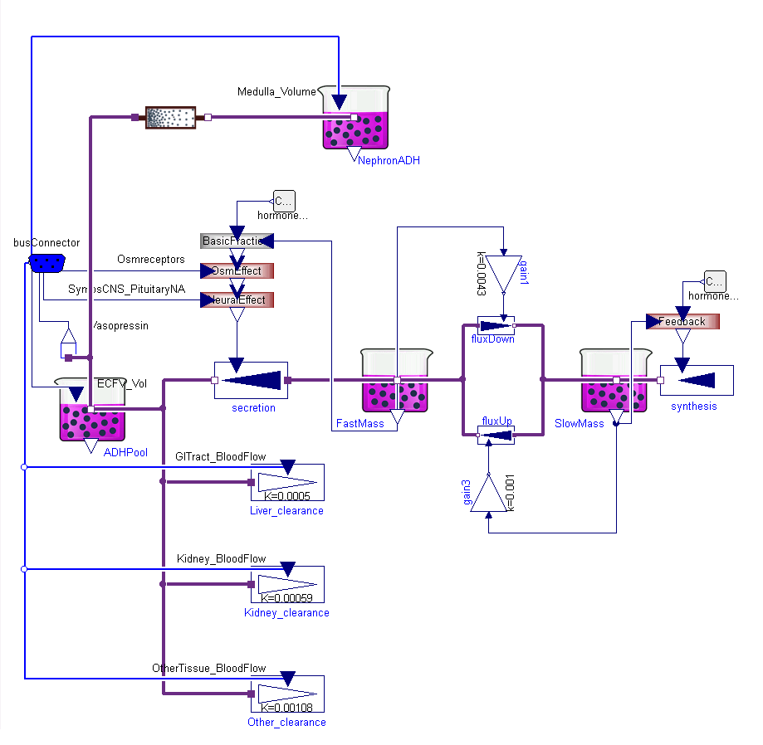

Figure

The model (Fig1) accumulates the amount of this hormone in four places: in the cell bodies of magnocellular neurons (Slow Mass), from where need to be transported to the posterior pituitary part of the cells; in the posterior pituitary side of neurons (Fast Mass), where ADH is prepared for secretion into blood; in the whole body extracellular fluid (ECF); and in the kidney nephron tissue, where it plays the role in water reabsorbtion. The normal amounts of ADH in these compartments are listed in table Tab1. The normal mean rate of synthesis, secretion and degradation is 3.2 ng/min (49.2 pmol/s) [1], where the secretion is determined by osmoreceptors and pituitary activity. Osmoreceptors are the cells in anterior hypothalamus near the supraoptic nuclei. When the osmolarity increase the osmoreceptors shrink and they send a neural signal to release ADH. Other possibility to regulate ADH secretion is cardiovascular centrum reflexes.

Table

|  |  |  |  |
| --- | --- | --- | --- |
| Slow Mass | Fast Mass | ECF | Medulla |
| 17 ug | 3.2 ug | 0.03 ug | 6.2e-5 ug |
| 15.7 nmol | 2.95 nmol | 0.028 nmol | 5.7e-5 nmol |
| 6.8 IU | 1.28 IU | 0.012 IU | 2.5e-5 IU |

Even the vasopressin inside cells is modeled using instances of chemical Substance class, the concentrations here do not have sense because ADH is transported by vesicles down the cell. The degradation is divided into liver, kidney and other tissue clearance.

Table

|  |  |  |
| --- | --- | --- |
| Liver degradation | Kidney degradation | Other degradation |
| 0.98 ng/min | 1.46 ng/min | 0.8 ng/min |
| 0.9 pmol/min | 1.35 pmol/min | 0.74 pmol/min |
| 0.39 mIU/min | 0.58 mIU/min | 0.32 mIU/min |

Clearance of ADH is divided into liver, kidney and other tissue [2]. To reach the mean constant level of ADH the sum of these changes from Tab2 must be the same as mean secretion during normal mean blood flow through liver (1.15 L/min), kidney (1.24 L/min) and other tissue (0.4 L/min), which are equivalents of clearances from table Tab3.

Table

|  |  |  |
| --- | --- | --- |
| Liver clearance | Kidney clearance | Other tissue clearance |
| 0.58 l/min | 0.73 l/min | 0.4 l/min |

A typical mean concentration in extracellular fluid is 2 ng/l, 1.8 pmol/l or 0.8 mIU/l [3]. Increasing of concentration will increase the water reabsorption in kidney.

# Renin

Renin is an enzyme for conversion of Angiotensinogen to Angiotensin I. From Michaelis-Menton equation (Eq1) is known, that the rate of enzymatic chemical reaction *v* is linearly proportional to the enzyme molar concentration *E* at defined substrate concentration *S*. So instead the extremely small molar concentration it is wildly used Goldblatt unit (GU) of Renin , which is equal to the reaction flow rate of one ng of AngiotensinI from one mg of Angiotensinogen per one hour (1 ng AI/h).

$$v=k_{cat}\frac{S}{K_{m}+S} E$$

Molecular mass of Renin is 48 kDa [4], normal plasma concentration are written in table Tab2. We use the conversion between renin activity GU and international unit as 11.2 uIU/GU and assumption that 1000 IU are equal 0.6 mg of renin as proposed Simon et al [5]. Problem is, that the renin activity (GU) change with many other factors like acidity [6] or bounding of renin with other molecules. That means problem with GU definition, which may differs from research to research. Therefore the GU unit is more like unit for angiotensin I synthesis rate, not the right unit for renin amount.

Table

|  |  |  |
| --- | --- | --- |
| Lower limit | Upper limit | Normal |
| 290 GU/L | 5700 GU/L | 2000 GU/L |
| 3.3 IU/L | 63.8 IU/L | 22.4 IU/L |
| 2 ug/L | 38.3 ug/l | 13.4 ug/L |
| 0.04 nmol/l | 0.8 nmol/l | 0.28 nmol/L |

[1] Thrasher TN, Chen H-G, Keil LC. Arterial baroreceptors control plasma vasopressin responses to graded hypotension in conscious dogs. American Journal of Physiology-Regulatory, Integrative and Comparative Physiology 2000;278:R469-R75.

[2] Share L. Control of vasopressin release: an old but continuing story. News in physiological sciences 1996;11:7-12.

[3] Raff H. Glucocorticoid inhibition of neurohypophysial vasopressin secretion. American Journal of Physiology-Regulatory, Integrative and Comparative Physiology 1987;252:R635-R44.

[4] SEALEY JE, ATLAS SA, LARAGH JH. Prorenin and Other Large Molecular Weight Forms of Renin*. Endocrine Reviews 1980;1:365-91.

[5] Simon D, Hartmann D, Badouaille G, Caillot G, Guyenne T, Corvol P, Pau B, Marchand J. Two-site direct immunoassay specific for active renin. Clinical chemistry 1992;38:1959-62.

[6] Guyene T, Galen FX, Devaux C, Corvol P, Menard J. Direct radioimmunoassay of human renin: comparison with renin activity in plasma and amniotic fluid. Hypertension 1980;2:465-70.

(http://europepmc.org/abstract/MED/2856717)

# Insulin

Insulin is one of the most studies hormone. First standard international unit of insulin from year 1958 has 41.67ug/IU ( <http://whqlibdoc.who.int/trs/WHO_TRS_172.pdf>  , page 10), the last discontinued definition from year 1986 has 38.46ug/IU ( <http://whqlibdoc.who.int/trs/WHO_TRS_760_(part1).pdf?ua=1>  , page 26). Using molar mass of 5808 Da it is possible to write also conversion such as 6.621pmol/IU.

Because molar mass of Angiotensingen is 56.8 kDa and molar mass of Angiotensin 1 is 0.9 kDa.