# Body water

The model of water (Fig1) such as the model of extracellular proteins is divided into eight main compartments: blood plasma (plasma), red blood cells (RBC), interstitial (IST)/intracellular(ICF) water of upper torso(UT), interstitial/intracellular water of middle torso(MT_IST,MT_ICF) and interstitial/intracellular water of lower torso(LT_IST, LT_ICF). These compartments are connected with osmotic connectors because an osmolality is the main force of transferring the water in the body. Normal distribution of water between compartments is written in table Tab1.

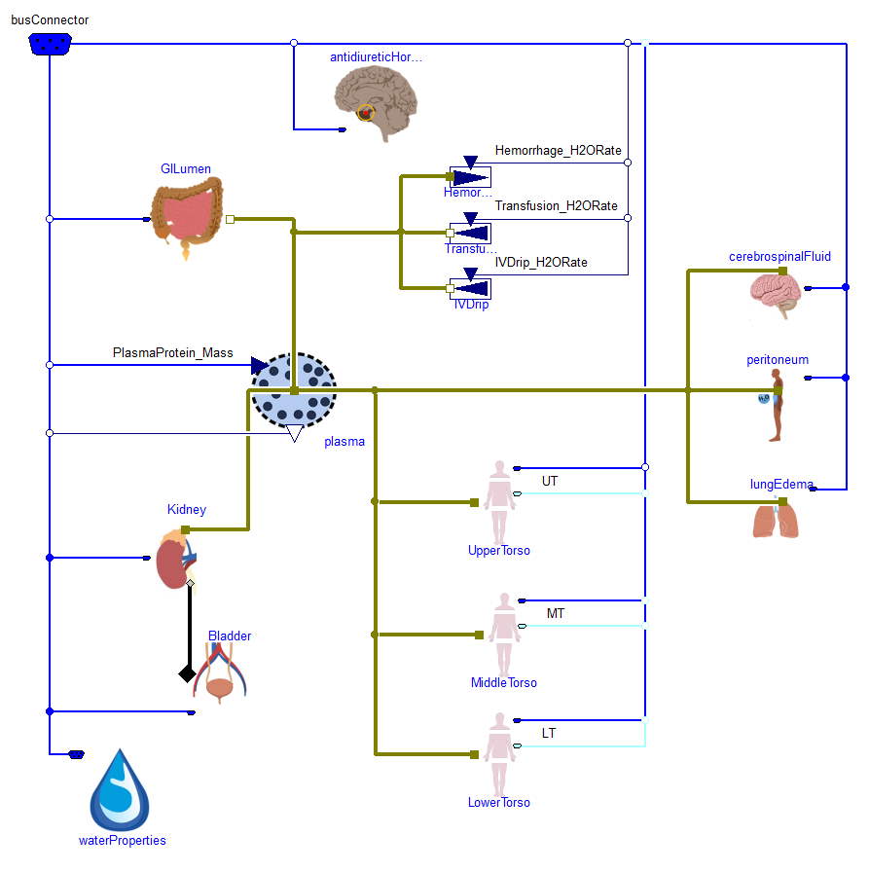

|  |  |  |  |  |  |  |  |
| --- | --- | --- | --- | --- | --- | --- | --- |
| plasma | RBC | UT_IST | UT_ICF | MT_IST | MT_ICF | LT_IST | LT_ICF |
| 3020 ml | 1570 ml | 2270 ml | 4980 ml | 5670 ml | 12460 ml | 3400 ml | 7470 ml |

Typical mean water flows between all compartments are listed in table Tab2. In gastrointestinal tract are absorbed, in each torso is metabolically produced and also excreted by sweating or by vaporization. Flows such as hemorrhage, transfusion, intravenous drip, to peritoneum, to lungs edema are zero at normal condition. Outflow of water to urine is modeled by kidney.

|  |  |  |  |  |  |  |  |
| --- | --- | --- | --- | --- | --- | --- | --- |
| GI absorption | UT lymph | UT capy | MT lymph | MT capy | LT lymph | LT capy | urine outflow |
| 1.5ml/min | 0.4ml/min | ‑5.2ml/min | 0.9ml/min | ‑1.1ml/min | 1.2ml/min | ‑0.2ml/min | 0.4ml/min |

## Gastro intestinal water absorption

Mean water in diet should be about 2.16 l/day, which is the sum of water in food and drinks. Firstly is water accumulated in gastro intestinal lumen (GILumen), where it has the mean osmolarity about 253 mosm/l. This osmolarity is composed mostly with sodium with anions (160 mosm/l), dietary fiber (43 mosm/l) and potassium with anions (50 mosm/l). Water is sucked by gastrointestinal cells, where is the mean osmolarity about 286 mosm/l called OsmBody_CellWall in Fig1.

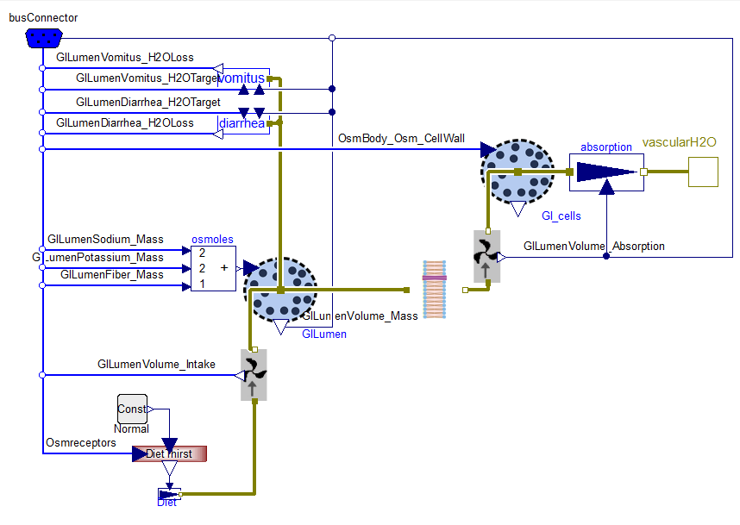

Because in original HumMod 1.6.1 model is the mean absorption from GILumen calculated by coefficient of osmotic gradient Absorption [ml/min] = 150 * (0.286 [osm/l] - 0.253 [osm/l]), the pressure-gradient osmotic permeability (cond) of library membrane block has to be derived to have the same flow at the same settings. We know that the volumetric flow in this block is calculated by equation Eq1, so the recalculated parameter cond to value 0.15/(8.314*310.15) [ml/(Pa.min)].

$$Absorption=cond∙(286-253)∙R∙T$$

## Upper/Middle/Lower torso water

Flow between plasma and interstitium is determined by colloid osmolarity of extracellular proteins. Through the capillaries wall is distributed the water to or from the interstitium. Another way is the one directional lymph flow from interstitium to blood plasma, where normal mean flows are 0.4 ml/min for upper torso, 0.8 ml/min for middle torso and 1.3 ml/min for lower torso. These flows can be influenced by the internal pressure in tissues caused by its volume and skin.

However the flow of water between interstitium and cells is determined by all substances. In cellular membrane the proteins osmolarity plays the minor role, because their concentration is only about 1 mosm/l. Here in extracellular space is osmolarity divided into electrolytes, urea, glucose and others solutes. And in intracellular space are electrolytes, urea and others solutes. Osmolarity in equilibrium must be the same in interstitium and in cells (285 mosm/l).

|  |  |  |  |  |
| --- | --- | --- | --- | --- |
|  | electrolytes | Urea | glucose | Unknown |
| ECF | 250mosm/l | 6 mosm/l | 6 mosm/l | 24 mosm/l |
| ICF | 266 mosm/l | 6 mosm/l | 0 mosm/l | 13 mosm/l |

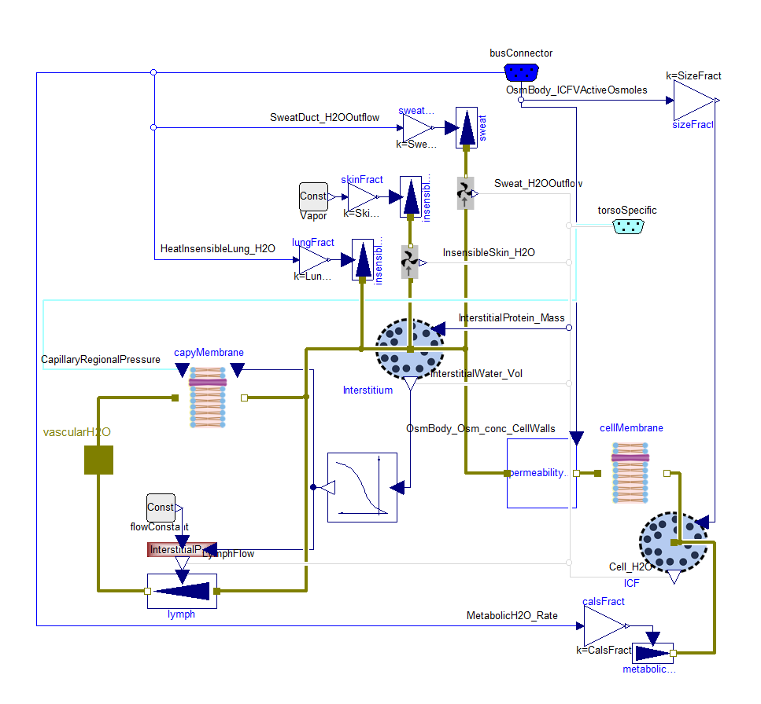

## Kidney

In kidney is water delivered by blood to the glomerulus, where is blood plasma filtrated to glomerular filtrate (120 ml/min). Most of this filtrate is reabsorbed in nephrons and collecting ducts and the rest is urine accumulated in bladder.

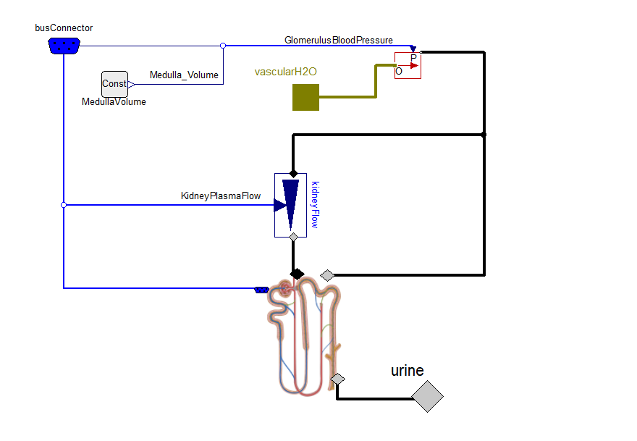

Nephron:

|  |  |  |  |  |
| --- | --- | --- | --- | --- |
| GFR | to LH | to DT | to CD | to Bladder |
| 120ml/min | 57 ml/min | 41 ml/min | 4.6 ml/min | 0.4 ml/min |

Proximal tubule:

Glomerular filtrate in glomerulus has the same pressure as blood in glomerulus and this pressure push it into nephrons at mean flow of 120 ml/min. Reabsorption fraction in proximal tubule is determined only with sodium reabsorption in proximal tubule.

Loop of Henle:

In contrast of other literature the model contains also water reabsorption from loop of Henle, where should not be the aquaporin channels. Reabsorption fraction is here 37% of sodium reabsorption fraction.

Distal tubule:

Outflow of filtrate to collecting duct is determined by outflow of sodium from equation Eq1, where coef is dependent on ADH nephron concentration and its normal value is 9.1 ml/mmol (9.1e-3 m3/mol).

Collecting duct:

In collecting duct are the number of active aquaporin channels driven by ADH and it proportionally means the volumetric flow rate of reabsorbed water by collecting duct tubules. Independently on aquaporin channels is calculated the minimal water outflow to urine, which is determined by sodium outflow to urine and medulla osmolarity.

