Final Project Submission
Group 06
“Tanks”
Nicholas Abrahan, Colin Biafore, Bryce Bowers, Benjamin Hartl
CS48, W14

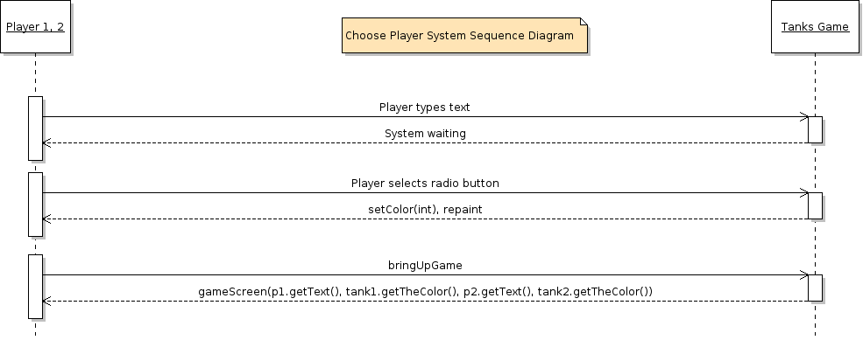

System Operations of the Play Game Use Case
Contract CO1: bringUpPlay()
Name: bringUpPlay()
Cross References: Use Cases: Play Game
Preconditions: To have mainMenu() up, and to have the playButton pressed from the mainMenu().
Postconditions: - A new window was created.
-User prompts for color and name are initialized.

Contract CO2: playScreen()
Name: playScreen()
Cross References: Use Cases: Play Game
Preconditions: To have a color and a name input from bringUpPlay()
Postconditions: -2 new Player classes are created with name/color attributes (instance creation).
-Tanks and appropriate colors/labels are drawn.
-Players are associated with their tanks.
-playScreen takes control of turns/movements to begin the game.
Static Class Diagram
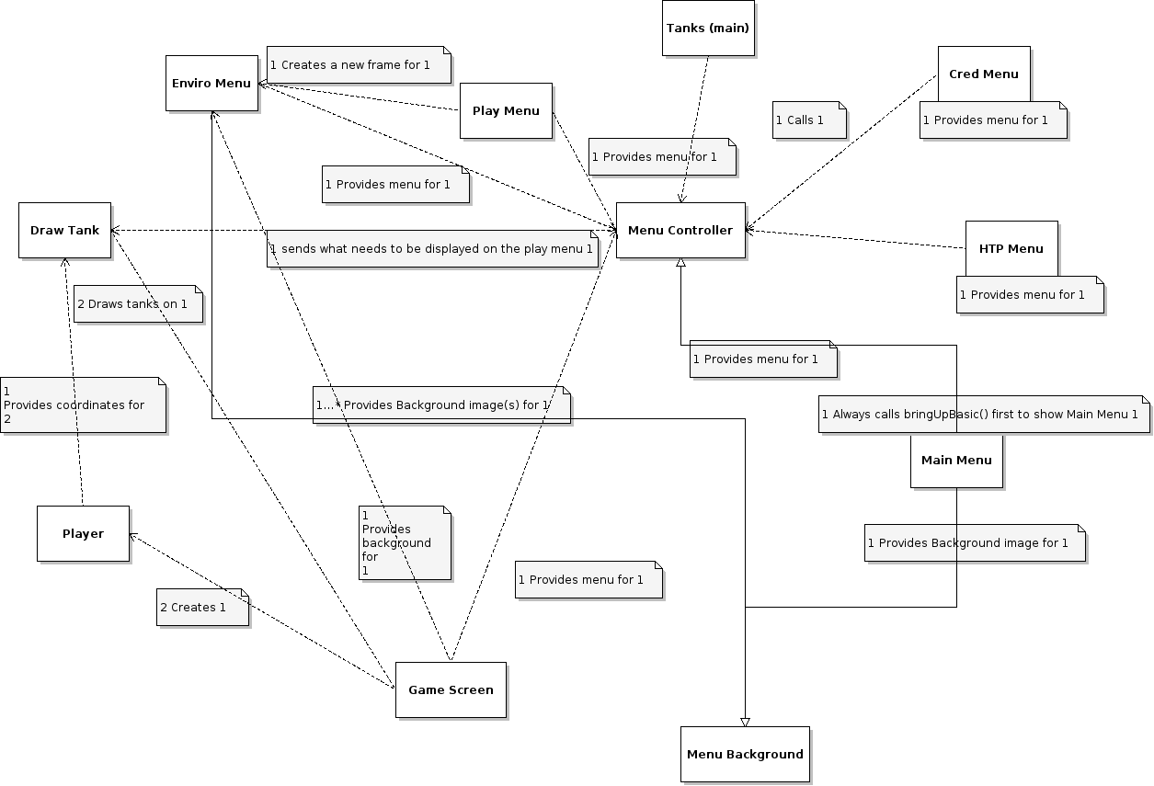

Upgraded Static Class Diagram
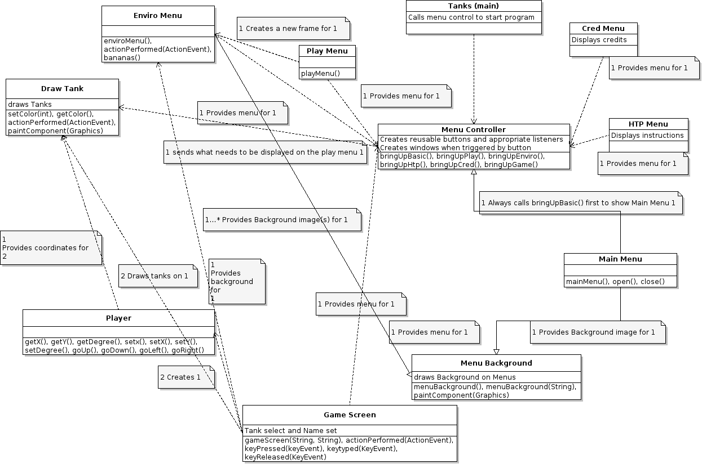

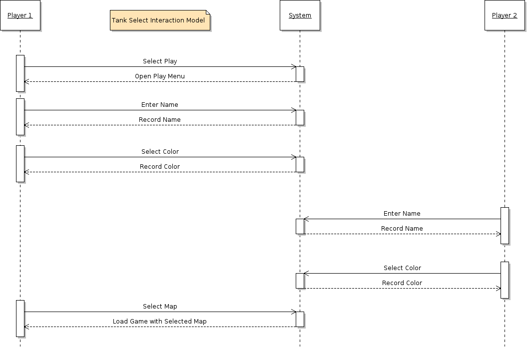
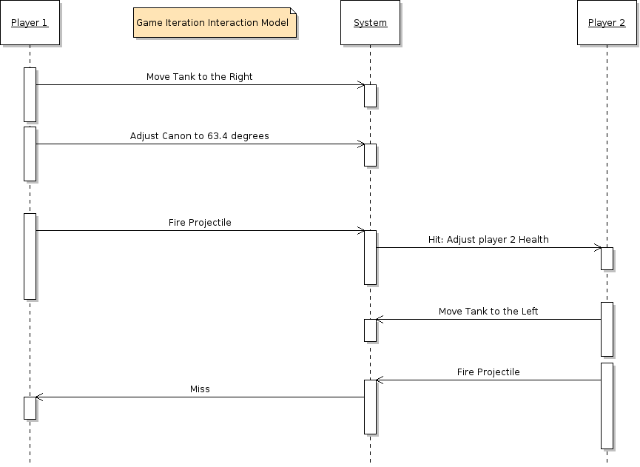

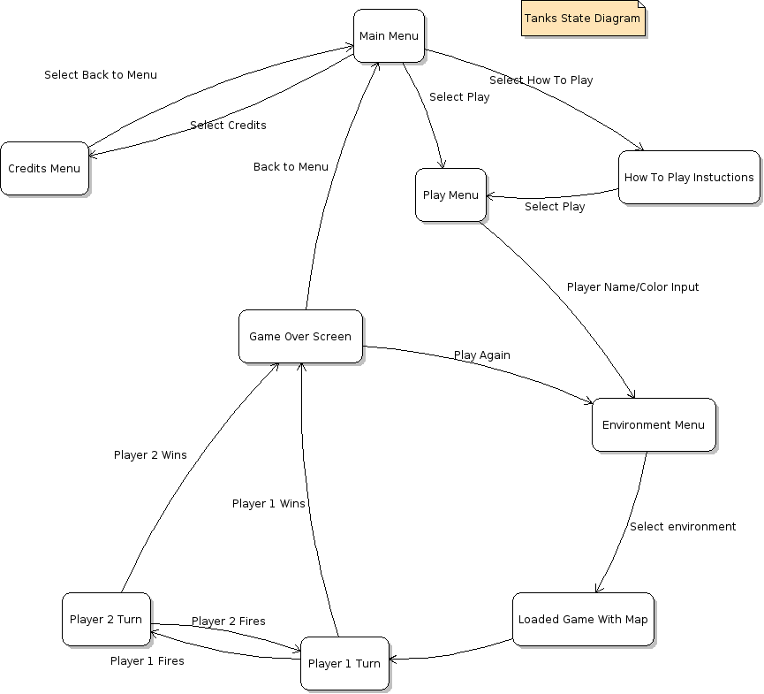

Glossary:

Menu Controller:
Definition: Central hub for menu GUIs, calls proper frames/panels as response to the buttons.
Format: N/A
Validation Rules: N/A
Aliases: Hub, general controller
bringUpBasic:
Definition: Function that calls the basic Main Menu.
Format: N/A
Validation Rules: N/A
Aliases: Main Menu
bringUpPlay:
Definition: Function that calls the gameConfig window.
Format: N/A
Validation Rules: N/A
Aliases: Character Select, Color Select
bringUpEnviro:
Definition: Function that calls the stage select window.
Format: N/A
Validation Rules: N/A
Aliases: Stage Select, Environment Select
bringUpGame:
Definition: Function that calls the actual in-game screen.
Format: N/A
Validation Rules: Appropriate name/color for tanks.
Aliases: in game, game, game screen.
DrawTank:
Definition: Function that calls the color select pane.
Format: N/A
Validation rules: N/A
Aliases: character select, color select, tank draw
menuBackground:
Definition: Jpanel that creates a template for creating a window with a background.
Format: N/A
Validation rules: Image exists in folder
Alises: JpanelWithBackground

Unit:
Definition: Base unit, with a health, weapons, and ammo attribute.
Format: N/A
Validation Rules: N/A
Aliases: Tank, Player(X), Character
Game Map:
Definition: In-game level, with unique color schemes, and a “wind” attribute.
Format: N/A
Validation Rules: N/A
Aliases: Stage, Level, Environment
Menu:
Definition: User interface, context-base choices
Format: Basic GUI, with pointer-controlled buttons.
Validation Rules: N/A
Aliases: Play Menu, How To Play Menu, Credits

