**Mid-term Exam**

# SCMA 691 Decision & Risk Analytics

## Spring 2021

1. (20 pts) Erica is going to fly to London on August 5th and return home on August 20th. It is now July 1st. On July 1st, she may buy a one-way ticket (for $350) or a round-trip ticket (for $660). She may also wait until August 1st when a one-way ticket will cost $370 and a round-trip ticket $730. It is possible that between July 1st and August 1st, her sister (who works for the airline) will be able to obtain a free one-way ticket for Erica. The probability that her sister will obtain the free ticket is 0.3. If Erica has bought a round trip ticket on July 1st and her sister has obtained the free ticket, she may return “half” of her round-trip to the airline. In this case her total cost will be $330 plus a penalty of $50. Use a decision tree to determine Erica’s lowest expected cost of obtaining a round-trip ticket to London.

* Erica’s lowest expected cost of obtaining a round-trip ticket to London is $576. She should buy the round trip now (July 1st) and wait to see if she will receive a ticket from her sister.

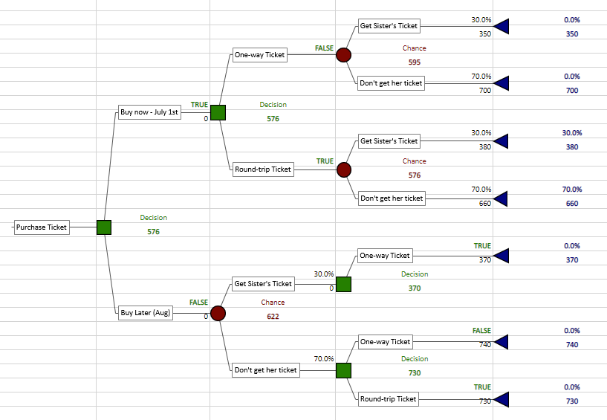

([Supporting document](https://vcurams-my.sharepoint.com/:x:/g/personal/bowlesbe_vcu_edu/EXCwGNv_jkBGrZPamuyvs7ABooIrzQqi2XmXyCVBYLdAvw?e=K0IfQX))

1. (25 pts) An electric utility company is trying to decide whether to replace its PCB transformer in a generating station with a new and safer transformer. To evaluate this decision, the utility needs information about the likelihood of an incident, such as a fire, a cost of such an incident and the cost of replacing a unit. Suppose the total cost of replacement, as a present value, is $75,000. If the transformer is replaced, there is virtually no chance of a fire. However, if current transformer is retained, the probability of a fire is assessed to be 0.0025. If a fire occurs, then the clean-up cost could be high ($80 million) or low ($20 million). The probability of a high clean-up cost, given that a fire occurs, is assessed to be 0.2.
2. If the company uses the expected monetary value as its decision criterion, should it replace the transformer?

* Yes

1. Perform sensitivity analysis on the key parameters of the problem that are difficult to assess, namely, the probability of a fire, the probability of a high clean-up cost and the high and low clean-up costs. Does the optimal decision from part a) remain optimal for a “wide” range of these parameters?

* The optimal decision from part a) does not remain optimal for a “wide” range of parameters within the Fire probability.
* Probability of a fire
  + Your decision changes after you reduce your probability by 15% (not very much) to 0.2125%
* Probability of high cost
  + Decision does not seem to change with anything less than a 25% change in probability
* Probability of low cost does not have room to change to make a difference

([Supporting document](https://vcurams-my.sharepoint.com/:x:/g/personal/bowlesbe_vcu_edu/EWQynMSuWIBFoh12rctWYw4B0b0p4epukMDeeudeZ5ePQw?e=XZE4lb))

1. (25 pts) A nuclear power company is deciding whether to build a nuclear power plant at Diablo Canyon or at Roy Rogers City. The cost of building the power plant is $10 million at Diablo and $20 million at Roy Rogers City. If the company builds in Diablo, however, and an earthquake occurs at Diablo during the next 5 years, construction will be terminated, and the company will lose $10 million (and will still have to build the power plant at Roy Rogers City). Without further information, the company believes that there is a 20% chance that an earthquake will occur at Diablo during the next 5 years. A geologist can be hired to analyze the fault structure at Diablo Canyon. She will either predict an earthquake will occur or that it will not. The geologist’s past record indicates that she will predict an earthquake on 95% of the occasions when an earthquake will occur and no earthquake on 90% of the occasions for which an earthquake will not occur. What is the most the power company should pay this geologist? What is the most the power company should pay any geologist?

* What is the most the power company should pay this geologist?
  + $1,100,00.00 – any more than this and the decision changes to do not hire.
* What is the most the power company should pay any geologist?
  + Depends on how well they predict an earthquake. When the probabilities change, so does the model payoff.

([Supporting document](https://vcurams-my.sharepoint.com/:x:/g/personal/bowlesbe_vcu_edu/EVo7L09C4zdHt9nUl3AMrEsBNFVzc3Wo6J3jL-gfn4BWOQ?e=WOVacs))

1. (30 pts) Each year 9.2 million containers are shipped to the US with consumer goods and products from all over the world. There is concern that terrorists may obtain nuclear material from Russia, Pakistan, or North Korea and attempt to smuggle it in to the US in one of these containers. Such material could be used to make a dirty bomb. Radiation detectors can be installed at ports to detect radiation leaking from a container. DHS wants to determine whether screening for nuclear materials on incoming containers is worthwhile. The main decision is **whether to screen each container or not.** If the detector’s radiation **alarm goes off or not**, then the decision must be made whether there is sufficient cause to physically **inspect the container** by opening it and scanning all contents with a Geiger counter. The cost of installing such equipment at all ports is estimated to be $6 per container screened. The cost of a physical inspection is estimated to be $600 per container inspected. If nuclear material is found, specialists must be flown in to secure and dispose of the material, at a cost of $100,000. If the material is not found and it is used in a dirty bomb, the estimated economic impact of such a disaster is $40,000,000,000. The probability that nuclear material is being smuggled in any given container is estimated to be 5x10-9. There is an 80% chance that the alarm will sound if a container that contains nuclear material goes through the scanner, but there is also a 2.5% chance that the alarm will sound even if there is no nuclear material in the container. There is a 50% chance that nuclear material will be found during a physical inspection if there is some in the container. There is a 50% chance of an attack if the terrorist manages to successfully smuggle the material through the port.
2. Use an influence diagram to depict this decision situation.



1. Build the decision tree.

* ([Supporting document](https://vcurams-my.sharepoint.com/:x:/g/personal/bowlesbe_vcu_edu/EUCcW9LGgSJJtn6KbM90WKcBkm_1oyvmvrjFfFi5e5u_UA?e=xRWcMr))

1. Perform the necessary probability calculations to find the probabilities in your decision tree.
2. Obtain risk profiles for each alternative. Do you think EMV is the best criterion to use here?
3. Is screening containers a good choice?

|  |  |  |  |  |
| --- | --- | --- | --- | --- |
| Pr. Alarm | Threat | Radiation Alarm goes off | Alarm Does not go off |  |  |
| Threat | 0.8 | 0.2 |  |  |
| No Threat | 0.025 | 0.975 |  |  |
|  |  |  |  |  |
|  | Radiation Alarm goes off | Alarm Does not go off | Nuclear Material |  |
| Threat | 0.000000004 | 0.000000001 | 0.000000005 |  |
| No Threat | 0.025000000 | 0.974999995 | 0.999999995 |  |
|  | 0.025000004 | 0.974999996 |  |  |
|  |  |  |  |  |
| Pr. Threat | Alarm | Radiation Alarm goes off | Alarm Does not go off |  |  |
| Threat | 0.000000005 | 0.000000001 |  |  |
| No Threat | 0.031250000 | 0.999999999 |  |  |
|  |  |  |  |  |
|  | Radiation Alarm goes off | Alarm Does not go off | No Screen | Given threat |
| Find | 0.0000000025 | 0.0000000005 | 0.0000000000 | 0.5 |
| Don't Find | 0.9999999975 | 0.9999999995 | 1.0000000000 | 0.5 |
|  |  |  |  |  |
|  | Radiation Alarm goes off | Alarm Does not go off | No Screen | Given threat |
| Attack | 0.0000000025 | 0.0000000005 | 0.0000000025 | 0.5 |
| No Attack | 0.9999999975 | 0.9999999995 | 0.9999999975 | 0.5 |

(Notes for tree tree)

1. Container screen: (Decision)
   * screen each container
     + Installing inspector/equipment (**$6** per container screened)
   * Don’t screen each container
     + Don’t install inspector $0
2. Radiation Alarm: (Chance)
   * radiation alarm goes off
     + Given there is Nuclear material, alarm will go off (80%)
     + Given there is NOT Nuclear material, alarm will go off (2.5%)
     + Used “Flipped Radiation Alarm Tree” to get probabilities (2.5% alarm goes off)
   * radiation alarm does not go off
     + Used “Flipped Radiation Alarm Tree” for probabilities
3. Physical container inspection: (Decision)
   * physically inspect the container
     + Given there is Nuclear material, 50% chance that nuclear material will be found
     + physical inspection (**$600** per container inspected)
   * Do not physically inspect container
4. Nuclear material found?: (Chance)
   * Nuclear Material found: 5x10-9
     + **$100,000**
   * No Nuclear Material found
     + 0
5. Smuggler’s success: (Chance)
   * Smuggler successful / Nuclear not found
   * Smuggler Unsuccessful / Nuclear found
     + Calculate probabilities
6. Smuggler’s result/decision: (Chance)
   * Smuggler attacks 50%
     + Given they are successful, 50% chance of an attack
     + $40,000,000,000
   * Smuggler does not attack 50%
     + $0