Yanjo Smithson
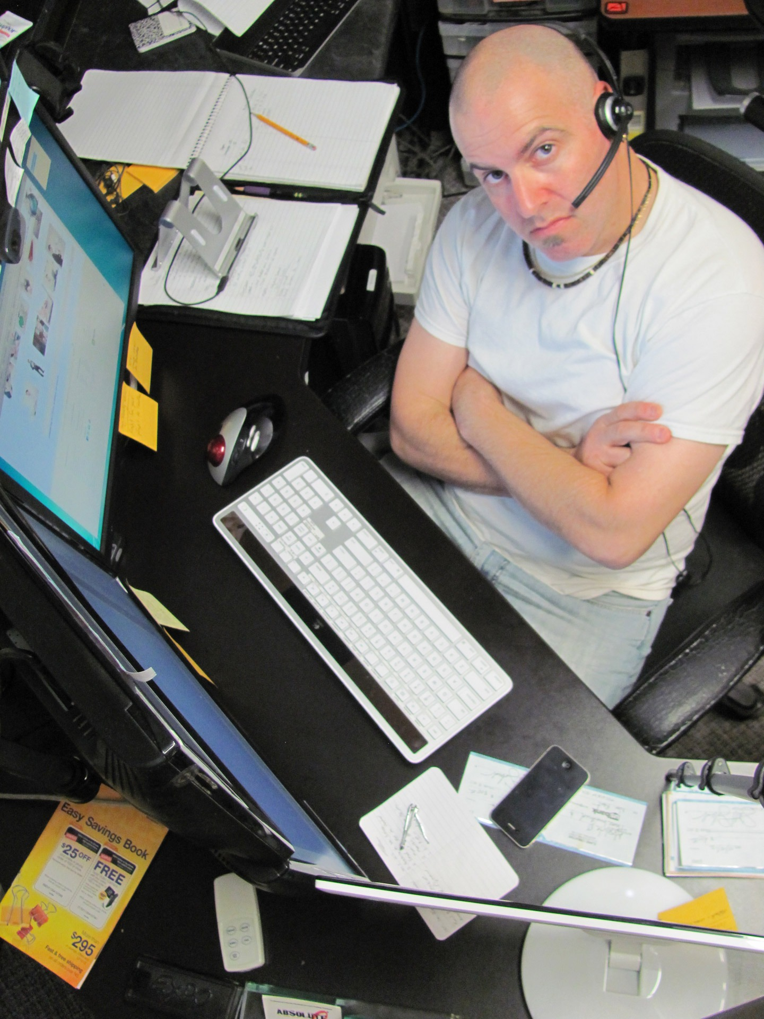Figure 1: an unhappy man at a computer workstation (n.d.). PxHere.
28 He/Him/His

Cultural identity: Jewish–Canadian
Religion: Reform Judaism

Highest education attained: post-secondary
Occupation: Data engineer
Salary: $75,000–$90,000

Skills: machine learning, statistics, bayesian statistics, SQL, Python, R, VBA, Microsoft Office, Tableau ;; relation to my site: data scientists spend a lot of time reading programming blogs from other creators to both find inspiration, learn new methods, and use them as reference when they're troubleshooting a data pipeline; it's also fun to see what is going on in the lives of other data professionals ;; Yanjo Smithson is not experienced with Linux™ or UNIX®, as he has worked at Microsoft–consuming offices during his career, and only uses Windows® on his home workstation;; Yanjo loves to learn about how scientists and data professionals use R and Python in their work, he often learns something new or has an uncommon or obscure aspect of a methodology or a programming language refreshed in his mind when he reads a programming blog — "It's a lot more fun to read and browse than refernce material like a specification. I don't learn a lot from specs, I only consult them for, well, reference; like when I need to know what arguments or data types a function accepts and returns.".
Goals and motives: Yanjo Smithson loves to read about programming, Data science, statistics, and computers in general; his friends on the internet use Linux, and he'd like to learn more about it to see if he can use it to make his workflow more efficient.
Approach to site use: Yanjo usually sees what's on offer before he finds something of interest, he doesn't like to see the whole history of the blog. He uses a search bar when its there, or a tag cloud, but when those aren't present he looks at the headings until he finds something interesting, and then reads that through if it holds his interest after the first paragraph or two. If its something he needs to know about, then he reads the whole blog entry, but he hates when there is no table of contents or useful headings that summarize a longer entry; when the entry is badly written or doesn't discuss something new or more advanced he gets annoyed about his wasted time. He has few favourite blogs that he checks first when he feels like reading, or when he needs to search something up, but if they don't have it then he looks for tutorials or blogs on Google (he doesn't like Bing!).

Diya Natt
Figure 2: A woman wearing a green head covering and scarf (n.d.). PxHere.
43 She/Her/Hers

Cultural identity: Indian expat in Canada
Religion: none

Highest education attained: post-secondary
Occupation: Computer security researcher
Salary: $69,420

Skills: C programming, exploit and malware development, Linux kernel development
Goals and motives: Diya likes to read about Linux users to gain insight into the software that is popular, so he can research it for security flaws. He loves
Approach to site use: Because Diya is a computer security professional and computer science student, he doesn't like to waste a lot of time with the actual content of the website. He likes to look at the sources of the website, the general structure and layout, and look for security holes in the website. He does this occasionally.

Ario Fisher
Figure 3: Photograph by WOCInTech Chat (2016b). Flickr.
23 She/Her/Hers

Cultural identity: African-American
Religion: Baptist Christianity

Highest education attained: post-secondary
Occupation: Personnel Research Psychologist
Salary: $132,000

Skills: assessing how various people might use a tool, website, etc. in part of a larger system to see if it poses any psychological hazards.
Goals and motives: Ario works for a large software manufacturer, and assesses the personnel who use various software for cognitive hazards such as over-exposure to mundane and repetitive tasks that do not engage professionals, resulting in turnover due to boredom and dissatisfaction. Ario likes to read about the habits of happy computer users and geeks to gain insight into their satisfaction, so that same satisfaction can be transposed onto other computer professionals by ensuring they use software that doesn’t irritate them.
Approach to site use: Ario loves to crawl every nook and cranny of the website, ensuring nothing is missed and that she understands all the context of the content and the layout. If she was a web developer, she’d do very well, but she is more interested in how software affects people’s psychological outlook and whether that can be improved. She is very apt at navigating both well and poorly designed systems, but when she gets to use a good product that “makes me happy,” she says.

Udonavon Cooper
Figure 4: Photograph by WOCInTech Chat (2016a). Flickr.
19 She/Her/Hers

Cultural identity: African-Canadian
Religion: Pentecostal Christianity

Highest education attained: secondary
Occupation: undergraduate biology student
Salary: N/A

Skills: Udonavon is adept at picking up new computer skills quickly, and she likes to read about Emacs and R to improve her skills with these tools.
Goals and motives: to get better at working with R and troubleshooting her R code, especially when she uses it in Emacs and not RStudio, because she wants to be a bio-statistician one day and needs to learn these skills now while she has extra time outside of classes.
Approach to site use: Udonavon opens the site every couple weeks and looks for an article to read. She follows along to the best of her ability, trying to learn new skills. When she’s looking for an article she reads the title first, and then usually navigates to it if it is interesting and reads the first paragraph or two.

References
A woman wearing a green head covering and scarf n.d.. PxHere. https://get.pxhere.com/photo/girl-woman-hair-photography-portrait-model-green-color-darkness-clothing-black-lady-scarf-close-up-human-body-face-eye-head-skin-beauty-organ-models-portrait-photography-764061.jpg
An unhappy man at a computer workstation. n.d.. PxHere. https://pxhere.com/en/photo/978710
wocintechchat.com. (2016a). Untitled [Photograph]. Flickr. https://www.flickr.com/photos/wocintechchat/25926660641/in/album-72157664006621903/
wocintechchat.com. (2016b). Untitled [Photograph]. Flickr. https://www.flickr.com/photos/wocintechchat/25720812110/in/album-72157664006621903/

