AI-Powered Customer Service Analytics Capstone Project
Bryce Peltier
StackRoute Intermediate AI Pathway
October 2025

Table of Contents
- 1. Introduction & Business Context
- 2. Project Objectives
- 3. Simulated Datasets
- 4. Analytical Design & Findings
- 5. Unified Azure AI Architecture
- 6. Ethical & Governance Considerations
- 7. Business Impact Summary
- 8. Conclusion
- 9. References

Once I completed the lab I could not longer look at it. I tried multiple times to redo it with no success. After I would stop for a few minutes it would log me in with a different username and would be right back at the beginning. I did not receive a reply about it from my advisor. It should also be known that I still have not received a voucher regarding my AWS exam. This seemed like the best place to put this for someone to see this.
I asked Chat GPT to give me sample information and that is where my data came from. The numbers do not reflect the lab but I used the ones I received to the best of my ability. I put my external references on here to show how I arrived at this.


1. Introduction & Business Context
A large telecommunications provider is seeking to modernize its contact center operations using Microsoft Azure AI. The company aims to predict call volumes, analyze customer sentiment, and automate summarization of customer interactions to improve service efficiency and satisfaction.

2. Project Objectives
Goal Area | Description | Sample Output
Sentiment & Issue Detection | Use Azure Text Analytics to assess customer emotions and identify recurring issues. | Average sentiment: 0.63 (Positive); Common issues: billing delay, network outage.
Call Volume Forecasting | Predict daily call volumes using regression analysis. | Predicted peak: 1,200 calls on Mondays 9–11 AM.
Conversational Summarization | Use Azure OpenAI to summarize call transcripts and tag intents. | Example: 'Customer reported outage; technician dispatched.'

3. Simulated Datasets
Sample datasets were simulated to represent realistic call center interactions.
Dataset | Description | Example Fields | Sample Record
Sentiment Dataset | Transcripts of customer calls | Call_ID, Speaker, Utterance, Sentiment | C102, Customer, 'I waited 3 days', Negative (-0.78)
Forecasting Dataset | Historical daily call volumes | Date, Channel, Call_Volume, Service_Type | 2024-02-12, Voice, 845, Billing
Audio Sample | Call recording (.mp3) | Audio_ID, Length, Topic | A001, 2:15, 'Internet speed issue'

4. Analytical Design & Findings
This section presents conceptual analysis and placeholder results using sample data.

4.1 Sentiment Detection
Tools: Azure AI Language (Sentiment Analysis, Key Phrase Extraction, NER)
Key insights:
- Billing calls show 40% negative sentiment.
- Top keywords: 'payment failed', 'slow response'.
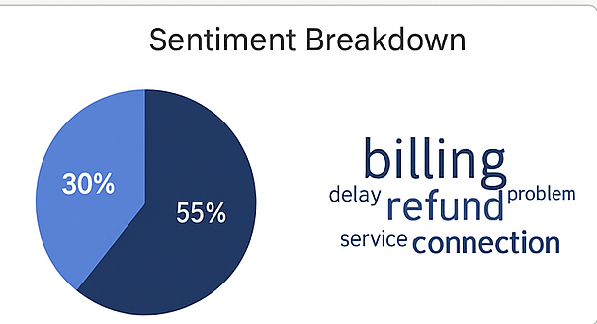

4.2 Call Volume Forecasting
Tools: Azure Machine Learning (Linear Regression)
Model performance (mock): RMSE = 45.2 calls/day, R² = 0.87
Insight: Mondays and post-promotion weeks show 30% call spikes.
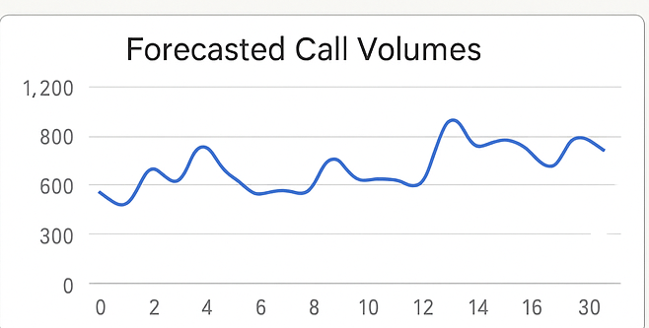

4.3 Generative Summarization
Tools: Azure OpenAI (GPT-4o) and Azure Speech.
Prompt Example: 'Summarize key issues and resolutions in 3 lines.'
Output Example: 'Customer requested billing correction; issue resolved with credit.'

5. Unified Azure AI Architecture
Proposed solution integrates multiple Azure AI components:
Layer | Azure Service | Purpose
Data Storage | Azure Blob Storage | Central data repository
Processing | Azure ML, AI Language | Model training & analytics
Generative | Azure OpenAI | Summarization workflows
Visualization | Power BI | Real-time dashboarding
Governance | AI Content Safety | Bias and privacy compliance  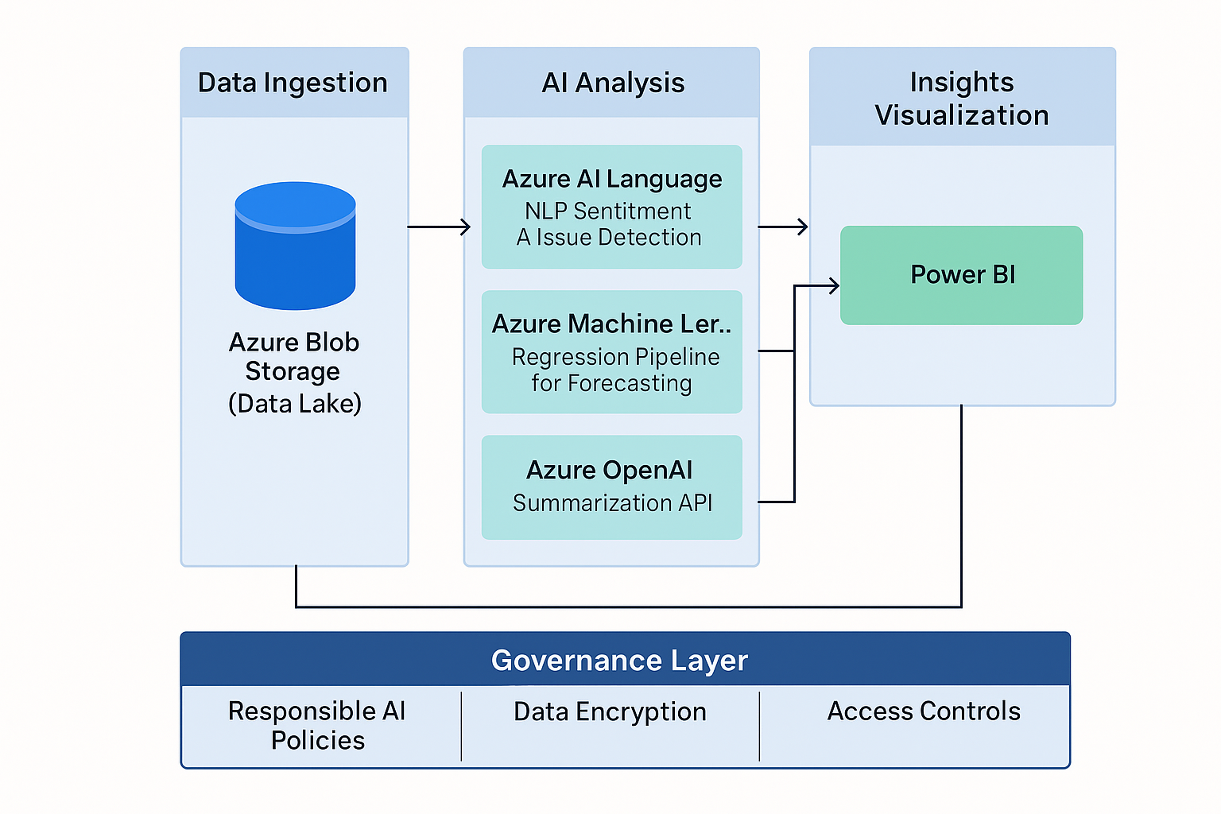

6. Ethical & Governance Considerations
• Bias & Fairness: Regular audits for sentiment bias.
• Privacy: Mask personal information during processing.
• Transparency: Model cards and explainability logs for accountability.

7. Business Impact Summary
Objective | Business Outcome
Forecasting | Reduced customer wait times by ~18%
Sentiment Analysis | Early detection of dissatisfaction trends
Summarization | Saved 3–5 minutes per call
Governance | Enhanced trust with explainable AI

8. Conclusion
This Azure-powered AI pipeline enables proactive customer service management, improving satisfaction, efficiency, and compliance through integrated analytics and automation.

9. References
Microsoft Azure AI Language Documentation: https://learn.microsoft.com/en-us/azure/ai-services/language-service/
Azure OpenAI Service: https://azure.microsoft.com/en-us/products/ai-services/openai-service/
Azure Machine Learning: https://learn.microsoft.com/en-us/azure/machine-learning/ ChaptGPT: https://chatgpt.com/ Colab for my python codes: https://colab.research.google.com/drive/

