LAB REPORT
Lab2: Counters
万晨阳 3210105327
2023/12/7

1. Problem Description

Part I
Here is a 4-bit synchronous counter which uses four T-type flip-flops in the figure below. The counter increments its count on each positive edge of the clock if the Enable signal is asserted. The counter is reset to 0 by using the Reset signal.
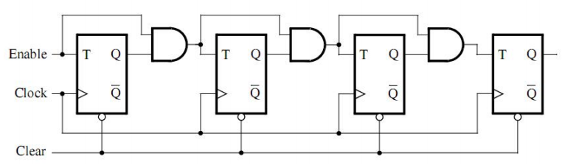

We are to implement a 16-bit counter of this type and finish tasks followed:
① Write a VHDL file that defines a 16-bit counter and compile the circuit. Then Simulate the circuit to verify its correctness.
② Augment your VHDL file to use the pushbutton KEY0 as the Clock input, switches SW1 and SW0 as Enable and Reset inputs, and 7-segment displays HEX3-0 to display the hexadecimal count as your circuit operates. Make the necessary pin assignments and compile the circuit.
Finally, implement the circuit on the DE2 board and test its functionality by operating the implemented switches
③ Implement a 4-bit version of your circuit and use the Quartus II RTL Viewer to see how Quartus II software synthesized your circuit.

Part II
Design and implement a circuit that displays the word HELLO, in ticker tape fashion, on the eight
7-segment displays HEX7 − 0. Make the letters move from right to left in intervals of about one
second. The expected effects are shown in the table below.
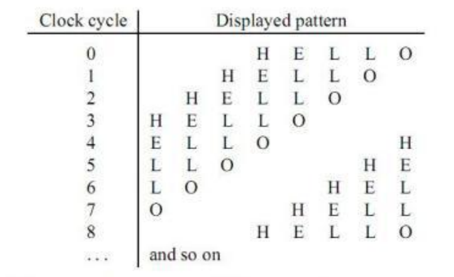

2. Design Formulation

Part I
We need to design two components, the T trigger and the AND gate.
T trigger:
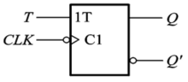
- x := T xor Q
- Q <= x
AND gate:
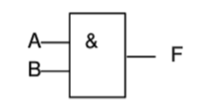
- TQ <= T and Q
Then we get a basic unit: T trigger AND gate. We just need to connect these units end-to-end to get the counter of the type we need.
Then we need to design the Nixie tube part, divide the 16-bit binary number obtained by the counter into 4 parts as the input of the Nixie tube part, and then let the Nixie tube display the base 16 number according to the input.
- when "0000" => Display <= "11000000"
- when "0001" => Display <= "11111001"
- when "0010" => Display <= "10100100"
- ……

Part II
Using the counter in Part I to implement a 3-bit counter to record the number of rising edges of the clock signal. Notice that we chose a 50MHz clock signal, and the goal was to make the letters roll every second, so we need to set up a suitable frequency divider so that the high-frequency clock signal becomes a low-frequency signal of the target frequency. In a word, we need a 3-bit counter to record the state and deciding how to display the words HELLO on the 7-segment decoders with the state signal (maintained by the 3-bit counter). The other works are similar to the former part.

3. Design Entry
Part I
1. 16-bit counter
- -- THIS PROGRAM IS ONLY USED FOR CHECKING THE CORRECTNESS OF THE 16-BIT COUNTER
- LIBRARY ieee;
- use ieee.std_logic_1164.all;
- use ieee.std_logic_unsigned.all;

- entity counter16 is
- port(
- SW:in bit_vector(2 downto 1);--SW1 start SW2 reset
- iCLK_50:in bit; --clk
- outbit:buffer bit_vector(15 downto 0));
- end counter16;

- ARCHITECTURE Behavior OF counter16 IS
- signal M : bit_vector(14 downto 0);

- component T_trigger
- port(Enable,clk,clear:in bit;
- outbit: buffer bit);
- end component;

- begin
- T0:T_trigger port map(SW(1),iCLK_50,SW(2),outbit(0));
- M(0) <= (SW(1) and outbit(0));
- T1:T_trigger port map(M(0),iCLK_50,SW(2),outbit(1));
- M(1) <= (M(0) and outbit(1));
- T2:T_trigger port map(M(1),iCLK_50,SW(2),outbit(2));
- M(2) <= (M(1) and outbit(2));
- T3:T_trigger port map(M(2),iCLK_50,SW(2),outbit(3));
- M(3) <= (M(2) and outbit(3));
- T4:T_trigger port map(M(3),iCLK_50,SW(2),outbit(4));
- M(4) <= (M(3) and outbit(4));
- T5:T_trigger port map(M(4),iCLK_50,SW(2),outbit(5));
- M(5) <= (M(4) and outbit(5));
- T6:T_trigger port map(M(5),iCLK_50,SW(2),outbit(6));
- M(6) <= (M(5) and outbit(6));
- T7:T_trigger port map(M(6),iCLK_50,SW(2),outbit(7));
- M(7) <= (M(6) and outbit(7));
- T8:T_trigger port map(M(7),iCLK_50,SW(2),outbit(8));
- M(8) <= (M(7) and outbit(8));
- T9:T_trigger port map(M(8),iCLK_50,SW(2),outbit(9));
- M(9) <= (M(8) and outbit(9));
- T10:T_trigger port map(M(9),iCLK_50,SW(2),outbit(10));
- M(10) <= (M(9) and outbit(10));
- T11:T_trigger port map(M(10),iCLK_50,SW(2),outbit(11));
- M(11) <= (M(10) and outbit(11));
- T12:T_trigger port map(M(11),iCLK_50,SW(2),outbit(12));
- M(12) <= (M(11) and outbit(12));
- T13:T_trigger port map(M(12),iCLK_50,SW(2),outbit(13));
- M(13) <= (M(12) and outbit(13));
- T14:T_trigger port map(M(13),iCLK_50,SW(2),outbit(14));
- M(14) <= (M(13) and outbit(14));
- T15:T_trigger port map(M(14),iCLK_50,SW(2),outbit(15));
- end Behavior;

- entity T_trigger is
- port(Enable,clk,clear:in bit;
- outbit: buffer bit);
- end T_trigger;

- ARCHITECTURE Behavior OF T_trigger IS

- begin
- process(clk, enable, clear)
- variable x : bit := '0';
- begin
- if clear = '1' then
- x := '0';
- elsif clk'event and clk = '1' then
- x := enable xor x;
- end if;
- outbit <= x;
- end process;
- end behavior;
2. 16-bit counter with four 7-segment decoders
- LIBRARY ieee;
- use ieee.std_logic_1164.all;
- use ieee.std_logic_unsigned.all;

- entity counter16_plus is
- port(
- SW:in bit_vector(1 downto 0); --SW1 enable, SW0 Reset
- iCLK_50:in bit; --clk
- HEX0,HEX1,HEX2,HEX3: out bit_vector(6 downto 0));
- end counter16_plus;

- ARCHITECTURE Behavior OF counter16_plus IS
- signal outbit: bit_vector(15 downto 0);
- component counter16 is
- port(
- SW:in bit_vector(1 downto 0);--SW1 start SW2 reset
- iCLK_50:in bit; --clk
- outbit:buffer bit_vector(15 downto 0));
- end component;

- component encoder is
- port(
- Number:in bit_vector(3 downto 0);
- Display:out bit_vector(6 downto 0));
- end component;

- begin
- c16:counter16 port map(SW,iCLK_50,outbit);
- encode0:encoder port map(outbit(15 downto 12),HEX3);
- encode1:encoder port map(outbit(11 downto 8),HEX2);
- encode2:encoder port map(outbit(7 downto 4),HEX1);
- encode3:encoder port map(outbit(3 downto 0),HEX0);
- end behavior;

- --------------counter16-------------------
- entity counter16 is
- port(
- SW:in bit_vector(1 downto 0); --SW1 enable, SW0 Reset
- iCLK_50:in bit; --clk
- outbit:buffer bit_vector(15 downto 0));
- end counter16;

- ARCHITECTURE Behavior OF counter16 IS
- signal M : bit_vector(14 downto 0);

- component T_trigger
- port(enable,clk,clear:in bit;
- outbit: buffer bit);
- end component;

- Begin
- T0:T_trigger port map(SW(0),iCLK_50,SW(1),outbit(0));
- M(0) <= (SW(0) and outbit(0));
- T1:T_trigger port map(M(0),iCLK_50,SW(1),outbit(1));
- M(1) <= (M(0) and outbit(1));
- T2:T_trigger port map(M(1),iCLK_50,SW(1),outbit(2));
- M(2) <= (M(1) and outbit(2));
- T3:T_trigger port map(M(2),iCLK_50,SW(1),outbit(3));
- M(3) <= (M(2) and outbit(3));
- T4:T_trigger port map(M(3),iCLK_50,SW(1),outbit(4));
- M(4) <= (M(3) and outbit(4));
- T5:T_trigger port map(M(4),iCLK_50,SW(1),outbit(5));
- M(5) <= (M(4) and outbit(5));
- T6:T_trigger port map(M(5),iCLK_50,SW(1),outbit(6));
- M(6) <= (M(5) and outbit(6));
- T7:T_trigger port map(M(6),iCLK_50,SW(1),outbit(7));
- M(7) <= (M(6) and outbit(7));
- T8:T_trigger port map(M(7),iCLK_50,SW(1),outbit(8));
- M(8) <= (M(7) and outbit(8));
- T9:T_trigger port map(M(8),iCLK_50,SW(1),outbit(9));
- M(9) <= (M(8) and outbit(9));
- T10:T_trigger port map(M(9),iCLK_50,SW(1),outbit(10));
- M(10) <= (M(9) and outbit(10));
- T11:T_trigger port map(M(10),iCLK_50,SW(1),outbit(11));
- M(11) <= (M(10) and outbit(11));
- T12:T_trigger port map(M(11),iCLK_50,SW(1),outbit(12));
- M(12) <= (M(11) and outbit(12));
- T13:T_trigger port map(M(12),iCLK_50,SW(1),outbit(13));
- M(13) <= (M(12) and outbit(13));
- T14:T_trigger port map(M(13),iCLK_50,SW(1),outbit(14));
- M(14) <= (M(13) and outbit(14));
- T15:T_trigger port map(M(14),iCLK_50,SW(1),outbit(15));
- end Behavior;

- entity T_trigger is
- port(enable,clk,clear:in bit;
- outbit: buffer bit);
- end T_trigger;

- ARCHITECTURE Behavior OF T_trigger IS

- begin
- process(clk,enable,clear)
- variable x : bit := '0';
- begin
- if clear = '1' then
- x := '0';
- elsif clk'event and clk = '1' then
- x := enable xor x;
- end if;
- outbit <= x;
- end process;
- end behavior;

- ------------------encoder4---------------
- entity encoder is
- port(
- Number:in bit_vector(3 downto 0);
- Display:out bit_vector(6 downto 0));
- end encoder;

- ARCHITECTURE Behavior OF encoder IS
- begin
- process(Number)
- begin
- case Number is
- when "0000" => Display <= "1000000"; --0
- when "0001" => Display <= "1111001"; --1
- when "0010" => Display <= "0100100"; --2
- when "0011" => Display <= "0110000"; --3
- when "0100" => Display <= "0011001"; --4
- when "0101" => Display <= "0010010"; --5
- when "0110" => Display <= "0000010"; --6
- when "0111" => Display <= "1111000"; --7
- when "1000" => Display <= "0000000"; --8
- when "1001" => Display <= "0010000"; --9
- when "1010" => Display <= "1001000"; --A
- when "1011" => Display <= "0000011"; --b
- when "1100" => Display <= "1000110"; --C
- when "1101" => Display <= "0100001"; --d
- when "1110" => Display <= "0000110"; --E
- when "1111" => Display <= "0001110"; --F
- end case;
- end process;
- end behavior;
3. 4-bit counter
- LIBRARY ieee;
- use ieee.std_logic_1164.all ;
- use ieee.std_logic_unsigned.all ;

- entity counter4 is
- port(
- SW:in bit_vector(1 downto 0);
- iCLK_50:in bit;
- outbit:buffer bit_vector(3 downto 0));
- end counter4;

- ARCHITECTURE Behavior OF counter4 IS
- signal M : bit_vector(2 downto 0);

- component T_trigger
- port(enable,clk,clear:in bit;
- outbit: buffer bit);
- end component;

- Begin
- T0:T_trigger port map(SW(0),iCLK_50,SW(1),outbit(0));
- M(0) <= (SW(0) and outbit(0));
- T1:T_trigger port map(M(0),iCLK_50,SW(1),outbit(1));
- M(1) <= (M(0) and outbit(1));
- T2:T_trigger port map(M(1),iCLK_50,SW(1),outbit(2));
- M(2) <= (M(1) and outbit(2));
- T3:T_trigger port map(M(2),iCLK_50,SW(1),outbit(3));
- end Behavior;

- entity T_trigger is
- port(enable,clk,clear:in bit;
- outbit: buffer bit);
- end T_trigger;

- ARCHITECTURE Behavior OF T_trigger IS

- begin
- process(clk,enable,clear)
- variable x : bit := '0';
- begin
- if clear = '1' then
- x := '0';
- elsif clk'event and clk = '1' then
- x := enable xor x;
- end if;
- outbit <= x;
- end process;
- end behavior;
Part II
- LIBRARY ieee;
- use ieee.std_logic_1164.all ;
- use ieee.std_logic_unsigned.all ;

- entity part2 is
- port(
- SW:in bit_vector(1 downto 0);
- iCLK_50:in bit;
- HEX0,HEX1,HEX2,HEX3,HEX4,HEX5,HEX6,HEX7: out bit_vector(6 downto 0));
- end part2;

- ARCHITECTURE Behavior OF part2 IS

- component counter3 is
- port(
- SW:in bit_vector(1 downto 0);
- iCLK_50:in bit;
- outbit:buffer bit_vector(2 downto 0));
- end component;
- signal switch: bit_vector(2 downto 0);

- Begin
- C0:counter3 port map(SW, iCLK_50, switch);
- process(switch)
- begin
- case switch is
- when "000"=>
- HEX0<="1111111";HEX1<="1111111";HEX2<="1111111";HEX3<="0001001";HEX4<="0000110";HEX5<="1000111";HEX6<="1000111";HEX7<="1000000";
- when "001"=>
- HEX7<="1111111";HEX0<="1111111";HEX1<="1111111";HEX2<="0001001";HEX3<="0000110";HEX4<="1000111";HEX5<="1000111";HEX6<="1000000";
- when "010"=>
- HEX6<="1111111";HEX7<="1111111";HEX0<="1111111";HEX1<="0001001";HEX2<="0000110";HEX3<="1000111";HEX4<="1000111";HEX5<="1000000";
- when "011"=>
- HEX5<="1111111";HEX6<="1111111";HEX7<="1111111";HEX0<="0001001";HEX1<="0000110";HEX2<="1000111";HEX3<="1000111";HEX4<="1000000";
- when "100"=>
- HEX4<="1111111";HEX5<="1111111";HEX6<="1111111";HEX7<="0001001";HEX0<="0000110";HEX1<="1000111";HEX2<="1000111";HEX3<="1000000";
- when "101"=>
- HEX3<="1111111";HEX4<="1111111";HEX5<="1111111";HEX6<="0001001";HEX7<="0000110";HEX0<="1000111";HEX1<="1000111";HEX2<="1000000";
- when "110"=>
- HEX2<="1111111";HEX3<="1111111";HEX4<="1111111";HEX5<="0001001";HEX6<="0000110";HEX7<="1000111";HEX0<="1000111";HEX1<="1000000";
- when "111"=>
- HEX1<="1111111";HEX2<="1111111";HEX3<="1111111";HEX4<="0001001";HEX5<="0000110";HEX6<="1000111";HEX7<="1000111";HEX0<="1000000";
- END CASE;
- end process;
- end behavior;

- entity counter3 is
- port(
- SW:in bit_vector(1 downto 0);
- iCLK_50:in bit;
- outbit:buffer bit_vector(2 downto 0));
- end counter3;

- ARCHITECTURE Behavior OF counter3 IS
- signal M : bit_vector(1 downto 0);

- component T_trigger
- port(Enable,clk,clear:in bit;
- outbit: buffer bit);
- end component;

- Begin
- T0:T_trigger port map(SW(0),iCLK_50,SW(1),outbit(0));
- M(0) <= (SW(0) and outbit(0));
- T1:T_trigger port map(M(0),iCLK_50,SW(1),outbit(1));
- M(1) <= (M(0) and outbit(1));
- T2:T_trigger port map(M(1),iCLK_50,SW(1),outbit(2));
- end Behavior;

- entity T_trigger is
- port(Enable,clk,clear:in bit;
- outbit: buffer bit);
- end T_trigger;

- ARCHITECTURE Behavior OF T_trigger IS

- shared variable a : integer := 0;
- begin
- process(clk,enable,clear)
- variable x : bit := '0';
- constant n : integer := 50000000;
- begin
- if clear = '1' then
- x := '0';
- elsif clk'event and clk = '1' then
- a := a + 1;
- if a >= n then
- x := enable xor x;
- a := 0;
- end if;
- end if;
- outbit <= x;
- end process;
- end behavior;
4. Simulation and Synthesis Results

Part I
1. 16-bit counter
- Timing Simulation
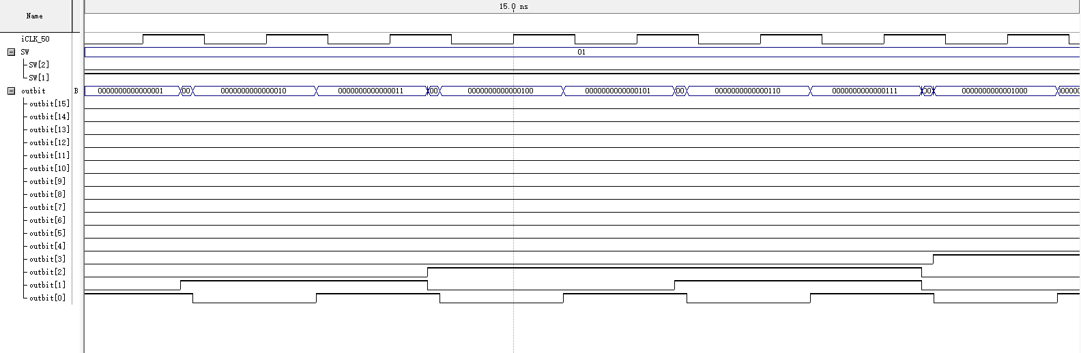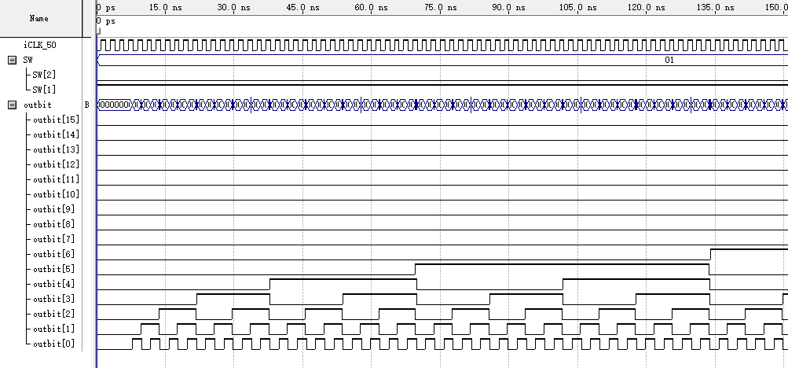
- Functional Simulation
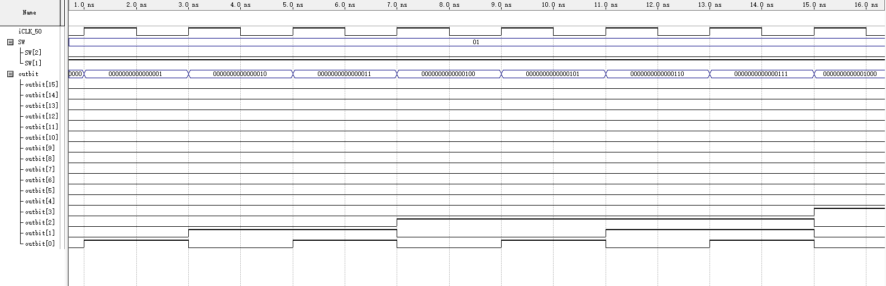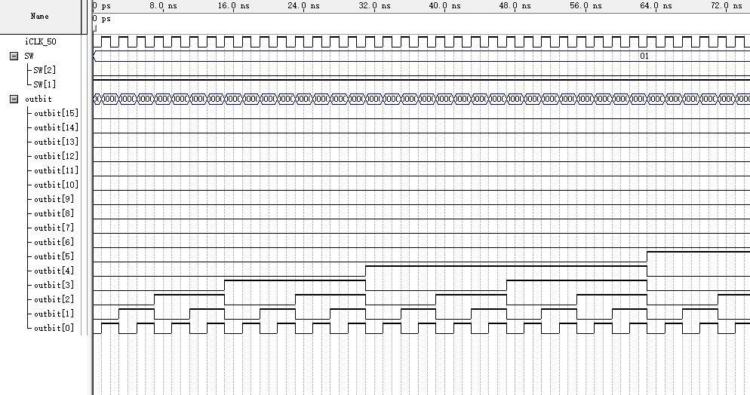
- Synthesized Circuit
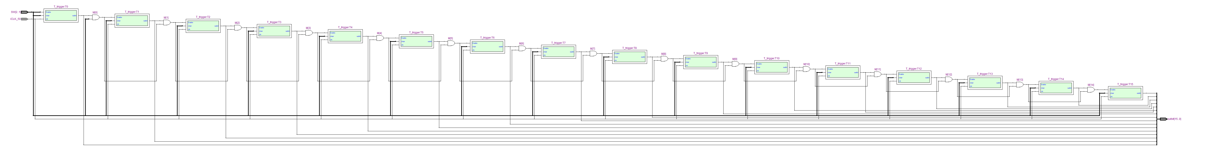

- Description
For a certain frequency of clk input, we can see that the 16-bit counter correctly accomplishes the counting function, For the time domain simulation, there is a delay.

2. 16-bit counter with four 7-segment decoders
- Timing Simulation
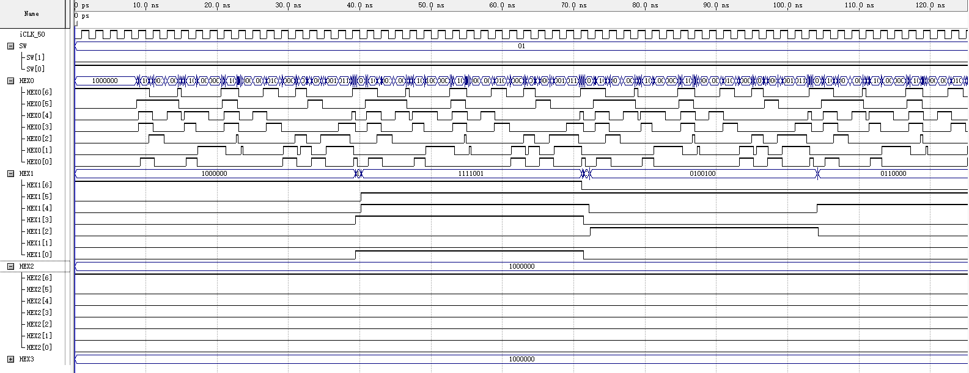
- Functional Simulation
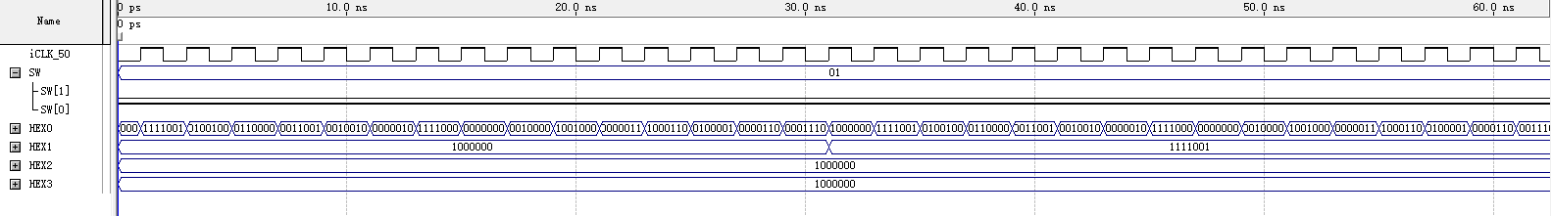
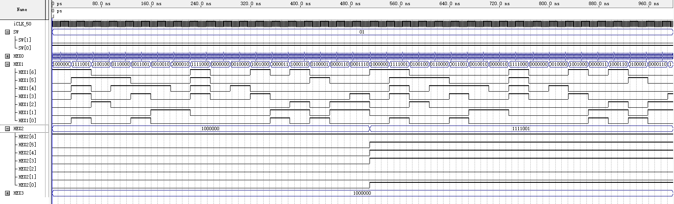
- Synthesized Circuit
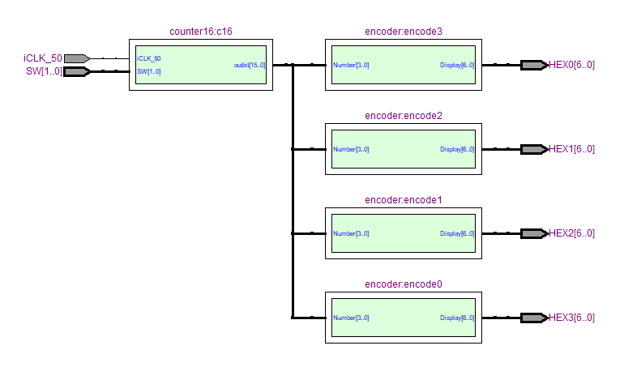
- Description
For a certain frequency of clk input, we have verified the correctness of the 16-bit counter earlier, and we are now utilizing a 7-segment digital tube for the output, and the results are as expected. The results in the time domain simulation have some delays and burrs.
3. 4-bit counter
- Timing Simulation
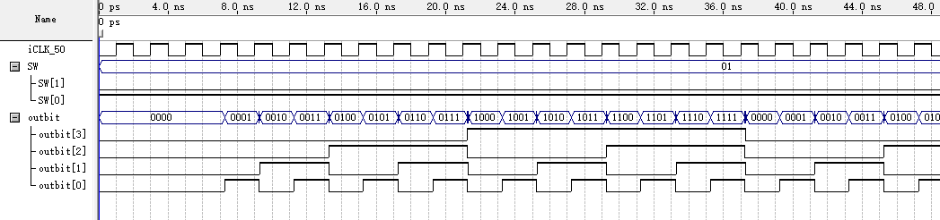
- Functional Simulation
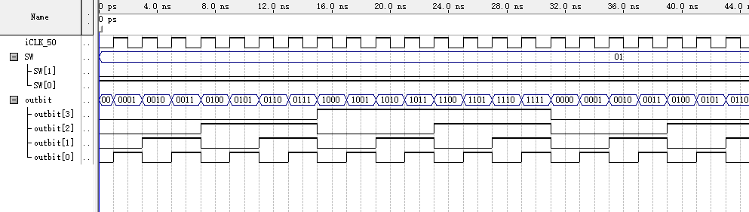
- Synthesized Circuit
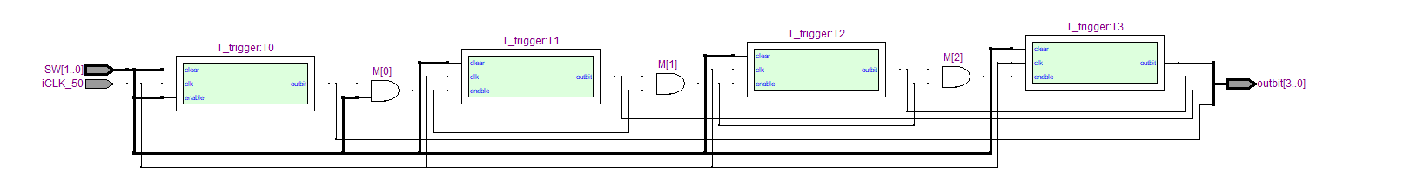
- Description
For a 4-bit counter, we can see that the counting function is done correctly in the functional simulation, while for the time domain simulation there are delays and burrs. It can be seen that the circuit obtained contains 4 t-flip-flops and 3 AND gates.

Part II
- Timing Simulation
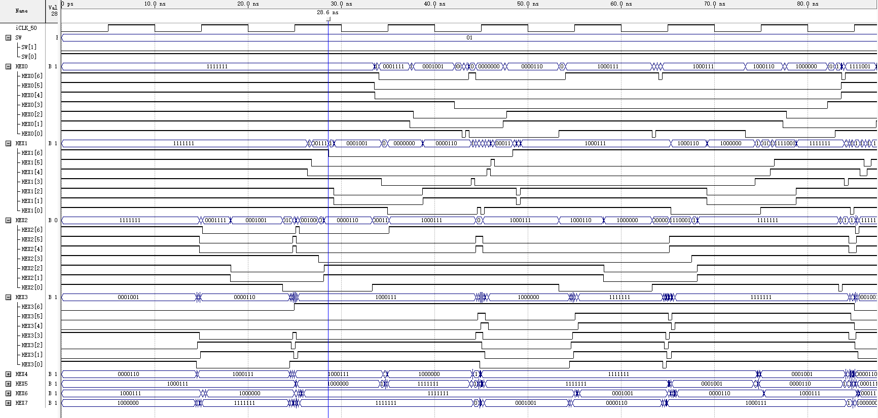
- Functional Simulation
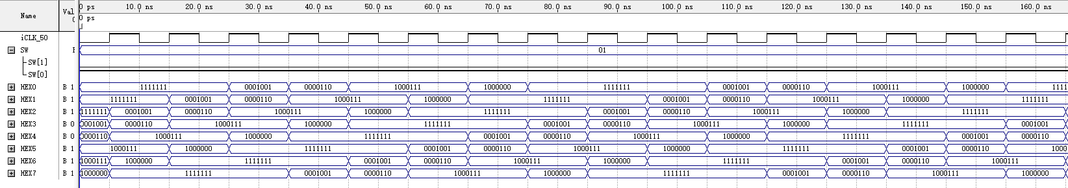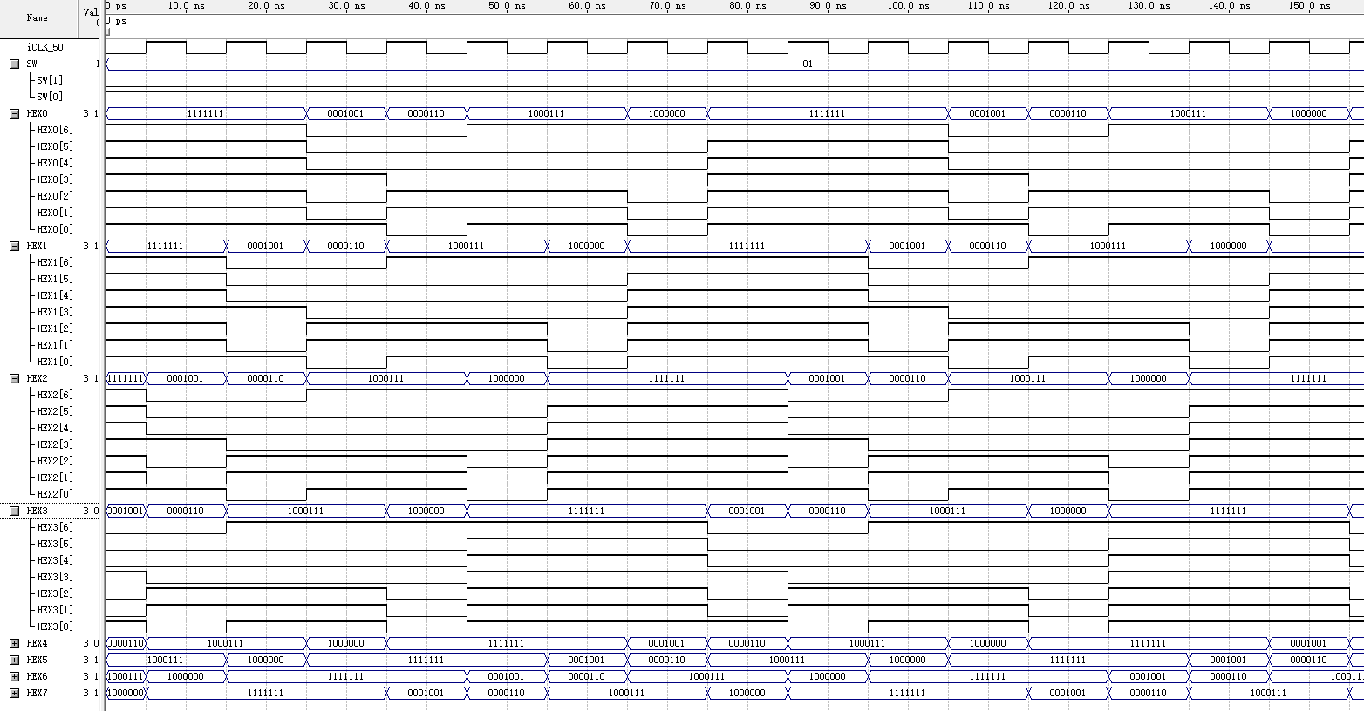
- Synthesized Circuit
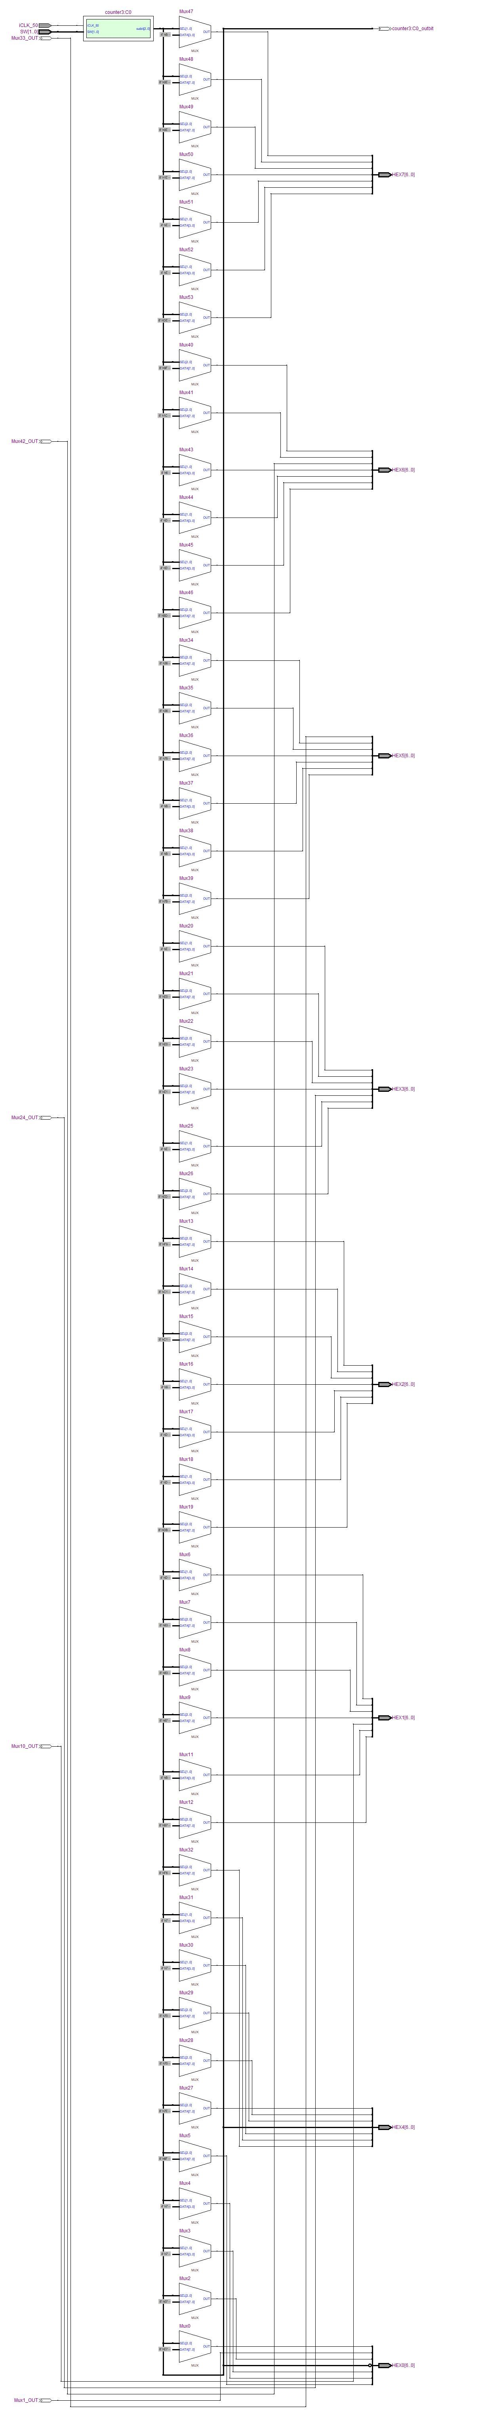
- Description
This part of the work is based on Part I counters, combined with digital tubes for scrolling displays. As can be seen from the functional simulation, for a certain frequency of clk input, the 3-bit counter correctly records eight states, and then the digital pipe display switches accordingly. The circuit is relatively complex due to the large number of state cases.

5. Experimental Results
Part I
The following image (003A and 002d) shows the counter value change (HEX0 to 3) after pressing button KEY0, as expected.
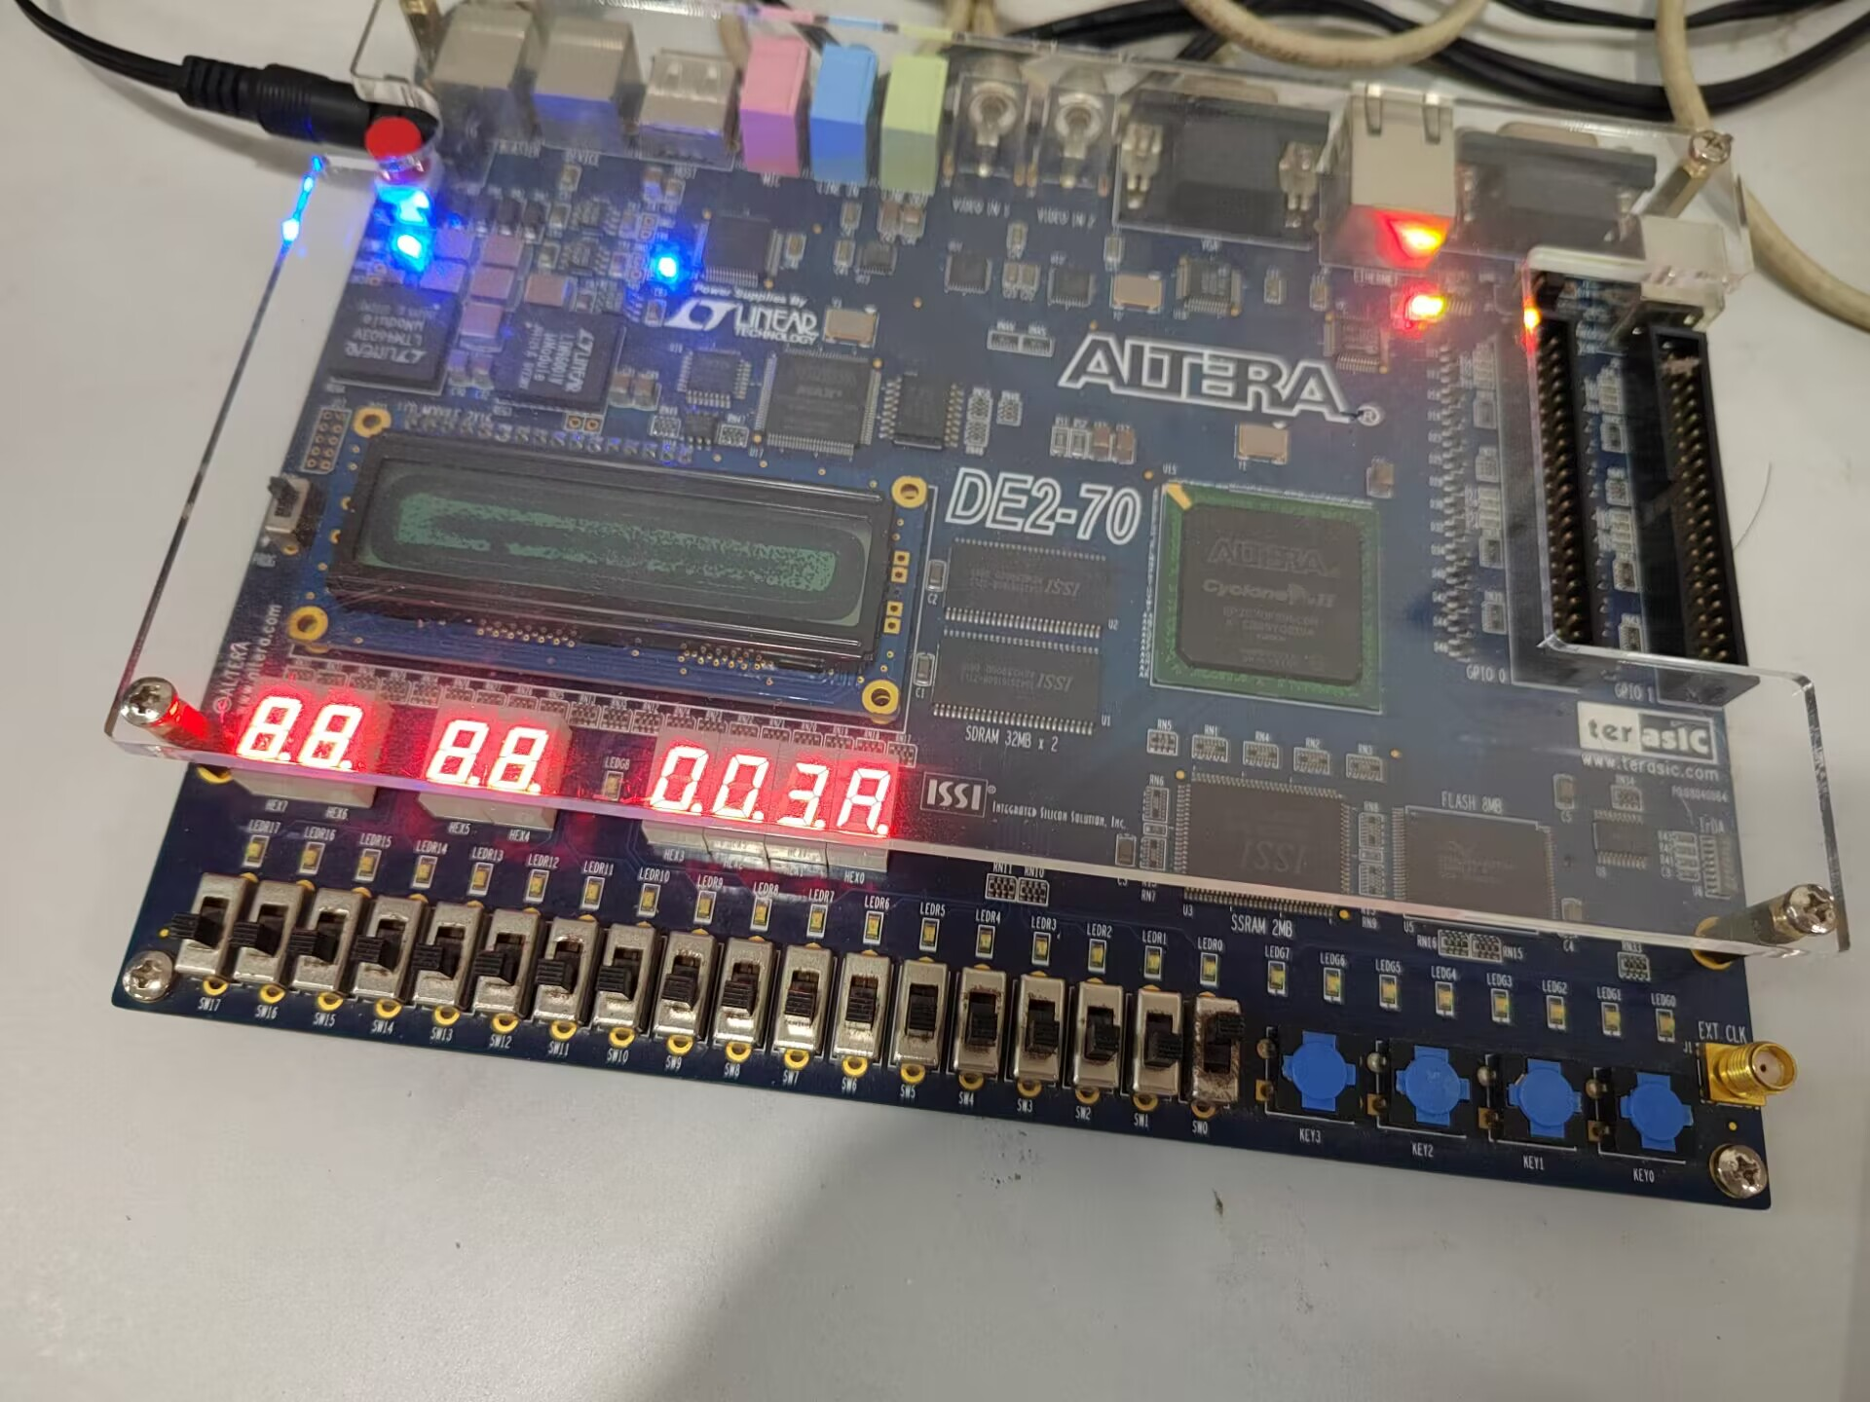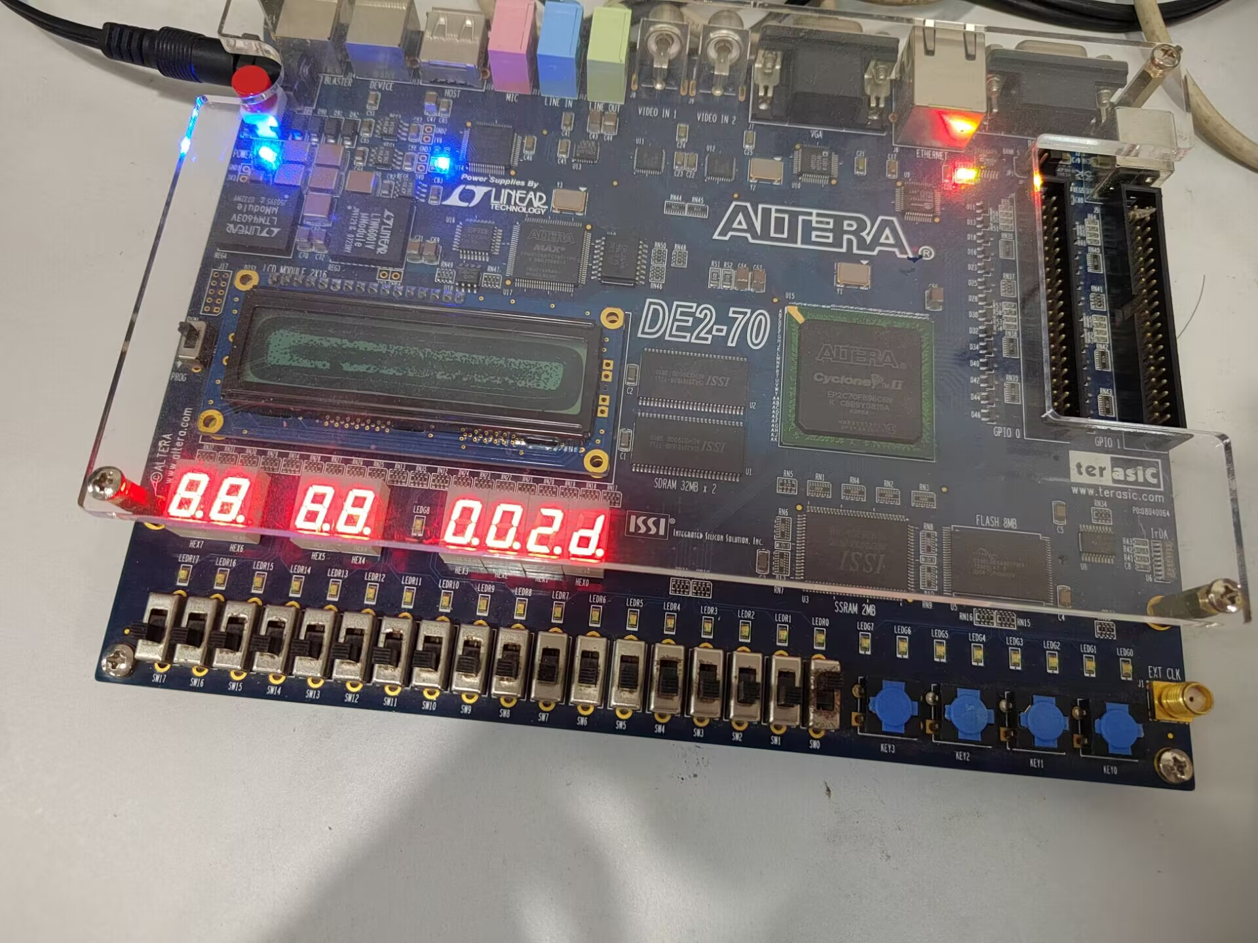
Part II
The following image shows the display of the word HELLO, in ticker tape fashion, on the eight 7-segment displays HEX7 − 0. The letters move from right to left in intervals of about one second. Since the actual digitizer serial number on the board increases from right to left, the display results in a HELLO sequence that is the opposite of what was expected, but the function meets the requirements.
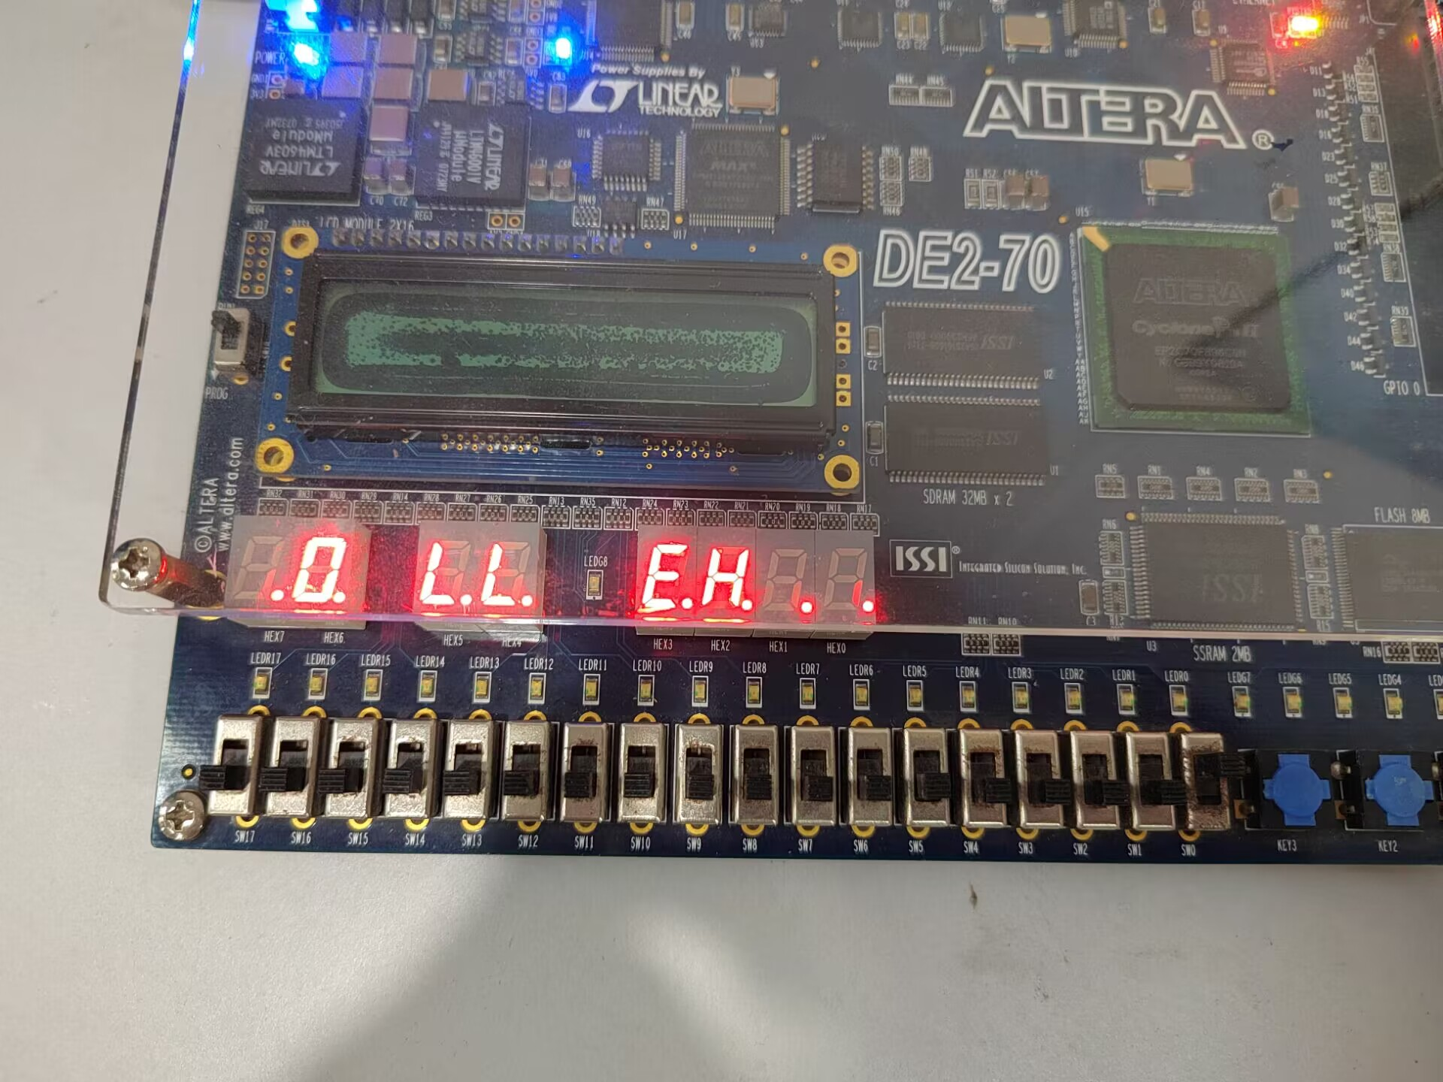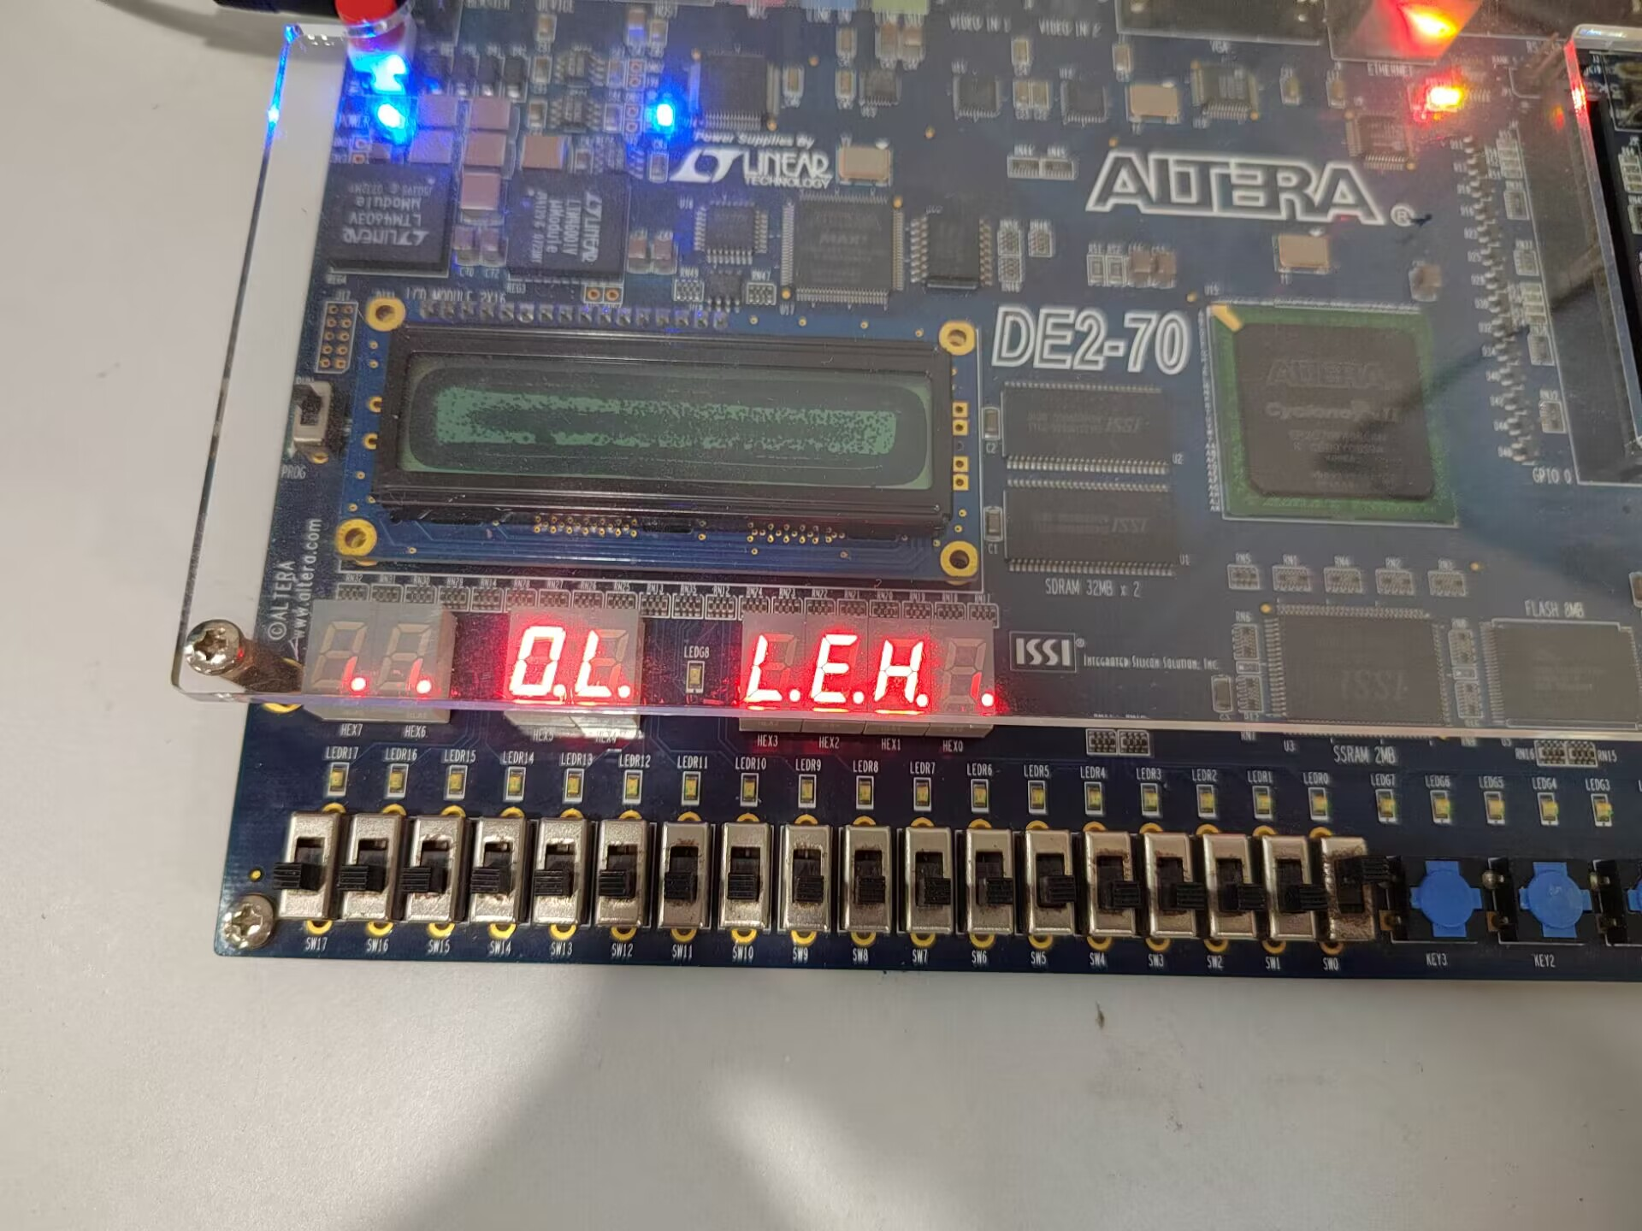
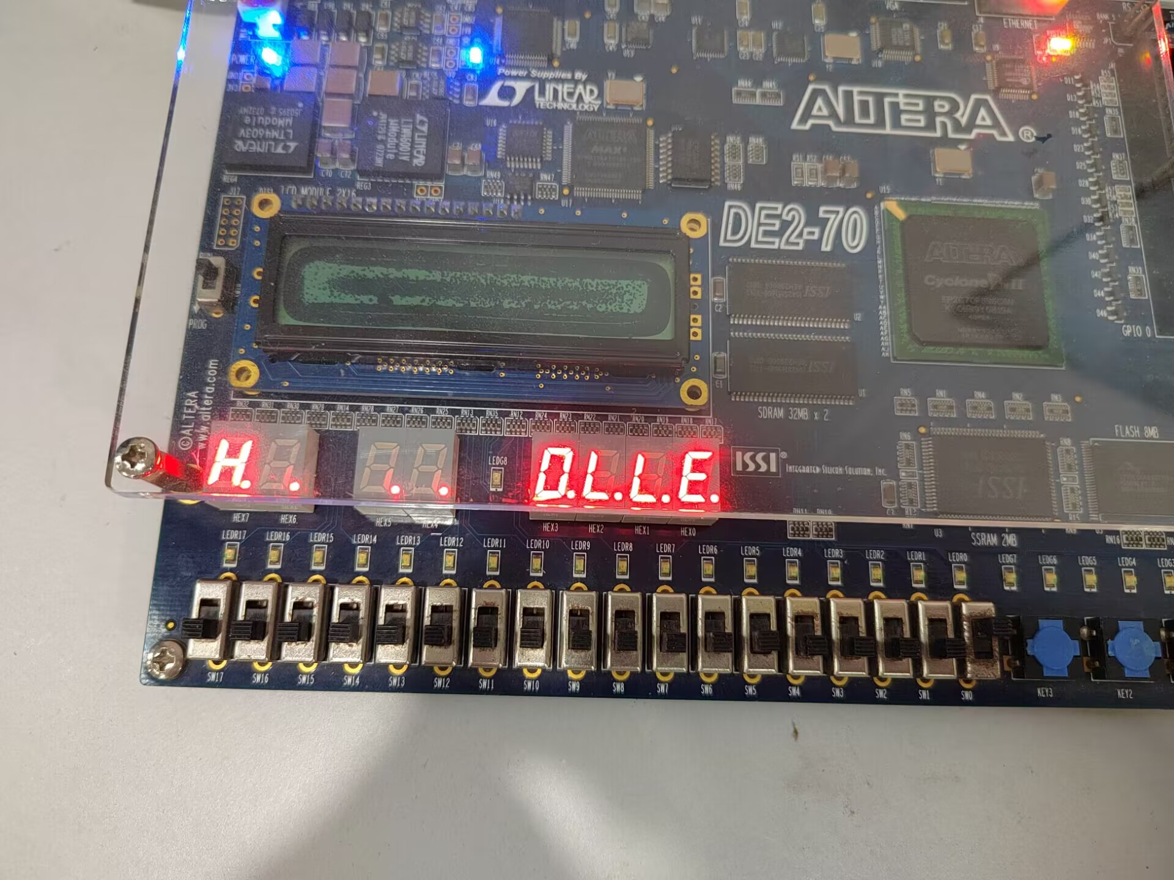

6. Discussion and Conclusion
After this experiment, I learned about the implementation of T-flip-flops in FPGA systems and familiarized myself with the design of counters.
The difficult parts I have encountered in the simulation part and what I have done are:

1. Bind the CLK input in the first part work to KEY0 instead of the system crystals.
2. Add the frequency division function. Since the frequency of the base crystal is 50MHz, in order to make the display switching interval close to 1s, I chose to add a counting part to the T-flip-flop to ensure that the switching frequency is close to 1Hz.I didn't do this part in the preliminaries (the simulation only verified the correctness of the rest of the code, and the frequency of the inputs was controllable, so the lack of this part of the function wasn't detected), and it was done on-site at the lab class. It was done on-site in the lab class.

