双足移动机器人技术及强化实践 实验3

3210105327 万晨阳

对ZJU-I型桌面机械臂，建立坐标系如图：

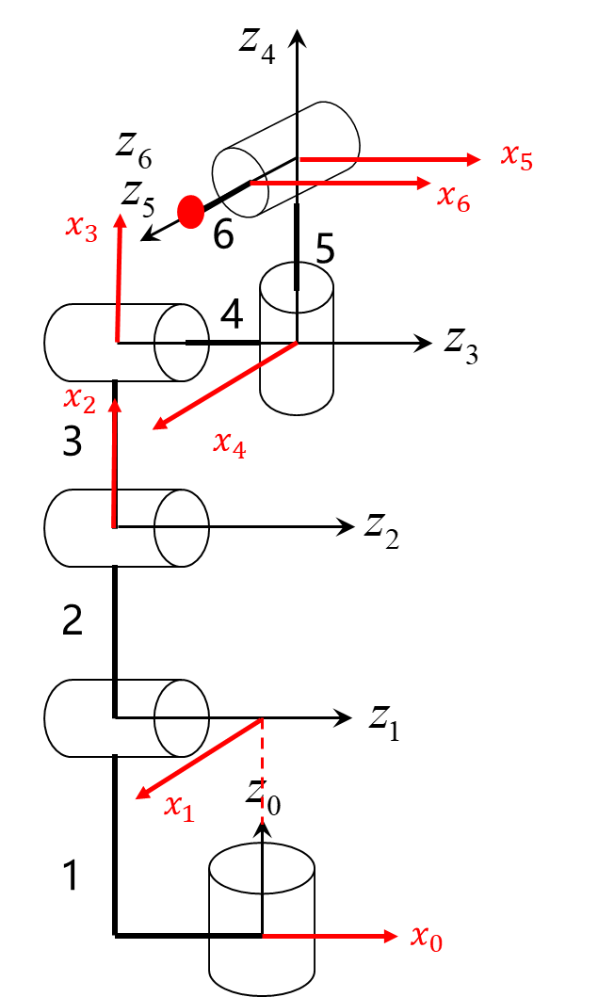

DH参数表：

|  |  |  |  |  |
| --- | --- | --- | --- | --- |
| $$No.$$ | $$a_{i}$$ | $$α_{i}$$ | $$d_{i}$$ | $$θ_{i}$$ |
| 1 | 0 | -90° | 230mm | $θ_{1}$ |
| 2 | 185mm | 0 | -54mm | $θ_{2}$ (-90°) |
| 3 | 170mm | 0 | 0 | $θ_{3}$ |
| 4 | 0 | 90° | 77mm | $θ_{4}$ (90°) |
| 5 | 0 | 90° | 77mm | $θ_{5}$ (90°) |
| 6 | 0 | 0 | 85.5mm | $$θ_{6}$$ |