Report for Computer Networks Project

Group member: 邵可乐-3210100786，万晨阳-3210105327

Project Number: #2

Date: 2023.3.27

**1. Run nslookup to obtain the IP address of a Web server in Asia.**

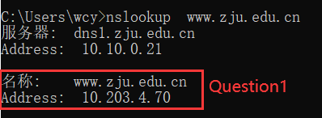

**2. Run nslookup to determine the authoritative DNS servers for a university in Europe.**

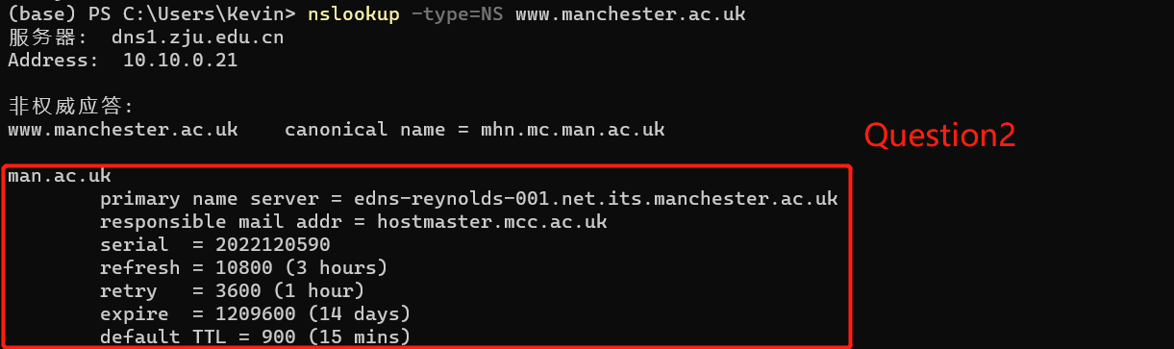

**3. Run nslookup so that one of the DNS servers obtained in Question 2 is queried for the mail servers for Yahoo! mail.**

DNS server can not resolve mail.yahoo.com, but it can resolve www.facebook.com.

**4. Locate the DNS query and response messages. Are they sent over UDP or TCP?**

UDP.

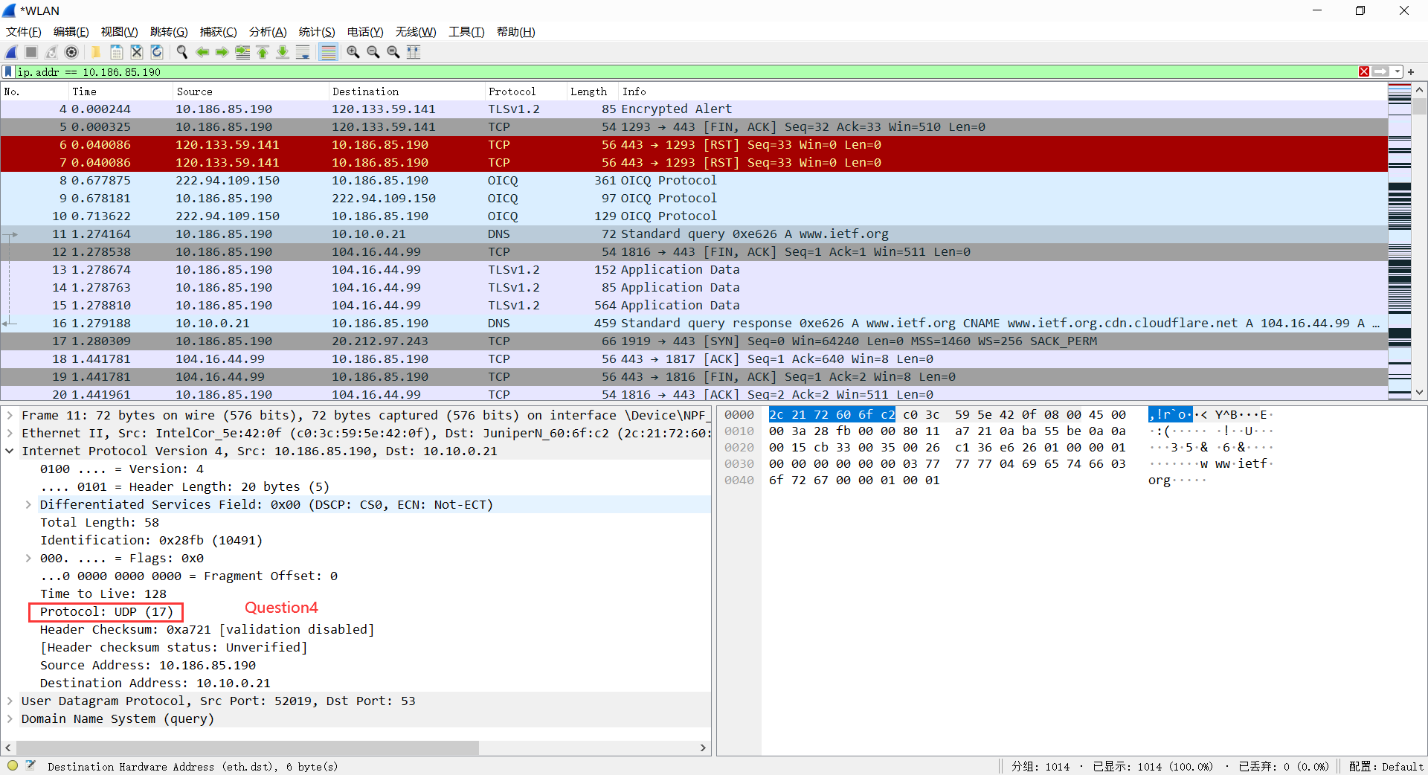

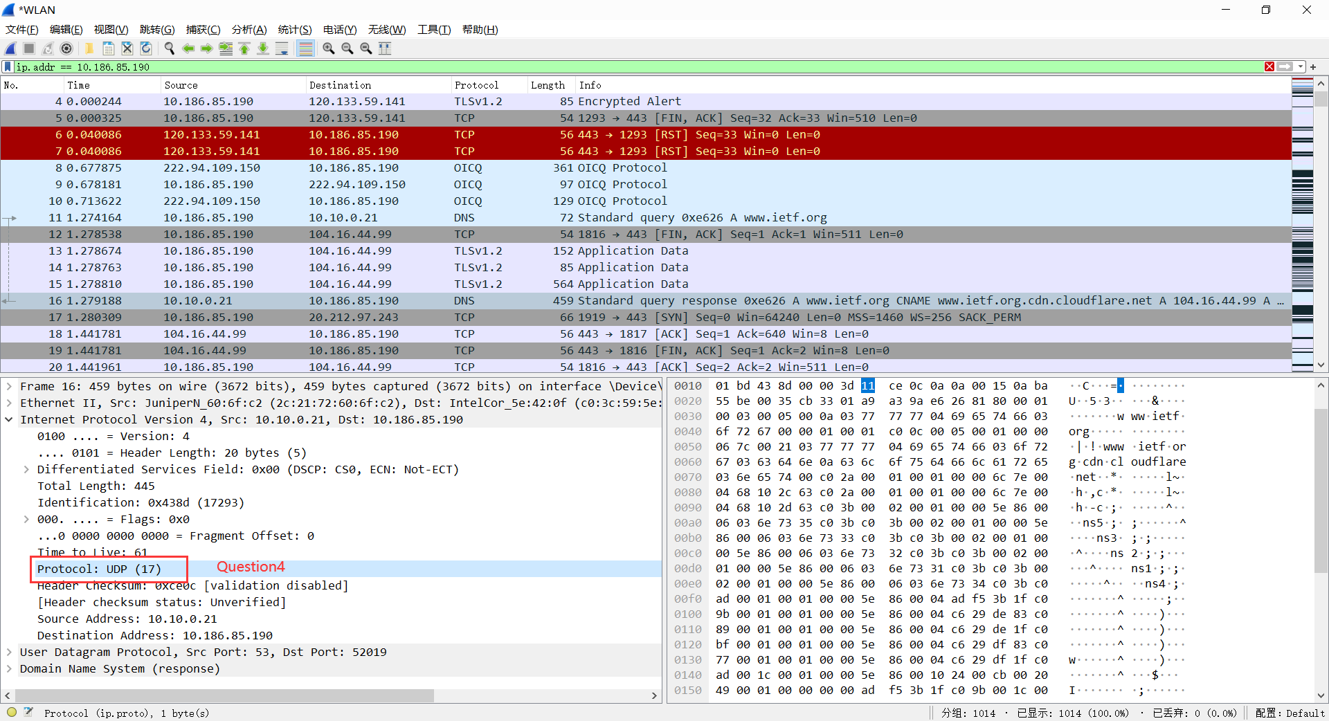

**5. What is the destination port for the DNS query message? What is the source port**

**of DNS response message?**

Both 53.

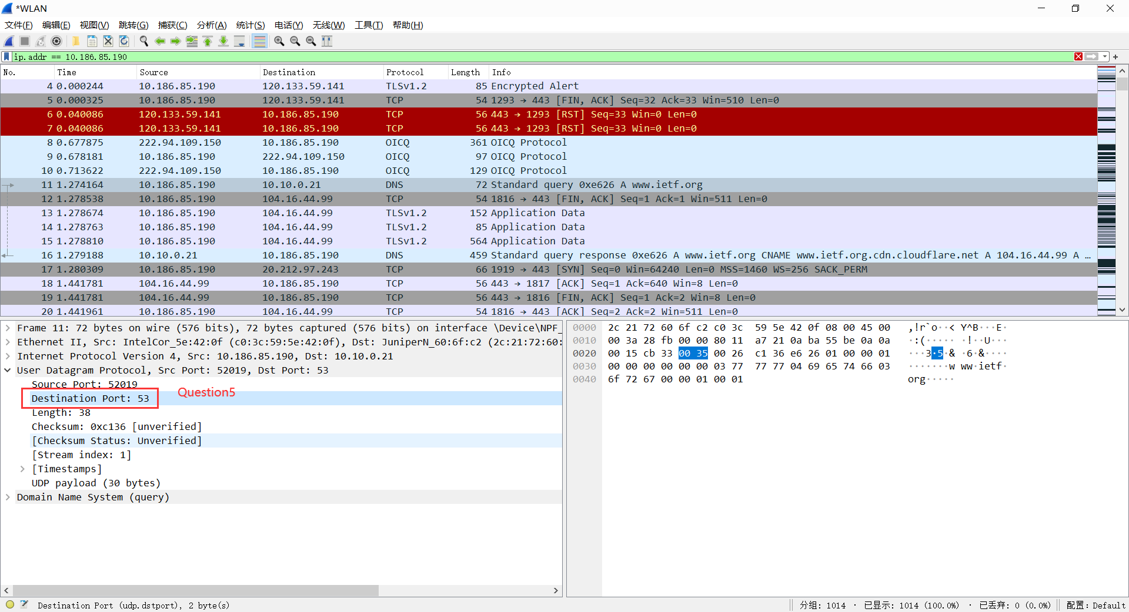

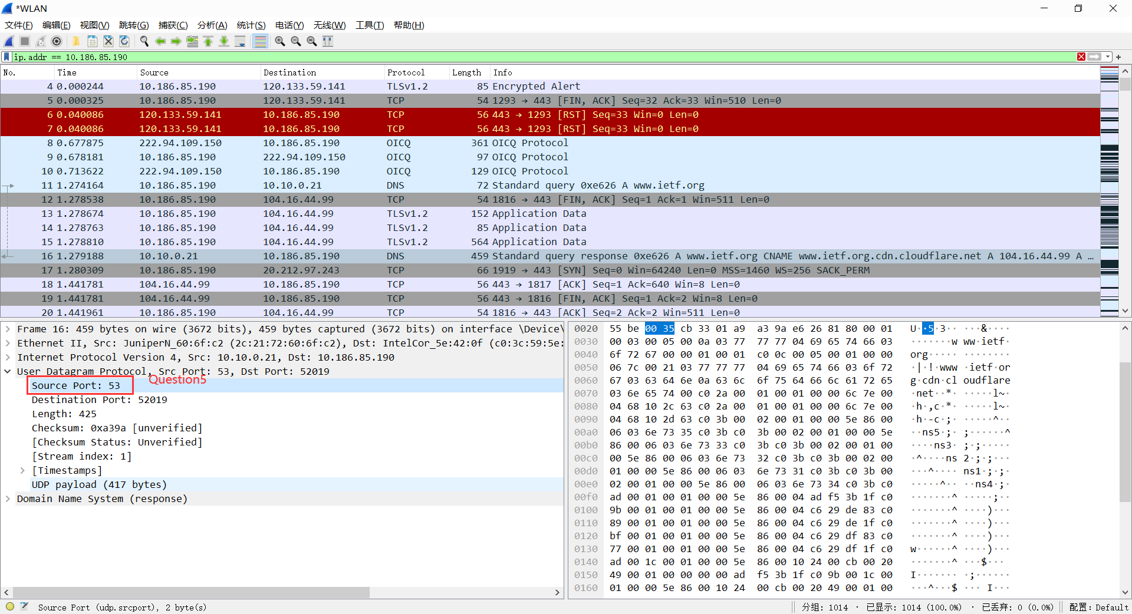

**6. To what IP address is the DNS query message sent? Use ipconfig to determine the**

**IP address of your local DNS server. Are these two IP addresses the same?**

The query message is sent to 10.10.0.21.

The IP address of my local DNS server is 10.10.0.21 10.10.2.21

These two IP addresses are the same.

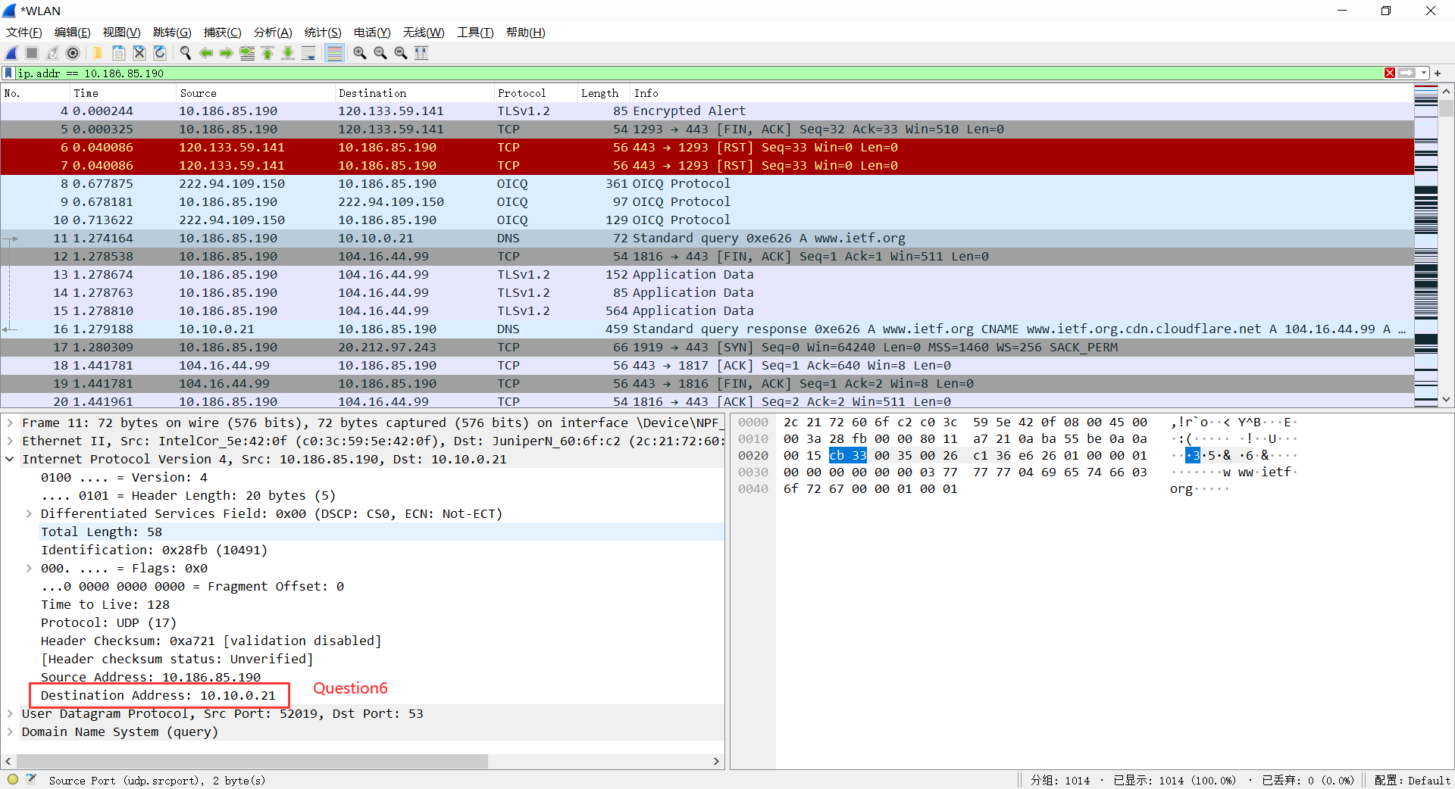

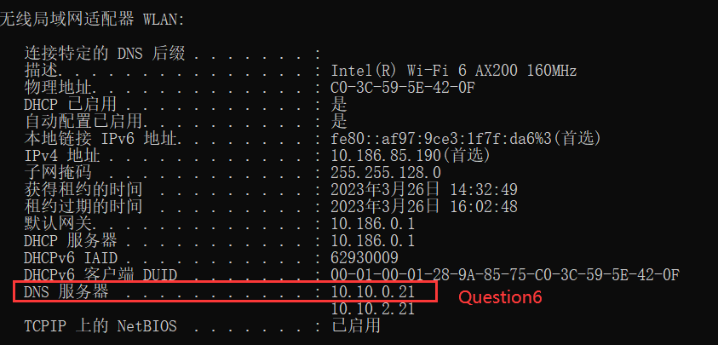

**7. Examine the DNS query message. What “Type” of DNS query is it? Does**

**the query message contain any “answers”?**

Type A. No answers.

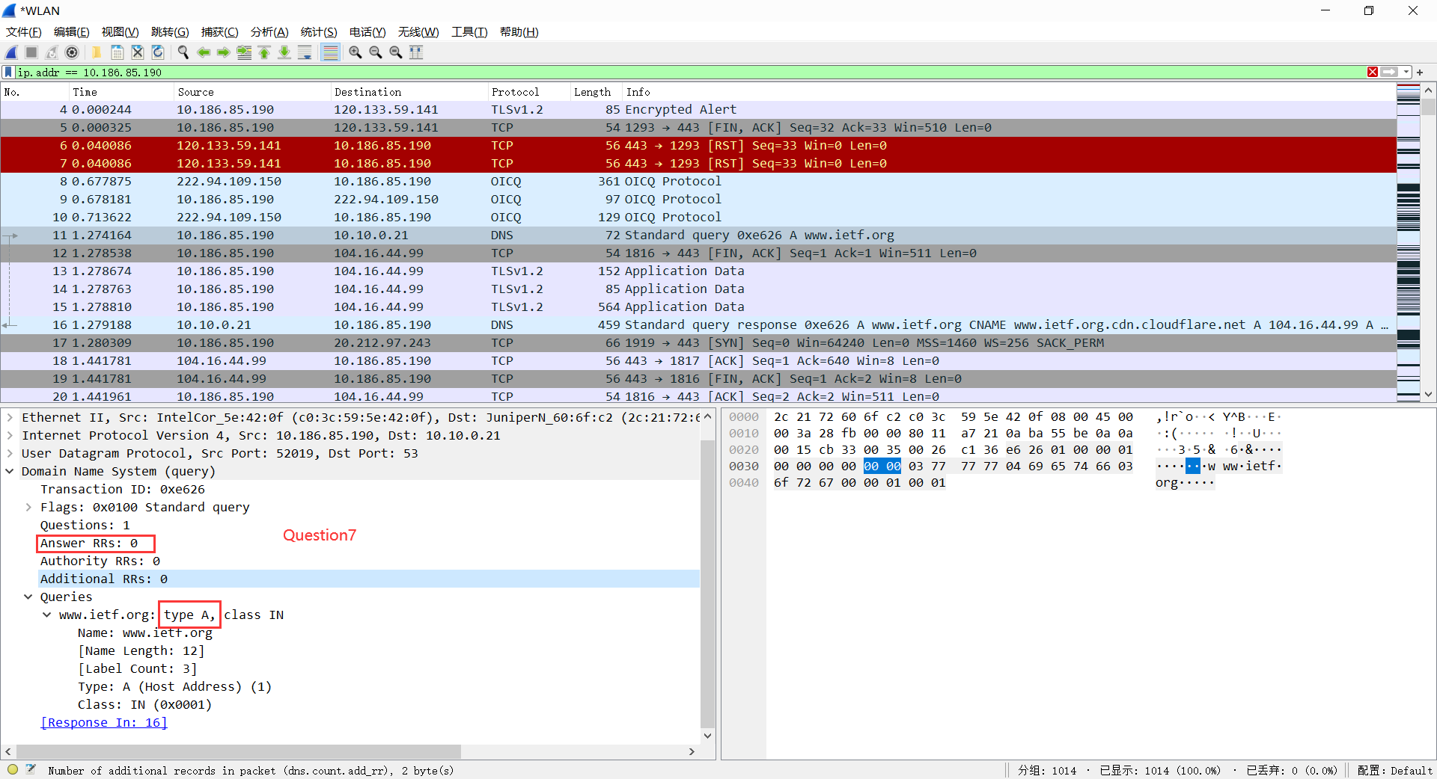

**8. Examine the DNS response message. How many “answers” are provided? What**

**does each of these answers contain?**

3 answers.

Each answer includes Name, Type, Class, TTL, Data length and IP address.

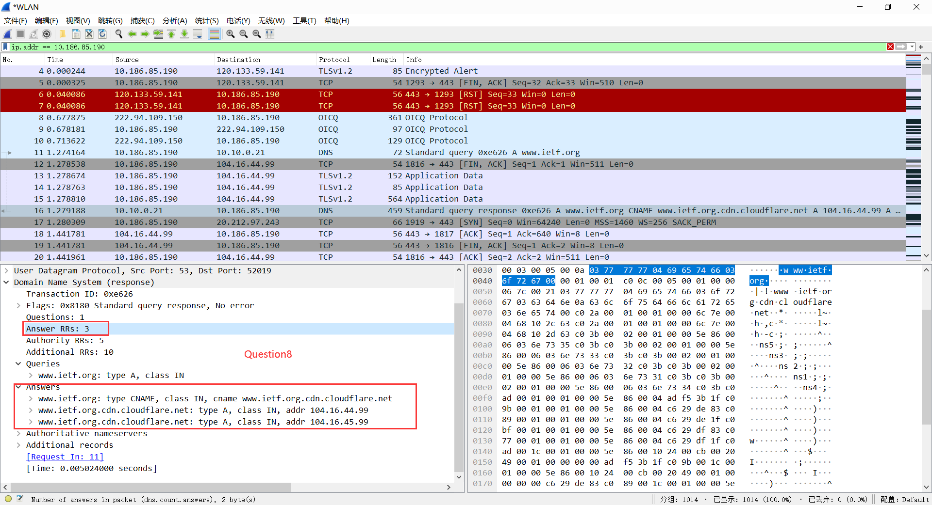

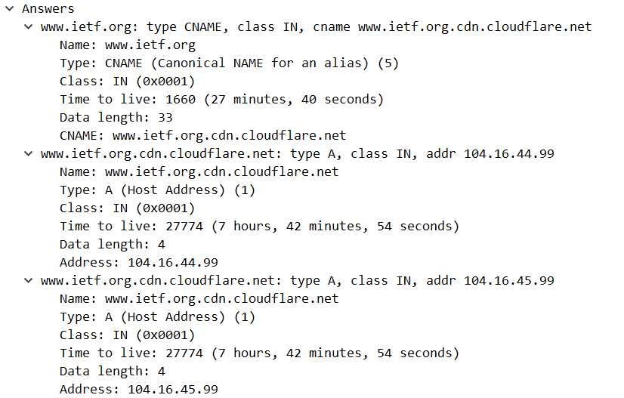

**9. Consider the subsequent TCP SYN packet sent by your host. Does the destination**

**IP address of the SYN packet correspond to any of the IP addresses provided in**

**the DNS response message?**

Yes, the destination IP address correspond to 104.16.44.99 in the DNS response message.

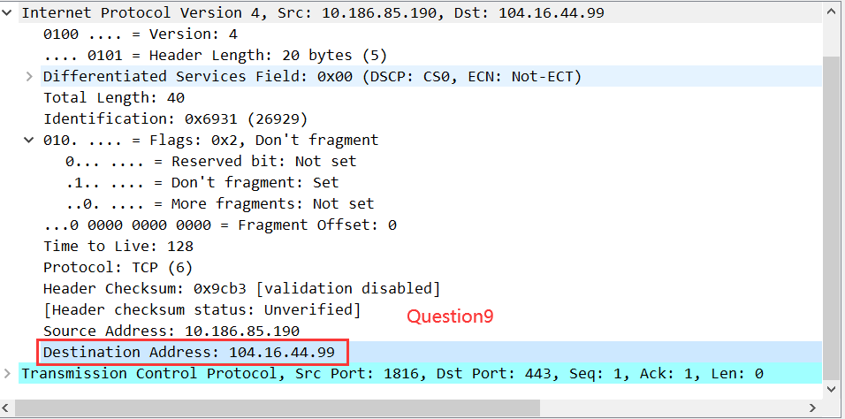

**10. This web page contains images. Before retrieving each image, does your host**

**issue new DNS queries?**

No, my host doesn’t issue new DNS queries.

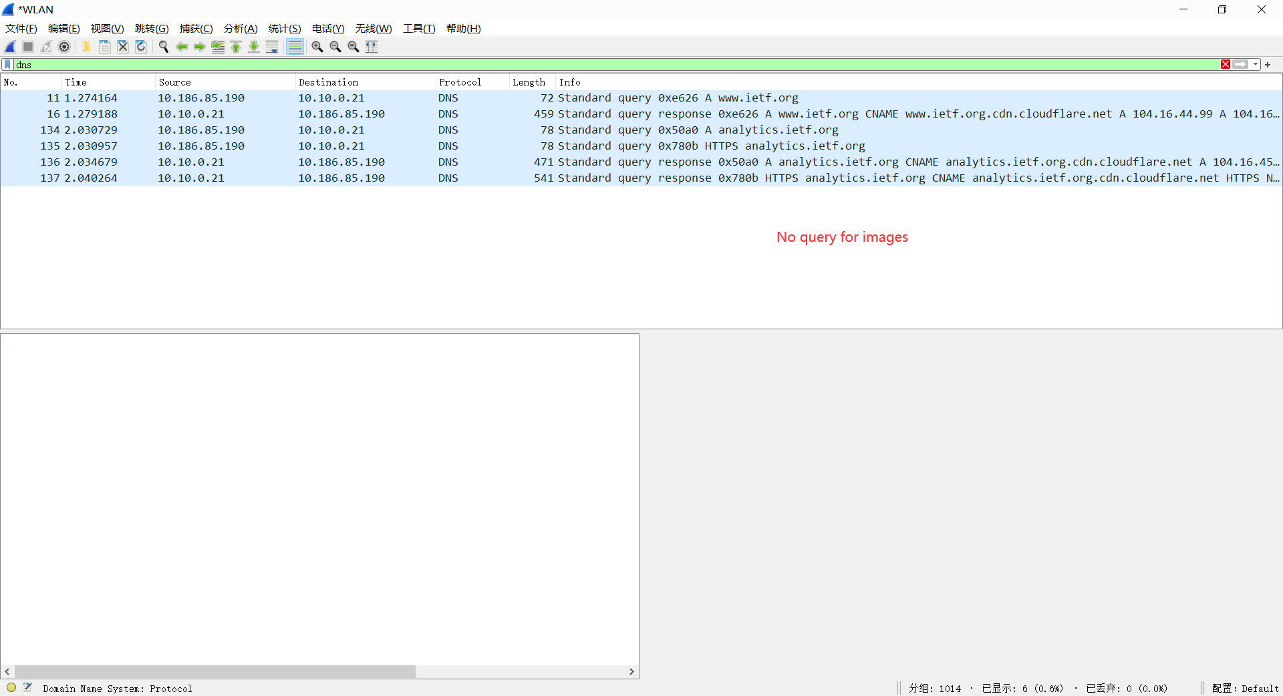

**11. What is the destination port for the DNS query message? What is the source port**

**of DNS response message?**

Both 53.

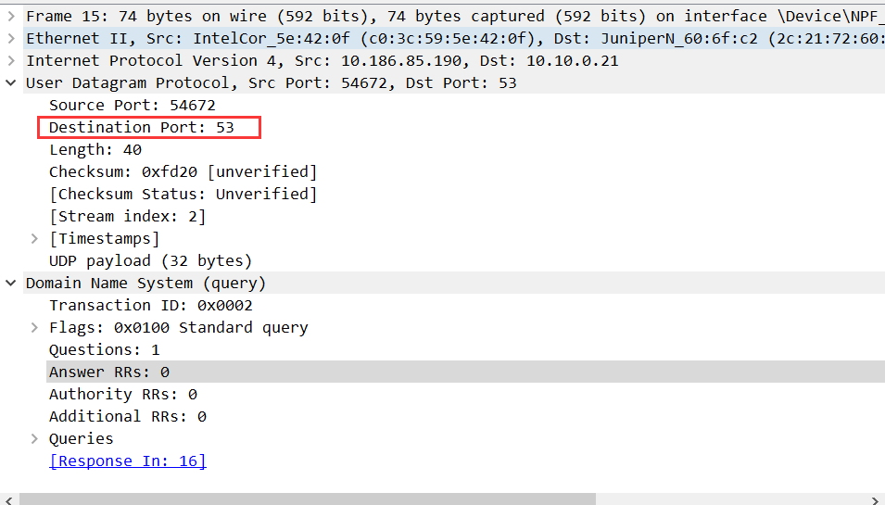

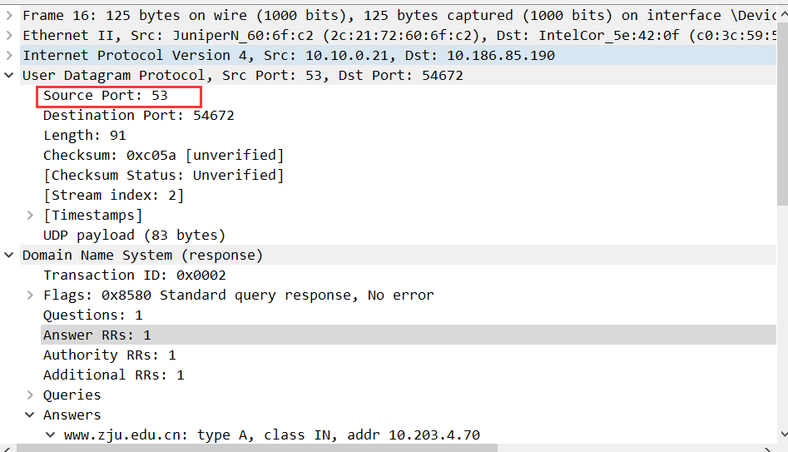

**12. To what IP address is the DNS query message sent? Is this the IP address of your**

**default local DNS server?**

10.10.0.21

Yes

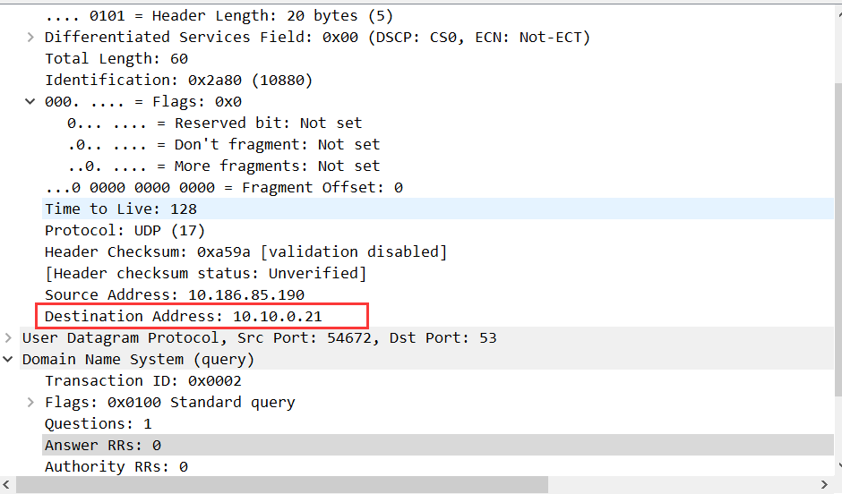

**13. Examine the DNS query message. What “Type” of DNS query is it? Does**

**the query message contain any “answers”?**

Type: A、AAAA

No answers

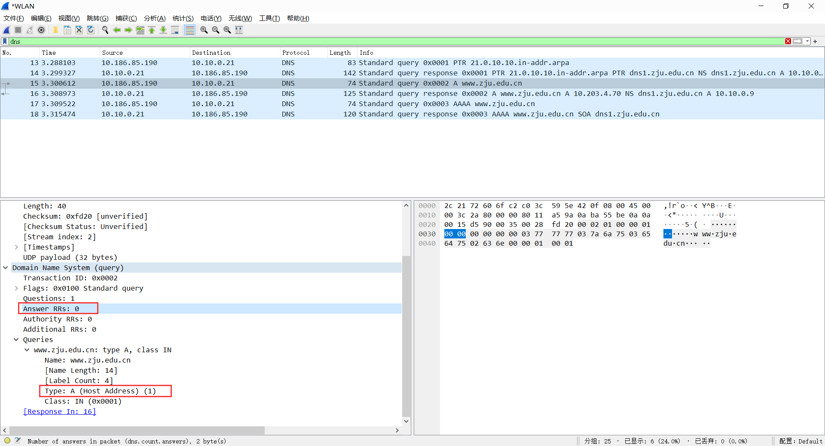

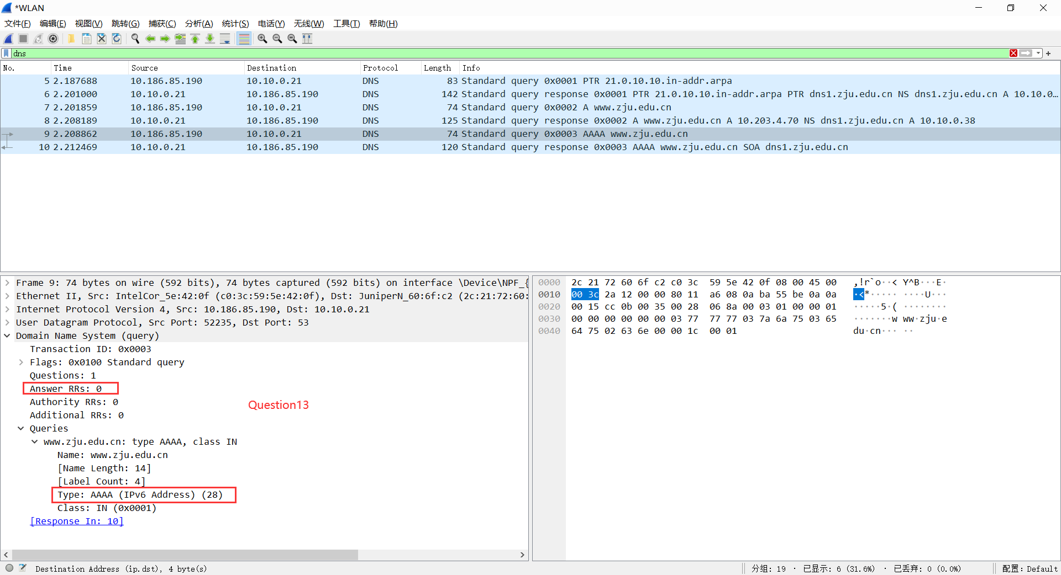

**14. Examine the DNS response message. How many “answers” are provided? What**

**does each of these answers contain?**

1 answer.

The answer includes Name, Type, Class, TTL, Data length and IP address.

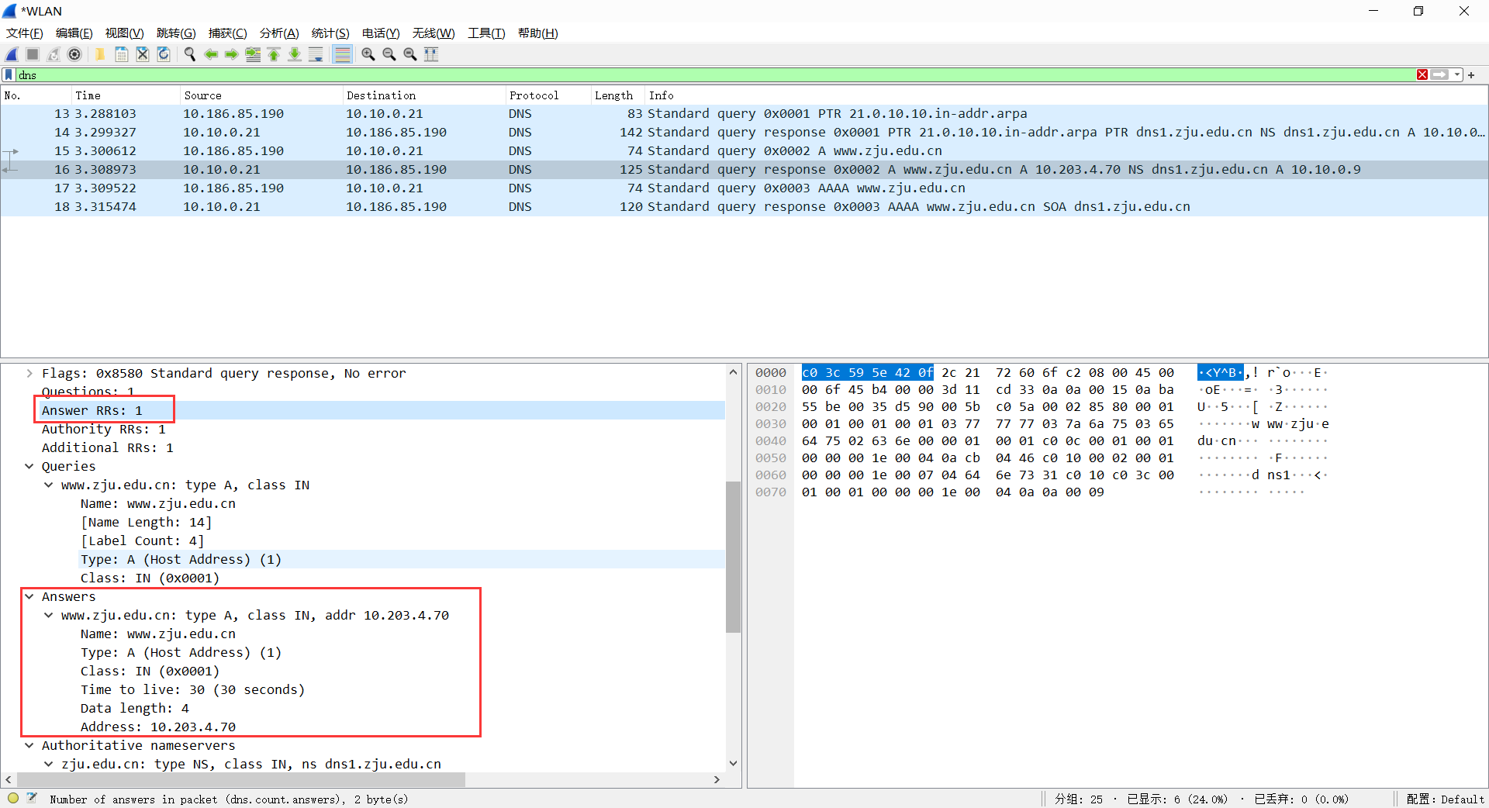

**15. Provide a screenshot.**

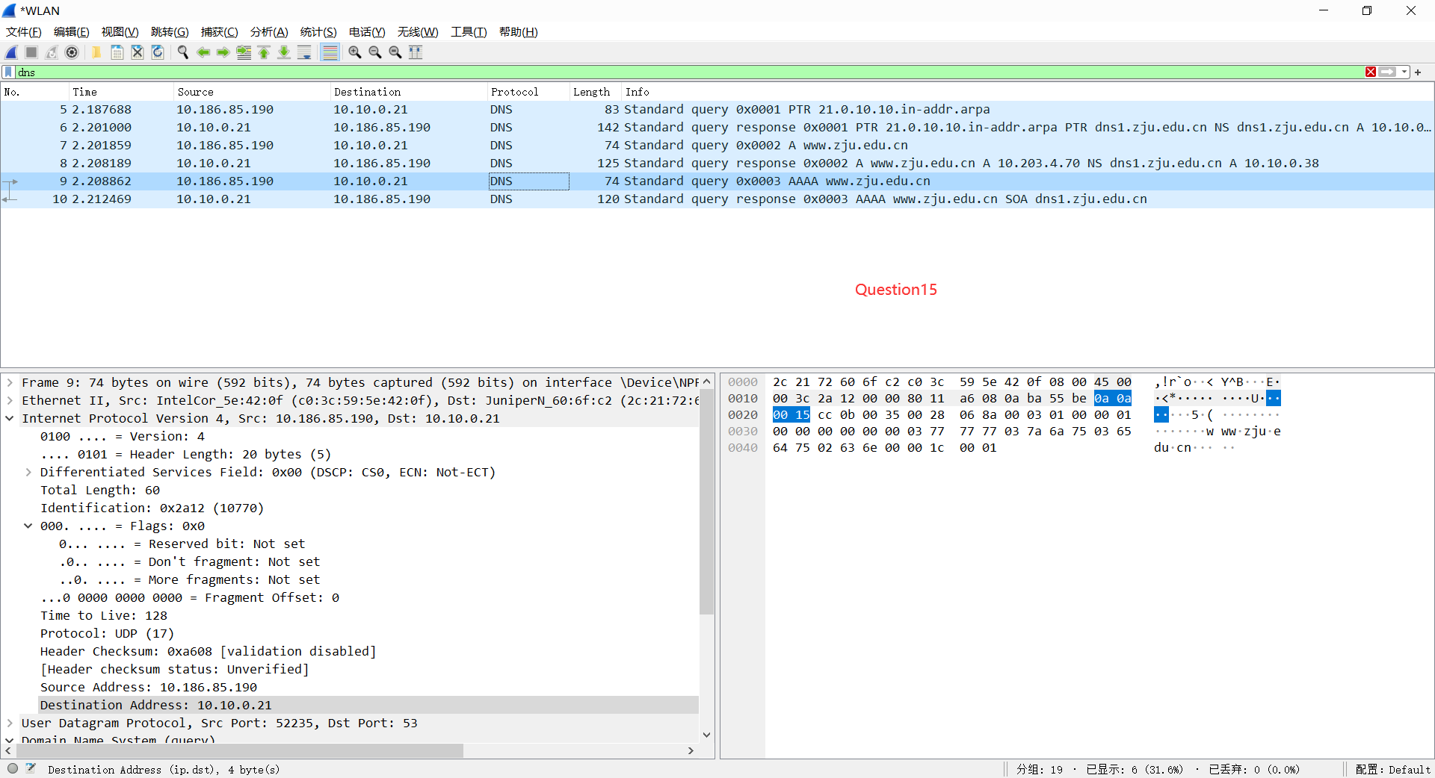

**16. To what IP address is the DNS query message sent? Is this the IP address of your**

**default local DNS server?**

10.10.0.21

Yes

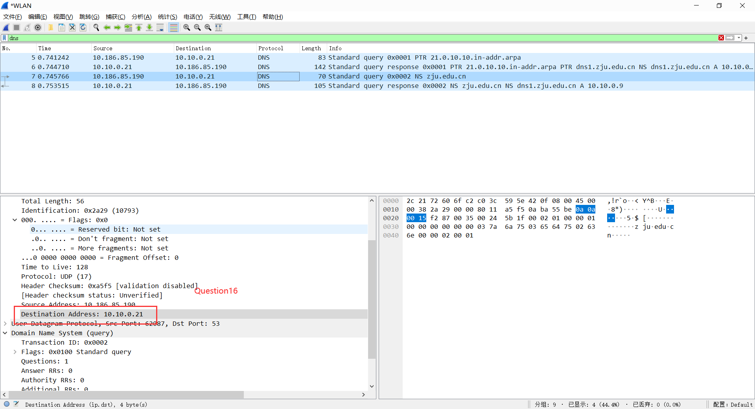

**17. Examine the DNS query message. What “Type” of DNS query is it? Does**

**the query message contain any “answers”?**

Type: NS

No answers

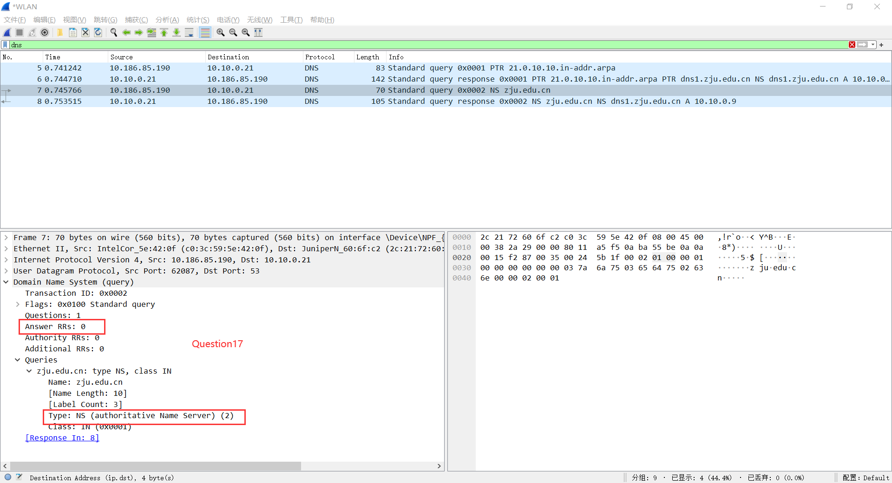

**18. Examine the DNS response message. What ZJU name servers does the response**

**message provide? Does this response message also provide the IP addresses of**

**the ZJU name servers?**

dns1.zju.edu.cn

Yes, it’s 10.10.0.9

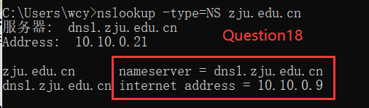

**19. Provide a screenshot.**

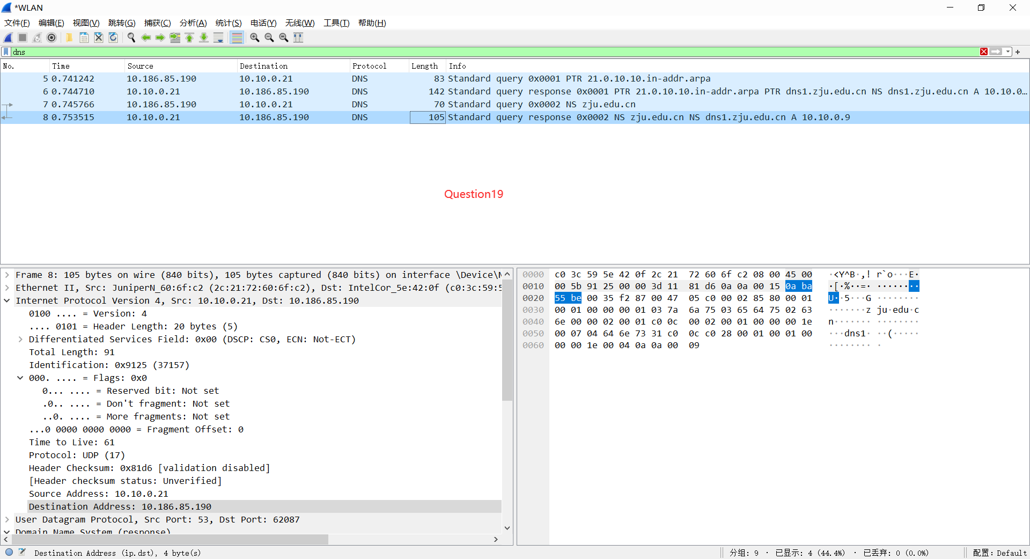

**20. To what IP address is the DNS query message sent? Is this the IP address of your**

**default local DNS server? If not, what does the IP address correspond to?**

10.10.0.21

Yes

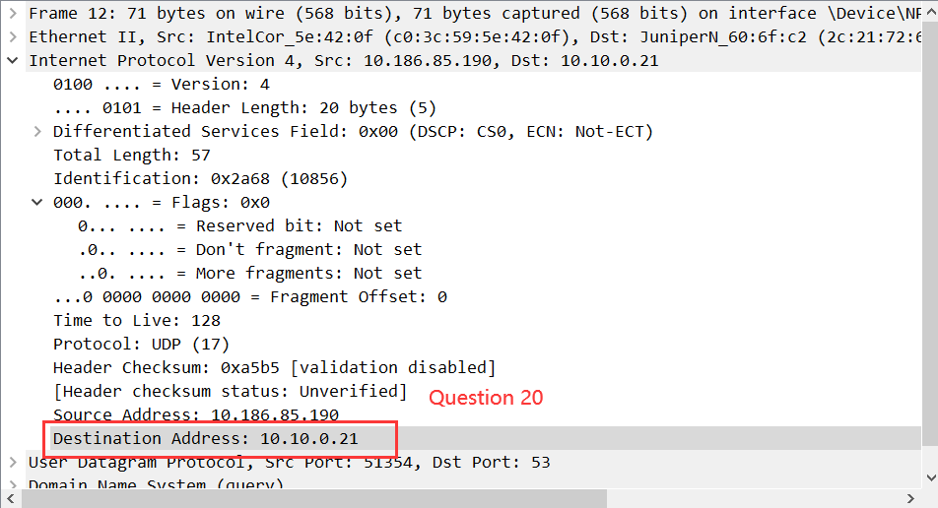

**21. Examine the DNS query message. What “Type” of DNS query is it? Does**

**the query message contain any “answers”?**

Type: A、AAAA

No answers

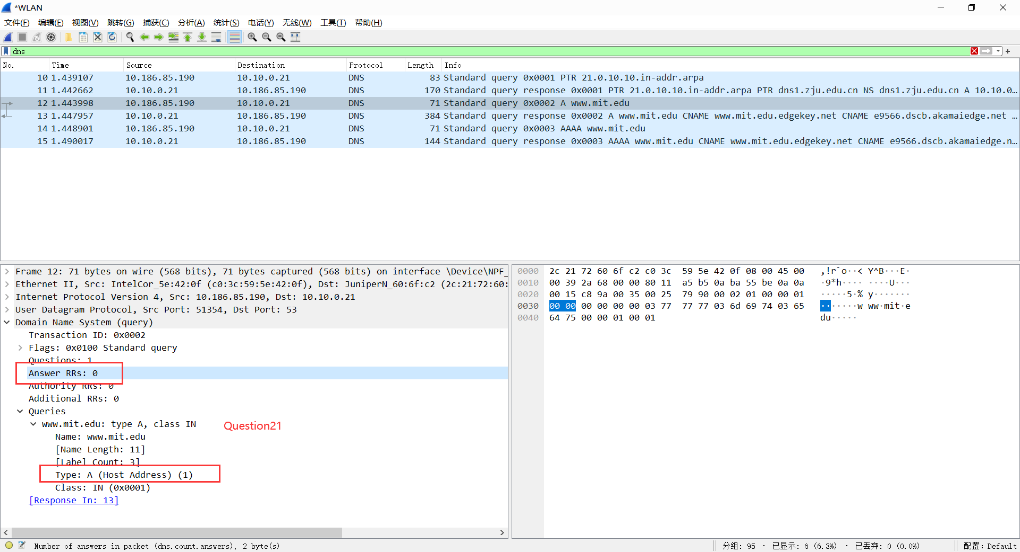

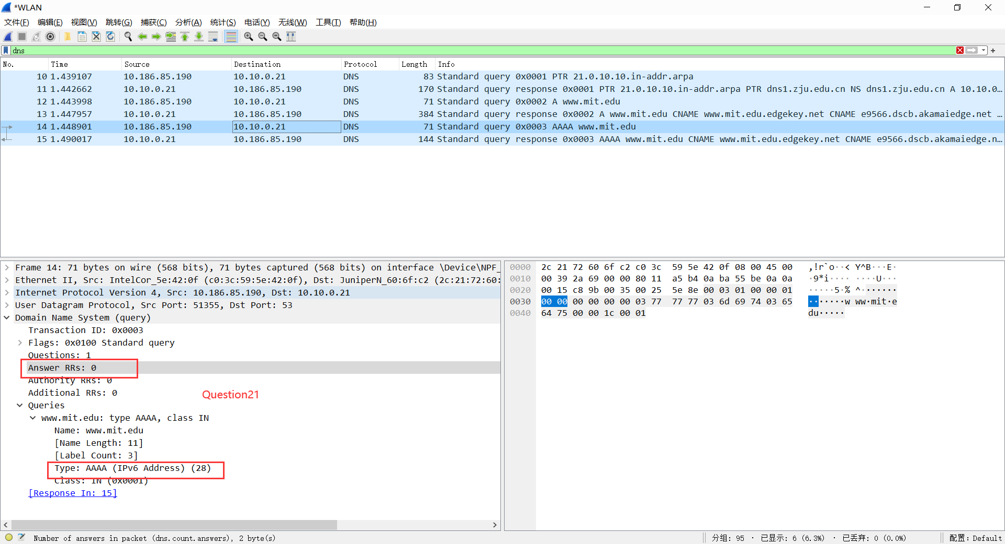

**22. Examine the DNS response message. How many “answers” are provided? What**

**does each of these answers contain?**

3 (Type A) and 2 answers (Type AAAA)

Each answer includes Name, Type, Class, TTL, Data length and IP address.

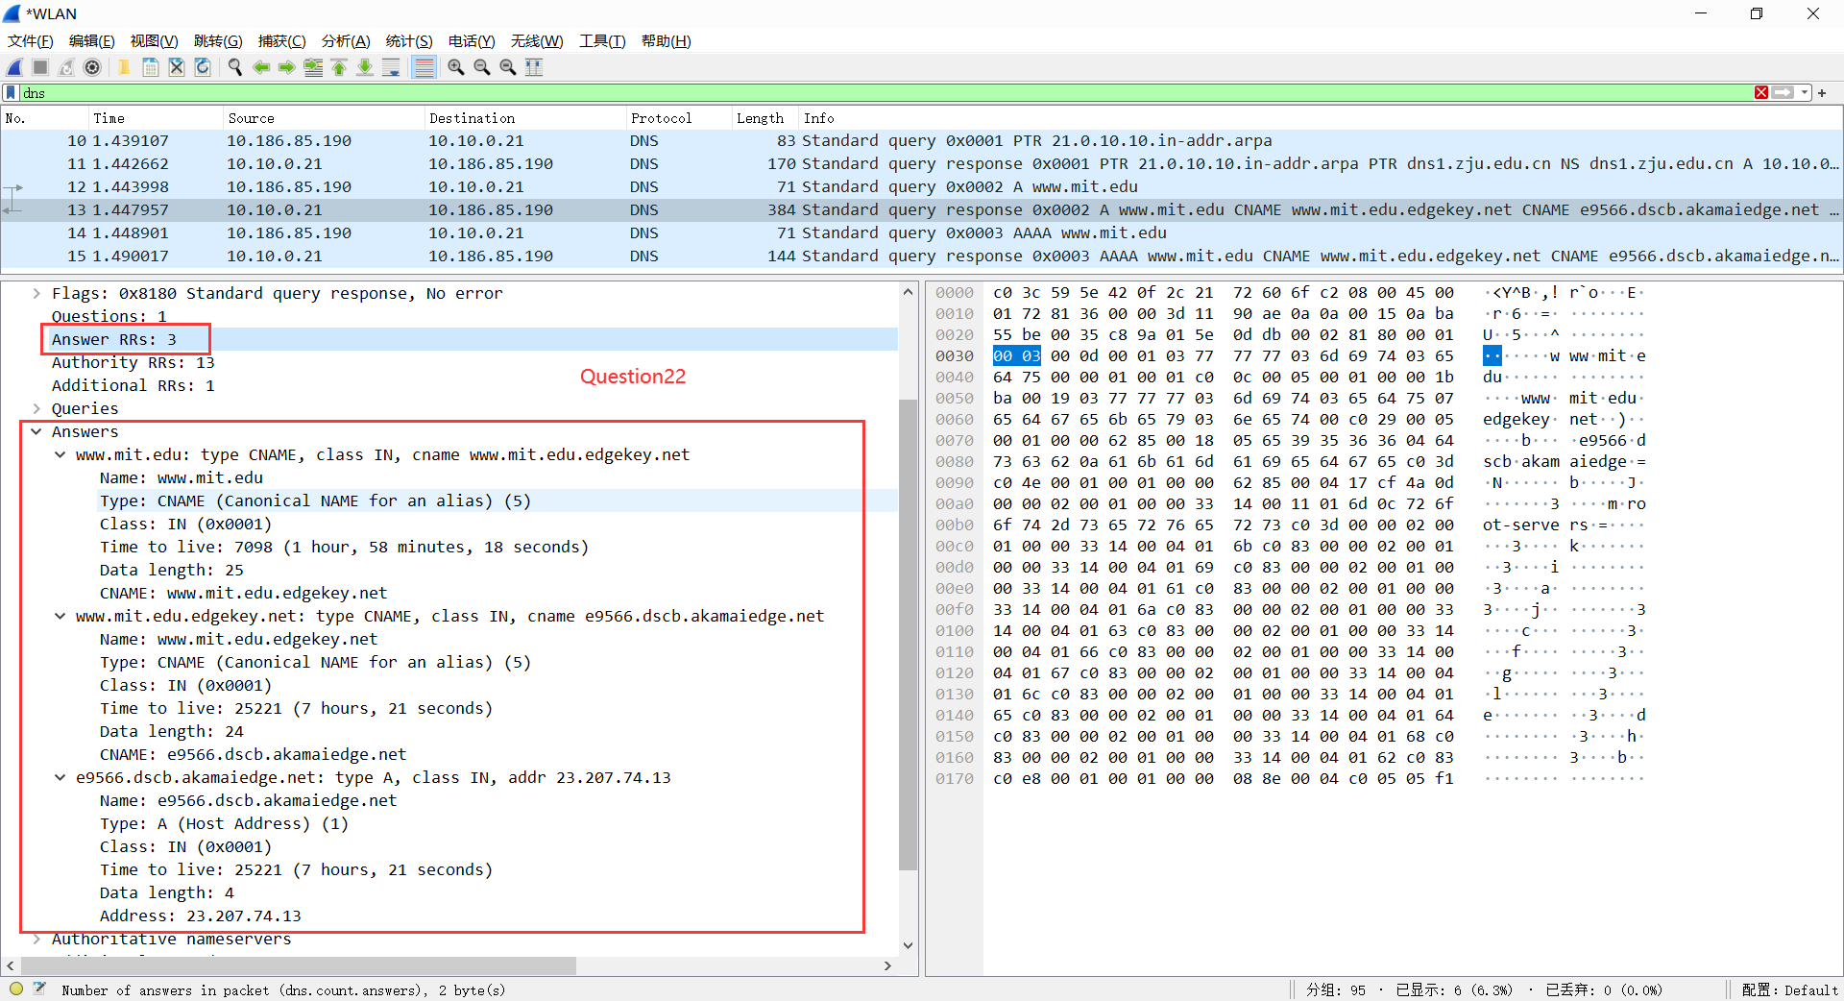

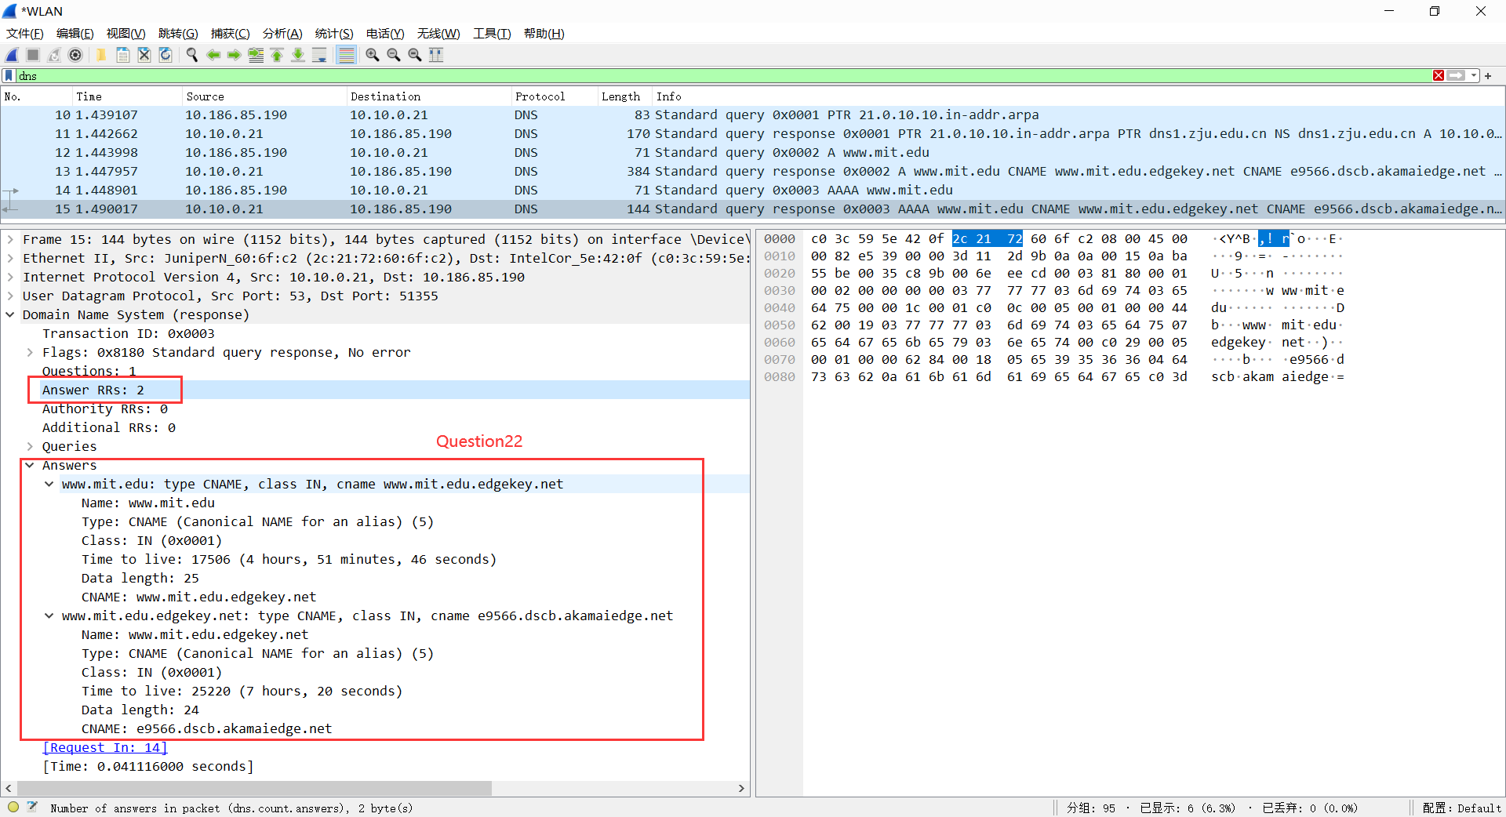

**23. Provide a screenshot.**

