## Introduction

I will be constructing and validating a CV pipeline that will identify ships on the ocean. This is a problem that has numerous commercial, military, and academic applications. As a result, there are numerous competitions and open-source projects in this area. Some applications require advanced satellite imagery but lacking any knowledge of radar imagery, I have limited this project to simple RGB satellite pictures. I will be constructing a two-stage pipeline that makes use of transfer learning: First, I will identify images that contain a body of water. Secondly, I will scan the images for possible ships.

## Data

I will be using a subset of Microsoft® Bing™ Maps called the MAritime SATellite Imagery (MASATI-v2). This dataset contains “optical aerial images from the visible spectrum”, which is to say they are simple RBG pictures taken top-down (Gallego, 2018). All the images evaluated to date are squares with a length of 512 pixels, limiting the amount of preprocessing work needed to begin the modeling process.

The dataset has 7 image types, shown in Appendix 1. The sub-classes have essentially the same number of samples, except for the “multi-ship” class. This under-sampling is not a problem, since the “multi-ship” class is a subset of the “ship”, and the same methodologies are likely to work on both classes equally well. For the images that contain a ship, the data set contains the bounding boxes. I will not be utilizing the section “Detail” because it contains zoomed-in pictures of the ship. This could be useful if we also had zoomed-in pictures of non-ships, so that I could further refine the model. However, I will leave this as a future validation if I am able to find a data source.

The data is available at the following link: <https://www.iuii.ua.es/datasets/masati/index.html> and has been made publicly available for non-profit research or educational purposes. Accessing this dataset requires the completion of a short form which asks for basic user information and the expected use.

There is a wide range of heterogeneity in the images. There are built-up harbors and abandoned beaches, differing tidal ranges, ocean depths, and weather conditions. A few samples are shown in Appendix 2.

## Technical Overview

My pipeline will run in a two-stage process. First, I will identify and extract the images that have water in them. As I sit here now, I am not entirely sure if this step will be necessary. I have not yet attempted to run the ship detection and classification model over land-only images. It is conceivable that this model may be able to discern the differences between a ship on the ocean and a truck in the field, but I cannot be of that now.

Secondly, I will then pass over the images to conduct object detection and classification to determine if there is a ship in the image. The classification may seem unnecessary, but I do think that the model may confuse breaking waves with the wake for a ship and I will need to validate that this is not occurring.

## Anticipated Challenges

One of the main issues with this data set is that all the images are taken during the day and are therefore well lit. This problem could be addressed if we were to add additional image-types, but for now I will need to content myself with this limitation. Further, I have not found any images where there is something on the ocean that is not a ship. Therefore, the resulting model may run into a problem when deployed. Again, this is a limitation of the data that I do not currently have a good way around.

Further, the images are not in any way obstructed by cloud cover. This may result in an issue when the pipeline is deployed in the wild, since such manicured images are unlikely to be the norm. I do think, however, that the first-stage image classification described above will help with this problem, as it will be able to identify images where there is ocean visible and therefore identify usable images.

There may also be a scaling issue, as sometimes the ships in the images are very small and any filtering or manipulation of the image may result in the ship being represented by just a single pixel. One possible work around is to use the Hough Filter, which accentuates straight lines. This is useful for identifying ships that are moving, since this will highlight the wake. However, this method may obscure ships at move, since they would appear as small boxes in the image.

## Technical Specifics

I will be comparing transfer learning models for each step in the object detection parameters, Resnet and EfficientNet. I plan to use EfficientNetB6, because it uses a resolution of 528, which is the closest to the original images. I will use zero-padding to make up the difference. However, I will also explore using the Resnet model because it requires a smaller input size. This may allow me to slice the pre-filtered pictures into smaller tiles and help avoid the scale issue described above. I anticipate this to be a better option in the second-stage search.

I will need to explore whether the models can get away with using a grey-scale image or whether I will need to include the RGB channels. I can imagine that the model will be able to identify ocean from land while using grey scale, but I suspect that having the three separate channels may help detect the small ship on the ocean. I anticipate this will help because it appears from a visual inspection that the ships themselves are mostly white, meaning they will have high values in all three channels, while the ocean is blue/green, meaning they will have high values in just one or maybe two channels.

# Appendix

## A1: MASATI Data Categories

|  |  |  |  |
| --- | --- | --- | --- |
| Main Class | Sub-Class | # Of Images | Description |
| Ship | Ship | 1027 | Sea with a ship (no coast) |
| Detail | 1789 | Ship Details |
| Multi | 304 | Multiple Ships |
| Coast & Ship | 1037 | Coast with Ships |
| Non-Ship | Sea | 1022 | Sea (no ships) |
| Coast | 1132 | Coast (no ships) |
| Land | 1078 | Land (no sea) |

## A2: MASATI-v2 Sample Images

### Coast with Ship

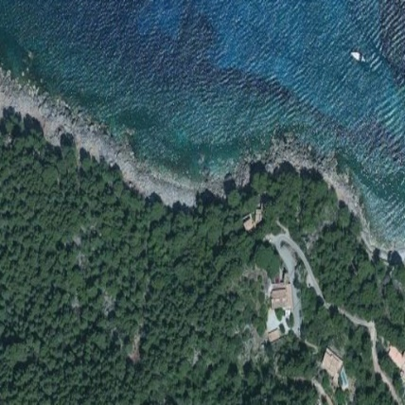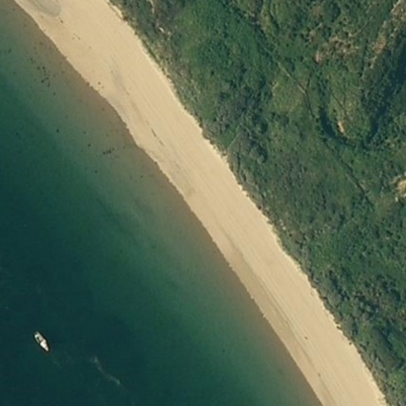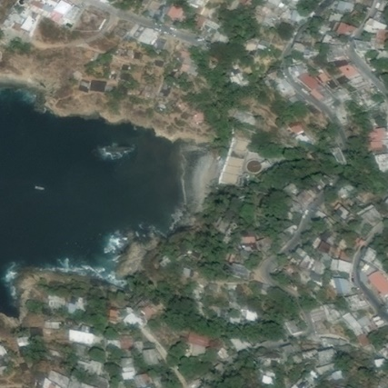

### Ship (No Land)

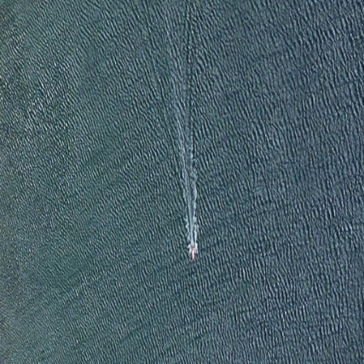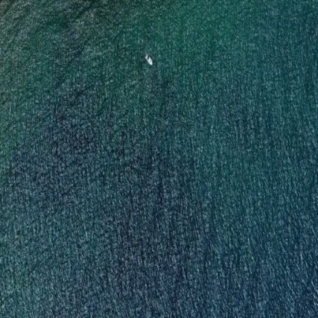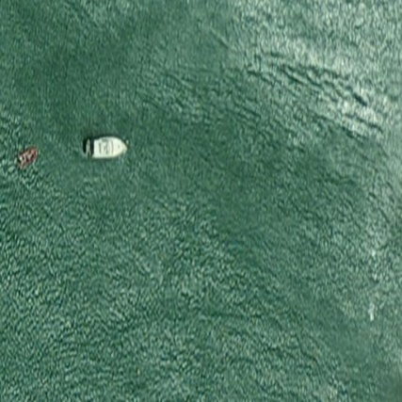

### Sea (No Ship)