Build Your Own Marshmallow Bot
Complete Component, Assembly, Wiring, Programming, and Launcher Guide
BUILD • PROGRAM • DRIVE • CREATE
This version is for builders starting with separate components and 3D-printed parts. Read the full guide before connecting power.

What the Project Does
Marshmallow Bot is a small Wi-Fi-controlled two-wheel robot built around an ESP32-C3 Super Mini. A phone, tablet, or computer connects directly to the robot’s Wi-Fi network and opens a browser-based controller. An optional mousetrap mechanism can launch a soft mini marshmallow.
SAFETY: Keep hands clear of the mousetrap whenever it is cocked. Wear eye protection during launcher setup. Use only soft mini marshmallows and never aim at people, animals, faces, breakable objects, or electrical equipment.

Parts List
Required electronics | 1 × ESP32-C3 Super Mini  1 × ESP32-C3 Super Mini expansion board  2 × continuous-rotation micro servos with wheels  1 × 4-AA battery holder  1 × 3-position servo-style connector or lead
Required hardware | 1 × #8 screw, approximately 2 inches long, with nut  2 × servo-retaining screws or other suitable fasteners
3D-printed parts | 1 × chassis  1 × tail wheel or skid
Optional launcher | 1 × standard micro servo  1 × standard wooden mousetrap  1 × 3D-printed launcher holder  2 × #8 tapered-head screws, approximately 3/4 inch long, with nuts  Launching arm made from a spoon, craft sticks, or a printed part
Tools and supplies | Phillips screwdriver and small wrench  Wire cutters and strippers  Soldering iron and solder, or suitable crimping tools  Heat-shrink tubing or electrical tape  USB-C data cable  Computer with Arduino IDE  Four AA batteries

1. Print and Inspect the Chassis Parts
Download the chassis, tail-wheel, and optional launcher-holder files from the project repository. Print the parts using settings appropriate for the selected filament and printer. Remove supports and confirm that the servo pockets and screw holes are clear. The current project documentation does not specify required layer height, infill, or support settings, so record any print settings that work well for your printer.

2. Install the Drive Servos and Wheels
- ☐ Place one continuous-rotation micro servo in each side pocket of the chassis.
- ☐ Orient each servo with the output shaft near the upper portion of the wheel opening.
- ☐ Secure each servo using a suitable screw through the chassis mount. Do not overtighten into the plastic.
- ☐ Press or fasten one wheel onto each servo output shaft.
- ☐ Spin each wheel by hand and confirm that the chassis does not rub the tire.
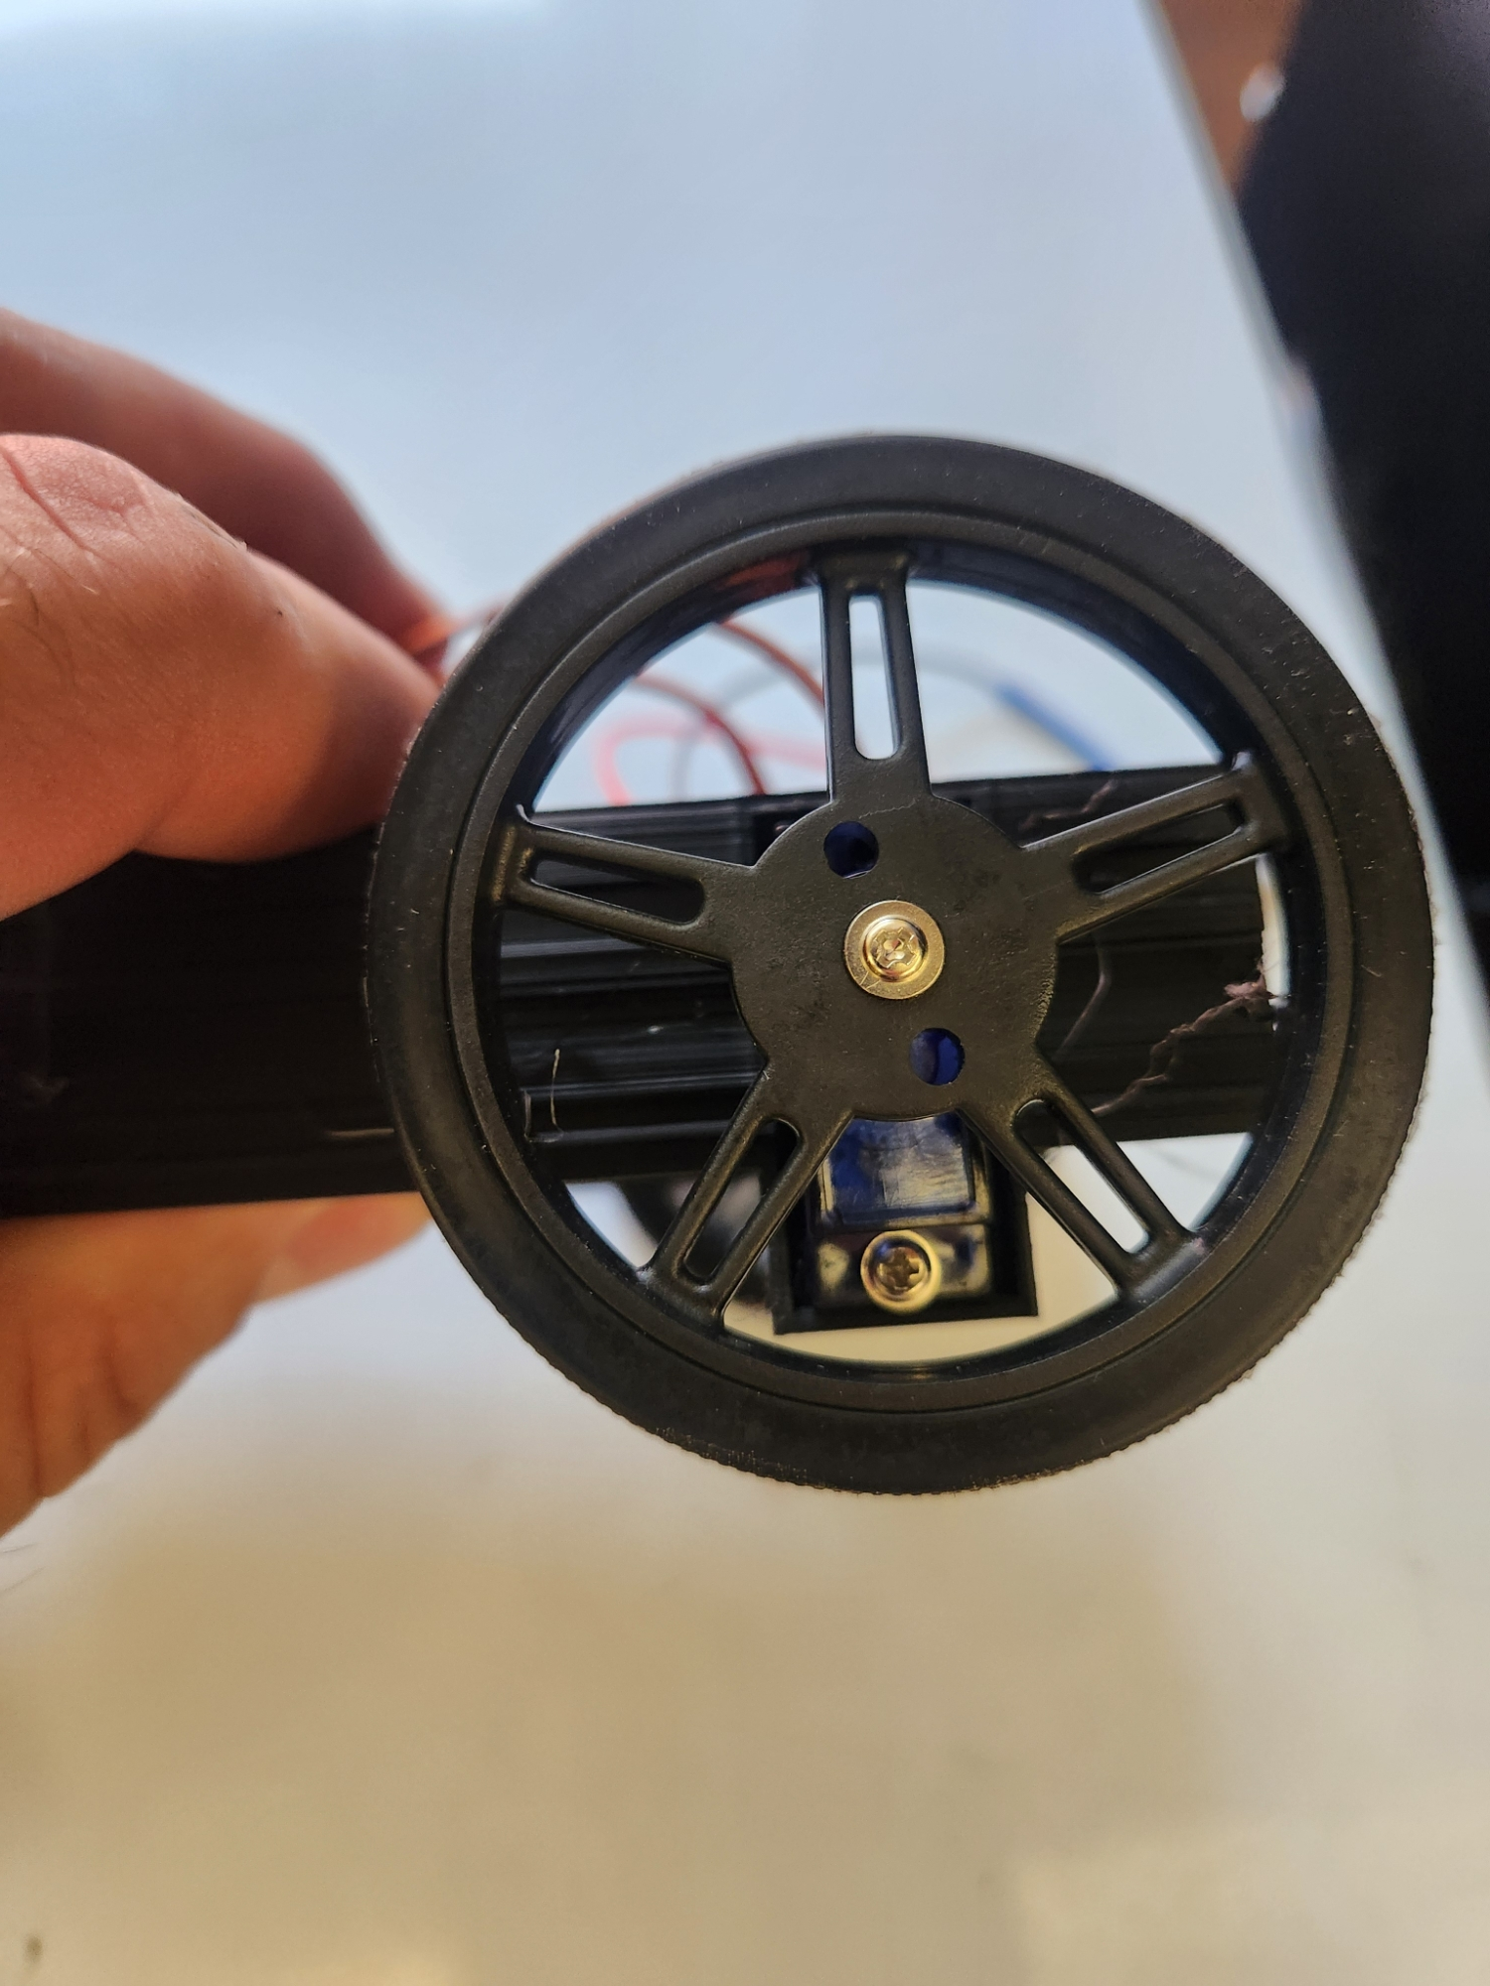
Wheel and drive-servo installation

3. Install the Tail Wheel
Position the printed tail wheel or skid at the rear of the chassis. Pass the approximately 2-inch #8 screw through the chassis and tail-wheel part, install the nut, and tighten only enough to remove excess looseness. The tail part should still move or roll as intended.

4. Install the Battery Holder
Slide the 4-AA battery holder into the matching chassis slot. Route the red and black wires away from the wheels, servo horns, and mousetrap mechanism.

5. Make the Battery Power Lead
Do not install batteries and do not connect USB power while cutting, stripping, soldering, or crimping wires.
1. Cut a three-wire servo extension or connector lead.
2. Keep the middle conductor and one outside conductor. Remove or insulate the unused outside conductor.
3. Connect the battery holder’s red wire to the retained outside conductor.
4. Connect the battery holder’s black wire to the middle conductor.
5. Insulate each splice separately with heat-shrink tubing. Electrical tape may be used if heat-shrink is unavailable.
6. Before applying power, use the board markings and the connection photograph to identify the positive and ground rows. Do not rely only on wire colors if your connector differs from the pictured build.
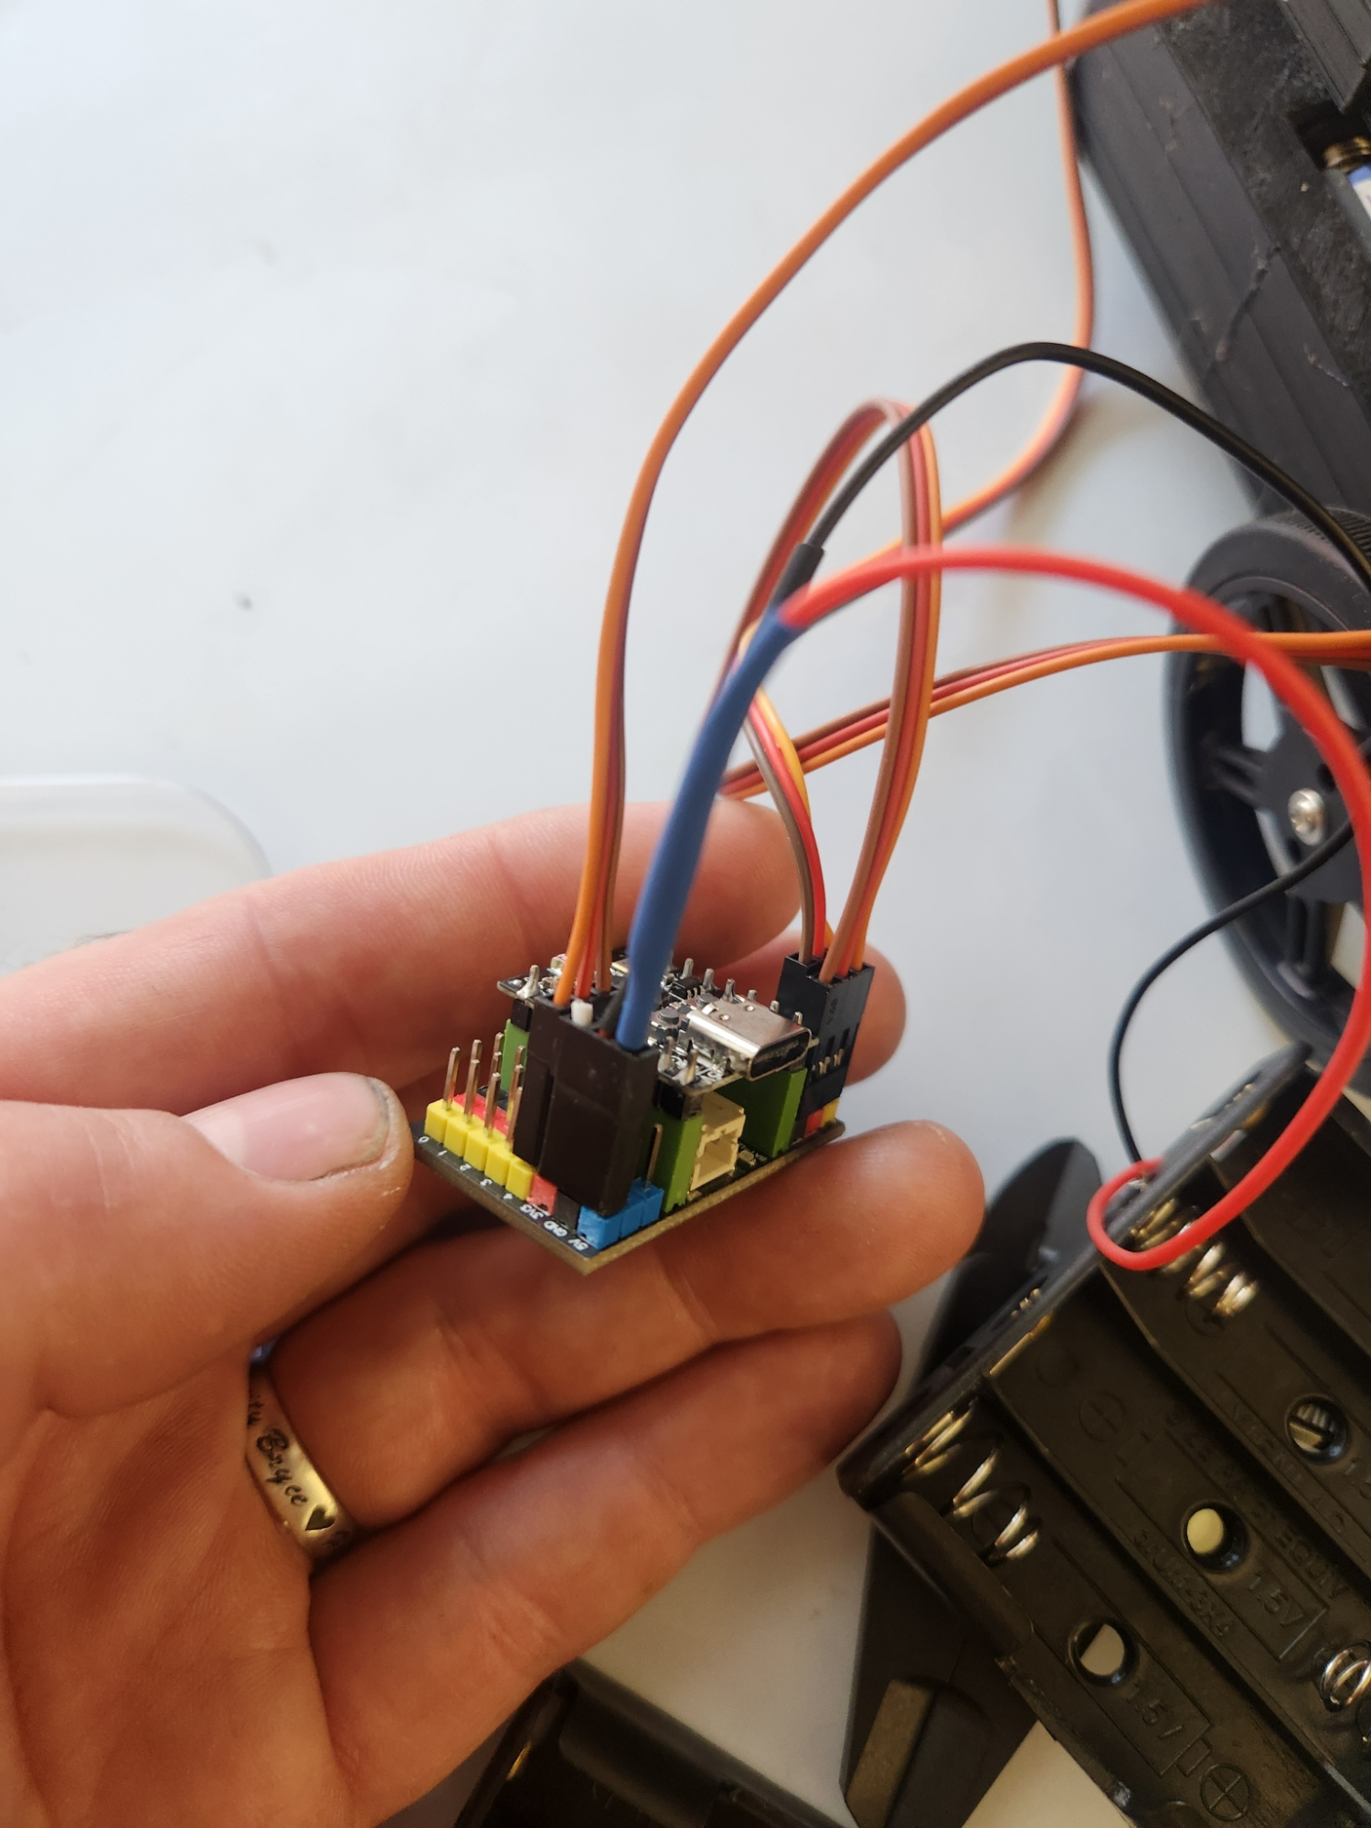
Power-lead orientation used on the pictured build

6. Install the ESP32-C3 and Connect the Servos
Seat the ESP32-C3 Super Mini in the expansion board. The USB-C connector must be on the same side as the expansion board’s white connector. Verify orientation carefully because the controller can physically fit backward.
For each servo lead, align the yellow or orange signal wire with the expansion board’s yellow signal row. Align the brown or black ground wire with the black row. Connect the left and right wheel servos to the locations shown in the photographs. If installed, connect the trigger servo beside the right wheel servo.
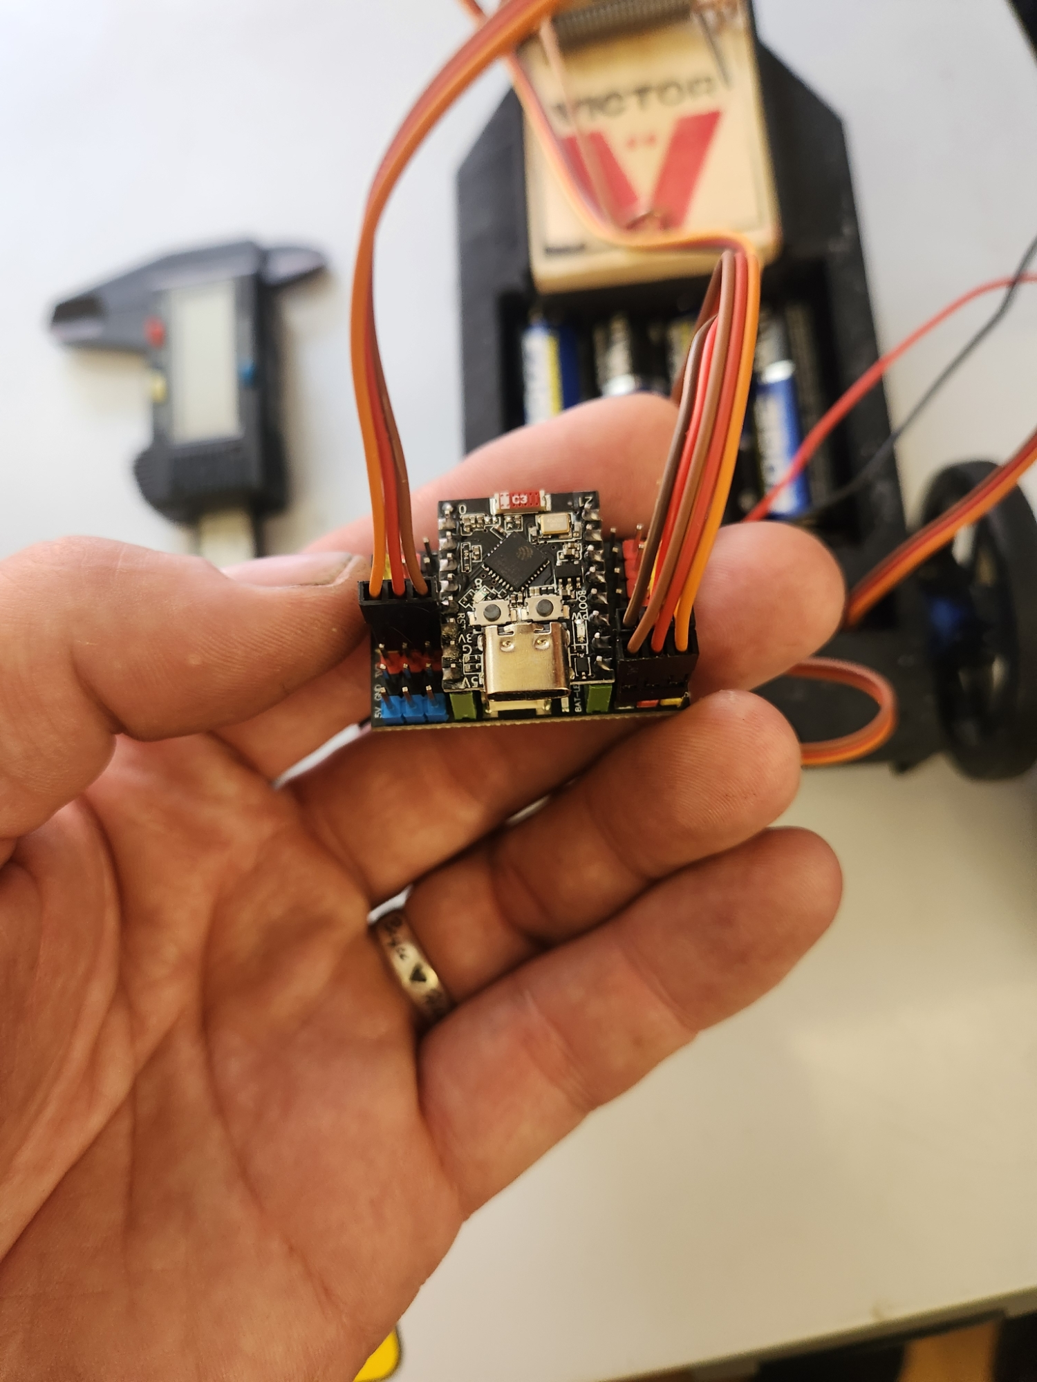  Left drive | 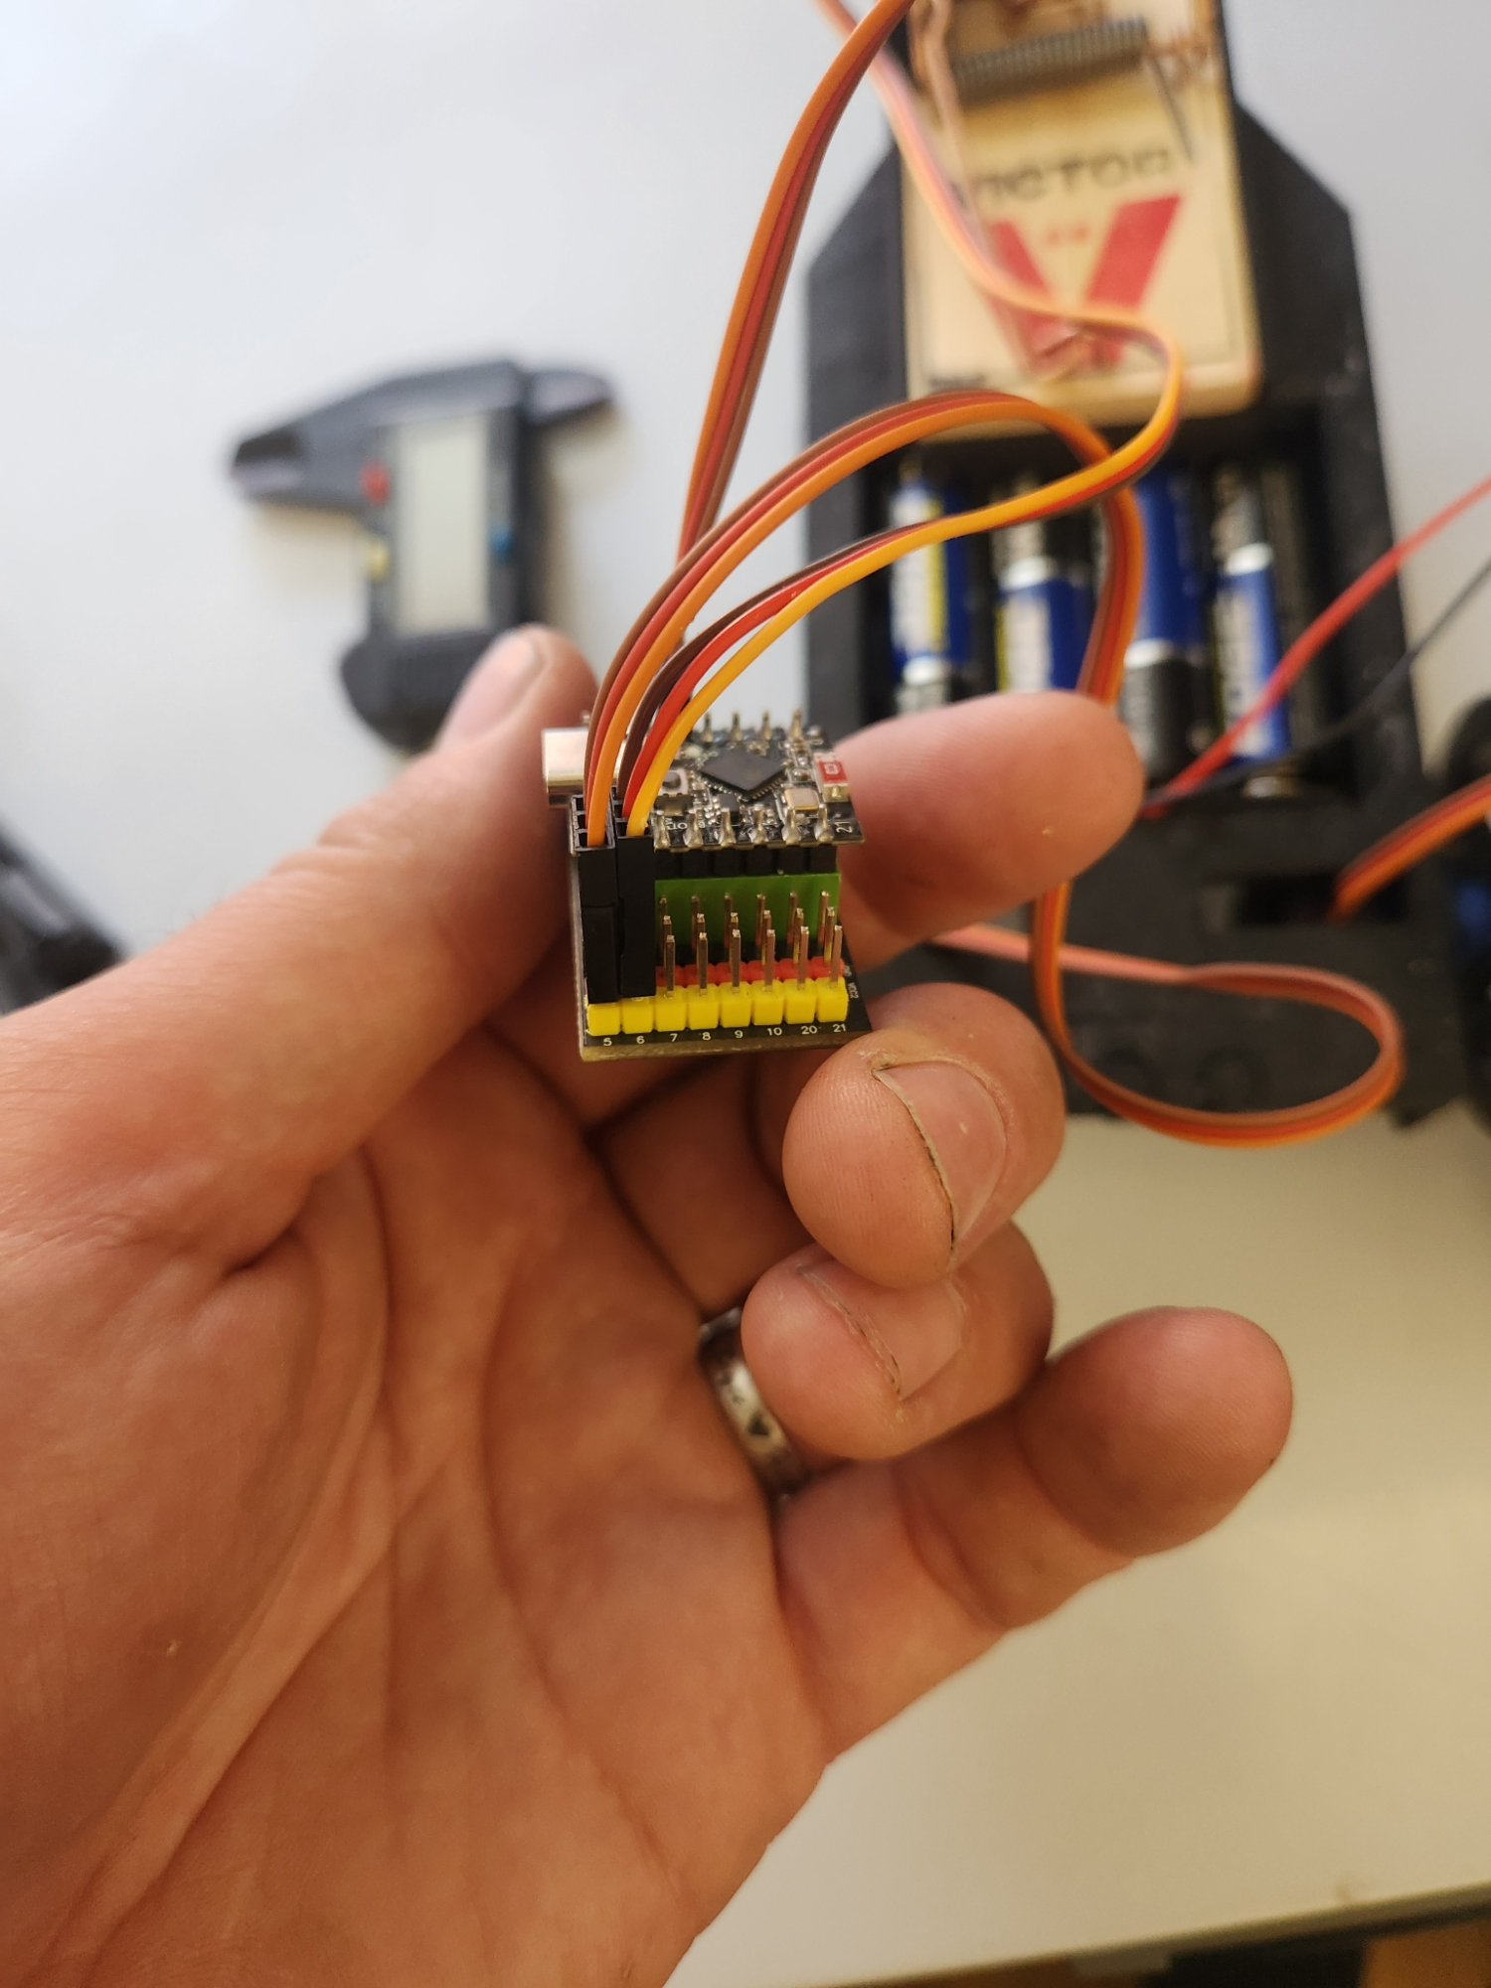  Right drive / trigger | 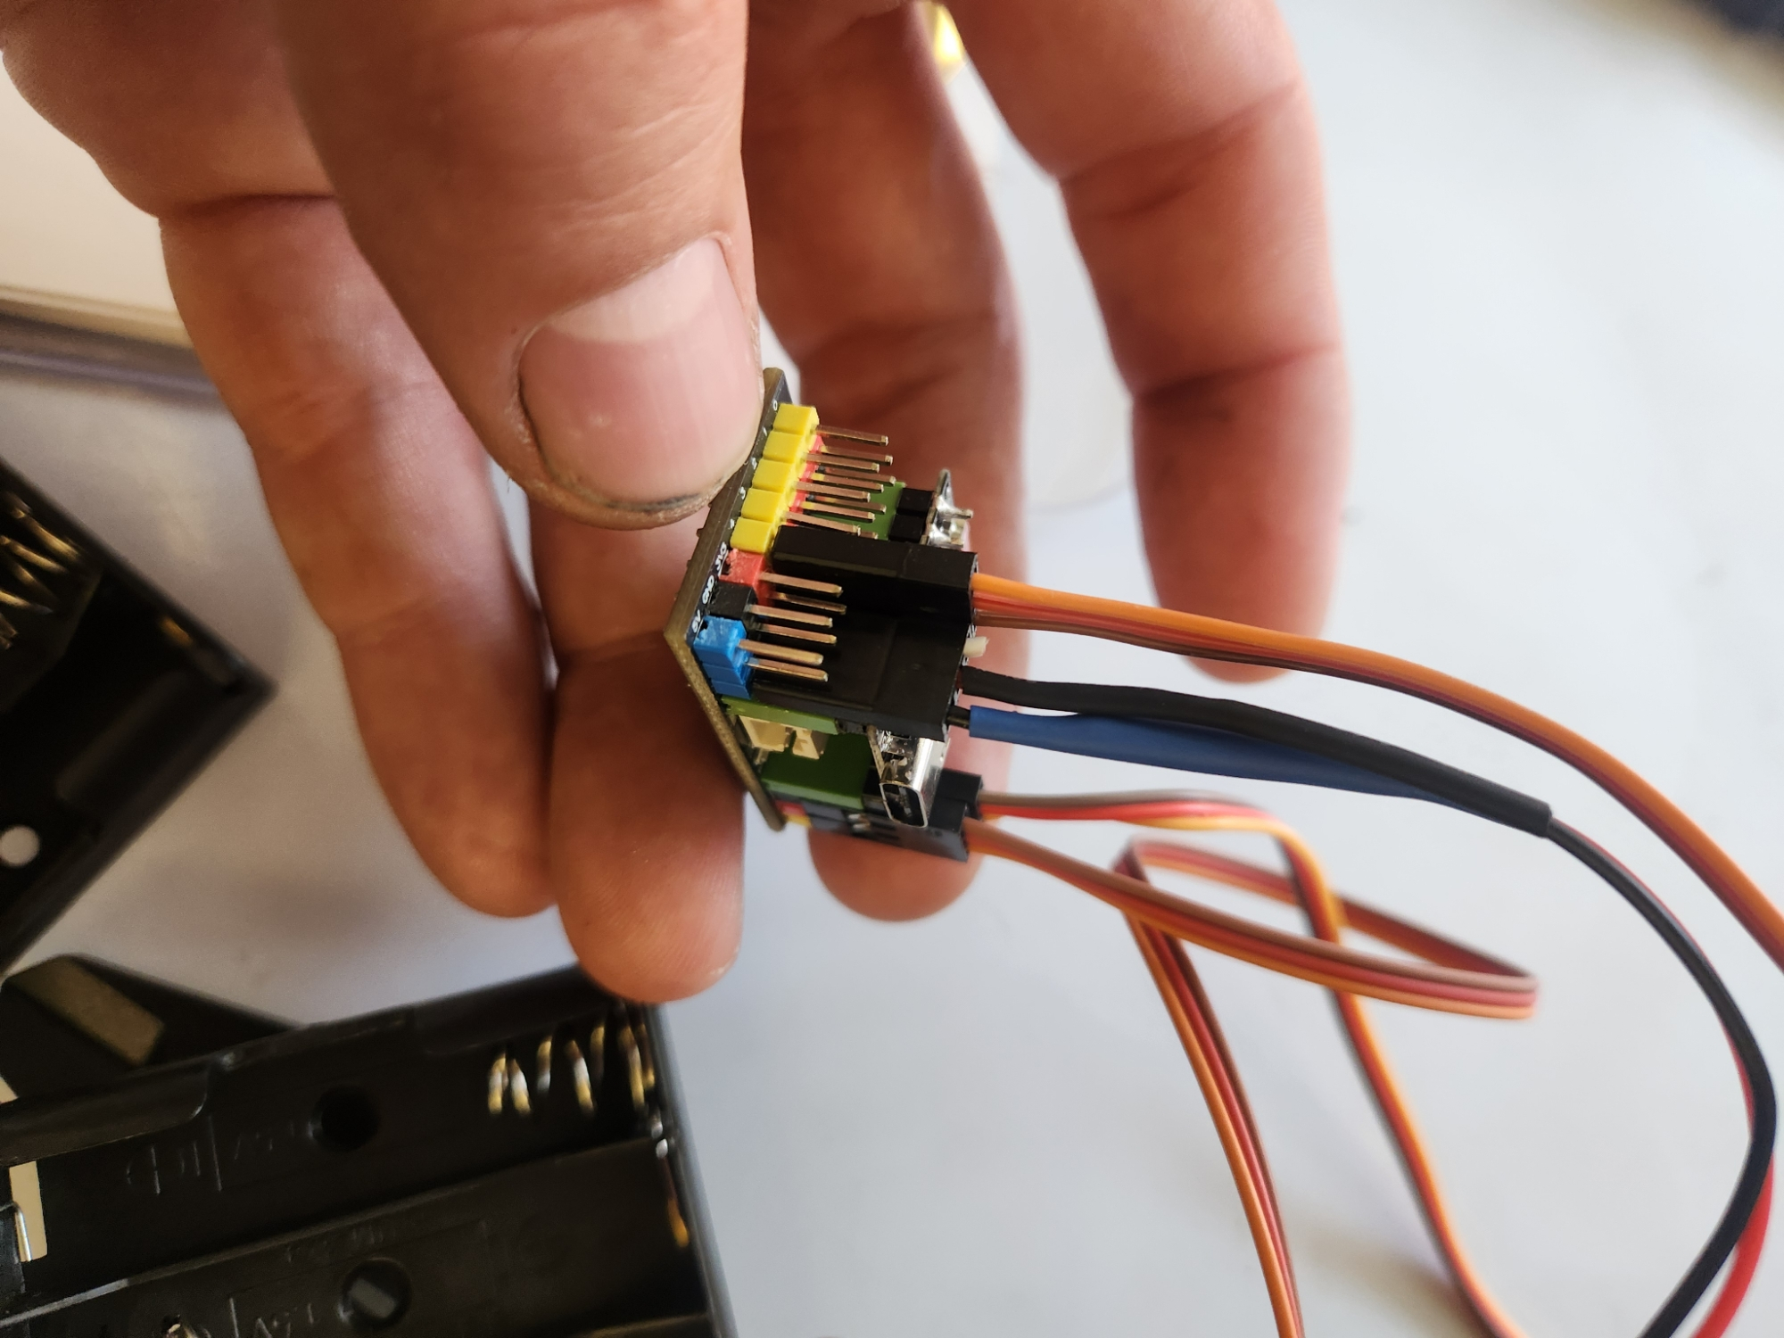  Overall orientation

7. Program the ESP32-C3
- ☐ Install the Arduino IDE on the computer.
- ☐ Open Boards Manager, search for ESP32, and install the board package published by Espressif Systems.
- ☐ Download or clone the MarshmallowBot repository. Open MarshmallowBot.ino in the Arduino IDE.
- ☐ Connect the ESP32-C3 to the computer with a USB-C data cable. A charge-only cable will not work for programming.
- ☐ Select the connected serial port and the appropriate ESP32-C3 board entry. If the repository later specifies an exact board profile, use that setting.
- ☐ Click Verify to compile the sketch, then click Upload.
- ☐ If upload does not begin, place the ESP32-C3 in its bootloader mode using the board’s BOOT and RESET controls, then retry. Exact button timing can vary by board version.
- ☐ After a successful upload, disconnect USB before attaching the battery pack for the first powered test.

8. First Power-Up and Drive Test
- ☐ Raise the drive wheels slightly so the robot cannot run off the table.
- ☐ Install four AA batteries.
- ☐ Check power-lead polarity one final time, then connect the battery lead.
- ☐ Confirm that an LED lights on the controller.
- ☐ Connect a phone, tablet, or computer to Wi-Fi network MarshMallowBot using password 12345678.
- ☐ Open a browser and enter 192.168.4.1.
- ☐ Test Stop first, then Forward, Reverse, Left, and Right. Disconnect power if either servo binds or wiring becomes warm.

9. Add the Optional Marshmallow Launcher
- ☐ Fasten the printed launcher holder to the chassis with the two tapered-head screws and nuts.
- ☐ Install the standard micro servo with the output shaft on the lower side of the holder, as shown.
- ☐ Secure the mousetrap in the holder. Keep the trap released during alignment.
- ☐ Connect the trigger servo before installing its horn. Power the robot and open the browser controller.
- ☐ Press Fire to move the trigger servo to its commanded position. Disconnect power.
- ☐ Install the horn at an angle that presses the mousetrap trigger when Fire is commanded, then secure the horn screw.
- ☐ With the trap released, cycle the servo and confirm that the horn moves freely.
- ☐ Create a lightweight launching arm from a plastic spoon, craft sticks, duct tape, or a 3D-printed design. Keep the arm light and clear of the wheels and wiring.
- ☐ Perform the first cocked test in a clear area with everyone behind the robot.
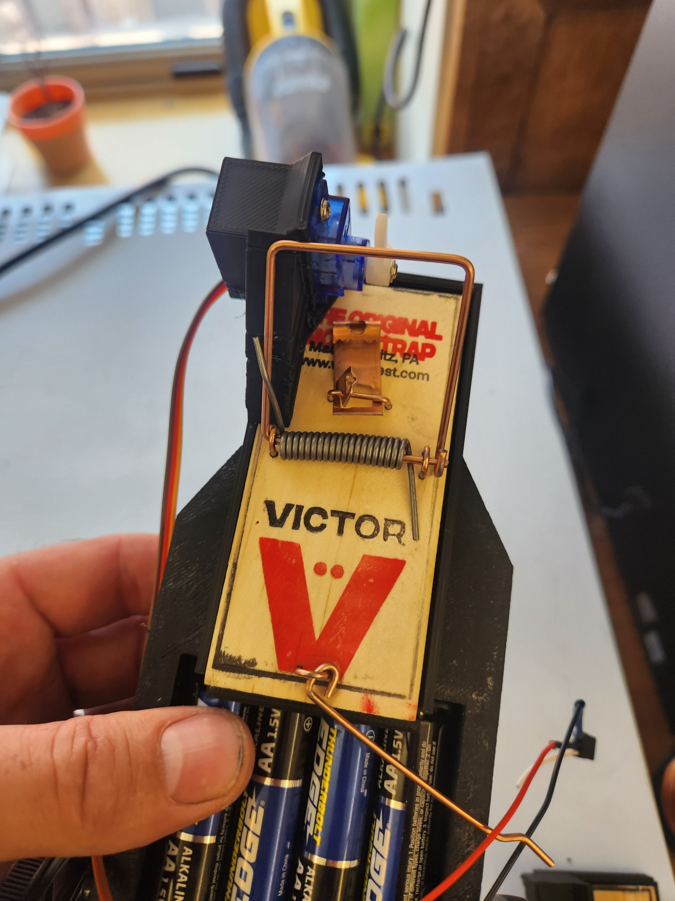
Trigger-servo horn position

10. Troubleshooting
Compilation fails: Confirm the Espressif ESP32 board package is installed and MarshmallowBot.ino is open as part of its sketch folder.
No serial port appears: Try a known USB data cable, another USB port, and reconnect the board. Some systems require a USB serial driver for the interface used on that board.
Upload fails: Select an ESP32-C3 target and the correct port, then retry using the board’s bootloader button sequence.
No controller LED: Disconnect immediately and verify battery voltage, splice continuity, and polarity.
Robot hotspot is missing: Restart the robot close to the controller device and confirm that the sketch uploaded successfully.
Bot creeps at Stop: Tune the neutral pulse or stop value in the sketch for the individual continuous-rotation servos.
Steering is reversed: Verify left/right servo placement, then reverse the affected motor direction in the sketch if necessary.

Repository README: Clean GitHub Version
The following section is formatted as repository-ready content. Add the component-buying links under “Compatible Hardware Links” when available.

MarshmallowBot
Files, code, and 3D-print models for a small Wi-Fi-controlled robot that can optionally launch a mini marshmallow using a mousetrap mechanism.

Features
• ESP32-C3 Super Mini controller
• Browser-based driving interface
• Direct Wi-Fi connection with no router required
• Two-wheel differential drive
• Optional servo-triggered mousetrap launcher
• 3D-printable chassis and launcher parts

Quick Start
1. Build the chassis and connect the servos.
2. Install the Espressif ESP32 board package in Arduino IDE.
3. Open and upload MarshmallowBot.ino.
4. Power the robot with the 4-AA holder after verifying polarity.
5. Join Wi-Fi network MarshMallowBot with password 12345678.
6. Browse to 192.168.4.1.

Safety
The mousetrap can pinch fingers and propel objects. Keep hands clear while cocked. Use only soft mini marshmallows. Never aim at people, animals, faces, windows, or fragile objects.

Compatible Hardware Links
Add purchasing links here. Recommended categories: ESP32-C3 Super Mini and expansion board; continuous-rotation micro servos with wheels; 4-AA battery holder; standard micro servo; standard mousetrap; fasteners.

Project Files
Repository: https://github.com/bryceehill/MarshmallowBot
Include the Arduino sketch, STL files, photographs, wiring information, and license in clearly named folders.

Contributing
Improvements to the chassis, launcher, documentation, and code are welcome. Document hardware changes and include clear photographs when possible.


