Marshmallow Bot User Instructions

This tutorial will help you use your new Marshmallow Bot. This bot is just for fun.

Step 1: Inspect your bot. It should have two drive wheels, and a marshmallow launcher. It should also have a 4xAA battery clip and a mini computer board.
Step 2: Make sure your motors are all plugged in the right spots the right way. Before you power on the bot, make sure the three connectors to each fo the three servos (motors) are connected as shown below. Note the color code of the wires and the locations of the three connectors. The left drive motor connects as shown below:
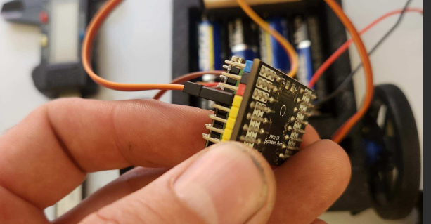

The right motor connects on the opposite side of the board as shown below in the top row:
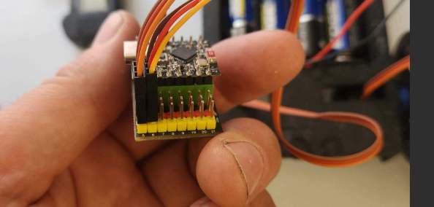
Also shown above is the trigger motor shown just to the right of the right servo (motor). Note the yellow or orange wire matches the yellow strip on the board and the black or brown wire matches the black stripe. The trigger servo motor is optional and originally used to trigger a mouse trap. Your bot should have come with the servo motor for this, but not the mouse trap or the 3d printed holder for it. You can purchase a standard mouse trap on your own and 3D Print the holder. The file for this is in the link in the QR code below along with all other information about this bot including code.
The image below may help clear up any questions about location and orientation:
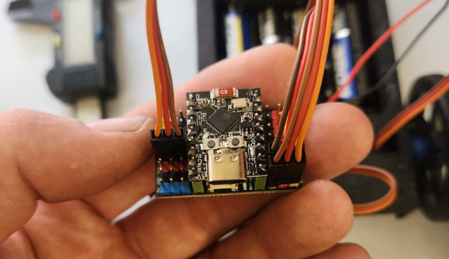

Step 4: Power it on. During this step be certain you plug in the connector correctly! First place the four AA batteries in the battery clip. Locate the connector of the battery clip. There are three pin sockets in it. One connects to nothing. Note the color of the heat shrink tubing on the wires. One is marked with blue and the other black.
On the board you should find a similarly colored array of pins in the red, black, blue orientation. Connect the three pin connector as shown below with the blue wire into the blue row, the black wire into the black row. Before connecting this make sure it matches the image below. If you plug it in backwards it will cook the board. (we are working on a pcb design that will solve this problem)
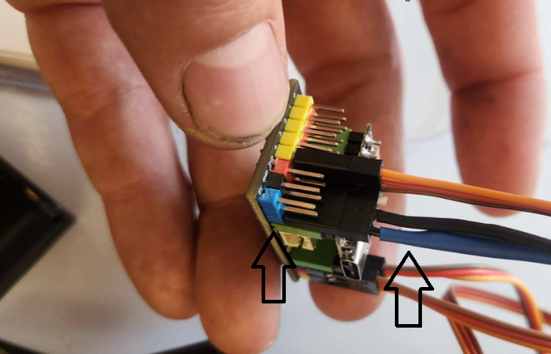
If you did this correctly, an LED will light up on the board.
Step 5: With the board powered on you will need to connect to it as a hot spot. By default the wifi SSID is "MarshMallowBot" but it may be customized. Use a computer, phone or tablet to connect to the wifi hotspot. It will not provide internet, but it will provide connection to the remote control.
Wifi Password: 12345678
Step 6: On your phone computer or tablet open a web browser and navigate to a web address that looks a bit strange. Be careful to type this in correctly:
192.168.4.1
Once you have this up you should be able to drive your marshmallowbot around and launch a mini marshmallow at your will.
Enjoy

