Week 5 ReadMe

Progress and Learnings:

* Our progress/learnings through Week 5:
  + We have now implemented the corners problem class, which adds a new level of complexity to our previous week's work.
  + One of the main takeaways and important lessons from this week was determining how to define a proper state representation, which includes the pacman current location and a list of the unvisited corners.
  + We can now solve game maps which have more than one goal (piece of food), as our goal state depends on visiting all corners. We remove a goal state each time a corner is reached and update the successor. PacMan uses a heuristic algorithm (which utilizes manhattan distance) to find an optimal path in visiting all corners.
  + For the heuristic, we iterate over all the corners associated with a state, find the Manhattan distance between each corner and the current state, and then return the max of this list.
  + Our current heuristic expands bfs in 1,966 nodes on the medium map. It expands the medium map in 1,136 nodes using our Astar search algorithm with cornersHeuristic.

Relevant screenshots:

BFS

mediumCorners

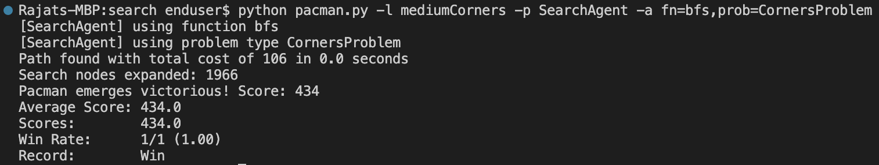

tinyCorners

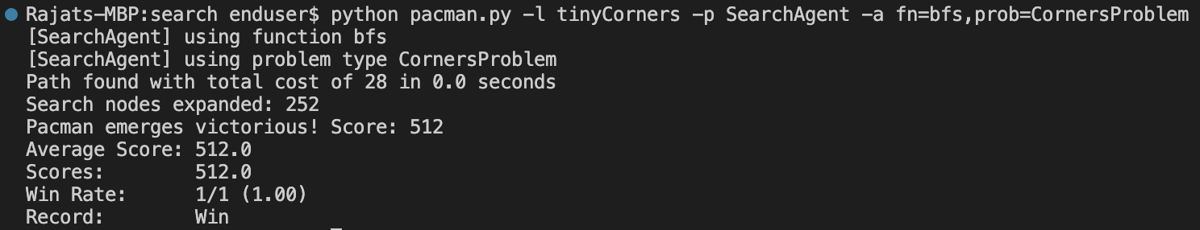

A Star

mediumCorners

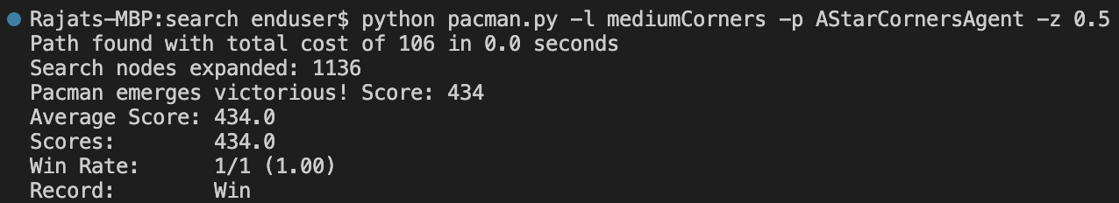

tinyCorners

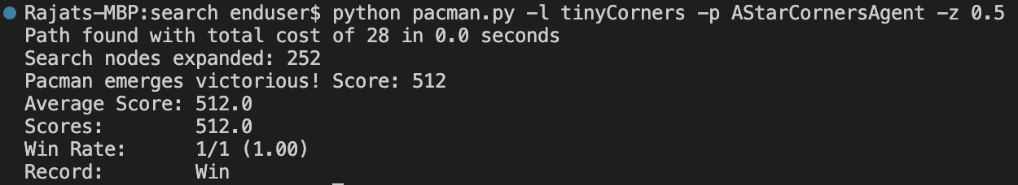

Autograder Results

Question 5

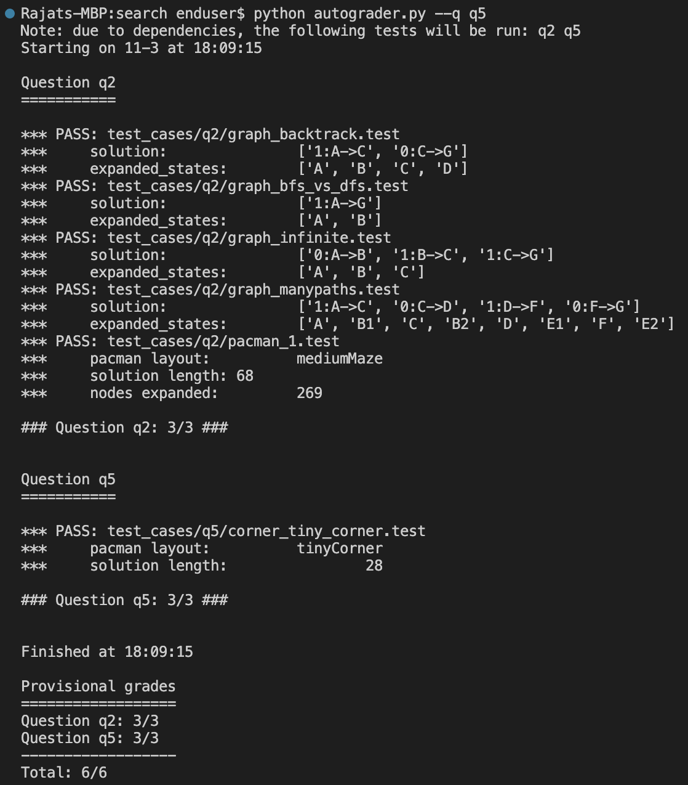

Question 6

