MelodyMatch
Technical Architecture & System Reference
AI-powered music discovery — semantic search by mood, melody, lyrics, and audio
Full-stack agentic application · React + FastAPI + Claude + Pinecone
Generated 2026-07-10 · v1.0

Table of Contents

1. Executive Summary
MelodyMatch is a full-stack, AI-driven music discovery application. A user describes the kind of music they want — by mood, melody / sonic feel, lyrical theme, a specific artist, or by uploading an audio clip — and the system returns real, semantically similar songs with a per-song explanation of why each matches.
The core idea is semantic vector search over a shared embedding space. Both catalog songs and user queries are turned into natural-language descriptions and embedded with Voyage AI, so a query like “sad rainy-day piano” lands near catalog vectors described as “low energy, slow, melancholic, acoustic.” A Claude agent orchestrates the search: it interprets the request, chooses the right tools, and streams its reasoning and results back to the browser in real time over Server-Sent Events (SSE).

1.1 Key Capabilities
- Text search — a Claude agent (claude-sonnet-4-6) runs a tool-use loop over audio, lyric, combined, and artist-specific search tools and streams results via SSE.
- Audio match — a “Shazam-like” flow: the browser records/uploads a clip, the backend extracts sonic features with librosa, and matches them against the catalog’s audio namespace.
- Artist-specific search — exact metadata-filtered lookup that returns songs by a named artist, with case-insensitive matching.
- Background catalog growth — when a query names an artist, that artist is silently queued and indexed into the catalog in the background.
- Monetization — tiered plans with Clerk authentication, Stripe subscriptions, and monthly search quotas enforced server-side.
- Developer mode — a DEV_MODE flag bypasses all paid-tier gating for unlimited local testing.

2. System Architecture
MelodyMatch is a cloud-deployed, service-oriented application. The React single-page app is served from Vercel; the FastAPI backend runs on Railway in a Docker container that bundles ffmpeg and libsndfile for audio decoding. Vectors live in Pinecone (serverless), relational data in Supabase (Postgres), and several third-party APIs supply intelligence and content.

2.1 Architecture Diagram
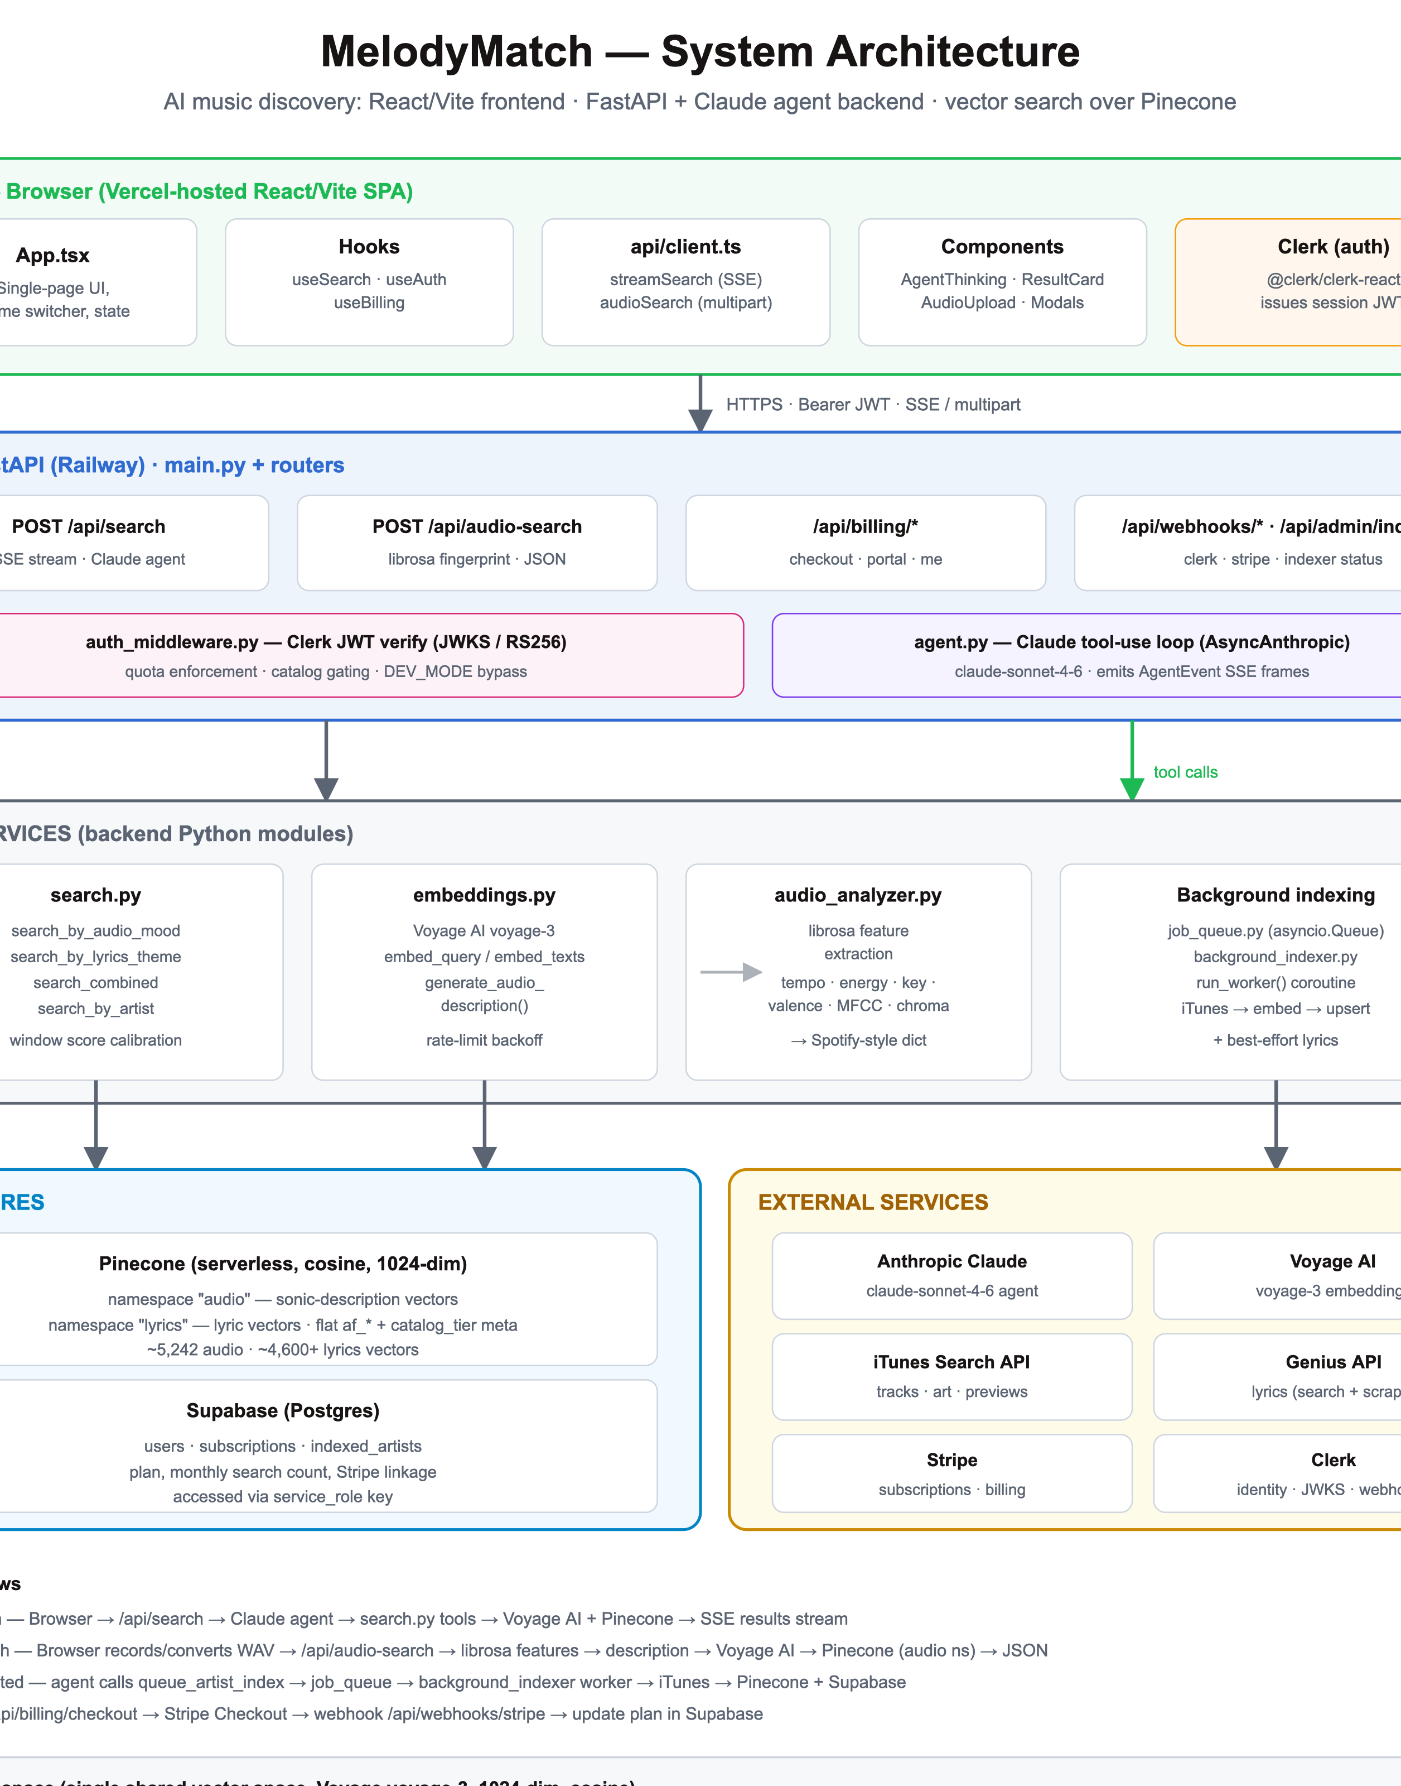

2.2 Technology Stack
Layer | Technology | Role
Frontend | React 18 + Vite + TypeScript | Single-page app; inline theme-token styling; shadcn/ui (Radix) components; Tailwind
Auth (client) | @clerk/clerk-react | Sign-in UI; issues short-lived session JWTs sent as Bearer tokens
Backend | FastAPI + Uvicorn (Python) | Async API; SSE streaming; routers for search, billing, webhooks, admin
Agent | Anthropic claude-sonnet-4-6 (AsyncAnthropic) | Tool-use loop that plans and executes searches
Embeddings | Voyage AI voyage-3 (1024-dim) | Turns descriptions & queries into vectors
Vector DB | Pinecone (serverless, cosine) | Two namespaces: audio, lyrics
Relational DB | Supabase (Postgres) | users, subscriptions, indexed_artists
Audio DSP | librosa + soundfile + numpy | Extracts sonic features from uploaded clips
Catalog data | iTunes Search API | Tracks, album art, 30-second previews (no key required)
Lyrics | Genius API + BeautifulSoup | Authenticated search + lyrics-page scraping
Billing | Stripe | Checkout, customer portal, subscription webhooks
Identity | Clerk | User lifecycle, JWKS verification, webhooks
Hosting | Vercel (web) + Railway (API) | Docker image includes ffmpeg + libsndfile1

3. Request Flows

3.1 Text Search (SSE, agent-driven)
- The React frontend (src/api/client.ts) POSTs { query, search_type } to /api/search with an optional Authorization: Bearer <JWT> header.
- FastAPI (main.py) resolves the user (if signed in), enforces quota, decides catalog gating, then returns a StreamingResponse wrapping agent.run_streaming().
- The Claude agent (agent.py) runs a tool-use loop (max 6 iterations). It emits AgentEvent SSE frames: thinking, tool_call, tool_result, and finally result.
- Each search tool calls search.py, which embeds the query via Voyage AI and queries Pinecone.
- The useSearch hook accumulates streamed events and updates the UI live (agent reasoning panel + result cards).

3.2 Audio Match (fingerprint, JSON)
- The user records or uploads a clip in AudioUpload.tsx. The browser converts it to true WAV (AudioContext + hand-written RIFF header) before upload.
- The blob is POSTed as multipart to /api/audio-search.
- audio_analyzer.py loads the bytes (soundfile, falling back to librosa+ffmpeg with magic-byte format detection) and extracts Spotify-style features: energy, tempo, valence, danceability, acousticness, instrumentalness, speechiness, loudness, key, mode, liveness.
- Features are rendered to a natural-language description (generate_audio_description), embedded, and queried against the Pinecone audio namespace — no Claude agent involved.
- Returns JSON (song list + detected features) — the frontend reuses the same result card component.

3.3 Artist Detected → Background Indexing
- When a query names an artist, the agent calls the queue_artist_index tool, which returns instantly.
- job_queue.enqueue() adds the artist to an in-process asyncio.Queue (deduplicated against a _known set pre-seeded from Supabase).
- A long-lived worker coroutine (background_indexer.run_worker(), started at app startup) processes artists one at a time: iTunes → genre-default features → Voyage embeddings → Pinecone upsert → best-effort Genius lyrics → Supabase indexed_artists record.
- Progress is observable at GET /api/admin/indexer.

3.4 Billing / Subscription
- Frontend calls /api/billing/checkout; the backend creates (or reuses) a Stripe customer and returns a hosted Checkout URL.
- On successful payment, Stripe calls /api/webhooks/stripe (checkout.session.completed), which updates the user’s plan in Supabase.
- customer.subscription.updated/deleted events keep the plan and subscriptions table in sync; a non-active status downgrades the user to free.

4. Authentication & Authorization

4.1 Clerk JWT Verification
Authentication is handled by Clerk on the frontend (@clerk/clerk-react). The client obtains a short-lived session JWT and sends it as Authorization: Bearer <token>. On the backend, auth_middleware.get_clerk_user_id() verifies the token against Clerk’s JWKS endpoint (CLERK_JWKS_URL) using RS256. The JWKS set is cached (PyJWKClient, 10-minute lifespan). On success it returns the sub claim (the Clerk user ID); on any failure it returns None — endpoints then treat the caller as anonymous.
Note: audience verification is disabled (verify_aud: False), so the token is validated on signature, issuer key, and expiry rather than a specific audience claim.

4.2 Anonymous vs. Authenticated
- Anonymous — no token. Allowed to search; limited to 3 searches tracked client-side in localStorage (mm_anon_searches) and gated to the popular catalog tier.
- Authenticated — a Supabase user row is created on first request (get_or_create_user). Plan, monthly usage, and Stripe linkage drive quota and catalog access.
Important caveat: the anonymous 3-search limit is enforced only in the browser, so it is not a hard security boundary. See §12 for hardening recommendations.

4.3 Quota Enforcement & Catalog Gating
For signed-in users, /api/search and /api/audio-search compare searches_used_this_month against the plan limit and return HTTP 429 when exceeded. maybe_reset_monthly_count rolls the counter over at the start of each billing month. Catalog gating applies a Pinecone metadata filter catalog_tier == "popular" for anonymous and free users; paid users query the full catalog.

4.4 Developer Mode
A DEV_MODE environment flag (read in main.py) bypasses all paid-tier gating: no quota enforcement, no catalog restriction, and usage counters are not incremented. The frontend mirrors this with Vite’s import.meta.env.DEV (true under npm run dev), which disables the client-side counter, hides the upgrade/catalog prompts, and shows a “Dev · unlimited” pill. DEV_MODE must remain false in production.

5. Song Querying — How Each Feature Works

5.1 The Shared Embedding Space
All vectors are 1024-dimensional Voyage AI (voyage-3) embeddings in one Pinecone index with two namespaces. Documents are embedded with input_type="document" and queries with input_type="query". embeddings.generate_audio_description() converts numeric audio features into rich natural language (energy, tempo with BPM, mood, major/minor tonality, vocal vs. instrumental, danceability, production character, live ambience). Because catalog descriptions and user queries share this vocabulary, cosine similarity is semantically meaningful.
Namespace | Source text | Captures
audio | Generated sonic description of a track | Mood, tempo, energy, acousticness, danceability, timbre
lyrics | Full song lyrics (Genius) | Theme, meaning, emotion, narrative

5.2 Search Tools (agent-callable)
Tool | Namespace | Mechanism
search_by_audio_mood | audio | Embed the descriptive query → cosine query on audio vectors → window-calibrated scores
search_by_lyrics_theme | lyrics | Embed the theme query → cosine query on lyric vectors → lyrics-window calibration
search_combined | both | Query both namespaces, calibrate per namespace, then weighted-average over the namespaces that actually matched
search_by_artist | audio | Metadata $or filter on artist_lower / artist (case variants) + client-side fallback; exact matches shown as 100%
queue_artist_index | — | Fire-and-forget enqueue for background indexing; returns instantly
return_results | — | Terminal tool: agent submits final ranked song IDs + per-song reasons

5.3 Artist-Specific Search
search_by_artist is intentionally not pure similarity search. It applies a Pinecone metadata filter combining artist_lower (populated on newer vectors) and artist with generated case variants via $in, covering vectors indexed before artist_lower existed. If the filter returns nothing, a broad top-500 query is filtered client-side by exact lowercased artist name. Because these are exact matches, similarity is forced to 1.0 (100%) rather than shown as a low cosine value. If no songs are found, the agent tells the user the artist has been queued for background indexing.

5.4 Audio Fingerprint Matching
audio_analyzer.analyze_audio() derives approximate Spotify-style features using librosa: RMS energy, beat-tracked tempo, spectral centroid/rolloff (brightness → valence & acousticness), zero-crossing rate (speechiness), MFCC variance (timbre → acousticness), chroma (key + major/minor via template correlation), onset strength/PLP (danceability), and rolloff variance (liveness). The goal is to land in the right region of the embedding space, not to replicate Spotify’s ML models. Analysis is capped at 60 seconds (middle slice) to bound latency.

5.5 Score Calibration
Raw voyage-3 cosine scores cluster in a narrow band (~0.40–0.60) and never approach 1.0, so displaying them directly is both misleadingly low and poorly differentiated. search.py maps each namespace’s meaningful window onto a readable display band: _AUDIO_WINDOW = (0.42, 0.60) and _LYRICS_WINDOW = (0.40, 0.55) are linearly mapped to [0.55, 0.99]. Combined search calibrates each namespace before merging (so it must not re-calibrate the merged value). Exact artist matches are pinned to 100%. This is a heuristic; §12 suggests a data-driven replacement.

6. Pricing & Billing

6.1 Plan Tiers
Plan | Price | Searches / month | Catalog & notes
Anonymous | Free | 3 (client-side) | Popular tier only; no account; limit enforced in browser
Free | $0 | 10 | Popular tier only; created on first authenticated request
Explorer | $4.99 / mo | 75 | Full catalog; Stripe subscription
Unlimited | $9.99 / mo | 300 | Full catalog; Stripe subscription

Plan limits live in backend/models.py (SEARCH_LIMITS, CATALOG_GATED_PLANS) with a parallel copy in database.py used by the billing endpoint. “Unlimited” is a marketing label for the 300/month tier, not truly unbounded.

6.2 Stripe Integration
- stripe_client.get_or_create_customer — finds a Stripe customer by clerk_user_id metadata or creates one.
- create_checkout_session — subscription-mode Checkout for the chosen price ID; plan carried in session + subscription metadata.
- create_billing_portal_session — hosted customer portal for managing/cancelling subscriptions.
- construct_webhook_event / price_to_plan — verify webhook signatures and map Stripe price IDs back to plan names.
Webhook events handled: checkout.session.completed, customer.subscription.updated, customer.subscription.deleted. Clerk’s user.created webhook provisions the Supabase user row (verified with Svix).

7. API Endpoints
Method | Path | Auth | Purpose
GET | /health | None | Liveness probe
POST | /api/search | Optional Bearer | Agent text search; SSE stream of AgentEvents
POST | /api/audio-search | Optional Bearer | Audio-fingerprint match; JSON response
GET | /api/admin/indexer | None | Background indexer status (worker, queue, history, totals)
POST | /api/billing/checkout | Bearer (required) | Create Stripe Checkout session
POST | /api/billing/portal | Bearer (required) | Create Stripe customer-portal session
GET | /api/billing/me | Bearer (required) | Current plan + usage for the frontend
POST | /api/webhooks/clerk | Svix signature | User lifecycle sync (user.created)
POST | /api/webhooks/stripe | Stripe signature | Subscription lifecycle sync

SSE event schema (AgentEvent): type ∈ {thinking, tool_call, tool_result, result, error}, plus optional text, tool, query, count, songs, explanation.

8. Data Stores

8.1 Pinecone (vectors)
One serverless index (default name melodymatch), 1024 dimensions, cosine metric, on AWS us-east-1, auto-created if missing (pinecone_client.get_index). Two namespaces: audio and lyrics. Upserts use exponential-backoff retry on transient connection resets. Because Pinecone metadata must be scalar, audio features are stored as flat af_* keys (nested dicts and null values are rejected — nulls are replaced with empty strings).
Metadata field | Type | Purpose
song_id, title, artist, album | string | Display + identity
artist_lower | string | Case-insensitive artist filtering
year, genre, duration | string/number | Display metadata
af_energy, af_tempo, af_valence, … | number | Flattened Spotify-style audio features
af_key, af_mode | number | Musical key (0–11) and mode (major/minor)
catalog_tier | string | "popular" vs "full" — gates free/anonymous users
preview_url, image_url, spotify_url | string | 30s preview, artwork, external link

8.2 Supabase (relational)
Table | Key columns | Purpose
users | clerk_user_id, email, plan, searches_used_this_month, searches_reset_at, stripe_customer_id | Account, plan, and monthly quota state
subscriptions | user_id, stripe_subscription_id, stripe_price_id, plan, status, current_period_end | Stripe subscription mirror
indexed_artists | artist_name, artist_key (unique), songs_indexed, status, indexed_at | Dedup + history for background indexing
Accessed with the Supabase service_role key. increment_search_count is a Postgres RPC for atomic quota increments. The indexed_artists table is created via migrations/create_indexed_artists.sql.

9. Key Modules, Classes & Scripts

9.1 Backend
File | Responsibility
main.py | FastAPI app, CORS, startup worker launch, DEV_MODE, /api/search, /api/audio-search, admin endpoint
agent.py | Claude tool-use loop; system prompt; TOOLS schema; SSE AgentEvent emission; 6-iteration cap + fallback
search.py | Pinecone query functions; window score calibration; artist filtering; combined-search merge
embeddings.py | Voyage AI client; embed_query/embed_texts with rate-limit backoff; generate_audio_description
audio_analyzer.py | librosa feature extraction from raw bytes; soundfile/ffmpeg loading with magic-byte detection
pinecone_client.py | Index bootstrap; upsert with retry; query normalization across Pinecone SDK versions
auth_middleware.py | Clerk JWT verification via JWKS (RS256)
database.py | Supabase client; user/subscription helpers; monthly reset; quota RPC
stripe_client.py | Customers, Checkout, portal, webhook verification, price→plan mapping
job_queue.py | In-process asyncio.Queue; _known dedup set; enqueue + status helpers
background_indexer.py | run_worker() coroutine; per-artist iTunes→embed→upsert pipeline + best-effort lyrics
genius_client.py | Authenticated Genius search + BeautifulSoup lyrics scraping; token validation
itunes_client.py | Keyless iTunes track search; high-res artwork; duration formatting
models.py | Pydantic models (SearchRequest, SongResult, AgentEvent); plan constants

9.2 Frontend
File | Responsibility
src/App.tsx | Single-page UI; owns top-level state; theme switching; dev-mode display handling
hooks/useSearch.ts | SSE streaming state machine; accumulates thinking steps + results; abort handling
hooks/useAuth.ts | Clerk auth + anonymous localStorage counter + backend usage fetch; dev-mode bypass
hooks/useBilling.ts | Stripe checkout/portal redirect
api/client.ts | streamSearch (SSE parsing) and audioSearch (multipart upload)
components/AudioUpload.tsx | Mic recording + file upload; browser WAV conversion (AudioContext + RIFF header)
components/ResultCard.tsx | Song card with match %, explanation, preview player
components/AgentThinking.tsx | Live-streaming display of the agent’s reasoning and tool calls
themes/index.ts | Theme token objects passed as props (no CSS-in-JS library)

9.3 Scripts & Migrations
- scripts/seed_songs.py — one-time catalog seeding across genres (iTunes → Genius → Voyage → Pinecone), with popular/full catalog tiers and null-safe metadata.
- scripts/backfill_lyrics.py — resumable lyrics backfill for songs that have audio but no lyric vectors. Uses an append-only, fsync’d checkpoint file plus Pinecone re-diff so it survives crashes and picks up exactly where it left off (--reset to start over).
- migrations/create_indexed_artists.sql — creates the background-indexing tracker table.

10. Data Pipeline & Catalog Growth

10.1 Initial Seeding
The seed script collects unique tracks per genre from iTunes, skips anything already in Pinecone, derives audio features (genre defaults, optionally Spotify), generates descriptions, fetches lyrics from Genius (rate-limited), embeds both namespaces, and upserts to Pinecone with a catalog_tier of popular or full per genre. The catalog currently holds roughly 5,242 audio vectors and 4,600+ lyric vectors.

10.2 On-Demand Background Indexing
When users mention artists, those artists are queued and indexed asynchronously so the catalog grows toward real demand. The worker is a single long-lived coroutine that processes one artist at a time, fetching up to 30 tracks, applying jittered genre-default audio features, and recording completion in Supabase to prevent re-indexing. All synchronous I/O runs inside loop.run_in_executor so the event loop is never blocked.

10.3 Lyrics Backfill
Because early seed runs indexed audio without lyrics, backfill_lyrics.py closes the gap incrementally and resumably. Its checkpoint records every processed song — including songs that have no findable lyrics — so restarts never re-query Genius for the same tracks.

11. Notable Implementation Details
- Async correctness — the agent uses AsyncAnthropic; a sync client would block the event loop inside the async generator and cause Uvicorn to drop the SSE connection mid-stream.
- Non-blocking I/O — all sync calls (Voyage, Pinecone, Supabase, iTunes, Genius) run in a thread pool via run_in_executor.
- Browser-side WAV conversion — Chrome’s MediaRecorder emits WebM, so the client re-encodes to true WAV before upload; the server also detects format by magic bytes.
- Genius fix — the public search endpoint now 403s; the client uses the authenticated api.genius.com/search and scrapes lyric containers. Token validation checks /search, not /account (client tokens 401 on the latter).
- Graceful degradation — startup pre-seeding tolerates an unreachable Supabase; empty/sparse lyrics namespace doesn’t break combined search.
- Reload caveat — Uvicorn --reload must not watch the in-tree .venv, or dependency installs trigger an infinite restart loop.

12. Next Features & Areas for Improvement

12.1 Search Quality
- Re-embed the existing ~5,242 audio vectors with the newer, richer description generator (today only new vectors and live queries use it), for full consistency.
- Adopt true audio embeddings (e.g., CLAP) as a third namespace so uploaded-audio matching no longer round-trips through hand-derived text descriptions.
- Replace the hardcoded calibration windows with data-driven percentile normalization computed from live score distributions.
- Use real Spotify audio features for background-indexed artists instead of static genre defaults + jitter, which are low fidelity.

12.2 Reliability & Scale
- Make background indexing durable: the current asyncio.Queue is in-process, single-worker, and lost on restart (only dedup state is persisted). Move to a DB/Redis-backed queue with retries and a dead-letter path.
- Add an embedding/result cache (Redis) to cut Voyage AI calls and latency for repeat queries.
- Finish the lyrics backfill (~600 songs remaining) and wire lyrics indexing reliably into the background pipeline.

12.3 Security & Correctness
- Enforce the anonymous limit server-side (per-IP or device signal) — it is currently client-side only and trivially bypassable.
- Add rate limiting / abuse protection on public endpoints, and lock down the currently unauthenticated /api/admin/indexer.
- Unify the duplicated plan/limit constants (models.py vs database.py) into a single source of truth.
- Introduce an automated test suite (unit + integration), especially around auth, quota, and score calibration — none exists today.

12.4 Product & UX
- Result pagination / “load more,” and a feedback loop (thumbs up/down) to tune ranking over time.
- Deeper playback (full-track Spotify/Apple integration) beyond 30-second iTunes previews.
- Multi-artist and disambiguation handling in artist search; richer explanations.
- Observability: structured logs, metrics, tracing, and error monitoring (e.g., Sentry).

Appendix A. Environment Variables

Backend
Variable | Purpose
ANTHROPIC_API_KEY | Claude agent
VOYAGE_API_KEY | Voyage AI embeddings
PINECONE_API_KEY / PINECONE_INDEX_NAME | Vector DB (default index: melodymatch)
CLERK_SECRET_KEY / CLERK_JWKS_URL / CLERK_WEBHOOK_SECRET | Auth verification + webhooks
STRIPE_SECRET_KEY / STRIPE_WEBHOOK_SECRET | Billing + webhook verification
STRIPE_EXPLORER_PRICE_ID / STRIPE_UNLIMITED_PRICE_ID | Subscription price IDs
SUPABASE_URL / SUPABASE_SERVICE_KEY | Relational DB (service_role key, bare URL)
GENIUS_ACCESS_TOKEN | Lyrics search + scraping
FRONTEND_URL | CORS + Stripe redirect URLs
DEV_MODE | Bypass all paid-tier gating for local testing (default false)

Frontend
Variable | Purpose
VITE_API_URL | Backend base URL (default http://localhost:8000)
VITE_CLERK_PUBLISHABLE_KEY | Clerk frontend key
import.meta.env.DEV | Vite-provided; true under npm run dev — enables frontend dev mode

