AT2 Final Project – Interface Design

30003673

Table of Contents

Intro 1

Colour Scheme 2

Navigation 3

Use 4

UI Testing Check List 5

Sign-off 8

# Introduction

This program is designed to allow the easy saving and browsing of many things related to music. Here we will create a suitable user interface (UI) so all data can be accessed and maintained through a series of menus and forms. Instruments, venues, bands musicians and shows are just some of the things that are displayed within this program. It also features a very user friendly interface that includes help buttons and simple navigation between different parts of the program.

# Colour Scheme

Within my program I went with a red and grey scheme with white as the background for most forms. The grey is used for the back buttons and red for the main menu and band menu buttons. Red is also used as the highlights for most form pages. I chose this scheme as red is a very dominant colour and draws your attention right away. With the white text font in the buttons it makes it easy to see from far away. For the main menu help form I used a gold back ground as the information on the page enriched you with useful information. I kept all the back ( < ) buttons dark grey and except the print report button I made white to stand out a little.

(Example Below)

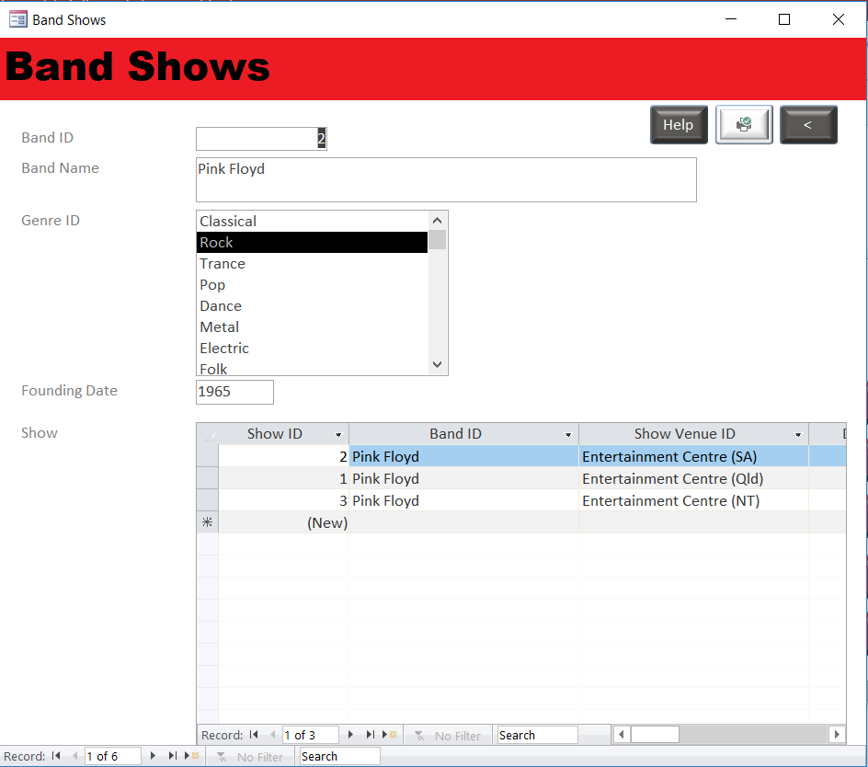

# Navigation

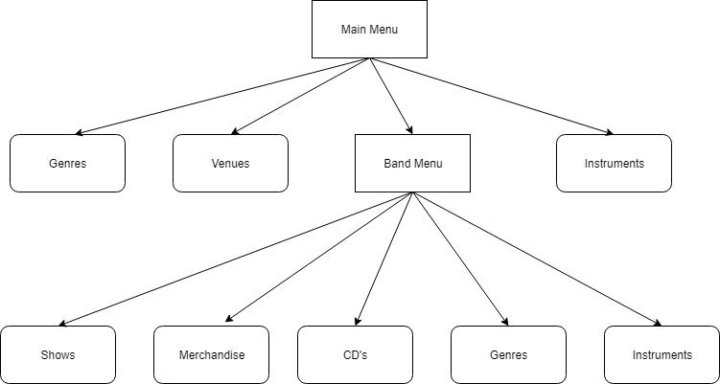It’s very easy to navigate through the program. From the main menu, you can choose one of the categories to look into. Genres, Venues and Instruments are forms with data that can be that can be clicked on from the main menu. The bands section however opens up to a sub menu for different forms, all with data that relates directly to bands. This includes Shows, Merchandise, CD’s, Genres and Instruments. The Shows form also has a help button to explain how to use the Band Shows form. There is also a print button that’ll print you a report of all the “Shows” by venue. There is also a help button on the Main Menu form with a diagram of how to navigate through the program. (Diagram Above)

# Use

The use of this program is to easily store vast amounts of information about something making it easy for the user to navigate through different section. In this case it’s a band with other musical related things. You can customize all the data to be personalized to whatever you want, allowing for a different set of data on each user computer.

# UI Testing Check List

|  |  |  |  |
| --- | --- | --- | --- |
| Check List | Description | Outcome | Evidence |
| Case 1: | Main Menu | Main menu displaying Band Menu, Genre, Venues and instruments |  |
| Case 2: | Help Button | Click on Help Button in the top right corner. Help form will open with explanation of how to navigate through the forms |  |
| Case 3: | Genre Button | Second button from the top of Main Menu. When clicked it opens up all the Genres |  |
| Case 4: | Venues Button | Third button from the top of Main Menu. When clicked opens up all the difference venues |  |
| Case 5: | Instrument Button | Last button on the Main Menu located fourth button from the top. This opens all the different instruments |  |
| Case 6: | Band Menu Button | First button from the top, this opens another form with five for button on it |  |
| Case 7: | Shows Button | First button from the top. Open all the shows that the musicians will be playing at |  |
| Case 8: | Band Show Help Button | Located in the top right of the band show form. This will open up a help form that will explain how to use the Band Show form |  |
| Case 9: | Print Button | Print button located on the top right corner of the screen will print a report of all the “Shows” by venue |  |
| Case 10: | Merchandise Button | Second button from the top. Opens all the merchandise available to buy |  |
| Case 11: | CD’s Button | Third button from the top. Opens all the CD’s |  |
| Case 12: | Genre Button | Forth button from the top of Band Menu form. Open all the genres |  |
| Case 13: | Instrument Button | Fifth button from the top of the Band Menu form. Opens all instruments |  |

# Sign-off

USER INTERFACE ACCEPTANCE SIGN-OFF FORM

For Project: AT2 Project 2019

Submitted for testing on: 27/06/2019

Test Team Leader: Bryce Huston

**Item Tested** On: 27/06/2019

* Main Menu Navigation
* Sub Menu Navigation
* Close Buttons
* Back Buttons
* Minor Data Entry (single table)
* Major Data Entry (multi-table)
* Report
* Help Files

**Proof of Compliance:**

User Acceptance Checklist completed

Test results attached

**Sign-Off Section:**

This system conforms to agreed specifications.

_________________________________ ____________

Signature of Executive Date

_______________________________________________________

Name/Position