# Contents

Contents 1

Questions: 1

Use Case Descriptions: 1

Diagrams 2

Domain: 3

Backlog: 3

Contributions: 4

# Questions:

In the individual races can a racer that started after someone finish before them?

Are the start and finish guaranteed to be on channel 1 and 2 respectively?

What is required of the quiescent state?

What should happen in the event of a tie? Will there be a way to go into thousandths of a second?

When the system is reset are all previous records deleted?

Is there a max number of racers in a group parallel race? Can more than 8 be recorded?

# Use Case Descriptions:

An event official takes a list of the teams in a bobsled competition. The official adds the different team numbers, and the order that the team is planned to compete.

The referee uses a button to trigger the start of the bobsled, thus recording the start time into the system. An external display may display the current time elapsed.

The bobsled team crosses the finish line, thus tripping the light sensor at the finish line, thus recording the end time into the timer.

A racer begins the race but is unable to complete the race.

Multiple racers line up in different lanes.

They all get the same signal to start.

As each racer finishes their times are recorded with their lane numbers.

# Diagrams

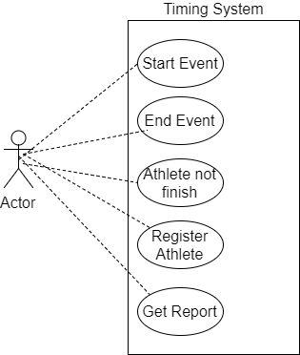

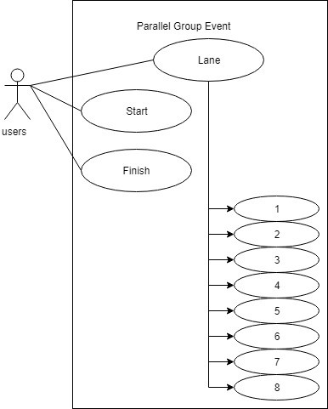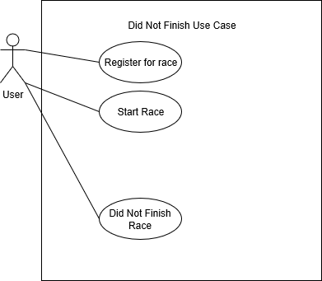

# Domain:

Challenges: Being able to work with all the hardware configurations of a timing system. How to deal with inaccurate data that will be given from the instrument. For example, in a ski race, snow could set off timer and interfere with the time result. Dealing with a domain that is constantly changing.

Common requirements/specifications: Going from small races to big races. Easy to use. Accurate to at least hundredths of a second.

# Backlog:

Bryce: Home Depot Employee

Alex: SwingMaster

Jaime: Simulated Existence

Dillan: NULL

|  |  |  |  |  |
| --- | --- | --- | --- | --- |
|  | Jaime | Bryce | Alex | Dillan |
| Sprint 1  Leader: Jaime  Notes: Bryce  Agenda: Alex | 2 channels, swap, conn, disc, newrun, endrun, num, clear, trig, start, finish | Power functions, exit, time, DNF | Events from CMD file or console | IND Races (Start, finish, DNF),  Update DM |
| Sprint 2  Leader: TBD  Notes: TBD  Agenda: TBD | Multiple channels, storage | Print, export, tog | Export data to file and display on console | Handle multiple channels, Update DM |
| Sprint 3  Leader: TBD  Notes: TBD  Agenda: TBD | Additional features and maintenance | Additional features and maintenance | GUI | Grp Races, Update DM |
| Sprint 4  Leader: TBD  Notes: TBD  Agenda: TBD | Additional features and maintenance | Additional features and maintenance | Parallel Grp Races | Interact with Web Server, Update DM |

# **Contributions**:

Jaime: 3 questions, 1 use case diagram, 1 use case description, contributed to domain and sprint backlog

Bryce: 1 question, 1 use case diagram, contributed to domain and sprint backlog

Alex: 1 question, 1 use case diagram, 3 use case descriptions, contributed to domain and sprint backlog

Dillan: 1 question, 1 use case diagram, 3 use case descriptions.