Evaluation of Performance Metrics for the Bear River Canal Company Before and After a Proposed Upstream Reservoir

*ILO-4. Reservoir Operation and Simulation*

Written By:

Bryce Mihalevich

Prepared For:

David Rosenberg

CEE6490 – Integrated River Basins/

Watershed Planning and Management

February 23, 2016

**Introduction**

The evaluation of the water supply in terms of monthly and annual target levels can provide performance metrics for existing management strategies and insight for future reservoir operation and release policies. In order to demonstrate this, this assessment simulates a scenario where a new reservoir is constructed on the Bear River upstream of a water user, Bear River Canal Company (BRCC) and the Little Bear River tributary. It is assumed in this scenario that the BRCC is a priority water rights holder on the Bear River. In this assessment I looked at the firm yield, reliability, resilience, vulnerability, and shortage costs (defined in Appendix 1) between 1971 and 2005 for scenarios with and without a reservoir. As a result, I successfully generated statistical data that shows averaged annual performance criteria for the BRCC and provided recommendations for reservoir operations and release rules.

**Methods**

Historical water flows from the Bear River and Little Bear River were provided to the class in an Excel spreadsheet (Rosenberg, 2016). The spreadsheet also contained reservoir surface area to volume calculation, monthly evaporation rates, and monthly delivery targets and monthly shortage costs for the BRCC. Inflows between 1971 and 2005 were used as these dates had complete annual data for both the Bear River and the Little Bear River. Excel was used to calculate reservoir releases and performance criteria and plot results (Mihalevich, 2016). Reservoir operation was simulated using the standard linear operating procedure (SLOP), modified for this scenario (Table 1 in Appendix 2).

**Results and Discussion**

The results of the performance criteria calculations between the current conditions and with an upstream reservoir are shown in Table 2 in Appendix 2. Clearly from the results the reservoir can increase the average reliability, resiliency, and decrease vulnerability for the BRCC. Additionally, the average firm yield and total shortage costs for the BRCC are reduced with an upstream reservoir. Comparison of the annual yield-reliability curves resulted in negligible differences (Figure 1 in Appendix 2). While the annual reliability with a reservoir is higher, the similarity is likely due to end-of-the-year flows balancing out. Thus, the results of adding a reservoir upstream demonstrates higher performance metrics, however, dam operation could be further improved if SLOP were replaced. Replacing SLOP is advantageous because there is no concern about future water availability or demands under this type of operation. It is recommended to modify SLOP to allow hedging. Hedging allows managers to balance shortages so that releases do no entirely drain what is in storage. A major concept associated with hedging is that greater shortages have larger associated storage costs. As a result of this assessment the shortage costs, calculated with exponential shortage cost function, were highest when the system was at its greatest vulnerability. Therefore, allowing for small shortages will reduce the vulnerability, which in turn reduces shortage costs.

**Conclusion**

This analysis shows that the addition of an upstream reservoir on the Bear River will improve the performance metrics of the BRCC. While these conclusions are made based on SLOP, SLOP should not be used to dictate reservoir releases. Instead, hedging should be used to mitigate shortage costs, especially in drier summer months. Overall, the results of this assessment provide water planners and reservoir operator’s metrics that may be used to better mange their system. **References**

Rosenberg, David (2016). LowerBearRiverData-Spring2016.xlxs. Accessed from Utah State University Canvas for CEE 6490 - Integrated River Basins/ Watershed Planning and Management.

Mihaelvich, Bryce (2016). GitHub Repository for Water Resources CEE6490. https://github.com/brycemihal/water_resources_CEE6490.git

Loucks, Daniel P.; van Beek, Eelco; Stedinger, Jery R.; Dijkman, Jozef P.M.; Villars, Monique T. (2005). Water Resources Systes Planning and Management: An Introduction to Methods, Models and Applications.

**Appendix 1: Definitions of Performance Criteria Statistical Evaluations**

Adapted fromLoucks et. al., 2005 and CEE 6490 course notes.

Firm Yield – the maximum quantity of water that can be guaranteed during a critical dry period.

Reliability – the fraction of time the system is in a satisfactory condition. It is calculated as the number of observations or length of time that is unsatisfactory, divided by the total number of observations or length of time.

Resilience – the likelihood that system will return to the satisfactory condition after reaching an unsatisfactory state. It is calculated as the number of times a satisfactory value follows an unsatisfactory value divided by the number of times and unsatisfactory value occurred.

Vulnerability – is the magnitude of failure to be expected when the system reaches an unsatisfactory state. It is calculated as the sum of the positive value of the difference between the observed value and the target value, divided by the number of unsatisfactory observations.

Shortage Cost – The cost to a user when there is a delivery shortage occurs. It is calculated as $Y_{t}= a_{t}{*X}_{t}^{b_{t}}$,where *Xt* is the delivery shortage in during the time step, and *at* and *bt* are empirical parameters during the time step.

**Appendix 2: Figures and Tables**

Table 1. SLOP rules for the upstream reservoir to meet Bear River Canal Company delivery targets.

|  |  |  |
| --- | --- | --- |
| **Condition** | **Reservoir Release (Rt)** | **Storage (St)** |
| AWt + LBRt < Dt | AWt | 0 |
| LBRt > Dt *AND* AWt < Ct | 0 | AWt |
| LBRt > Dt *AND* AWt > Ct | AWt - Ct | Ct |
| LBRt < Dt *AND* AWt + LBRt > Dt  *AND* AWt + LBRt - Dt < Ct | Dt - LBRt | AWt – (Dt – LBRt) |
| LBRt < Dt *AND* AWt + LBRt > Dt  *AND* AWt + LBRt - Dt > Ct | AWt - Ct | Ct |

Where,

AWt = Available water from the Bear River at the current time step (above reservoir).

LBRt = Available water from the Little Bear River at the current time step (below reservoir).

Ct  = Capacity of the reservoir at the current time step.

Dt = Delivery target of the Bear River Canal Company at the current time step.

Table 2. Comparison of Performance Metrics for the Bear River Canal Company Before and After a Proposed Upstream Reservoir.

|  |  |  |  |  |  |  |  |  |  |  |  |  |  |  |
| --- | --- | --- | --- | --- | --- | --- | --- | --- | --- | --- | --- | --- | --- | --- |
| Year | Reservoir | Current Conditions |  | Reservoir | Current Conditions |  | Reservoir | Current Conditions |  | Reservoir | Current Conditions |  | Reservoir | Current Conditions |
| Annual Firm Yield (ac-ft) | |  | Annual Reliability (%) | |  | Annual Resilience (%) | |  | Annual Vulnerability (ac-ft) | |  | Annual Shortage Costs | |
| 1971 | 55504.75 | 87816.61 |  | 100.00 | 100.00 |  | #DIV/0! | #DIV/0! |  | #DIV/0! | #DIV/0! |  | $- | $- |
| 1972 | 74106.19 | 76561.78 |  | 100.00 | 100.00 |  | #DIV/0! | #DIV/0! |  | #DIV/0! | #DIV/0! |  | $- | $- |
| 1973 | 35537.00 | 33331.44 |  | 100.00 | 83.33 |  | #DIV/0! | 100.00 |  | #DIV/0! | 13228.56 |  | $- | $16,284,527.64 |
| 1974 | 38977.78 | 38977.78 |  | 100.00 | 100.00 |  | #DIV/0! | #DIV/0! |  | #DIV/0! | #DIV/0! |  | $- | $- |
| 1975 | 47902.19 | 47902.19 |  | 100.00 | 100.00 |  | #DIV/0! | #DIV/0! |  | #DIV/0! | #DIV/0! |  | $- | $- |
| 1976 | 35537.00 | 36981.97 |  | 100.00 | 75.00 |  | #DIV/0! | 33.33 |  | #DIV/0! | 4972.46 |  | $- | $9,738,928.30 |
| 1977 | 4576.00 | 18145.35 |  | 100.00 | 83.33 |  | #DIV/0! | 50.00 |  | #DIV/0! | 11457.97 |  | $- | $20,771,683.00 |
| 1978 | 16691.00 | 29151.89 |  | 100.00 | 75.00 |  | #DIV/0! | 33.33 |  | #DIV/0! | 3919.03 |  | $- | $6,037,883.93 |
| 1979 | 4576.00 | 23890.89 |  | 91.67 | 75.00 |  | 100.00 | 66.67 |  | 603.42 | 11679.56 |  | $69,342.22 | $12,153,872.17 |
| 1980 | 50139.15 | 48537.39 |  | 100.00 | 100.00 |  | #DIV/0! | #DIV/0! |  | #DIV/0! | #DIV/0! |  | $- | $- |
| 1981 | 7272.58 | 20692.29 |  | 100.00 | 75.00 |  | #DIV/0! | 66.67 |  | #DIV/0! | 3746.90 |  | $- | $6,203,521.90 |
| 1982 | 33583.56 | 33583.56 |  | 100.00 | 91.67 |  | #DIV/0! | 100.00 |  | #DIV/0! | 14335.71 |  | $- | $15,130,599.72 |
| 1983 | 110833.36 | 110833.36 |  | 100.00 | 100.00 |  | #DIV/0! | #DIV/0! |  | #DIV/0! | #DIV/0! |  | $- | $- |
| 1984 | 116946.44 | 116946.44 |  | 100.00 | 100.00 |  | #DIV/0! | #DIV/0! |  | #DIV/0! | #DIV/0! |  | $- | $- |
| 1985 | 45953.00 | 38719.99 |  | 100.00 | 91.67 |  | #DIV/0! | 100.00 |  | #DIV/0! | 7233.01 |  | $- | $468,087.45 |
| 1986 | 86019.15 | 86019.15 |  | 100.00 | 100.00 |  | #DIV/0! | #DIV/0! |  | #DIV/0! | #DIV/0! |  | $- | $- |
| 1987 | 4576.00 | 28703.91 |  | 100.00 | 66.67 |  | #DIV/0! | 25.00 |  | #DIV/0! | 5437.02 |  | $- | $9,212,154.73 |
| 1988 | 4576.00 | 22900.24 |  | 91.67 | 66.67 |  | 100.00 | 25.00 |  | 4608.33 | 9237.78 |  | $2,197,693.13 | $11,830,264.24 |
| 1989 | 4576.00 | 21041.83 |  | 100.00 | 66.67 |  | #DIV/0! | 25.00 |  | #DIV/0! | 7204.67 |  | $- | $4,009,298.92 |
| 1990 | 4576.00 | 19708.65 |  | 100.00 | 83.33 |  | #DIV/0! | 100.00 |  | #DIV/0! | 12490.19 |  | $- | $4,257,210.23 |
| 1991 | 14661.22 | 20384.83 |  | 100.00 | 83.33 |  | #DIV/0! | 50.00 |  | #DIV/0! | 6952.05 |  | $- | $9,500,695.33 |
| 1992 | 1896.90 | 13060.32 |  | 91.67 | 75.00 |  | 100.00 | 33.33 |  | 17428.52 | 16415.80 |  | $21,090,473.44 | $61,889,388.54 |
| 1993 | 6086.50 | 20533.44 |  | 100.00 | 75.00 |  | #DIV/0! | 33.33 |  | #DIV/0! | 10771.45 |  | $- | $31,823,894.02 |

(Table 1. Continued)

|  |  |  |  |  |  |  |  |  |  |  |  |  |  |  |
| --- | --- | --- | --- | --- | --- | --- | --- | --- | --- | --- | --- | --- | --- | --- |
| 1994 | 2709.59 | 19694.41 |  | 100.00 | 58.33 |  | #DIV/0! | 20.00 |  | #DIV/0! | 5842.44 |  | $- | $12,983,904.52 |
| 1995 | 13267.93 | 30066.01 |  | 100.00 | 75.00 |  | #DIV/0! | 33.33 |  | #DIV/0! | 10434.06 |  | $- | $35,051,136.22 |
| 1996 | 15522.11 | 31042.50 |  | 100.00 | 75.00 |  | #DIV/0! | 33.33 |  | #DIV/0! | 10816.17 |  | $- | $31,451,537.92 |
| 1997 | 42294.30 | 42294.30 |  | 100.00 | 100.00 |  | #DIV/0! | #DIV/0! |  | #DIV/0! | #DIV/0! |  | $- | $- |
| 1998 | 50924.04 | 51238.86 |  | 100.00 | 100.00 |  | #DIV/0! | #DIV/0! |  | #DIV/0! | #DIV/0! |  | $- | $- |
| 1999 | 66612.73 | 69320.18 |  | 100.00 | 100.00 |  | #DIV/0! | #DIV/0! |  | #DIV/0! | #DIV/0! |  | $- | $- |
| 2000 | 16691.00 | 29028.95 |  | 100.00 | 83.33 |  | #DIV/0! | 100.00 |  | #DIV/0! | 2314.67 |  | $- | $1,873,642.34 |
| 2001 | 1801.69 | 18709.99 |  | 100.00 | 75.00 |  | #DIV/0! | 66.67 |  | #DIV/0! | 7678.49 |  | $- | $19,795,251.01 |
| 2002 | 2630.09 | 21181.61 |  | 100.00 | 75.00 |  | #DIV/0! | 66.67 |  | #DIV/0! | 10128.91 |  | $- | $3,248,060.11 |
| 2003 | 1561.00 | 10844.39 |  | 66.67 | 50.00 |  | 25.00 | 16.67 |  | 4156.46 | 8398.91 |  | $9,074,324.60 | $14,431,840.53 |
| 2004 | 1561.00 | 15672.67 |  | 66.67 | 58.33 |  | 25.00 | 20.00 |  | 15238.38 | 18936.72 |  | $63,915,351.40 | $66,419,573.83 |
| 2005 | 4576.00 | 28262.16 |  | 100.00 | 75.00 |  | #DIV/0! | 33.33 |  | #DIV/0! | 12912.04 |  | $- | $41,326,367.62 |
| Minimum | 1561.00 | 10844.39 |  | 66.67 | 50.00 |  | 25.00 | 16.67 |  | 603.42 | 2314.67 |  |  | Total Costs |
| Average | 29293.01 | 38908.04 |  | 97.38 | 82.62 |  | 70.00 | 51.32 |  | 8407.02 | 9439.36 |  | $96,347,184.79 | $445,893,324.24 |

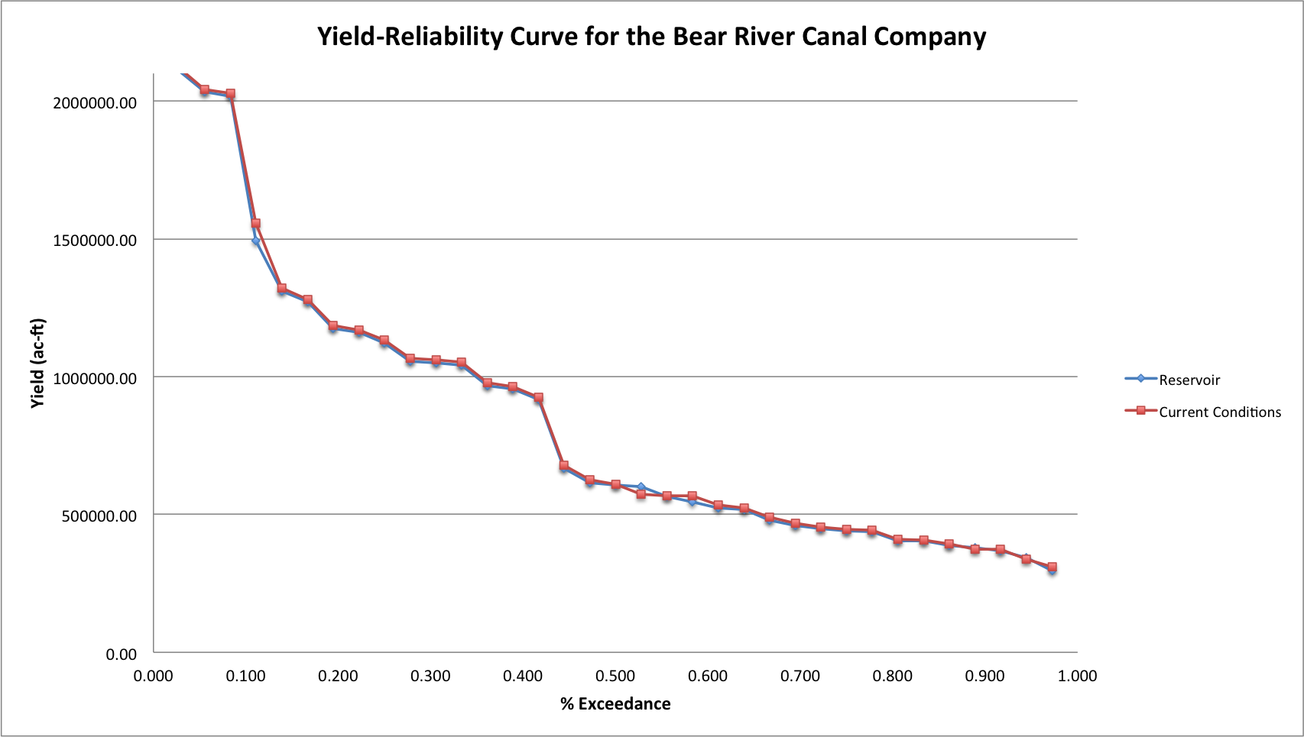

Figure 1. Yield-Reliability curves for the Bear River Canal Company with and without a new upstream reservoir.