Modeling of Structural and Non-Structural Approaches to Water Supply from the Bear River using WEAP

*ILO-5. River Basin Simulation with WEAP*

Written By:

Bryce Mihalevich

Prepared For:

David Rosenberg

CEE6490 – Integrated River Basins/

Watershed Planning and Management

March 15, 2016

**Introduction**

The evaluation of the water supply for multiple demand sites within a river basin to assess structural and non-structural management strategies may best be carried out at a regional scale. An effective method for evaluating complex river basins is with a model. The goal of this assessment was to evaluate water supplies from the Lower Bear River Basin (Figure 1, Appendix 1) to multiple user groups, therefore the Water Evaluation and Planning (WEAP) model was chosen (SEI, 2007). The WEAP model was used to test scenarios for performance metrics (Appendix 2) so that management approaches could be identified and recommended. As a result, I successfully set up and ran three scenarios using the WEAP model for the Lower Bear River Basin and provided recommendations for structural and non-structural approaches to water supply management.

**Methods**

Historical water flows and water use demands within the Lower Bear River Basin were provided to the class on Canvas (Rosenberg, 2016). The WEAP model was set up per the ILO-5 guidelines also provided on Canvas. The three scenarios tested included the current conditions, addition of an upstream reservoir, and a 10% reduction of urban water use within the river basin. The upstream reservoir operation rules were determined using the hedging results calculated in ILO-4. The performance metrics of the tested scenarios were calculated using MATLAB (Mihalevich, 2016). Questions asked during the WEAP model set up and execution are provided in Appendix 3.

**Results and Discussion**

The Bear River Canal Company (BRCC), Bear River Migratory Bird Refuge (BRMBR) and the Cache Valley New (CVN) sites were analyzed after running the WEAP model based on their location and respective priority levels. The three cases carried out with the WEAP model indicate that the reliability and resilience is on average greatest in the scenario of an upstream reservoir while vulnerability is lowest for the three chosen demand sites with the reference scenario (Table 1, Appendix 1). Of the demand sites, CVN had the greatest variability between the scenarios. This is likely due to it having the third lowest priority level of all the demand sites tested. Conversely, BRCC had the least amount of variability in performance metrics, which is likely due to having the highest priority level of all demand sites. Overall, it appear the 10% urban water use reduction had little positive effect on the simulations while the addition of a new reservoir significantly increased the performance metrics for nearly all sites. A scenario that could be recommended would be a agricultural water reduction of 10% to simulate higher efficiency irrigation.

**Conclusion**

This analysis shows that modeling is an effective method for evaluating complex river basins with multiple users. While these conclusions are based off of three conditions, using the model makes it easier for future implementation of water management recommendations. An example of this would be to go back and apply a 10% reduction to the agricultural users. Overall, the results of this assessment illustrate the performance metrics under three scenarios for several user groups within the Lower Bear River Basin.

**References**

Stockholm Environmental Institute (SEI) (2007). WEAP Water Evaluation and Planning

System User Guide for Version 3.2; (www.weap21.org).

Rosenberg, David (2016). LowerBearRiverData-Spring2016-strat.zip. Accessed from Utah State University Canvas for CEE 6490 - Integrated River Basins/ Watershed Planning and Management.

Mihaelvich, Bryce (2016). GitHub Repository for Water Resources CEE6490. https://github.com/brycemihal/water_resrouces_CEE6490/tree/master/ILO_5.

**Appendix 1: Figures and Tables**

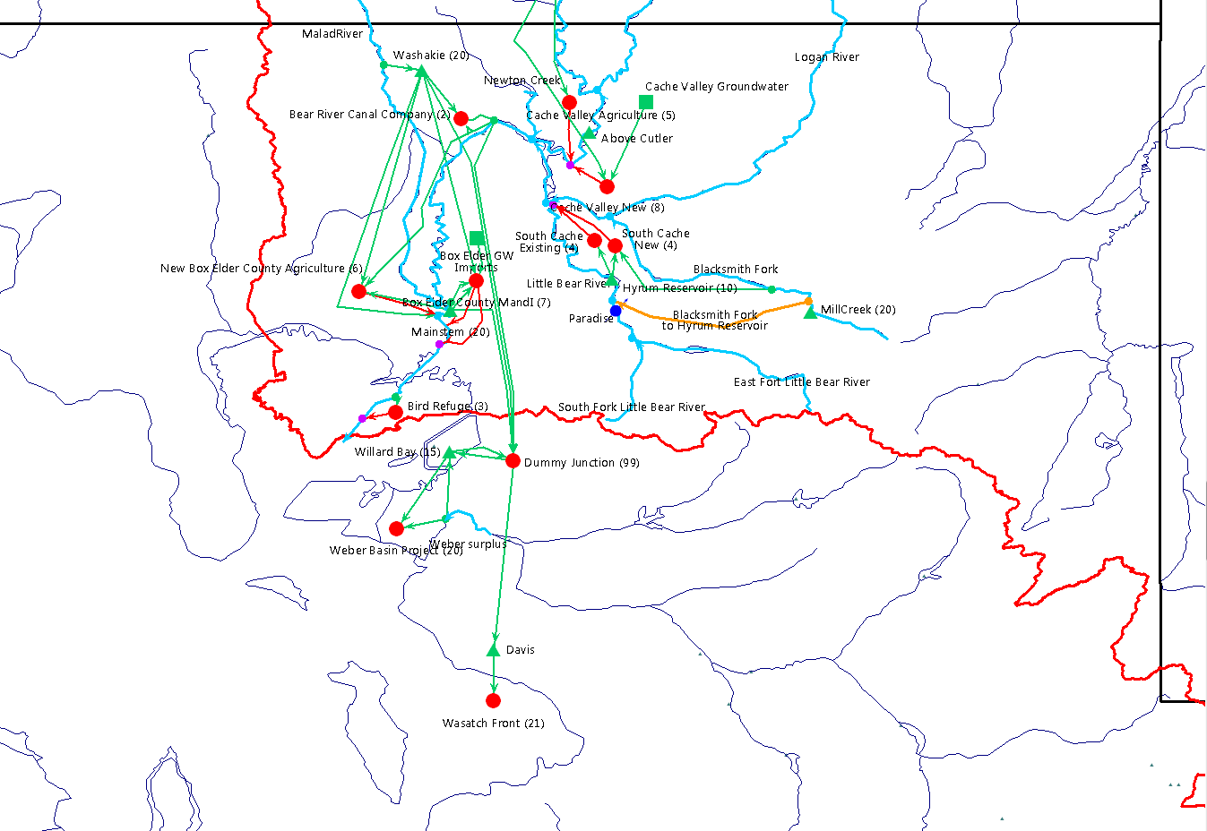

Figure 1. Scematic of the Lower Bear River Basin in the WEAP model.

Table 1. Comparison of the performance metrics for the three scenarios simulated in the WEAP Model at three demand sites.

|  |  |  |  |  |
| --- | --- | --- | --- | --- |
| **WEAP Scenario** | **Demand Site** | **Reliability (%)** | **Resilience (%)** | **Vulnerability (ft3)** |
| Reference | Bear River Canal Company | 97.76 | 54.55 | 711213341.74 |
| 10% Reduction | Bear River Canal Company | 97.76 | 54.55 | 711216552.17 |
| Reservoir | Bear River Canal Company | 97.97 | 60.00 | 782657713.30 |
| Reference | Bear River Migratory Bird Refuge | 76.83 | 23.68 | 1111022035.33 |
| 10% Reduction | Bear River Migratory Bird Refuge | 77.24 | 24.11 | 1061695389.21 |
| Reservoir | Bear River Migratory Bird Refuge | 82.72 | 29.41 | 1045117030.46 |
| Reference | Box Elder County M and I | 97.56 | 58.33 | 3584.44 |
| 10% Reduction | Box Elder County M and I | 79.88 | 27.27 | 3330.28 |
| Reservoir | Box Elder County M and I | 85.37 | 34.72 | 3671.74 |
| Reference | Cache Valley Agriculture | 97.56 | 50.00 | 14128.81 |
| 10% Reduction | Cache Valley Agriculture | 79.88 | 27.27 | 15652.60 |
| Reservoir | Cache Valley Agriculture | 85.37 | 34.72 | 15204.93 |
| Reference | Cache Valley New | 91.67 | 53.66 | 164575.82 |
| 10% Reduction | Cache Valley New | 77.64 | 24.55 | 219041.79 |
| Reservoir | Cache Valley New | 82.93 | 29.76 | 236358.12 |
| Reference | New Box Elder Agriculture | 98.17 | 66.67 | 14118.02 |
| 10% Reduction | New Box Elder Agriculture | 99.59 | 50.00 | 14178.84 |
| Reservoir | New Box Elder Agriculture | 99.59 | 50.00 | 14178.84 |
| Reference | South Cache Existing | 78.46 | 28.30 | 101338841.02 |
| 10% Reduction | South Cache Existing | 79.67 | 27.00 | 165505087.75 |
| Reservoir | South Cache Existing | 84.96 | 33.78 | 174477132.30 |
| Reference | South Cache New | 100.00 | 0.00 | NaN |
| 10% Reduction | South Cache New | 100.00 | 0.00 | NaN |
| Reservoir | South Cache New | 100.00 | 0.00 | NaN |
| Reference | Wasatch Front | 100.00 | 0.00 | NaN |
| 10% Reduction | Wasatch Front | 100.00 | 0.00 | NaN |
| Reservoir | Wasatch Front | 100.00 | 0.00 | NaN |
| Reference | Weber Basin Project | 2.44 | 0.21 | 139675401.27 |
| 10% Reduction | Weber Basin Project | 2.44 | 0.21 | 125913745.85 |
| Reservoir | Weber Basin Project | 2.44 | 0.21 | 139676565.33 |

**Appendix 2: Definitions of Performance Criteria Statistical Evaluations**

Adapted fromLoucks et. al., 2005 and CEE 6490 course notes.

Firm Yield – the maximum quantity of water that can be guaranteed during a critical dry period.

Reliability – the fraction of time the system is in a satisfactory condition. It is calculated as the number of observations or length of time that is unsatisfactory, divided by the total number of observations or length of time.

Resilience – the likelihood that system will return to the satisfactory condition after reaching an unsatisfactory state. It is calculated as the number of times a satisfactory value follows an unsatisfactory value divided by the number of times and unsatisfactory value occurred.

Vulnerability – is the magnitude of failure to be expected when the system reaches an unsatisfactory state. It is calculated as the sum of the positive value of the difference between the observed value and the target value, divided by the number of unsatisfactory observations.

**Appendix 3. WEAP Lab Exercise Questions**

*WEAP Resources, Installation, and Sample River Basins*

*3.a. How many headflows, reach gains, reservoirs, and aquifers are in the sample model?*

|  |  |
| --- | --- |
| Headflows | 3 |
| Reach Gains | 2 (weaping river) |
| Reservoirs | 2 |
| Aquifers | 2 |

*3.b. What is the data source for headflows for each river*

|  |  |
| --- | --- |
| Weaping River | .csv |
| Blue River | Monthly time series wizard |
| Green River | Monthly time series wizard |

*3.c. What menu options did you select to view water supplied to a demand site and shortages at a demand site (i.e., the difference between the actual delivery and the delivery target)?*

From the results tab I selected the following in the top drop down:

Demand -> Supply delivered

Demand -> Unmet demand

*The Lower Bear River Basin*

*Model Schematic*

*6.a. What reservoirs, demand sites, and other elements need to be added in WEAP?*

* Demand site Cache Valley New
* 2 transmission lines
* 1 return flow

*Data Entry*

*11.a. What Rivers has headflow data already been specified*

* QX41 - Blacksmith Fork
* QX61 - Malad River
* QX46 - Little Bear River
* QX77 - Weber Surplus

*11.a.2. What headflows need to be added to the WEAP model?*

* QX1 – Bear River

*11.a.3. Why? (not all rivers in the WEAP model will have head flows)*

Because some streams start from return flows that become local or tributary inflows that flow into a river

*12. To which reaches are the gains assigned*

Both are assigned to the Bear River reach

*15. What does a setting of 100% return flow routing mean?*

It indicates that 100% of the demand site outflow will return to the river.

*16.b.1. What type of operation (that you examined in ILO-4) does a buffer coefficient value of 1 represent?*

It represents a SLOP operation. If the buffer coefficient were closer to 0 it would reflect hedging operation.

*16.b.2. What was your reason for entering the Top of Inactive, Buffer, and Conservation Pool?*

The values chosen for these parameters were based on the hedging resulting in ILO-4. Top of Conservation was set up by the given reservoir capacity and flood pool season. The Top of Buffer was set to 15,000 ac-ft as this was the optimal storage solution for shortage costs. The Top of Inactive was set to 2000 ac-ft believing that an outlet level of 5ft above the bottom is reasonable.

*Model Results*

*20.a. Which demand site(s) have unmet demand (i.e., experience shortage(s))?*

Bear River Canal Company, Bird Refuge, Box Elder County MandI, Cache Valley Agriculture, Cache Valley New, New Box Elder County Agriculture, Wasatch Front, Weber Basin Project

*20.b. What is the reliability of annual deliveries to the Bear River Canal Company and*

*New Urban Users in Cache County? What is the reliability of annual deliveries to*

*the stakeholder your group is studying for the group project (if the stakeholder is*

*already included in the Lower Bear River model)?*

Bear River Canal Company: 97.76

Cache Valley New: 91.67

Bear River Migratory Bird Refuge: 76.83

*22.b. What data did you change?*

I changed the monthly demand of Box Elder County MandI, Weber Basin Project, South Cache Existing, and Cache Valley New. This was done by using expression builder and multiplying each series by 0.9.

*22.c.1 What are the answers to questions 20a,b*

*Which demand site(s) have unmet demand (i.e., experience shortage(s))?*

Bear River Canal Company, Bird Refuge, Box Elder County MandI, Cache Valley Agriculture, Cache Valley New, New Box Elder County Agriculture, Wasatch Front, Weber Basin Project

*What is the reliability of annual deliveries to the Bear River Canal Company and*

*New Urban Users in Cache County? What is the reliability of annual deliveries to*

*the stakeholder your group is studying for the group project (if the stakeholder is*

*already included in the Lower Bear River model)?*

Bear River Canal Company: 97.76

Cache Valley New: 77.64

Bear River Migratory Bird Refuge: 77.24

*22.c.2 How do results for this scenario change from the base case scenario?*

The performance metrics very with demand site when this scenario is implemented. Box Elder County M and I and Cache Valley New see decreases in reliability while agricultural sites increase reliability.

*23.1 What data did you change?*

I changed the Above Cutler reservoir capacity to 51,342 ac-ft. I added operation rules as described in question *16.b.2.*

*What are the answers to questions 20a,b above?*

*Which demand site(s) have unmet demand (i.e., experience shortage(s))?*

Bear River Canal Company, Bird Refuge, Box Elder County MandI, Cache Valley Agriculture, Cache Valley New, New Box Elder County Agriculture, Wasatch Front, Weber Basin Project

*What is the reliability of annual deliveries to the Bear River Canal Company and*

*New Urban Users in Cache County? What is the reliability of annual deliveries to*

*the stakeholder your group is studying for the group project (if the stakeholder is*

*already included in the Lower Bear River model)?*

Bear River Canal Company: 97.97

Cache Valley New: 82.93

Bear River Migratory Bird Refuge: 82.74

*24. What changes will you need to make to the WEAP model for the Lower Bear River basin to represent the stakeholder you are studying for your semester group project?*

We will need to incorporate our structural and non-structural scenarios, some of which will have very little change on the model (BRMBR project)