Simulation of Pareto-optimal solution for Stakeholders of Lake Maggiore

*ILO-6. Multi-Objective Optimization and Visualization*

Written By:

Bryce Mihalevich

Prepared For:

David Rosenberg

CEE6490 – Integrated River Basins/

Watershed Planning and Management

March 22, 2016

**Introduction**

The management of water resources is heavily influenced by the objectives of associated stakeholders. However, it is common that not all stakeholder objectives align with one another’s and therefore tradeoffs must be made to accommodate respective stakeholders. One method of resolving these objective conflicts is by using Pareto optimality and multi-dimensional data visualization (MDDV) and analysis tools. These tools were used in this assessment to simulate four stakeholders, flood protection, irrigation, hydropower, and recreation of Lake Maggiore, Italy, and three reservoir operation rules. This report demonstrate that MDDV software can be used to describe Pareto optimal surfaces and provides reservoir operation recommendations that reasonably balance the objectives of the four stakeholders.

**Methods**

Performance indicators and decision variables were provided to students as a .csv file obtainable from Canvas (Rosenburg, 2016). Data was loaded into a MDDV software called DiscoveryDV (DecisionVis LLC, 2014). Using this software, the data was explored by changing the dimension variables and performing a Pareto sort of the results. Marking was used to visualize the minimal points of a performance indicator against decision variable (Figure 1, Appendix 1). Since irrigation and hydropower share performance indicators (Figure 2, Appendix 1) only one was evaluated. Once each performance indicator was marked for each decision variable a 3D plot was created using flood, irrigation, and recreation indicators (Figure 3, Appendix 1) and used to make a reservoir operation recommendation. Lab exercise questions are provided in Appendix 2.

**Results and Discussion**

The Pareto optimal surface plot used to make recommendations had an ideal point at the minimum value of each performance indicator (Figure 4, Appendix 1). As points move away from the ideal point, associated tradeoffs become greater for a particular stakeholder, depending on the direction. Analysis of the data after Pareto sorting and marking optimal points, revealed a viable solution of the three decision variables (x1: 0.699; x2: 68; x3: 0.667). The stakeholder tradeoffs from this recommendation are 2.61 m, 10.46 m3/d, 10.46 m3/d, and 5.23 m3 for average flood intensity, unmet hydropower demand, unmet irrigation demand, and average storage deficit, respectively. While this solution was chosen from many Pareto optimal points, this option provides minimal tradeoffs to many of the stakeholders. The values represent a tradeoff of 10.82%, 9.29%, 9.29% and 45.48%, respectively, above the minimum values of each performance indicator. I believe that this solution is acceptable because it considers essential demands such as food availability, power, and safety highest. Other potential solutions were explored but none seemed to provide as low of tradeoffs in flood protection, irrigation, and hydropower while having a relatively low recreation deficit.

**Conclusion**

Pareto optimality allows for the resolution of satisfying multiple objective conflicts. The use of visualization and analysis software enhances ones ability to determine which Pareto optimal point provides the most balanced solution. The solution chosen in this assessment represents one that favors food, power, and safety. While other solutions provided lower storage deficits, the essential objectives incurred tradeoffs. Overall, this report demonstrates how Pareto optimality can help in making management decisions regarding water resources.

**References**

Rosenberg, David (2016). HW06_alts.csv. Accessed from Utah State University Canvas for CEE 6490 - Integrated River Basins/ Watershed Planning and Management.

DecisionVis LLC (2014). DiscoveryDV, Version 0.42. Accessed from https://www.decisionvis.com/

Mihaelvich, Bryce (2016). GitHub Repository for Water Resources CEE6490. https://github.com/brycemihal/water_resrouces_CEE6490/tree/master/ILO_6.

**Appendix 1: Figures**

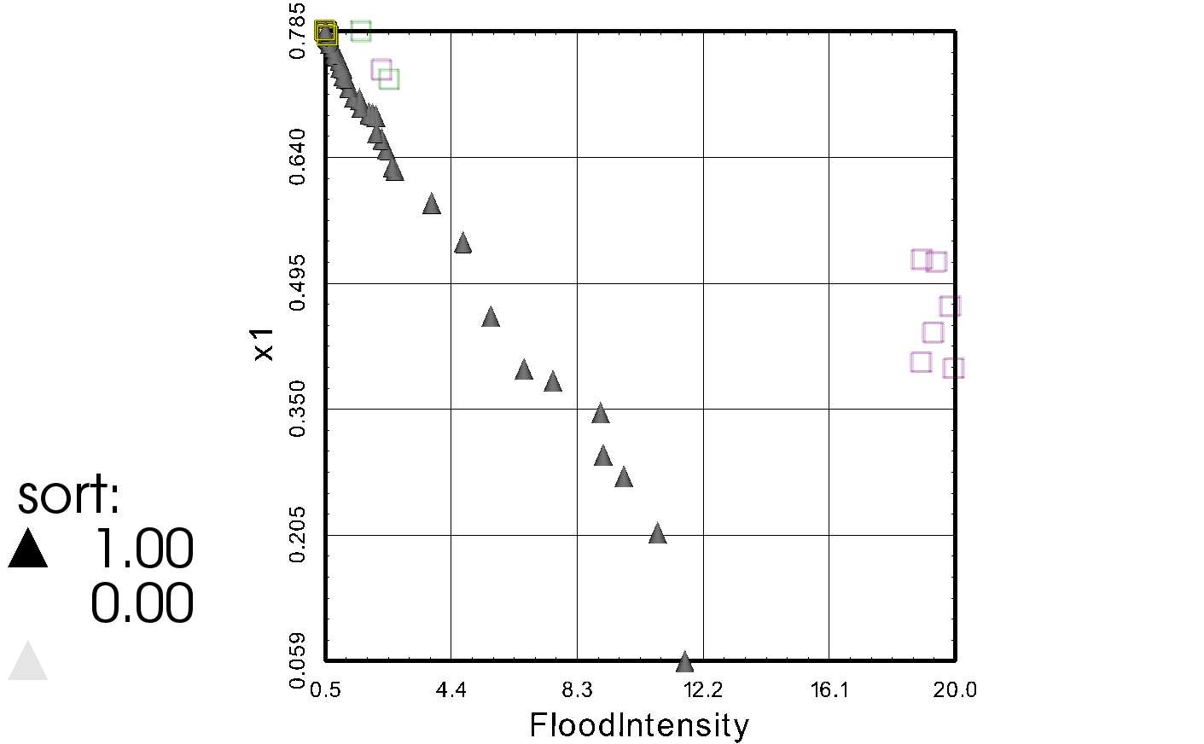

Figure 1. Illustration of marking optimal points (squares) of flood intensity for the first decision variable.

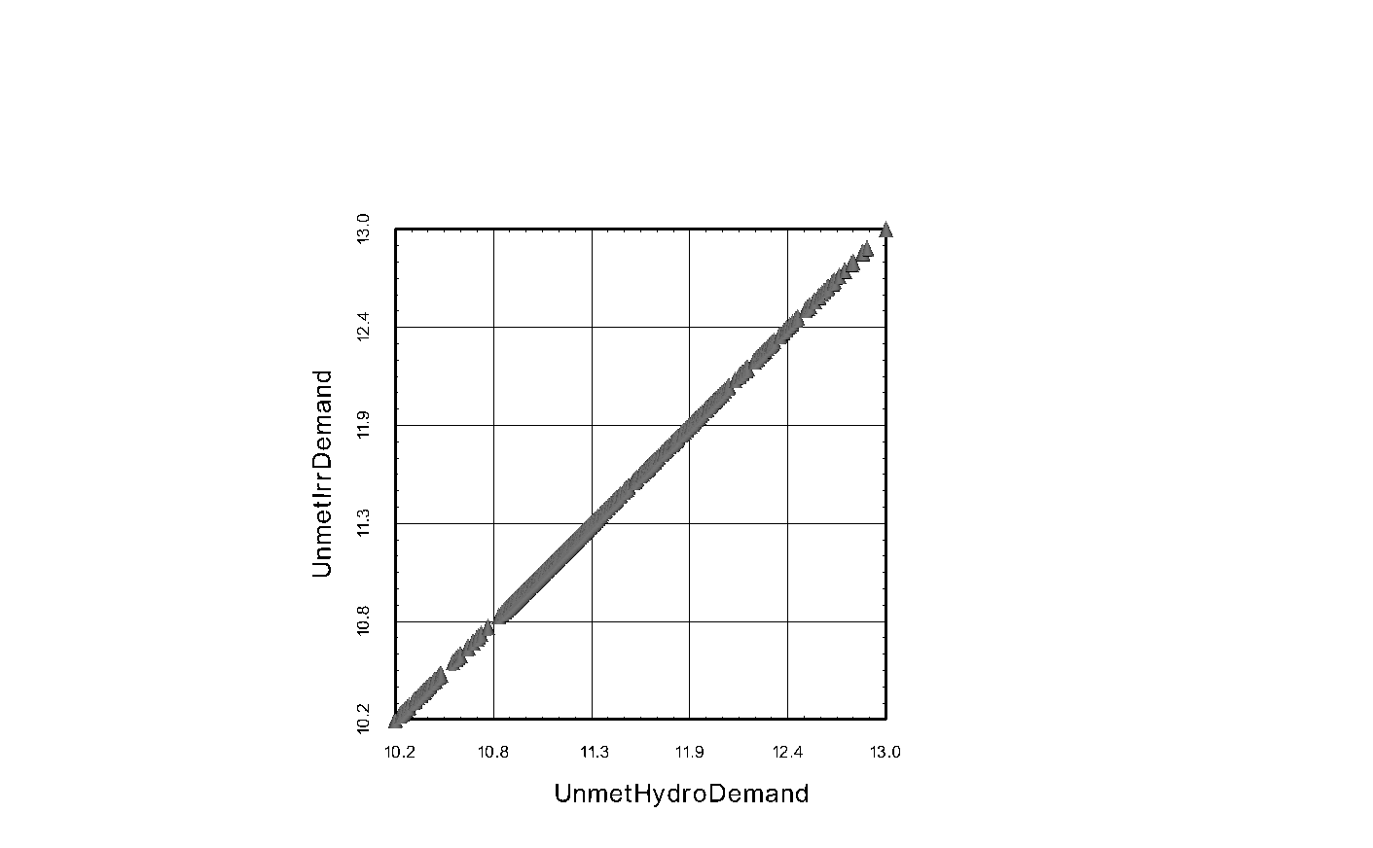

Figure 2. Illustration of the one-to-one ratio for unmet irrigation demand and unmet hydropower demand

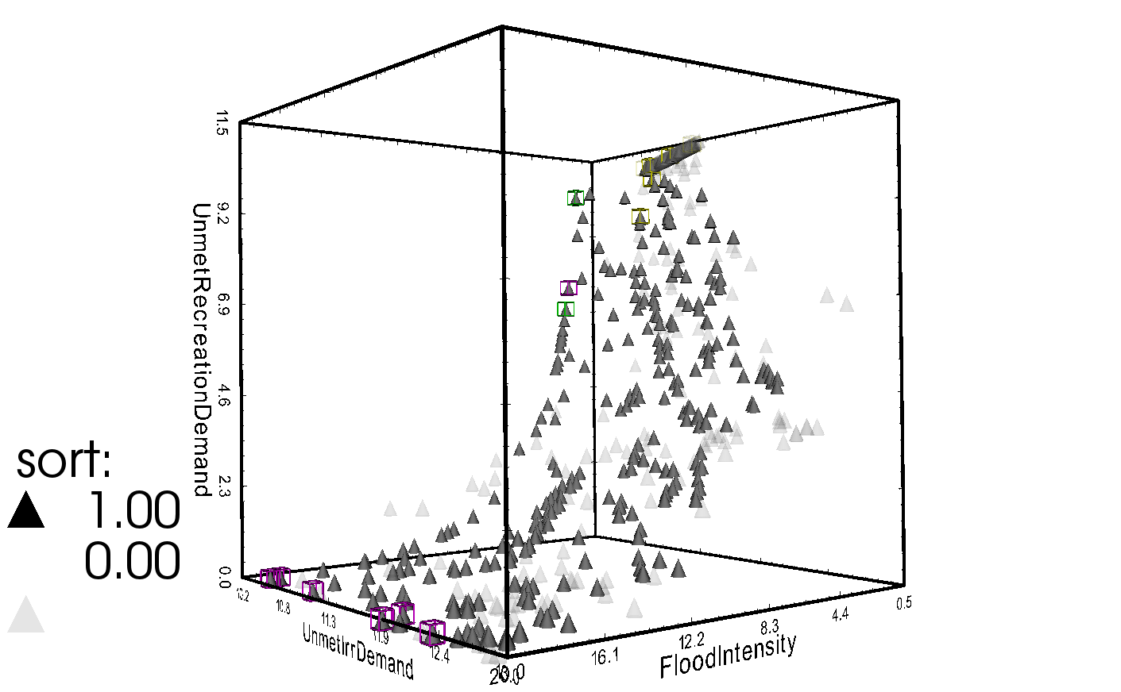

Figure 3. Five dimension plot including three performance indicators, a Pareto sort, and marked points used to determine the optimal solution.

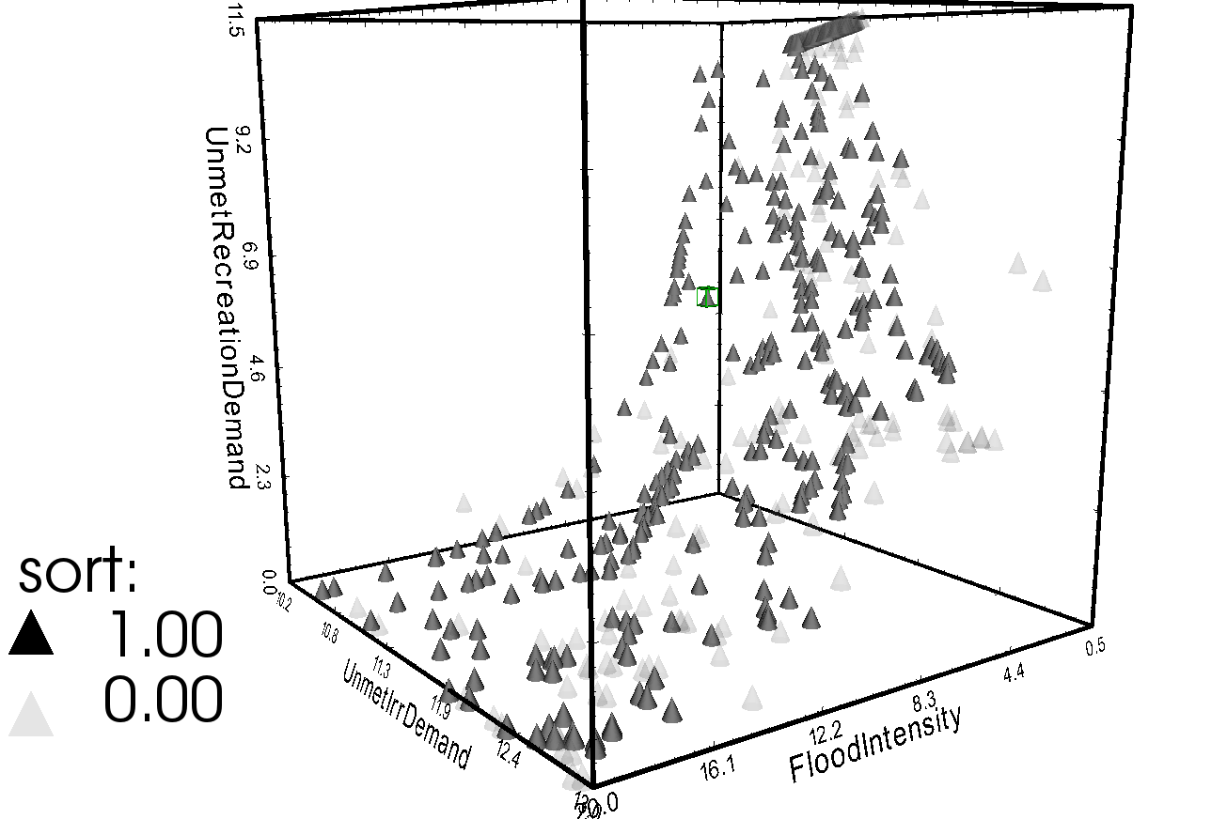

Figure 4. Five dimensional plot with the recommend reservoir operation solution marked.

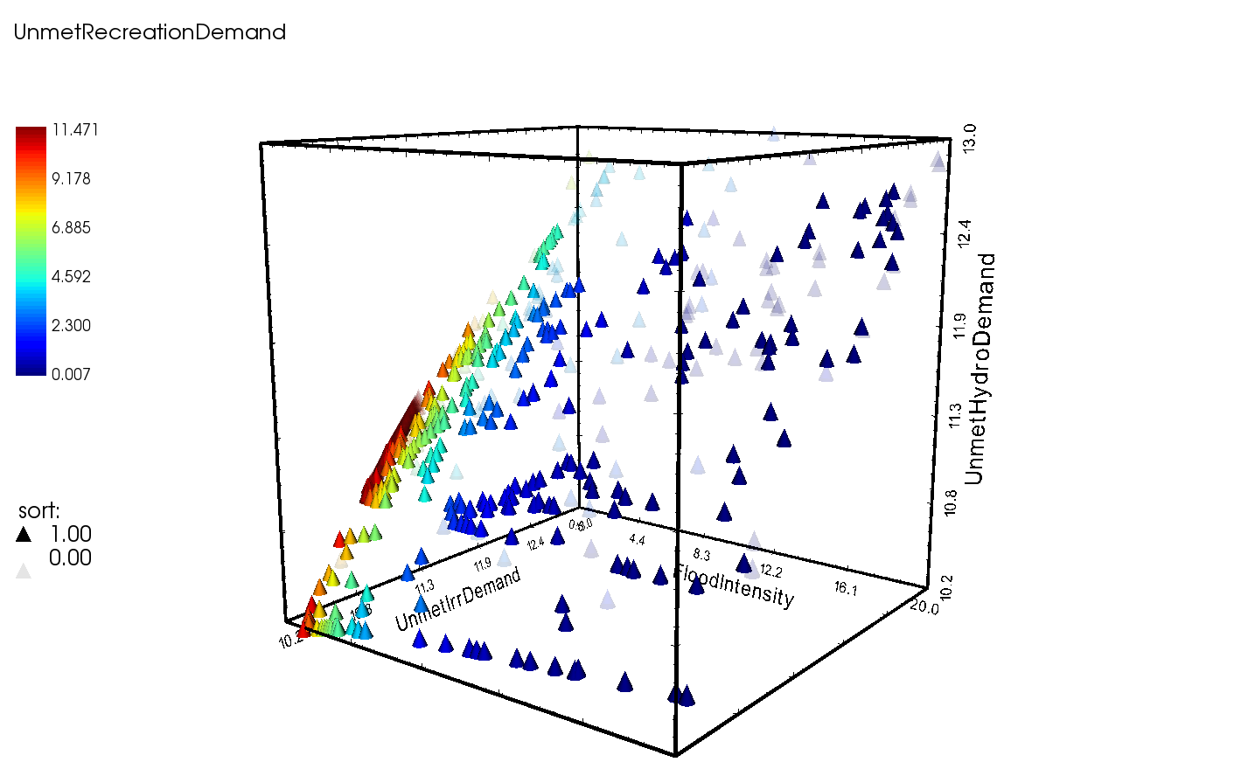

Figure 5. Illustration of the four performance indicators after a Pareto sort.

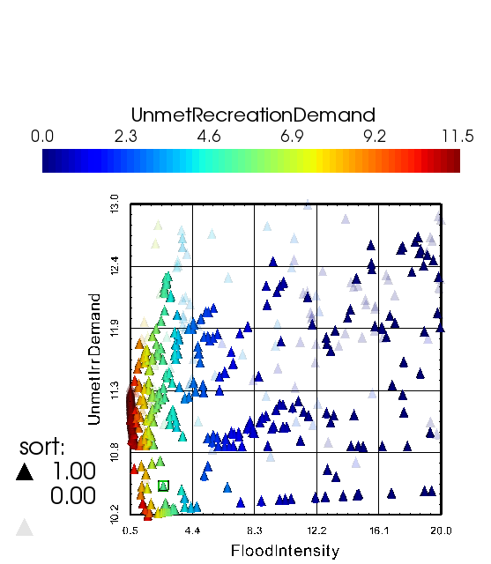

Figure 6. Illustration of Figure 5, where the repetitive performance indicator of hydropower has been removed.

**Appendix 2: ILO – 6 Lab Exercise Questions**

*1.d.iii.a How many visualization dimensions (i.e., objectives) can the software represent?*

Discovery DV can illustrate up to 11 dimensions.

*1.d.iii.b How many dimensions is the Lake Maggorie data set?*

The Lake Maggorie data set contains 7 dimensions.

*1.e. What is the relationship between these two objectives?*

For x: FloodIntensity and y: UnmetIrrDemand there is a week correlation between lower flood intensity and less unmet irrigation demand.

For x: UnmetHydroDemand and y: UnmetIrrDemand there a positive one-to-one relationship.

*2.b. Is there just one optimal point or many, composing a Pareto front?*

For all solutions there are many points included in the Pareto sort, representing the Pareto front. These represent the potential solutions considering respective tradeoffs.

*3. Record your observations.*

The 3D five dimension plot with the performance indicators listed in the lab guidelines creates a Pareto solution around the spatial ideal point located at the bottom right corner with low to high recreation benefit depicted with red to blue markers, respectively (Figure 5). Since irrigation and hydropower demand are a one-to-one ratio this plot could be simplified with only one of these performance indicators resulting in a 2D plot with one less dimension (Figure 6).

*Note*: Data files and full resolution figures can be found at my GitHub site (Mihalevich, 2016).