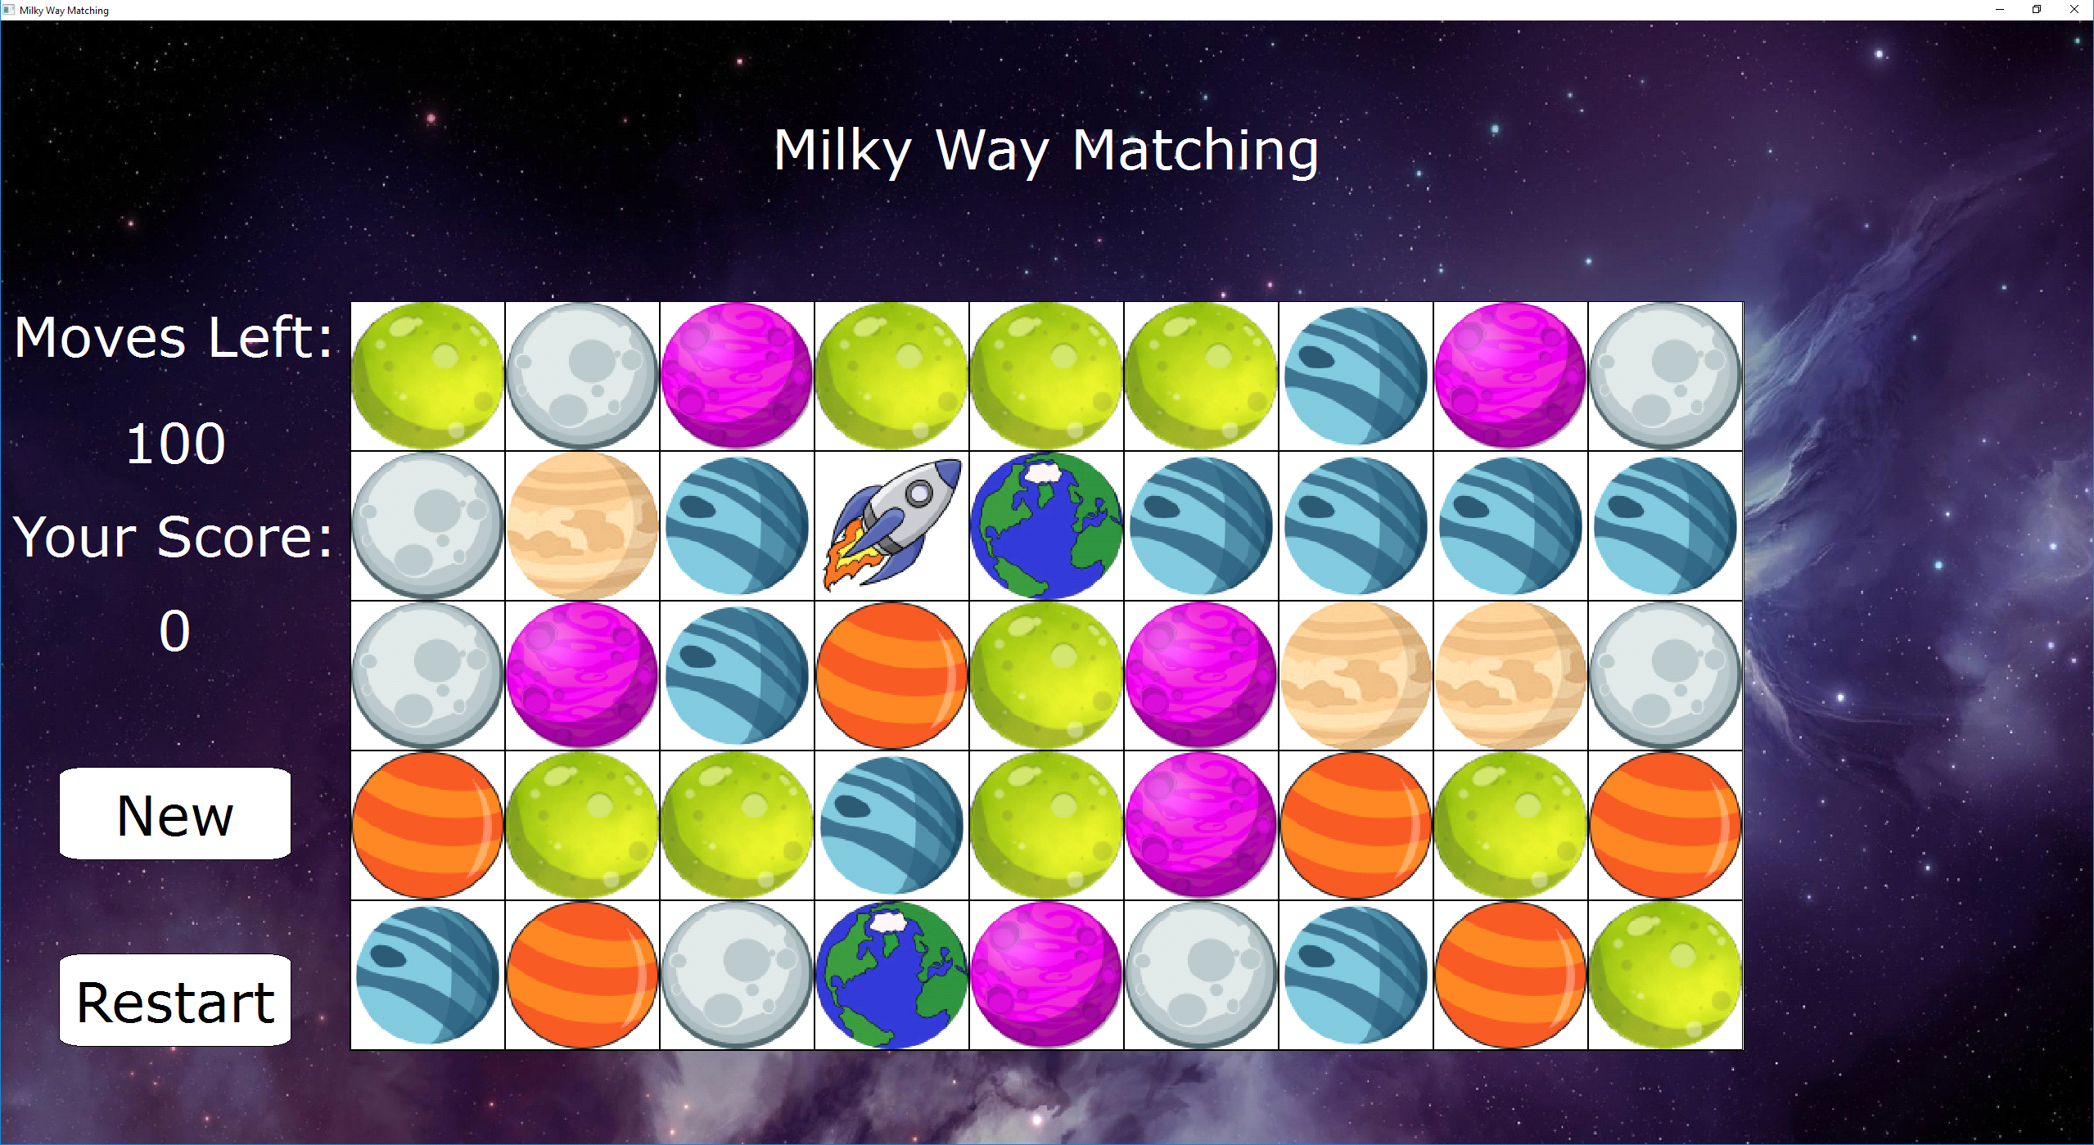

Milky Way Matching

You play as a lone astronaut flying through the galaxy collecting data samples from different planets. Once you have collected samples from three similar planets, you will blow them up and move on to the next planet.

The goal of this game is to accumulate points by creating tile matches. A match is defined as 3 or more adjacent tiles of the same planet in a row or column. Use the arrow keys or the 'w', 'a', 's', and 'd' keys to move the Rocket Ship to create matches and collect points.

When the Rocket Ship moves, it swaps its space with that of an adjacent tile.

Once you run out of moves, the game is over.

Scoring: Each tile in a match is worth 1 point.

How many points can you accumulate in 100 moves? Can you join the ranks of the top five scorers?