Dominic Delmolino Project 2 – Proposal Document

Sarah Kelly INFO W18 – Python Bridge 2

Andrea Pope

### Objective:

Our project will analyze data provided by the World Health Organization (WHO). Our analysis will explore life expectancy for various countries over different time periods and dive into various factors to determine their impact, if any, on life expectancy. Those factors include environmental factors, HIV prevalence, how health services are provided (government vs private) and aid provided to countries.

### Data:

Each section below describes the data sets included in our project. The appendix includes specific column names from each data set.

##### Life Expectancy:

***Overview:*** The life expectancy data set looks at life expectancy at birth and at age 60, for both males and females in 194 countries, for the years 1999, 2000, 2012, and 2013. The data set also includes Healthy Life Expectancy (HALE) at birth. This measure takes into account degraded health due to disease or injury. HALE numbers are only available for 2000, 2012, and 2013.

***Data source:***<http://apps.who.int/gho/data/node.main.3?lang=en>

***Total rows:*** 776 ***Total Columns:*** 10

***Planned Analysis:*** This data set will be used as the baseline on which we compare the other factors.

Within this file, introductory analysis will review male vs. female life expectancy, and a detailed comparison by country, noting outliers. A final analysis on this file will look at life expectancy at birth, vs at age 60, and highlight those countries with the biggest discrepancies.

***Initial Analysis***

As our primary data set, some initial analysis has been completed. 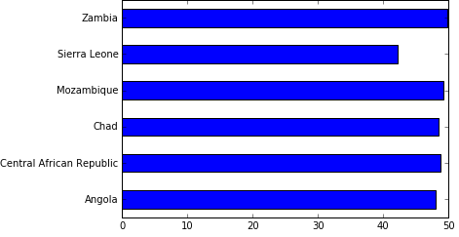

1. Life expectancy for both sexes ranges from a low of 38 years to a high of 87 years.
2. Countries where the expected life expectancy at birth (both sexes) is less than 50:
3. Countries where the expected life expectancy at birth (both sexes) is greater than 80: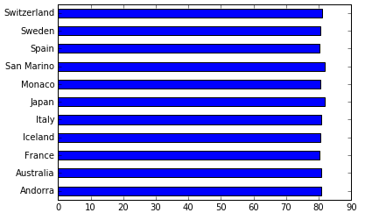
4. Normal distribution of HALE for both sexes.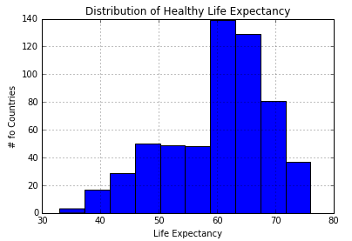

##### 

##### 

##### 

##### 

##### Environmental Factors (Hygiene):

***Overview:***  Access to improved drinking water and improved sanitation facilities has data for 192 countries and 3 sample years (1990,2000,2015) for Rural, Urban and Total populations as a percentage.

***Source:*** http://apps.who.int/gho/data/node.main.167?lang=en

***Total records:*** 558 ***Total Columns:*** 7

***Planned Analysis:*** For analysis in hygiene and sanitary conditions, we will check if life expectancy of the total population has any significant correlation with sanitary access for the different populations. To do this, we will look at Country, Population (Rural, Urban, Total) and data from 1990 & 2000 (as it matches up to the Life Expectancy). Our initial hypothesis is that countries with higher percentage of access will have higher life expectancy. Within the file itself, we will compare rural vs urban improvement over time.

##### HIV:

***Overview:***  This data provides HIV prevalence statistics for 158 countries for 2001, 2005, 2009, and 2013. We will match up data as closely to Life Expectancy dates as possible (2001 with 2000 and 2013 with 2013/2015). In practice, the HIV prevalence does not shift extraordinarily rapidly.

***Source:***<http://apps.who.int/gho/data/node.main.622?lang=en>

***Total rows:*** 158 ***Total Columns:*** 5

***Planned Analysis:*** Overall, we will analyze the prevalence of HIV and life expectancy.

Within the file itself, we will review changes over time between 2000 and 2015 and at the distribution of HIV across countries.

##### Healthcare Services:

***Overview:***  This data provides indicators of the % of GDP spent on healthcare for 191 countries for the years 2013, 2012, and 2000. Additional indicators include the type of healthcare spending (government, private, out of pocket).

***Source:*** http://apps.who.int/gho/data/node.main.75?lang=en.

***Total Rows:*** 191 ***Total Columns:*** 13

**Planned Analysis:** Overall, we will analyze how health care spending relates to life expectancy. We will explore the distribution of healthcare spending as a % of GDP and the cross national differences between government and private spending. Finally, we will compare health care spending patterns with countries with high HIV prevalence.

##### Aid – Commitments and Disbursement:

***Overview:***  This data set documents aid committed and disbursed to 119 different countries between the years 2000 and 2010.

***Source:*** http://apps.who.int/gho/data/node.main.A1626?lang=en

***Total rows:*** 1295 ***Total columns:*** 3

***Planned Analysis:*** Initial analysis will look at the difference between commitments and disbursements by country. Additionally, we will review the distribution of aid, and highlight those receiving the most, the least, and how those numbers have changed over time. Finally, we will analyze aid with life expectancy, and determine if there is a noticeable effect over time, after receiving aid.

### 

### Appendix:

#### Columns for each data source:

Life Expectancy Columns:

Country; Year

Life expectancy at birth (years); Both sexes

Life expectancy at birth (years); Female

Life expectancy at birth (years); Male

Life expectancy at age 60 (years); Both sexes

Life expectancy at age 60 (years); Female

Life expectancy at age 60 (years); Male

Healthy life expectancy (HALE) at birth (years); Both sexes

Healthy life expectancy (HALE) at birth (years); Female

Healthy life expectancy (HALE) at birth (years); Male

*Initial manipulation: The first column naturally splits into 2 separate columns, one for Country and Year.*

Environmental Factors (Hygiene) Columns:

Country; Year

Access to Clean Drinking Water (rural)

Access to Clean Drinking Water (urban)

Access to Clean Drinking Water (total)

Access to Improved Sanitation Facilities (rural)

Access to Improved Sanitation Facilities (urban)

Access to Improved Sanitation Facilities (total)

*Initial manipulation: The first column naturally splits into 2 separate columns, one for Country and Year.*

HIV Columns:

Country

HIV prevalence 2001

HIV prevalence 2005

HIV prevalence 2009

HIV prevalence 2013

Healthcare Services (applicable) Columns:

Country

Total expenditure on health as a percentage of gross domestic product 2013

General government expenditure on health as a percentage of total expenditure on health 2013

Private expenditure on health as a percentage of total expenditure on health 2013

Out-of-pocket expenditure as a percentage of total expenditure on health 2013

Total expenditure on health as a percentage of gross domestic product 2012

General government expenditure on health as a percentage of total expenditure on health 2012

Private expenditure on health as a percentage of total expenditure on health 2012

Out-of-pocket expenditure as a percentage of total expenditure on health 2012

Total expenditure on health as a percentage of gross domestic product 2000

General government expenditure on health as a percentage of total expenditure on health 2000

Private expenditure on health as a percentage of total expenditure on health 2000

Out-of-pocket expenditure as a percentage of total expenditure on health 2000

Aid – Commitments and Disbursement Columns:

Country; Year

Commitments to recipient countries (Million, constant 2009 US$

Disbursements to recipient countries (Million, constant 2009 US$

*Initial manipulation: The first column naturally splits into 2 separate columns, one for Country and Year.*