**C# CustomList<T> - Operator**

**DEFINITION:** Removes any occurrences of items inherent in selected list B from designated list A.

C#:

List1 = new CustomList<int>(){1, 3, 5};

List2 = new CustomList<int>(){2, 1, 6};

List3 = List1 – List2; //list3 contains {3, 5}

**EXAMPLES:**

**The following example demonstrates how to use the overloaded – operator in a simple test definition.**

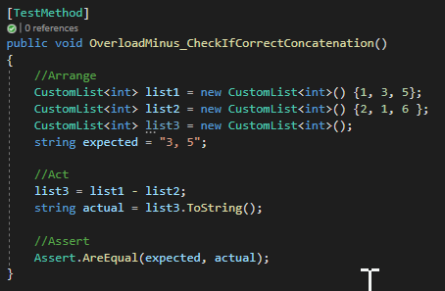

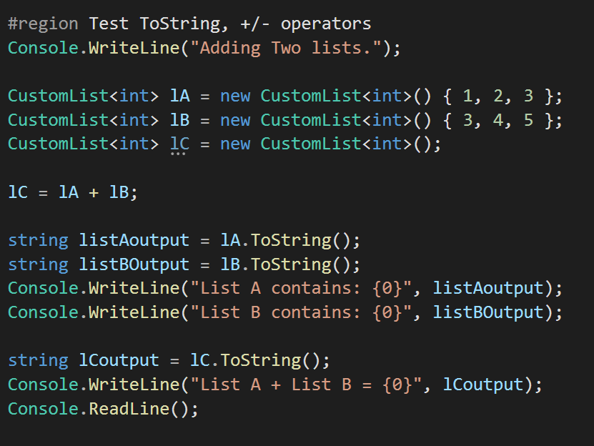**Example 2 – The – operator used for a simple output.**

**REMARKS:**

The – operator is overloaded in this method. This does not implement any interfaces, and overloads to be able to subtract one CustomList of type T from another.