Lab Book – Michelson Interferometer

Bryden Fogelman - 36294130

James Wasteneys – 34140137

DISCLAIMER: We had issues with our motor on the second lab and we were unable to retrieve any data that day. As a result some components of the lab are missing due to the fact that we had a very limited time to collect all the data. We focused on obtaining good data for the ZPL, coherence length, wavelength difference and Fourier spectroscopy.

**MON FEB 5, 2018**

Task List

In the first lab we will first play around the equipment and gain familiarity. We will try and perform some easy components of the lab as well.

* Find Fringes – this is pretty straight forward as we know what were are looking for. An important part of this is to make sure the mirrors are aligned. We will use the “metal post” that can be screwed into the mirror to do this.
* Determine the calibration constant – Find the actual position the motor moves by setting up horizontal fringes with the HeNe laser and counting them.

Finding Fringes

Questions:

Q: Justify why you can model an interferometer you are using in the lab as two point sources?

Interference occurs when two waves are added together. The interferometer splits the wave and causes them to be added together which will clearly lead to interference. Relative to the wavelength, the distance are very large so the light behaves like planes, with this assumption we can simplify the model by two point sources being added together.

Q: Derive an expression for the total intensity I.

The following equation from Steck corresponds to the total intensity of two monochromatic waves added together.

$$I=I_{1}+I_{2}+2\sqrt{I_{1}I_{2}}cos⁡(ϕ_{2}-ϕ_{1})$$

Simplifying the above to have the two intensities equal and subbing in for the angles we get the following expression:

$$I=I_{0}\left(1+\cos\left(\frac{2πnd}{λ}\right)\right)$$

Q: Describe how the intensity on the axis varies with d.

Cosine is bounded between -1 and 1 so as we vary d the intensity will change from perfectly constructive 2I to 0. We should also see the pattern repeat itself as cosine is periodic.

With this information we know that as we vary the stage position in one direction, at some point we should see fringes.

Observations/Procedure:

* Setup the beam splitter to direct a portion of the beam to the first mirror while another portion was directed to the second mirror
* Placed in the compensator in the reflected leg of the mirror, to compensate for the path length difference due to the index of refraction (the reflective portion of the beam splitter is at the front, therefore by using the compensator they travel through the same distance of glass)
* We found that fringes are a very sensitive to vibration, tapping the table causes them to move
* We noticed when changing the distance of the laser the fringe pattern was moving as expected

We were able to find the following fringe patterns given in the images below.

Centre Images (the location of maximum diffraction):

centreFringe_feb5_319.jpg

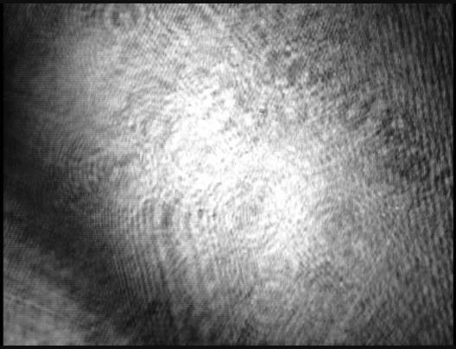

Curved Fringes:

curvedFringe_feb5_330.jpg

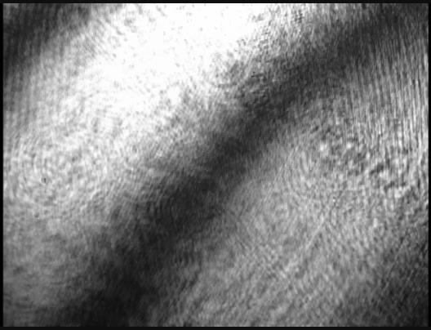

Horizontal Fringes:

horizontalFringe_feb5_320.jpg

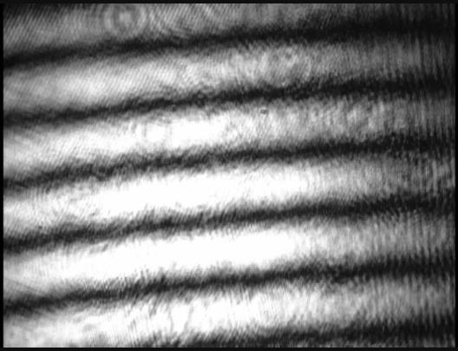

Calibration

Questions:

Q: Do you think the stage will move exactly to the position that you specify?

No because the laser is being moved with a stepper motor servo the distance can only change at discrete steps. If the stepper has incorporated micro stepping it can become more accurate but there is still a control loop that may not be fully accurate.

Q: What does it mean to calibrate the translation stage? What two pieces of information do you need to find the calibration factor?

Since the stage does not move as we expect due to backlash, we are trying to find the true position given the position we specified. To determine the calibration factor we need the wavelength (since we will be measuring fringes) and the distance we've travelled. The calibration is the ratio between the two.

Q: What distance does the mirror need to move such that one fringe passes a reference point on the CCD camera

The fringes appear every half wavelength so the mirror will need to move at least this distance for one fringe to pass.

Observations/Procedure:

* Opened the script called “*michelson_timestream.m*” and ran the command “data = michelson_timestream(0.01, 0.001);”
  + We were then prompted to select a pixel location, we tried to select a location that was not that saturated but still had enough information to see the fringes move
* We tried a range of spans and speeds
  + Faster speed usually isn't better, found that we had errors when we were too slow
  + Started with about 10 fringes and decided to try only 5 since we would see more movement as we changed the position of the laser

Data:

We recorded the movement of the fringes using *michelson_timestream.m*. We recorded the span and speed that we took the data at in the filename (span then speed).

span = 0.01, speed = 0.001 - tseries_0_01-0_001_feb5-358.mat

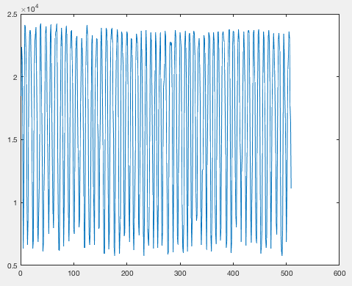

span = 0.1, speed = 0.001 - tseries_0_05-0_001_feb5-405.mat

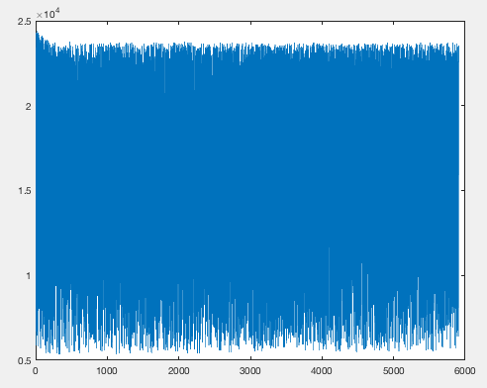

*Because we’ve increased the span and slowed down the speed we have much less data and much less risk to alias.*

span = 0.05, speed = 0.001 - tseries_0_05-0_001_feb5-433.mat

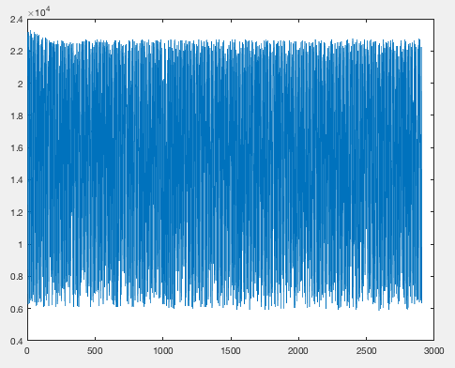

Results:

The following code was used to determine the calibration constant. To determine the number of fringes that have passed we determined the number of “zero crossings”. A sample plot of how the zero crossing was determined in given in the figure below.

Matlab Script (script used to determine the calibration constant):

zeroCrossingCode_feb5_418.m

%find zero crossings

zc = data > mean(data) & circshift(data,1)<mean(data) | data < mean(data)...

& circshift(data,1)>mean(data);

figure

plot(data(1:50)/max(data),'kx-');

hold on;

plot(zc(1:50)*mean(data)/max(data),'o')

lambda = 632.8e-9;

D = 20e-6;

K = lambda*sum(zc)/2/2/D;

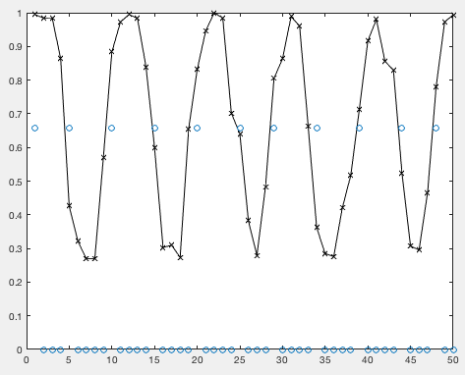

*Notice how the waveform is not perfectly sinusoidal, this is probably a result of the sampling as our rate is pretty small. Also any backlash in the motor could cause the weird jumps present.*

We found the calibration constant to be the following:

The average of the above three datasets was used as the value of the calibration constant. The uncertainty was the standard deviation of all three trials.

K = 0.95 +- 0.07

**MON FEB 26, 2018**

Task List:

This lab section we want to try and determine the coherence length of sodium and the white light. While doing this we should also be able to determine the ZPL. We can also determine the wavelength difference of sodium using the same data.

* Coherence Length – We can determine this by using the *michelson_timstream* code and measuring the intensity of a specific spot. We will determine the coherence length in the following order as it is easiest to determine the ZPL (and coherence length) in this way.
  + Sodium Light
  + White Light with orange filter
  + White Light
* Try and find the ZPL for sodium lamp and white light – The location of the ZPL is the center of the “pulse” with the highest intensity. We can determine this directly from the data received above
* Attempt to determine the wavelength difference of sodium – Using the same data, we can also determine the wavelength difference between the D1 and D2 lines of sodium.

Determining Wavelength of Sodium

Questions:

Q: What speed and span would be reasonable to use to measure the wave-length and the wavelength difference?

A fringe will appear each half wavelength so if we what at least two samples per frame at 30 FPS we need to move at least 0.01 mm/s as seen in the calculation below (input 0.01 as the input speed to michelson_timestream).

$$30\frac{frames}{s}*\frac{λ}{fringe}*\frac{fringe}{2 frames}≅10 μm/s$$

Procedure:

* Placed sodium lamp in front of the laser, then put the diffuser in front of the sodium lamp
* We used the lens to collimate the light from the sodium lamp
* We placed on the aperture changing component for the camera on and used the metal post in the mirror to align the two beams

Results:

Q: Determine the average wave length of the two sodium lines.

Expected Result: 589.3 nm

Actual Result: 560 +- 40 nm

This was calculated as follows:

wavelength = 4*span*K/numPeaks;

where:

K = calibration constant

numPeaks = total number of fringes

span = half the distance the stage reported translating

Q: Measure the difference in the wavelength between the D1 and D2 line.

This can be found from the beat frequency observed. We can calculated the difference in wavelength using:

$\delta \lambda = \lambda^2/(2d)$

Where: d = the average distance translated by the stage between beats

Expected Result: 0.6nm

Actual Result: 0.57 +- 0.05nm

Q: Compute the wavelength of the D1 and D2 lines and compare with known values.

D1 and D2 are the same to within our precision (560nm,

Know Values: 589.0 and 589.6 nm

ZPL/Coherence Length

The strategy for this section is to use the *michelson_timstream* code to record the intensity of a certain area on the screen. What we want to see is pulses of high and low with the overall intensity decreasing (an envelope).

We had issues this lab with the motor. Throughout the lab we would receive errors that the “motor was not found”. We had brought in TA to assist but the problems resolved itself randomly. It would continue to cycle between working and not working for 2 hours of the lab.

Due to time restrictions, the focus of the next lab will be to find the ZPL for the sodium lamp and white light.

**MON MAR 5, 2018**

Motor Issues

We were eventually able to resolve issues by a combination of weird techniques. We decided to record them for the benefit of the TA for whoever has the lab next. We are unsure of the root cause of the errors but found some fixes that seemed to work.

* “Wrong number of motors connected”: For some reason the computer is recognizing that the motor was connected, for some reason running “motor_op(0, ‘init’)” seems to solve the issues and the code has no problem working after. It may be because the motor was not properly cleaned up after a failed attempt of the script.
* “Errors with video capture”: In some cases the script will close before completing and the video clean up code will not run. Resetting Matlab is probably the easiest solution to this bug.

Task List

Due to time constraints (caused by previous motor issues) we will skip the section on the Index of Refraction of Air and focus on retrieving good data for the coherence length and ZPL (which will also be used for the Fourier spectroscopy component of the lab.

* The task list is the same as the previous lab as we were not able to accomplish much in the previous lab due to errors.

ZPL/Coherence

* Trying again to find the Coherence Light of Sodium
* Our strategy is to use the *michelson_timestream* code and record the intensity of a pixel over a large range
* We manually find using the jog function of the motor what appears to be the ZPL (highest intensity fringes)
* Next we run the code of +- 3mm, this will save the intensity of a small area
* With this we should see an envelope where the overall intensity slowly decays, we then try and fit this
* Our first rough attempt of this gave us a coherence length of 3mm with large error
* An issue we determined that was causing issues with our previous dataset was the speed at which we were moving

Next we need to try and find the ZPL

* The ZPL is the local maximum
* Using the data from the michelson_timestream code, the ZPL should occur at wherever the max is within this data

Data:

In general, we found a systematic error in all of our results that the interference pattern on the right of the plot appeared to have a smaller intensity then the left. We were unable to determine the cause of this error but suspect it was due to an issue with the motor moving the mirror around the position of the ZPL. We also found that the upper part of the envelope was being saturated so we only used to the lower portion of the envelope. This can be seen in the plots provided below.

Sodium Lamp at start_pos = 8.0 mm, span = 3 mm, speed = 0.003 mm/s

zpl_span_3_speed_0_003_mar_5_414.mat

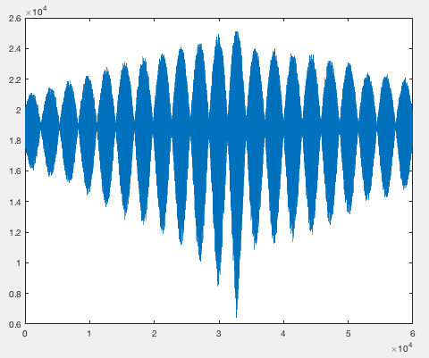

*Here we can clearly see the discrepancy between the right and left intensity.*

White Light with Orange Filter at start_pos = 7.7260 mm, span = 0.1 mm, speed = 0.001 mm/s

zpl_white_orange_span_0_1_speed_0_001_mar5_447.mat

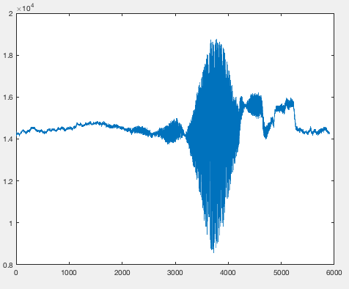

*The right side of this plot is weird. It could be due to bumping the table as the apparatus is sensitive or the light changed within the room.*

White Light Only

zpl_white_only_span_0_01_speed_0_0005_start_pos_7_6925_mar5_517.mat

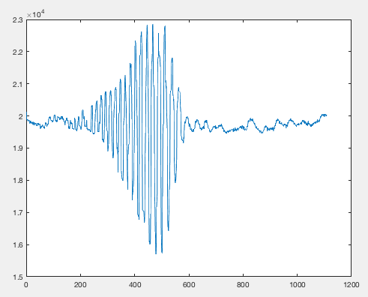

*Again the same intensity drop off appears on the right.*

Results:

Peaks were selected from the lower left envelope, this data was then put into the Matlab curve fit tool. The results for each of the datasets above is given below. The uncertainty was calculated from the confidence intervals in Matlab.

|  |  |  |
| --- | --- | --- |
|  | ZPL Location | Coherence Length |
| Sodium Lamp | 8.2612 +- 0.0006mm | 2.1 +- 0.1 mm |
| Orange Filter | 7.7524+- 0.0005mm | 0.013 +- 0,004mm |
| White Light | 7.7012 +- 0.0005mm | 0.0021 +- 0.0005mm |

The image below (next page) illustrates what portion of the envelope was used in the fit and the result of the fit. We expected the white light to be around 1um and had a result of 2um. We also expected white light to be the smallest. Overall the results are good and within our expectation but the errors in recording the intensity may have caused our values to be slightly off. If more time permitted we would attempt to retake the data or work with the TAs to determine a resolution.

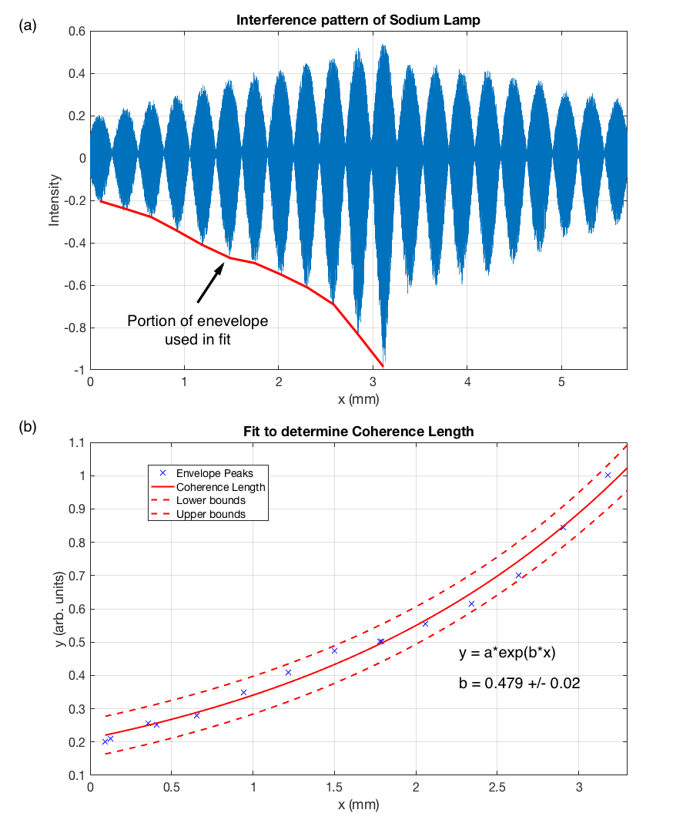

Questions:

Q: Assuming that your interferometer is aligned and at the ZPL, describe

how you would need to move the mirrors in order to achieve the ZPL if

a single 1 mm thick glass plate (index of refraction 1.52) was added to

one of the interferometer arms and you were using monochromatic light

at 632 nm.

We would need to account for the change in optical path length as the light moves through the glass. There is an increase in the path length by 2n*1mm = 3.52mm (as the light passes through the glass twice), moving the mirror by this distance should have you return to the ZPL.

Q: Why is there a compensator plate in the experimental setup?

The compensator plate forces the light to travel through the same distance of glass no matter which direction it travels in the interferometer. If this wasn’t the case, it would be much more difficult to determine the zero path length as there is now an affect due to the index of refraction not accounted for.

Q: What does it mean by the zero path length difference?

The light down each portion of the interferometer is completely in phase.

Fourier Transform Spectroscopy

Q: Take the spectrum and Fourier transform of the white light, white light with orange filter and sodium lamp. Compare the transform to what you expected. Discuss possible causes of any discrepancies you may see.

The same data used to determine the coherence length was used to produce the plots given below.

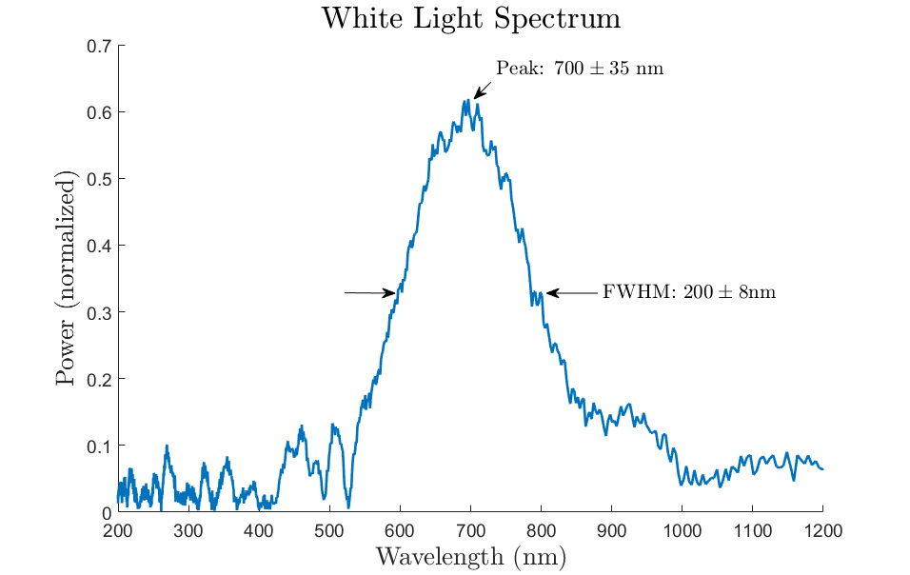

The spectral response of a CCD camera should range between 400-1000nm. As we can see from our plot, it clearly contains this range. Note, the result above is limited by the optical element of the interferometer and the sensitivity of the CCD detector.

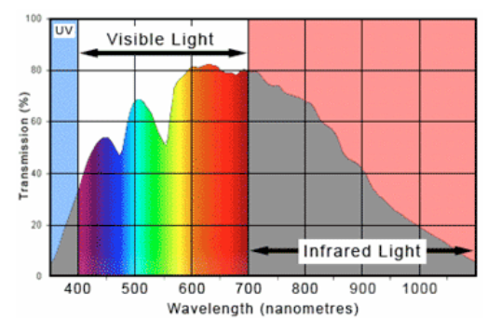

Above is the spectrum for a typical CCD camera. This image was taken from a previous PHYS 408 lab book created by David Jones. As we can see our peaks are also within uncertainty from this sketch above.

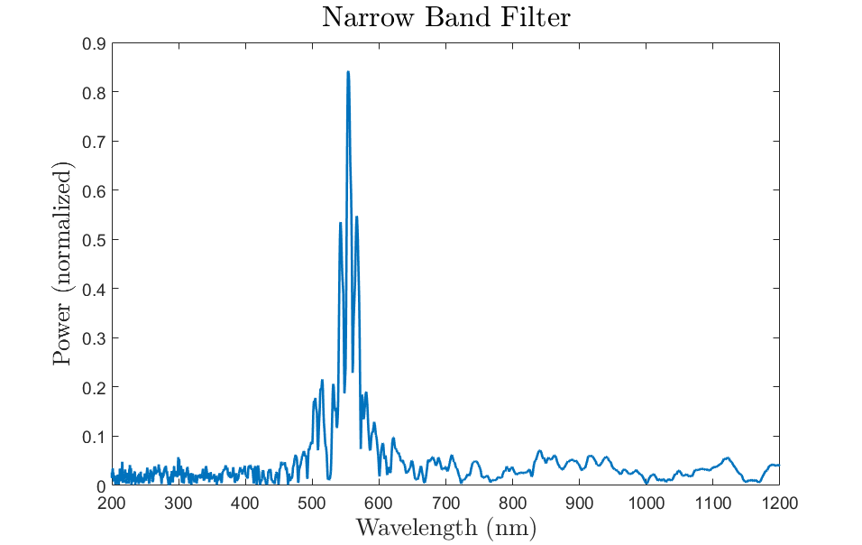

Orange light corresponds to a wavelength around 580 nm, the spectrum above has a peak at around 545 nm which is close to the expected wavelength. Compared to the white light, since we filter out all light but the orange light the spectrum should be more narrow.

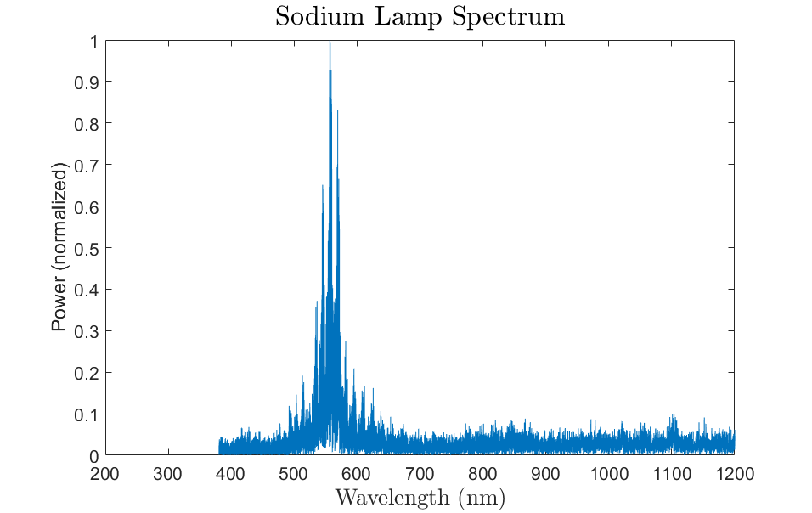

Sodium has two main lines, D1 and D2, corresponding to an average wavelength around 589 nm. As can be seen from above, the Fourier transform peaks close to this value.