**Optics 408 – HM 7**

Bryden Fogelman – 36294130

**Problem 1**

1. The number of layers need to achieve the reflectivity in the graph is at least 21. I used 22 layers just to make sure we had a reflectance above 99.97% as provided on the website (and also closer match the plot).
2. The following plot is an attempt to recreate the one provided in the homework assignment.

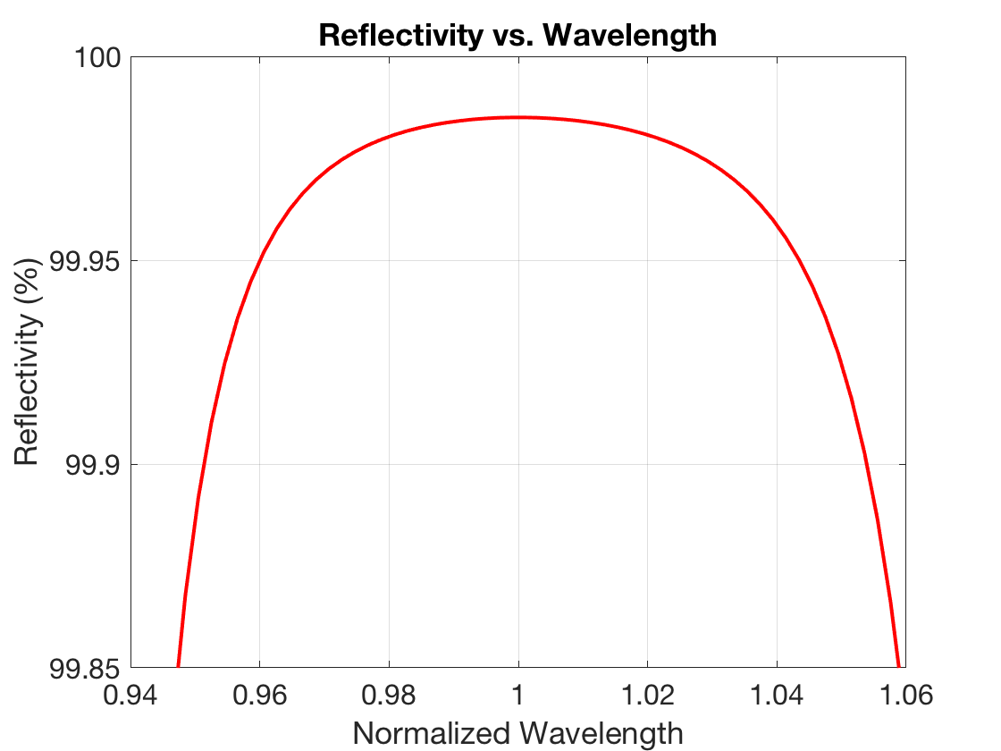

MATLAB CODE:

ni = 1; % air

ns = 1.52; % glass substrate

n1 = 1.65; % CeF3

n2 = 2.1; % ZrO2

design_lambda = 632.8e-9;

% function to determine reflectivity given the number of layer-pairs

R = @(N) (((ni/ns)*(-n2/n1)^(2*N)-1)/((ni/ns)*(-n2/n1)^(2*N)+1))^2;

% format long

% R(22) * 100

% from trial and error, we need at least 22 layer pairs to match the

% reflectance

% designed for HeNe laser

d = design_lambda / 4;

% function of the actual wavelength where d is held fixed

% assuming at incidence

f_delta = @(lambda) 2 * pi / lambda * d;

% alpha is really n/neta but the neta term cancels I believe

a1 = n1;

a2 = n2;

% M is the numbers of wavelengths (for creating plot)

M = 100;

% N is the number of layers

N = 22;

% create a range of lambdas from 0.9 * HeNe to 1.1 HeNe wavelength

lambdas = linspace(0.9*design_lambda, 1.1*design_lambda, M);

% reflectance

r = zeros(M,1);

% First create select lambda and update delta

for i=1:M

delta = f_delta(lambdas(i));

% Next, we recreate the F matrix and determine r

% F is the result of multiple matrix multiplication

% Reset each loop

F = eye(2,2);

for j=1:N

F1 = [cos(delta), -1i*sin(delta)/a1; -1i*sin(delta)*a1, cos(delta)];

F2 = [cos(delta), -1i*sin(delta)/a2; -1i*sin(delta)*a2, cos(delta)];

F = F * F1 * F2;

end

% determine the reflectance for a given lambda

r(i) = abs( ((ni * F(1,1) + ni * ns * F(1,2) - F(2,1) - ns * F(2,2)) / (ni * F(1,1) + ni * ns * F(1,2) + F(2,1) + ns * F(2,2))).^2 );

end

plot(lambdas / design_lambda, r * 100, 'r', 'LineWidth', 2)

ylim([99.85, 100.00])

ylabel('Reflectivity (%)')

xlabel('Normalized Wavelength')

title('Reflectivity vs. Wavelength')

grid on

set(gca,'fontsize',16)

1. The RMS phase right in a reflected full aperture light beam is as follows.

The surface flatness is $\frac{λ}{10}$ the design phase should be around $\frac{π}{2}$. What happens is this actually introduces an uncertainty in the actual target phase.

$$Δδ=\frac{2π}{λ}*\frac{λ}{10}=\frac{π}{5}$$

We want the phase at a given wavelength to be around $\frac{π}{2}$ but due to the surface flatness there is an uncertainty of $\frac{π}{5}$ introduced.

1. The following calculation outlines comparison of cost between this mirror and gold.

First find the volume of the mirror:

$$d=25.4mm$$

$$t=6.35mm$$

$$V=\frac{πd^{2}}{4}t=3218 mm^{3}$$

The density of gold is 19.32 g/cm^3, with this we can determine the mass of gold.

$$m=19.32\frac{g}{cm^{3}}*\frac{{cm}^{3}}{(10 m{m)}^{3}}*3128 mm^{3}=62.2 g$$

The cost of gold per gram is $42.33 (USD) so the final cost is the following:

$$C=m*\$42.33=\$2631$$

The density of glass is around 2 g/cm^3 and the cost of the mirror is $1320 so the cost per gram is around $205 for the mirror. We can see that cost of gold isn’t that much compared to this really expense fancy physics one.

**Problem 2**

The following plot was generated for the anti-reflective coating. The total thickness of the coating is as follows:

$$t=\frac{λ}{4n_{1}}+\frac{λ}{4n_{2}}=\frac{550}{4}nm \left(\frac{1}{2.1}+\frac{1}{1.65}\right)=149 nm$$

$$t_{1}=65.5 nm t_{2}=83.3 nm$$

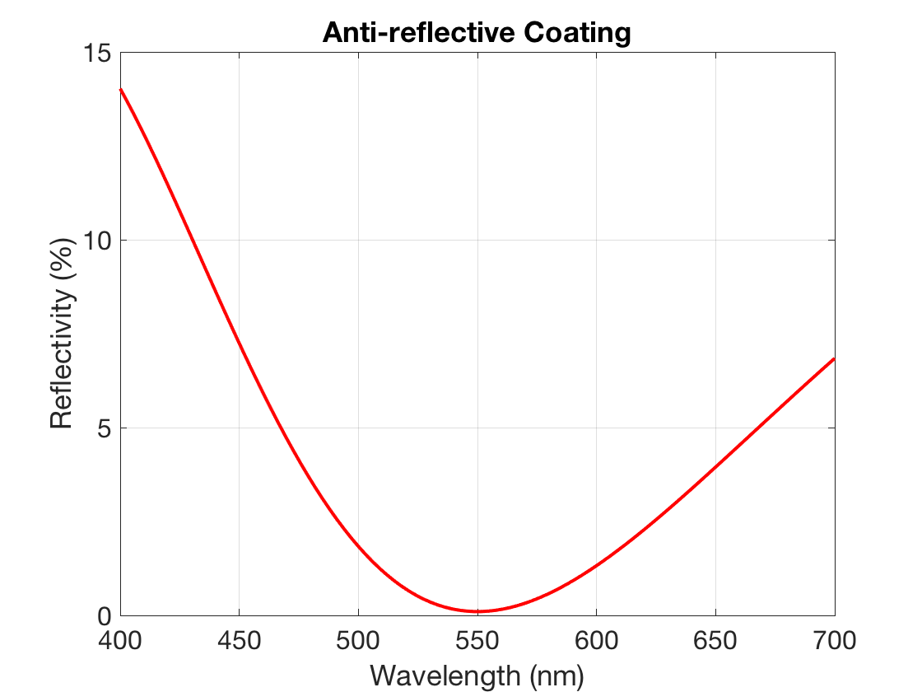

Q: At 400 nm, how bright will the secondary images caused by light bouncing within the glass

lenses be compared to the primary image? Would this anti-reflection coating be acceptable?

The reflectivity at 400nm is around 14%, one could then expect the intensity of the image at 400nm to be 0.14 * I (where I is the incident intensity). Therefore, the image would be 14% as bright as the incident image. This isn’t really acceptable as an anti-reflection coating as you would still be able to clearly see the image but it would just appear much darker.

MATLAB CODE:

ni = 1; % air

ns = 1.52; % glass substrate

n1 = 1.65; % CeF3

n2 = 2.1; % ZrO2

design_lambda = 550e-9;

% designed for HeNe laser

d = design_lambda / 4;

% function of the actual wavelength where d is held fixed

% assuming at incidence

f_delta = @(lambda) 2 * pi / lambda * d;

% alpha is really n/neta but the neta term cancels I believe

a1 = n1;

a2 = n2;

% M is the numbers of wavelengths (for creating plot)

M = 100;

% create a range of lambdas from 0.9 * HeNe to 1.1 HeNe wavelength

lambdas = linspace(400e-9, 700e-9, M);

% reflectance

r = zeros(M,1);

% First create select lambda and update delta

for i=1:M

delta = f_delta(lambdas(i));

% Next, we recreate the F matrix and determine r

% F is the result of multiple matrix multiplication

% Reset each loop

F = eye(2,2);

F1 = [cos(delta), -1i*sin(delta)/a1; -1i*sin(delta)*a1, cos(delta)];

F2 = [cos(delta), -1i*sin(delta)/a2; -1i*sin(delta)*a2, cos(delta)];

F = F1 * F2;

% determine the reflectance for a given lambda

r(i) = abs( ((ni * F(1,1) + ni * ns * F(1,2) - F(2,1) - ns * F(2,2)) / (ni * F(1,1) + ni * ns * F(1,2) + F(2,1) + ns * F(2,2))).^2 );

end

plot(lambdas * 10^9, r * 100, 'r', 'LineWidth', 2)

% ylim([99.85, 100.00])

ylabel('Reflectivity (%)')

xlabel('Wavelength (nm)')

title('Anti-reflective Coating')

grid on

set(gca,'fontsize',16)