APPENDICES

**APPENDIX A.**

**ENGLISH CRITIC’S CERTIFICATION**

**APPENDIX B.**

**STATISTICIAN’S CERTIFICATION**

**APPENDIX C.**

**PROJECT PROPOSAL**

**APPENDIX D.**

**COMMUNICATION LETTERS**

**APPENDIX E.**

**INTERVIEW GUIDE QUESTIONS**

**Interview Guide Questions**

PURPOSE: Your answer to the questions below will provide us with information about your establishment’s situation in carrying out daily activities using your existing system or operations. Please take as much space to answer each question as you need.

1. Does your establishment use any software product/s (e.g. attendance monitoring, payroll system, etc.)?
   1. If not, how long have you been operating manually?
   2. What are the usual problems that you encountered when performing your day-to-day activities?
   3. To these stated problems, what specific problem you encountered most?
   4. Does it affect your job? How?
2. Are there any instances that you encountered a problem wherein there’s a missing document or any information for a resident within the barangay?
   1. What actions you usually do when you encountered this kind of situation?
3. Are you familiar in utilizing various websites (e.g. Facebook, Twitter, etc.)?
   1. If yes, please state your insight/s about these software products.
4. What is your personal view in automating the manual recording, retrieving and producing of different types of document (e.g. residents' information, clearances, permits, etc.)?
   1. What are the possible features that you expect from this automated system aside from the ones stated above?
5. Do you think that this kind of system is needed in your establishment? Why?
6. Are you in favor of replacing the manual labor into an automated management system?
7. If this project is somehow implemented, what are the possible benefits that you expect from this automated system to have?
8. What might possible problems do you see if the system is implemented?

**APPENDIX F.**

**SURVEY QUESTIONNAIRES**

**APPENDIX G.**

**FORMS AND DOCUMENTS**

**APPENDIX H.**

**SYSTEM EVALUATION**

**APPENDIX I.**

**SOFTWARE DEVELOPMENT COST**

**SOFTWARE DEVELOPMENT COST**

1. **Hardware Depreciation Cost**

HP Pavilion 15 Laptop Php 31,600.00

ASUS X441SA Laptop 19,500.00

Canon Printer Pixma MP237 3,465.00

**Total Hardware Cost Php 54,565.00**

Hardware Cost : Php 54,565.00

Life Expectancy : 3 years

Development Period : 10 months

Salvage Value [(Hardware Cost / Life Expectancy) * Development Period] / 12

= [(54,565.00 / 10) * 3] / 12

**= Php 1,364.13**

Annual Depreciation Cost = (Hardware Cost – Salvage Value) / Life Expectancy

= (54,565.00 – 1,364.13)/ 3

**= Php 17,733.62**

Monthly Depreciation Cost = Annual Depreciation Cost / 12

= 17,733.62/ 12

**= Php 1,477.81**

**Hardware Depreciation Cost** = Monthly Depreciation Cost * Development Period

= 1,477.81* 10

**= Php 14,778.10**

1. **Software Depreciation Cost**

Microsoft Windows 10 Php 7,000.00

Microsoft Office 2010 Professional Edition 3,000.00

Sublime Text Editor 1,500.00

**Total Software Cost Php 11, 500.00**

Software Cost : Php 11, 500.00

Life Expectancy : 2 years

Development Period : 10 months

Salvage Value [(Software Cost / Life Expectancy) * Development Period] / 12

= [(11, 500.00 / 2) * 10] / 12

**=Php 4,791.67**

Annual Depreciation Cost = (Software Cost – Salvage Value) / Life Expectancy

= (11, 500.00 –4,791.67) / 2

**=Php3, 354.17**

Monthly Depreciation Cost = Annual Depreciation Cost / 12

= 3,354.17/ 12

**= Php 279.51**

**Software Depreciation Cost** = Monthly Depreciation Cost * Development Period

= 279.51 * 10

**=Php 2,795.10**

1. **Labor Cost**

Programmer/System Analysts (per Head) : Php 28,500.00/Mo

Project Manager 23,250.00

Technical Writer 20,500.00

System Designer 21,100.00

**Total Salary 93,350.00/Mo**

Development Period : 10 Months

**LaborCost**  = Developer’s Fee * 10

= 93,350.00 * 10

**= Php 933,500.00**

1. **Miscellaneous Cost**

**Web Hosting Php 3,000.00**

Web Hosting Plan - Personal 1,500.00

Domain name registration fee/year 1,500.00

2 ream Letter-sized bond paper (160.00 per ream) Php 320.00

Canon Ink refill 379.00

Others (Transportation, food, etc) 1,200.00

**Total Miscellaneous Cost Php 4,899.00**

1. **Overhead Cost**

1st Month - Electric Bill Php 250.00

2nd Month- Electric Bill 250.00

3rd Month - Electric Bill 250.00

4thMonth- Electric Bill 250.00

5th Month- Electric Bill 250.00

6th Month- Electric Bill 250.00

7th Month- Electric Bill 250.00

8th Month- Electric Bill 250.00

9th Month- Electric Bill 250.00

10th Month- Electric Bill 250.00

**Total Overhead Cost Php 2,500.00**

1. **Summary**

|  |  |
| --- | --- |
| **Category** | **Cost** |
| Hardware Depreciation Cost | Php 14,778.10 |
| Software Depreciation Cost | 2,795.10 |
| Labor Cost | 933,500.00 |
| Miscellaneous Cost | 4,899.00 |
| Overhead Cost | 2,500.00 |
| **Total Development Cost** | **Php 956,472.20** |

**APPENDIX J.**

**COST BENEFIT ANALYSIS**

**APPENDIX K.**

**DATA FLOW DIAGRAM**

//This will serve as a guide for the DFD

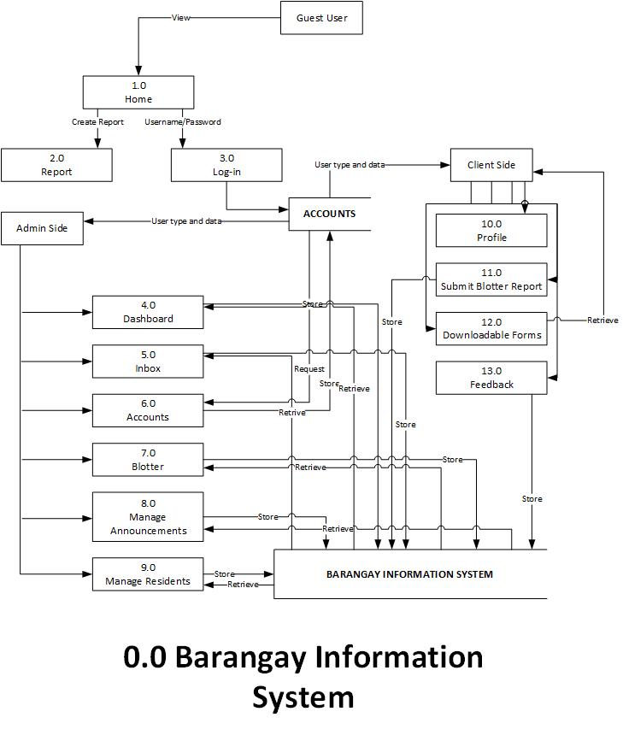

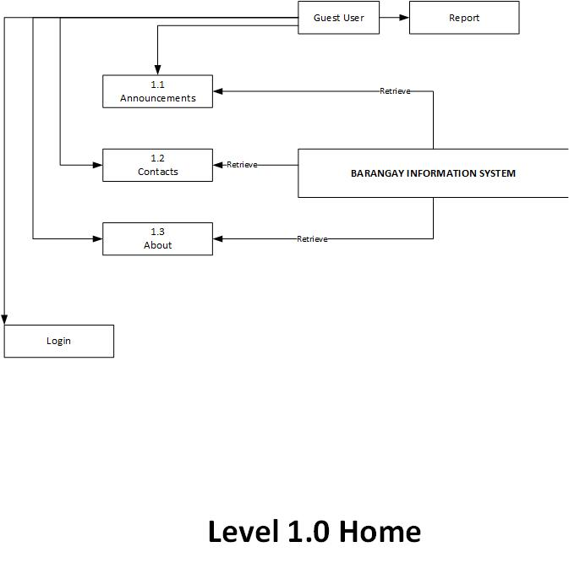

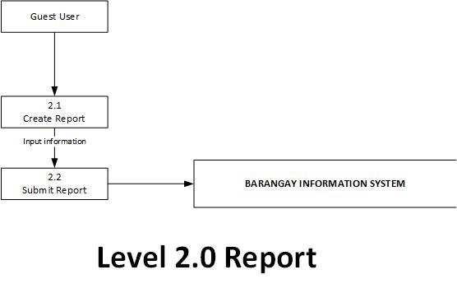

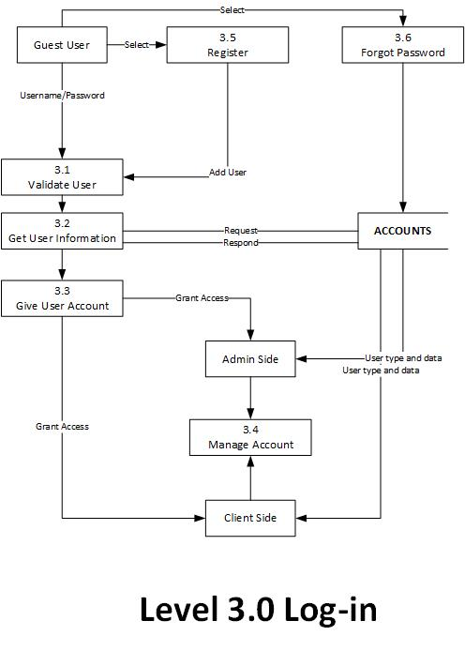

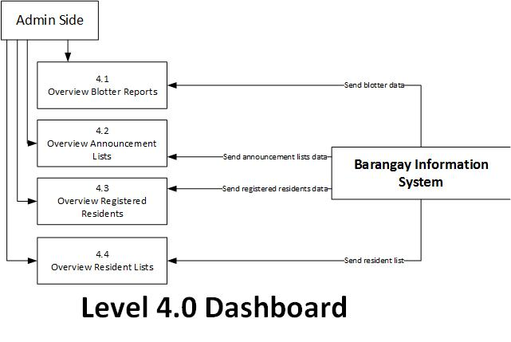

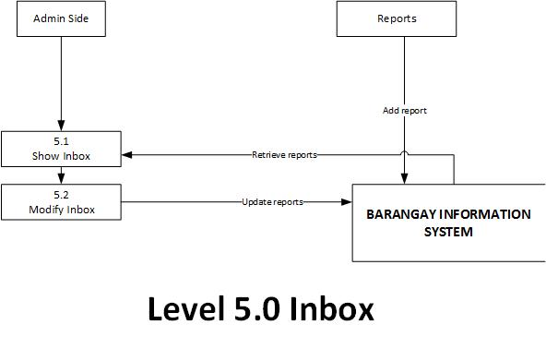

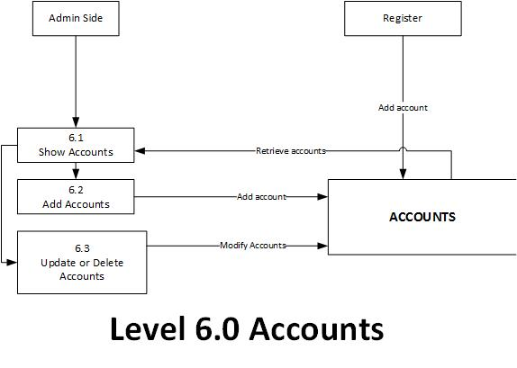

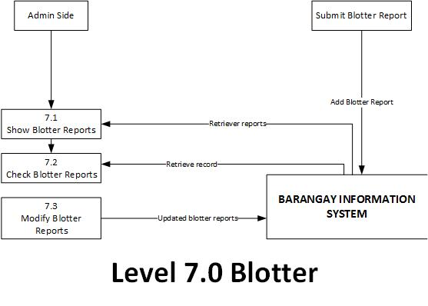

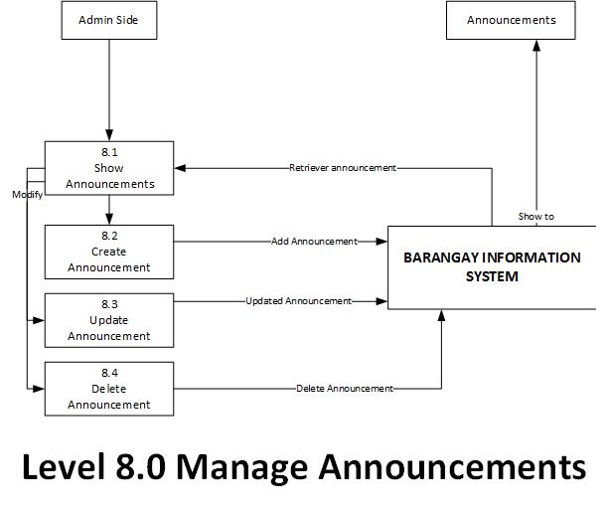

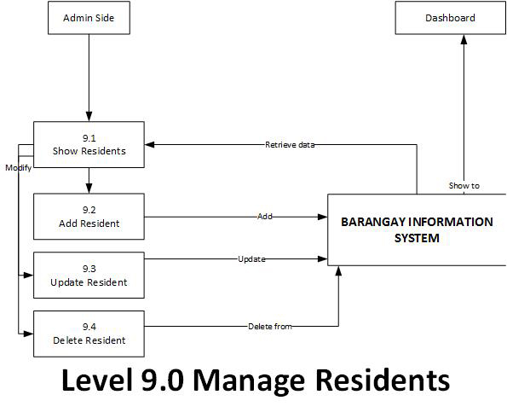

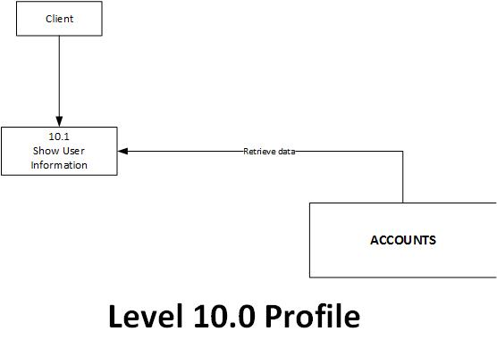

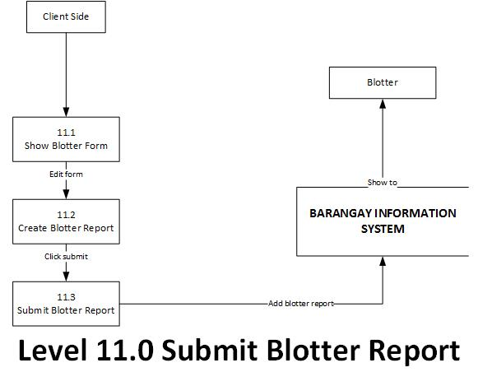

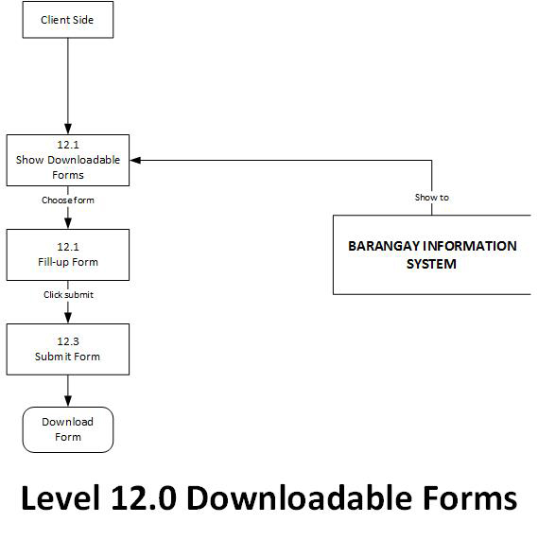

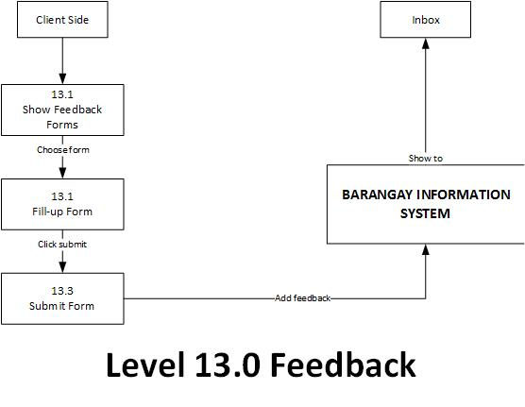

**APPENDIX L.**

**SYSTEM FLOWCHART**

ADMIN SIDE

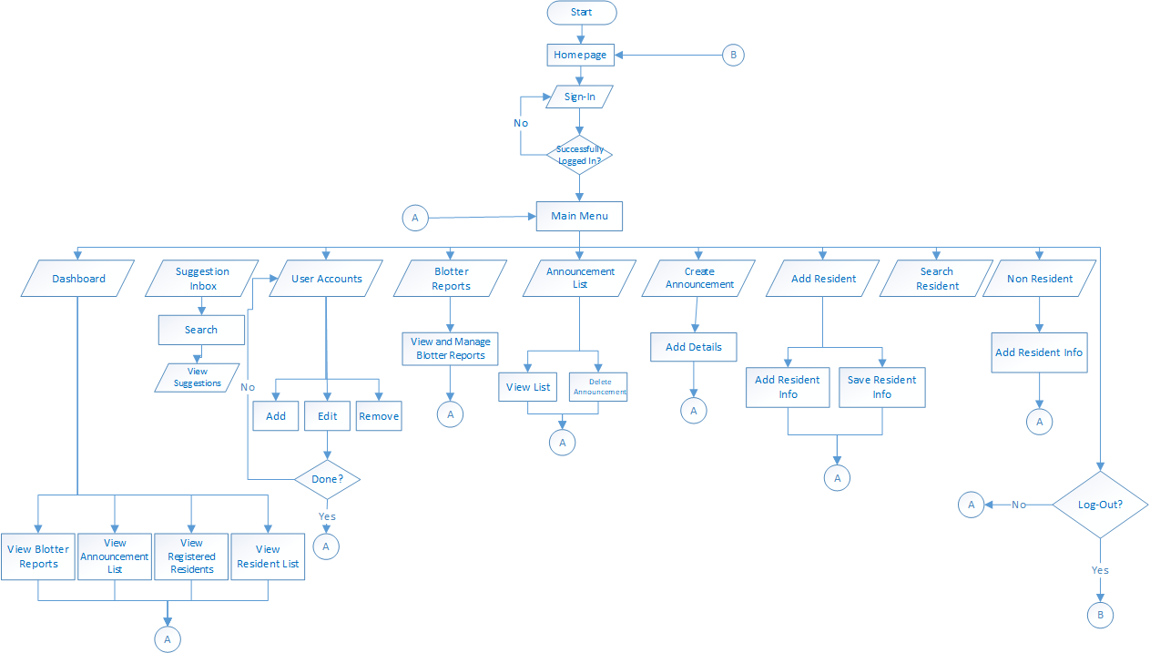

NON- RESIDENT SIDE

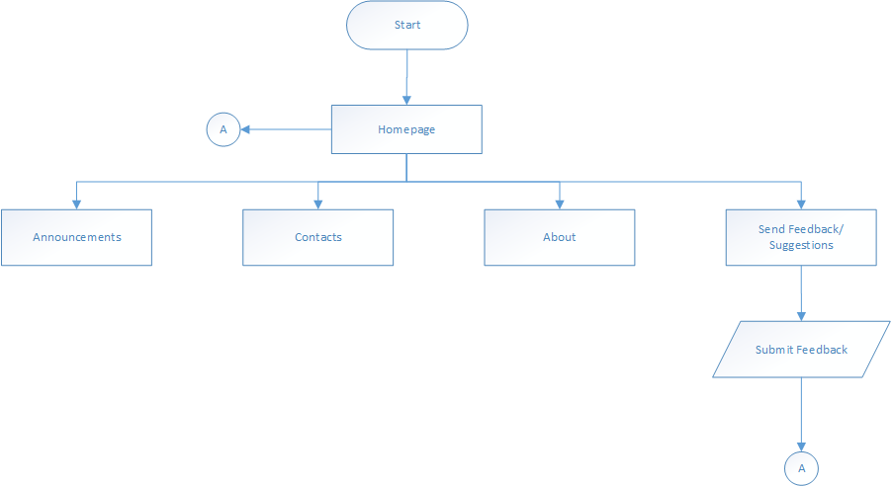

RESIDENT SIDE

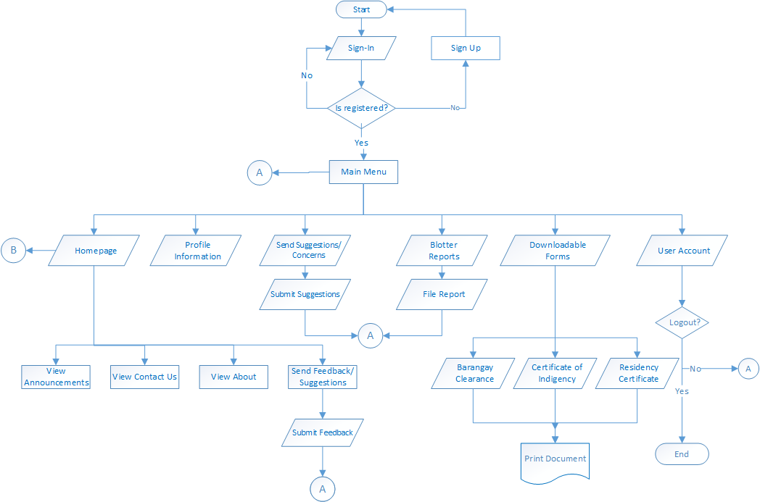

**APPENDIX M.**

**DATA DICTIONARY**

**APPENDIX N.**

**ENTITY RELATIONSHIP DIAGRAM (ERD)**

**APPENDIX O.**

**VISUAL TABLE OF CONTENTS (VTOC)**

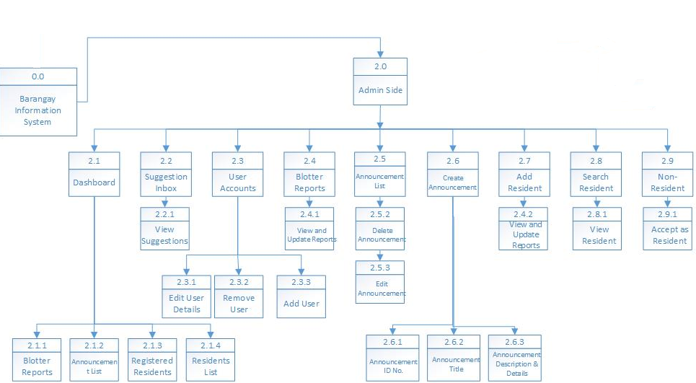ADMIN SIDE

CLIENT SIDE

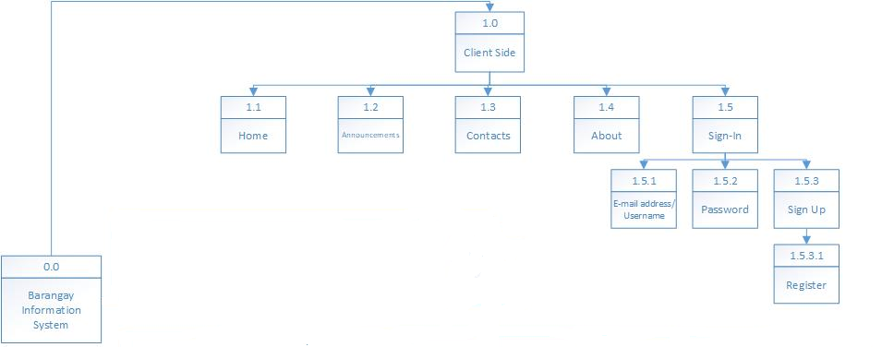

**APPENDIX P.**

**INPUT- PROCESS- OUTPUT**

**APPENDIX Q.**

**PROGRAM FLOWCHART**

**APPENDIX R.**

**USER GUIDE**

**APPENDIX S.**

**PROGRAM OUTPUT SNAPSHOTS**

**APPENDIX T.**

**PROGRAM CODE LISTING**

**APPENDIX U.**

**PHOTO DOCUMENTATION**

**APPENDIX V.**

**CURRICULUM VITAE**