**CST-247 Topic 2 Activity**

Brydon K. Johnson

Grand Canyon University

CST-247

Michael Pritchard

January 17, 2020

**Part 1**

Git Repo: <https://github.com/brykeith/cst-247_GuidedAssignments>

Screenshot 1

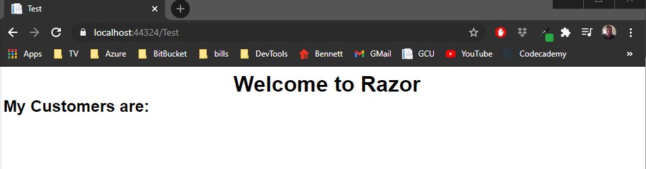

Screenshot 2

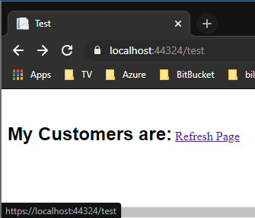

Screenshot 3

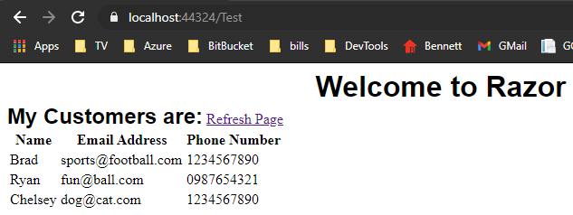

Screenshot 4

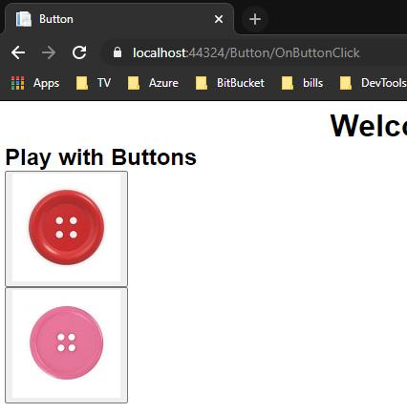

Screenshot 5

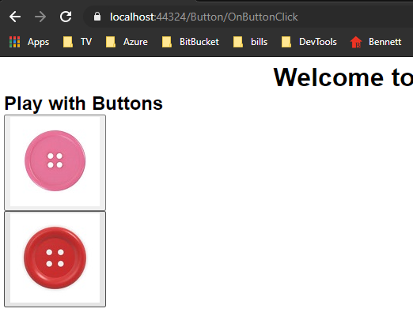

**Part 2**

Screenshot 6

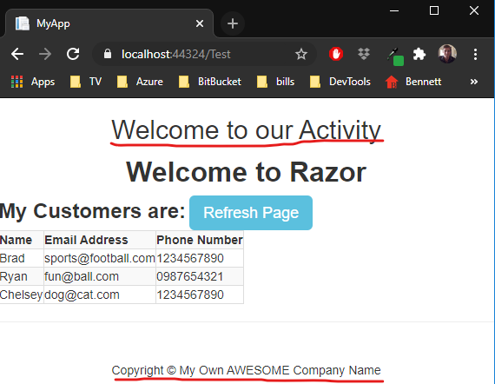

Screenshot 7

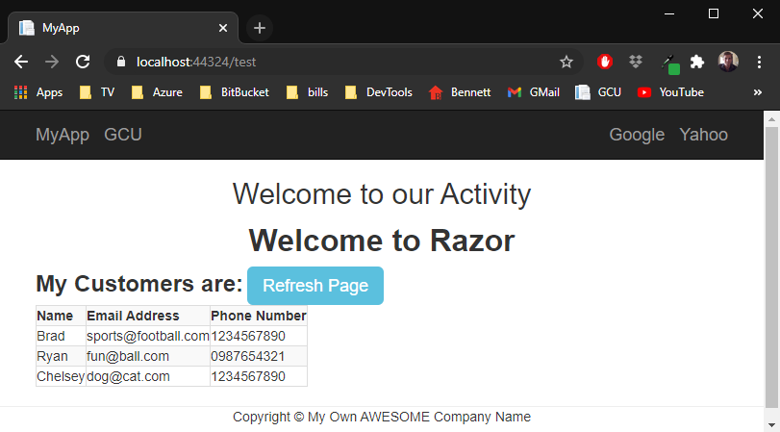

**Part 3**

Screenshot 8

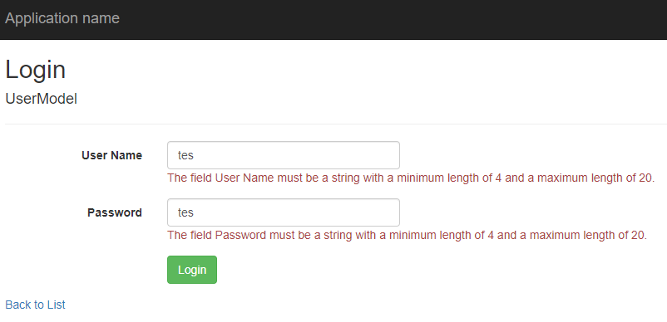

Screenshot 9

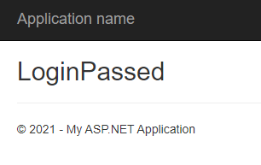

**Part 4**

* 1. Results of your Daily Standup (who did what over the course of the week)
     1. They are going well
     2. Evenly dividing labor between teammates
        1. Brydon: Presentation
        2. Josh: Visual assets
        3. Don: Developed and converted code from old Minesweeper project to adapt to MVC context
  2. Sprint Plan for this week
     1. 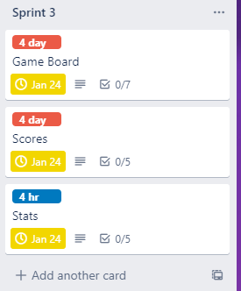
     2. Game Board
        1. GameBoardModel
        2. _GameBoard partial view
        3. GameCenterController
        4. GameCenter View
        5. CellModel
     3. Scores
        1. Database tables
        2. Data access objects (DAO)
        3. ScoreModel
           1. Wire into UserModel
     4. Stats
        1. Database tables
        2. Data access objects (DAO)
        3. StatModel
  3. Sprint Burn Down Chart for this week

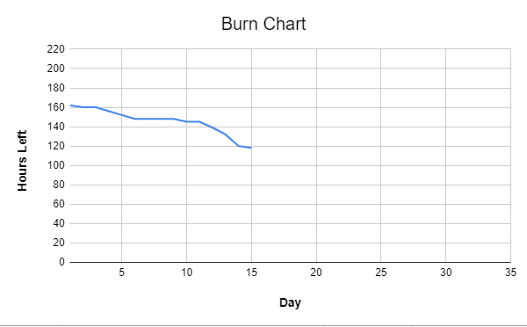

* 1. Results of Retrospective for this week
     1. Things are going well.
     2. We all feel that we are working well as a team
     3. Things done well:
        1. Work division
        2. Communication
     4. Things to improve:
        1. Get things done earlier in the week
        2. Shorter Scrums