**CST-247 Topic 1 Activity 3**

Brydon K. Johnson

Grand Canyon University

CST-247

Michael Pritchard

February 7, 2020

Screenshot 1:

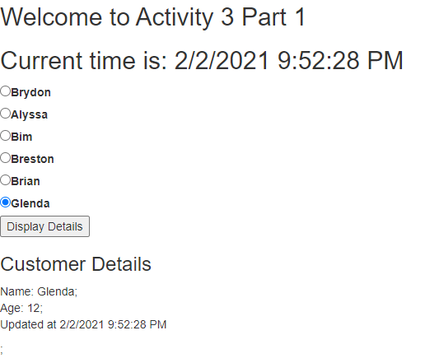

Screenshot 2

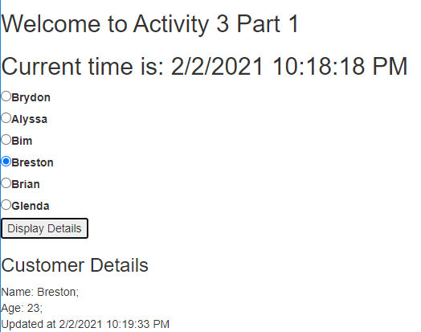

Screenshot 3

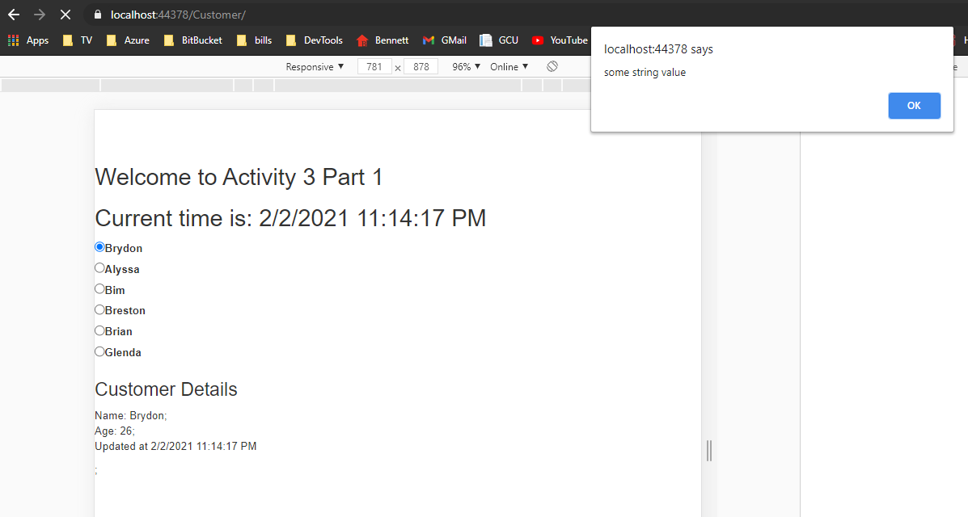

Screenshot 4



Screenshot 5



Screenshot 6



Screenshot 7

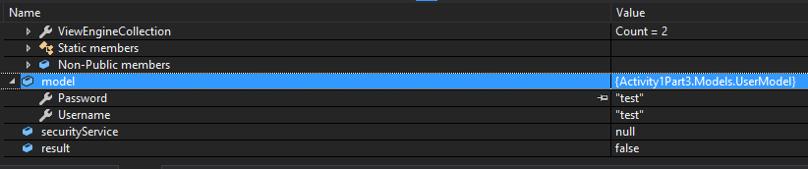

Screenshot 8



Screenshot 9

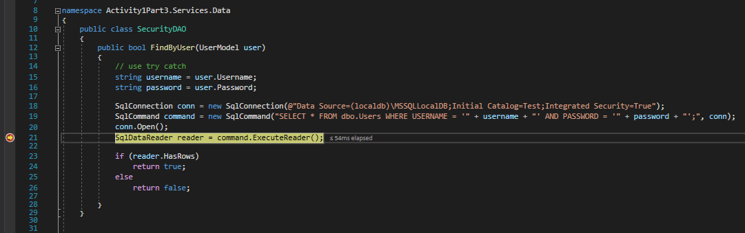

Screenshot 10

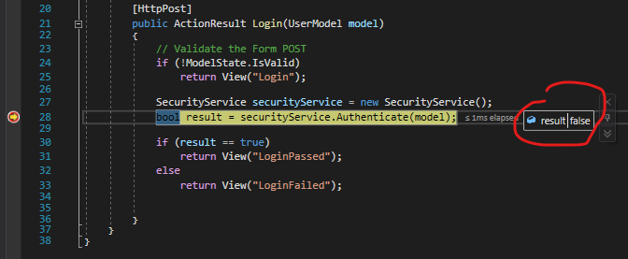

Screenshot 11

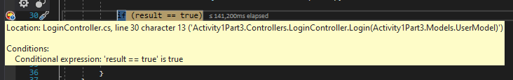

Screenshot 12

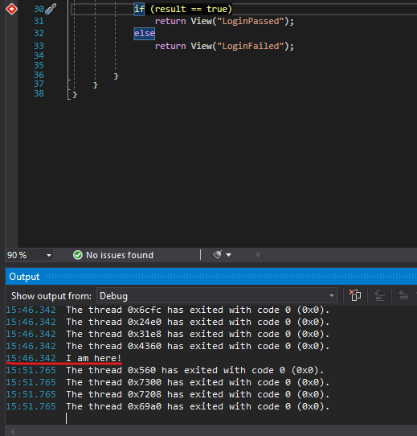

Screenshot 13

