**CST-247 Topic 7 Activity 5**

Brydon K. Johnson

Grand Canyon University

CST-247

Michael Pritchard

February 21, 2020

**Part 1**

Screenshot 1

These screenshots demonstrate returning the string from my index method and it appearing as well using the Info() in my log file

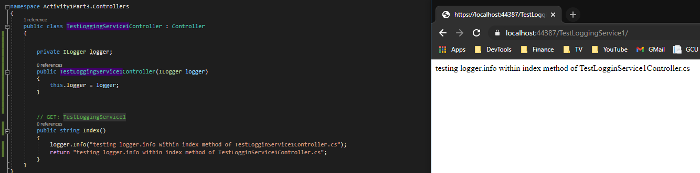

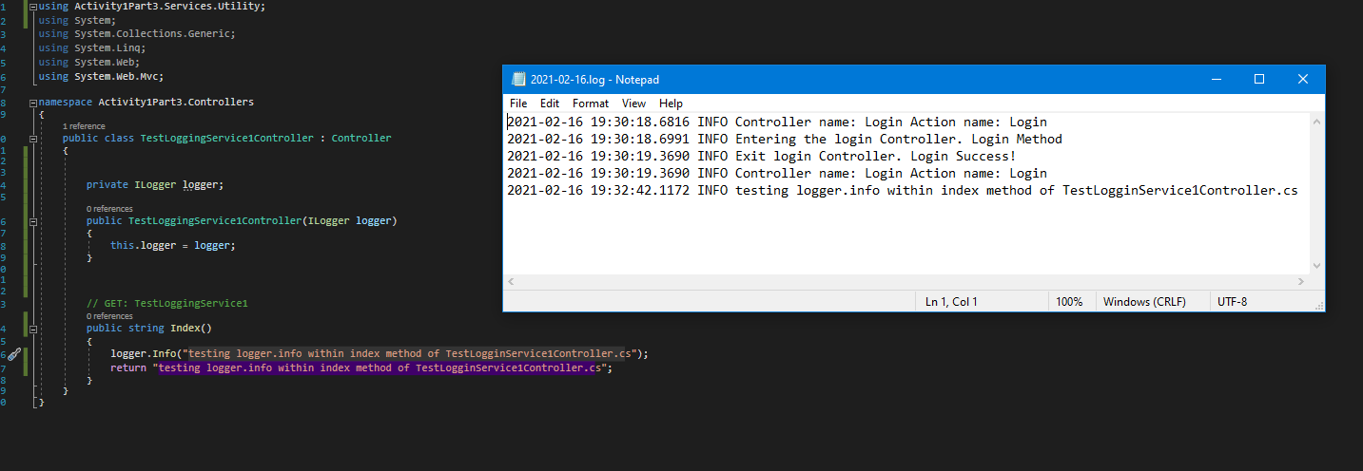

Screenshot 2

These screenshots demonstrate returning the string from my index method and it appearing as well using the Info() in my log file from TestLoggingService**2**Controller.cs

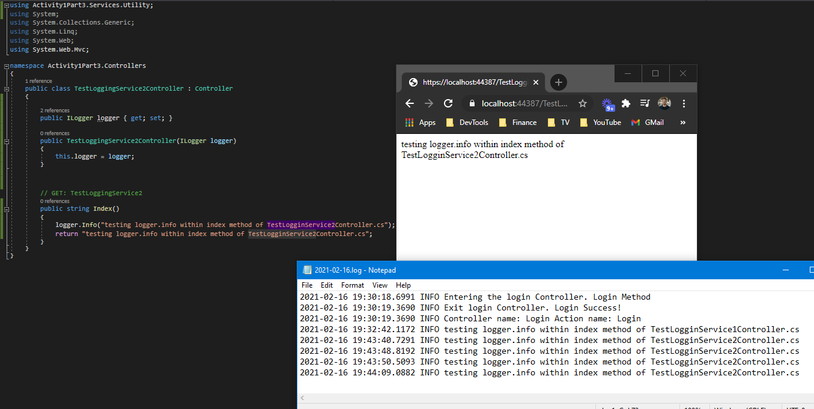

Screenshot 3

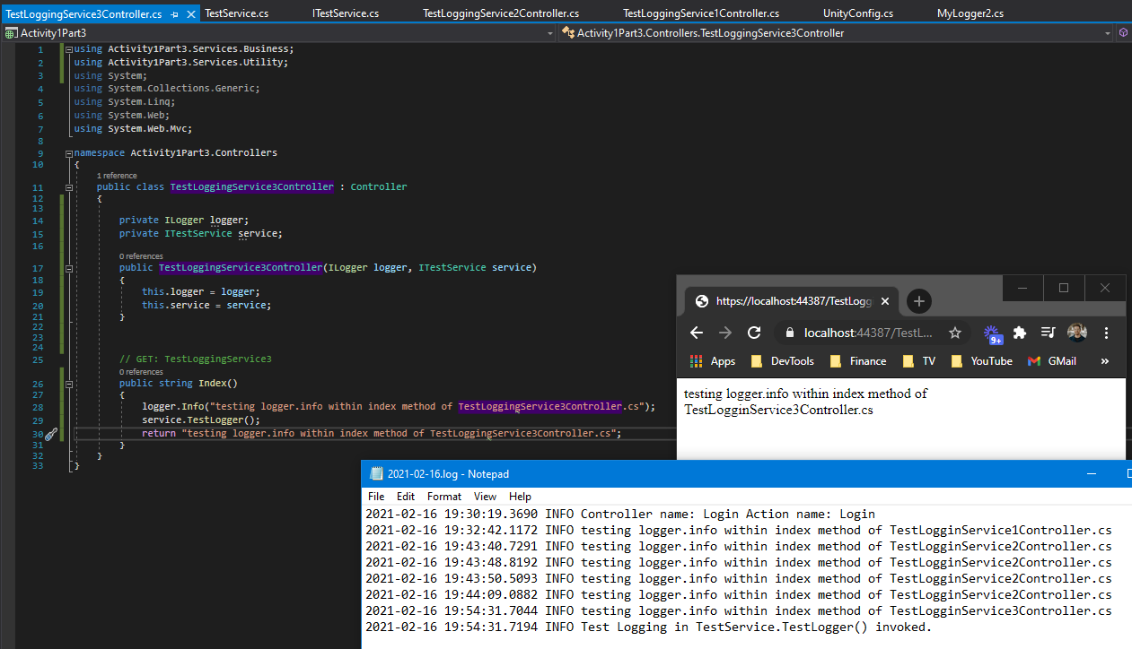

Screenshot 4

Screenshot 5

**Part 2**

Screenshot 6

Screenshot 7

Screenshot 8

Screenshot 9

Screenshot 10

Screenshot 11

Screenshot 12

Screenshot 13

Screenshot 14

Screenshot 15

Screenshot 16

Screenshot 17

Screenshot 18

Screenshot 19