Bryl Hotel Booking System
(Manual Instructions)

Developed by: Bryl C. Rabadon

BSIT - 2C

Introduction

This system is designed to make hotel room booking and management much easier. By providing a digital dashboard for administrators, staff, and guests, the system replaces old paper records with a secure, real-time solution. It helps hotel management organize their rooms efficiently while giving guests a simple way to find and reserve accommodations.

Significance

The Bryl Hotel Booking System greatly improves the efficiency and accuracy of managing hotel operations. It helps hotel owners and staff by making it easier to handle rooms, reservations, and payments. With better data organization and easier access to information, the system supports smoother daily operations and enhanced guest experiences.

Benefactors:

The following groups benefit most from using this system:

A· Hotel Administrators: They gain a professional tool to manage users, track rooms, oversee all bookings, and monitor revenue.

B· Hotel Staff: They get efficient tools to process bookings, handle payments, and manage guest check-ins and check-outs.

C· Hotel Guests: They get an easy way to browse rooms, make reservations, process payments, and view receipts from any device.

How to Use the Program
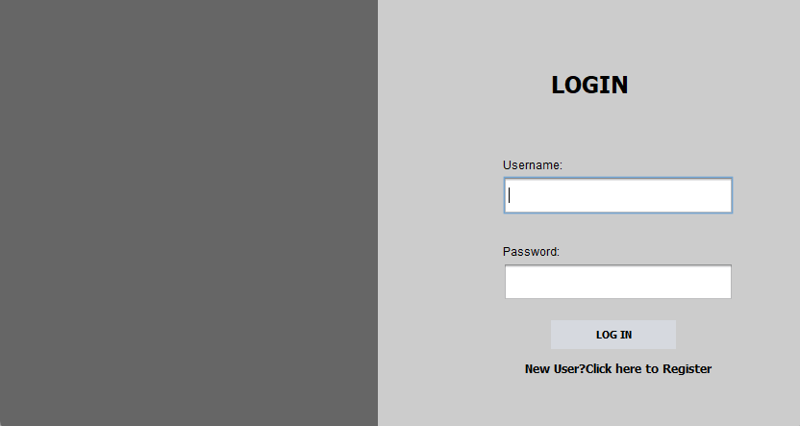

Upon running the program, you will be presented with the main log in form.

Features & Actions:

Username: Enter the username you chose during registration.

Password: Enter your password (securely hashed in the system).

Login Button: Click this button to sign into the system. Upon successful login, you will be directed to your role-specific dashboard (Admin, Staff, or Guest).

"Don't have an account? Sign up": If you are a new user, click this link to go to the Create Account screen.

Create Account
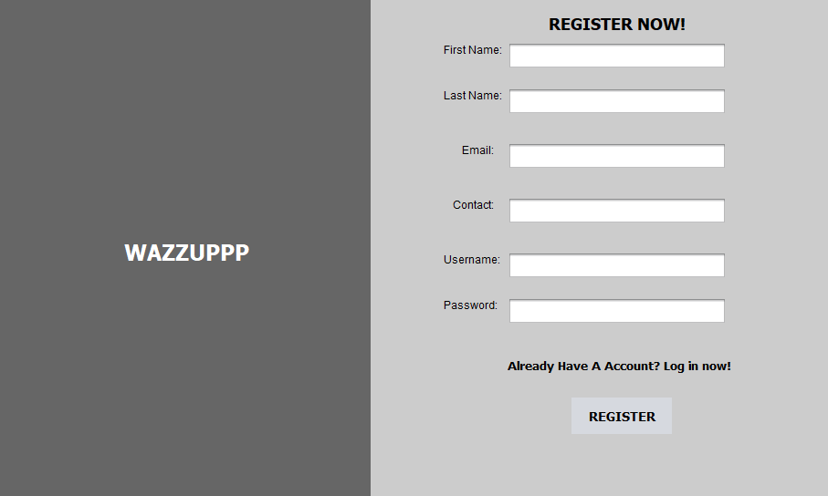

The process begins with the Create Account screen. This screen is for new users to register on the platform.

Features & Actions:

First Name: Enter your given name.

Last Name: Enter your family name.

Email: Enter a valid email address for account communication.

Contact: Enter your phone number.

Username: Choose a unique username for logging into the system.

Password: Set a strong, secure password (will be hashed for security).

Register: Click this button once all fields are complete to create your account.

"You already have an account? Login": If you have an account, click this link to go to the Login screen.

Note: New accounts are created with "Guest" role by default and "Active" status.

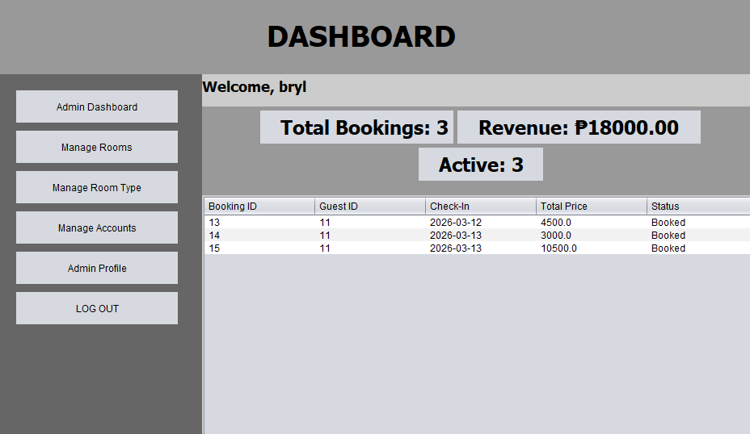
ADMIN DASHBOARD

Upon successful login as an administrator, you will land on the Admin Dashboard. This is your central hub for monitoring hotel operations and managing the entire system.

Features & Actions:

Admin Dashboard: Returns to the main statistics view.

Manage Rooms: Control room inventory and availability.

Manage Room Type: Administer room categories.

Manage Accounts: Control all user accounts in the system.

Admin Profile: View and edit your personal account details.

Log Out: Safely exit the system.

* Statistics Panel: The dashboard displays three key metrics:

* Total Bookings: Shows the count of all bookings in the system.

* Revenue: Displays total income from all bookings.

* Active Status: Shows the number of currently active bookings.

* Booking ID: A unique identifier for each reservation.

* Guest ID: The ID of the guest who made the booking.

* Check-In: The scheduled check-in date.

* Status: The current state of the booking (Booked, Cancelled)

* Welcome Message: Displays "Welcome, [username]" at the top of the main panel.

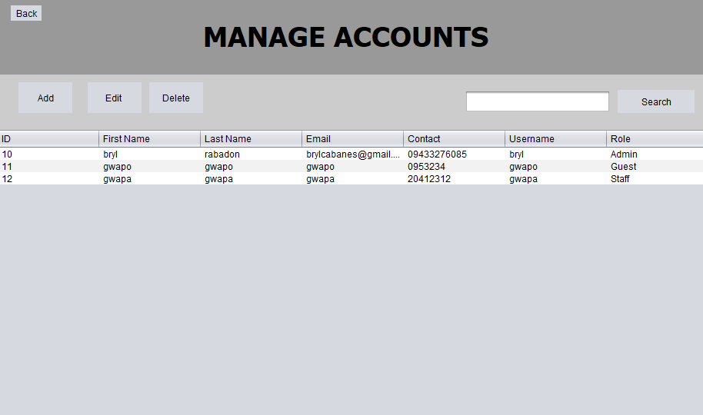
MANAGE ACCOUNTS

Viewing All User Accounts

When you click "Manage Accounts" from the sidebar, you will see the User Management interface. This is your control center for administering all system users.

Features & Actions:

Users Data Table: A comprehensive list displaying the following columns:

User ID: The unique system identifier for each account.

First Name: The user's given name.

Last Name: The user's family name.

Email: The user's contact email address.

Username: The login credential for the account.

Role: The user's permission level (Admin, Staff, or Guest).

Status: Indicates if the account is Active, Inactive, or Suspended.

Management Buttons:

Add: Opens a blank form to register a brand-new user account.

Edit: Select a row in the table first, then click this to modify existing user details.

Delete: Removes a selected user from the database (with confirmation).

Search Functionality: Enter a name, username, or email in the search box and click the search icon to filter the list instantly.

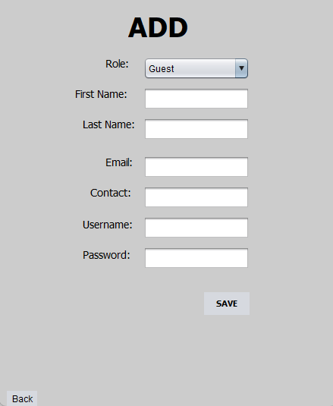
ADD USER ACCOUNT

When you click the "Add" button from the Manage Accounts screen, this blank entry form appears.

Features & Actions:

Identification Fields:

First Name & Last Name: Enter the user's legal name.

Email: Enter a valid email address.

Contact: Enter the user's phone number.

Account Credentials:

Username: Set a unique login name.

Password: Create a secure password for the user.

Permissions & Role:

Role Dropdown: Assign the user a role:

- Admin: Full system access

- Staff: Operational access (bookings and payments)

- Guest: Customer access (personal bookings only)

Save Button: Click to commit the new user to the database and return to the user list.

Note: All fields are required. The system will validate data before saving.

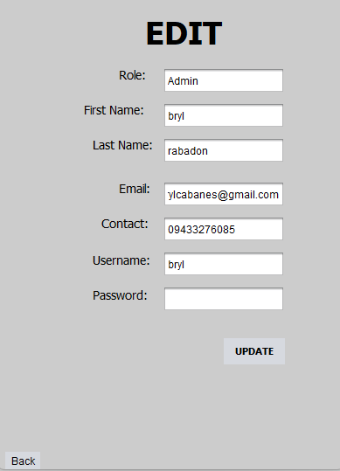
EDIT USER ACCOUNT

When you select an existing user and click "Edit," the form populates with their current data to ensure accuracy during updates.

Features & Actions:

Pre-filled Data: The form automatically displays current user information.

Read-Only User ID: The User ID is locked to maintain data integrity.

Data Correction: Modify any existing fields:

Update name, email, or contact information

Change username (must remain unique)

Reset password if needed

Modify role (Admin/Staff/Guest)
Change status (Active/Inactive/Suspended)

Update Button: Finalize the changes by clicking this button. The system will validate the data and return you to the user list.

Important: Changing a user's role will affect their access permissions immediately upon next login.

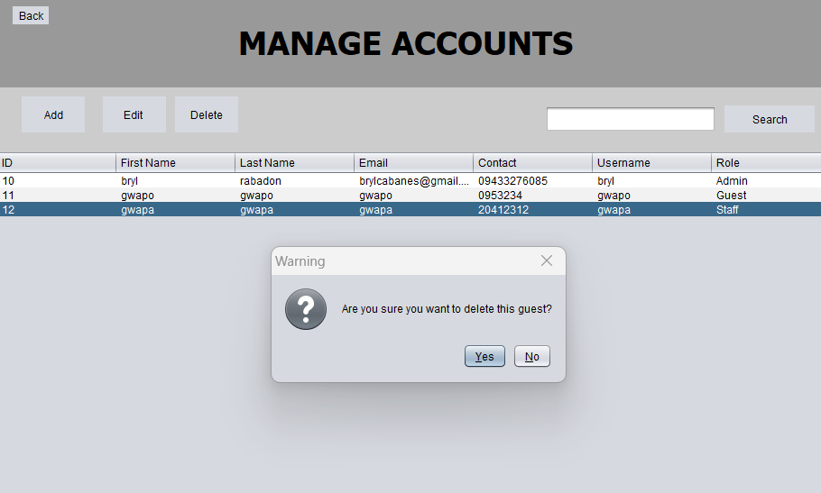
DELETE USER ACCOUNT

When you select a user from the table and click the "Delete" button, a confirmation dialog box appears.

Features & Actions:

Confirm Delete Prompt: The message "Are you sure you want to delete this user?" is displayed.

Yes Button: Click "Yes" to permanently remove the selected user account. The dialog will close, and the user list will refresh.

No Button: Click "No" to cancel the deletion request and return to the user list without making any changes.

Close 'X' Icon: Clicking the small 'X' in the top right of the popup will perform the same action as the "No" button.

Warning: Deleting a user may impact their associated bookings and payment records. Consider setting the status to "Inactive" instead if you want to preserve historical data.

MANAGE ROOMS
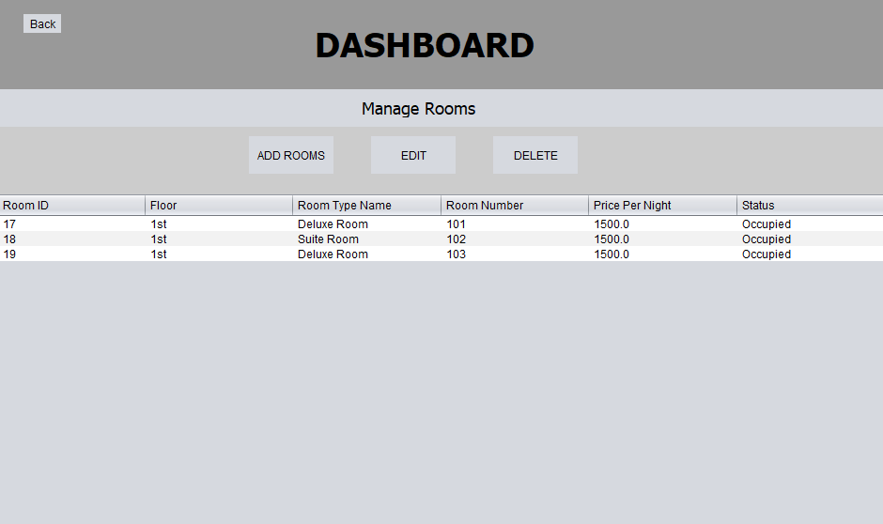

This is the primary control center for your hotel room inventory. It provides an at-a-glance view of every room registered in the system.

Features & Actions:

Rooms Data Table: A comprehensive list displaying the following columns:

Room ID: The unique system identifier for the room.

Room Number: The specific room number or name.

Room Type: The category of the room (Single, Double, Suite, etc.).

Price: The nightly or total rental cost.

Status: Indicates if a room is Available, Occupied, or Under Maintenance.

Floor: The floor level where the room is located.

Management Buttons:

Add: Opens a blank form to register a brand-new room.

Edit: Select a row in the table first, then click this to modify existing room details.

Delete: Removes a selected room from the database (with confirmation).

Room Type Lookup: Opens a dialog to search for rooms by specific type.

Search Functionality: Enter a room number, type, or ID in the search box and click the search icon to filter the list instantly.

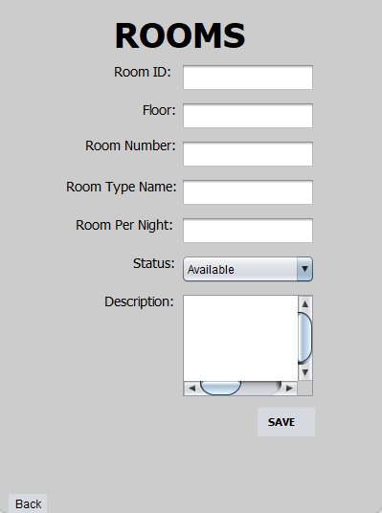
ADD ROOM

When you click the "Add" button from the Manage Rooms screen, this blank entry form appears.

Features & Actions:

Text Input Fields: Fill out the following details:

Room Number: The unique identifier for the room (e.g., "101", "Suite A").

Room Type: Select from the dropdown menu (types are managed in "Manage Room Type").

Price: Enter the numerical value for the room rate (â‚±).

Floor: Specify the floor level (e.g., "1", "2", "Ground").

Status: Set the initial availability:

- Available: Room is ready for booking

- Occupied: Room is currently in use

- Maintenance: Room is under repair

Save Button: Click this to finalize the entry and add the room to the main list. The system will validate that the room number is unique.

Note: Room types must be created first in the "Manage Room Type" section before they can be assigned to rooms.

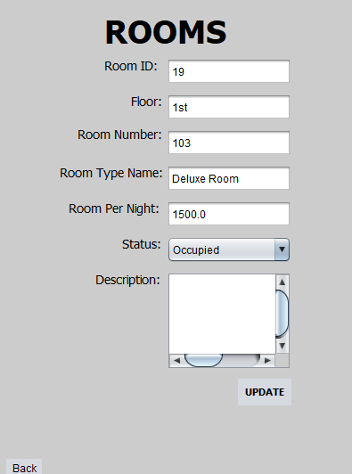
EDIT ROOM

This screen appears when you select an existing room and click "Edit." It allows for real-time adjustments to room information.

Features & Actions:

Pre-filled Data: The form automatically populates with current room information.

Editing: Click into any field to change the information:

Update room number (must remain unique)

Change room type

Adjust pricing

Modify floor location

Update Button: Click this button to save your changes. The system will validate the data and return you to the Manage Rooms screen.

Common Use Cases:

Changing room status from Available to Maintenance

Updating seasonal pricing

Correcting room information

Reassigning room types

DELETE ROOM
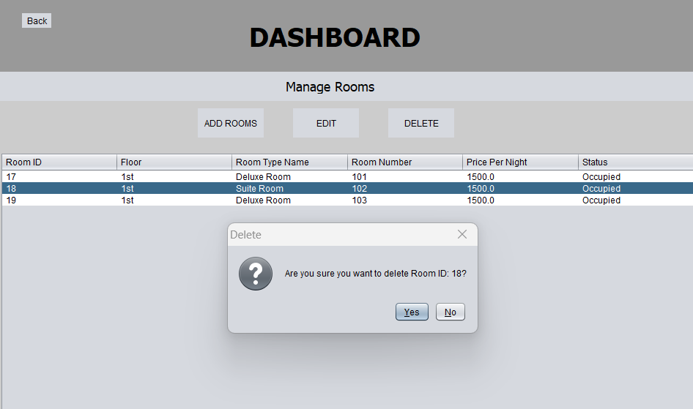

To prevent accidental data loss, the system triggers a confirmation prompt when the "Delete" button is pressed.

Features & Actions:

Safety Prompt: A dialog box appears stating: "Are you sure you want to delete this room?"

Yes Button: Click this to permanently erase the room and all its associated data from the system.

Warning: This action cannot be undone.

No Button: Click this to cancel the request and keep the room in your inventory.

Exit Icon (X): Closes the prompt without making any changes.

Safety Tip: If a room has active bookings, you may not be able to delete it. Consider changing its status to "Maintenance" instead of deleting it entirely.

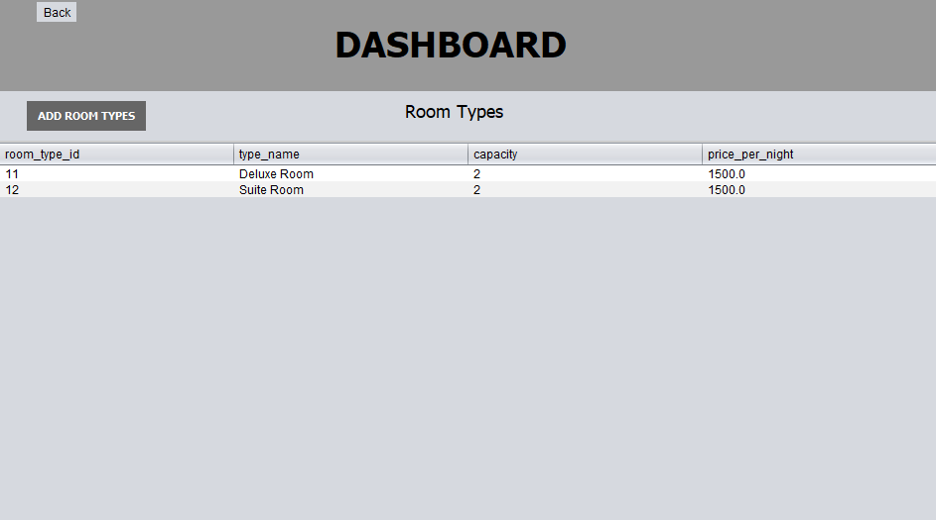
MANAGE ROOM TYPES

When you click "Manage Room Type" from the sidebar, you will see the Room Type Management interface. This allows you to define and manage the categories of rooms available in your hotel.

Features & Actions:

Room Types Data Table: Displays all room categories with the following columns:

Type ID: The unique system identifier for the room type.

Type Name: The name of the category (e.g., "Standard", "Single", "Suite", "Deluxe").

Description: Details about the room type and its features.

Base Price: The standard rate for this room category.

Capacity: Maximum number of guests allowed.

Management Buttons:

Add: Opens a form to create a new room type category.

Edit: Select a room type and click to modify its details.

Delete: Removes a selected room type (only if no rooms are assigned to it).

Note: Room types must be created before you can assign them to individual rooms in the "Manage Rooms" section.

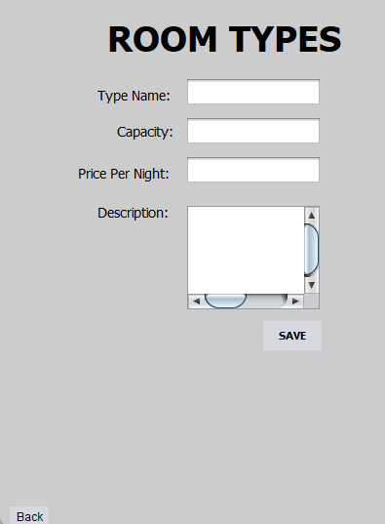
ADD ROOM TYPE

When you click the "Add" button from the Manage Room Type screen, this form appears.

Features & Actions:

Type Name: Enter the name of the room category (e.g., "Suite", "Standard ").

Description: Provide detailed information about this room type, including features and target guests.

Base Price: Set the standard nightly rate for this category .

Capacity: Enter the maximum number of guests allowed in this room type.

Description: List the features included (e.g., "King Bed, Mini Bar, Ocean View, WiFi").

Save Button: Click to create the new room type. It will now be available in the room type dropdown when adding or editing rooms.

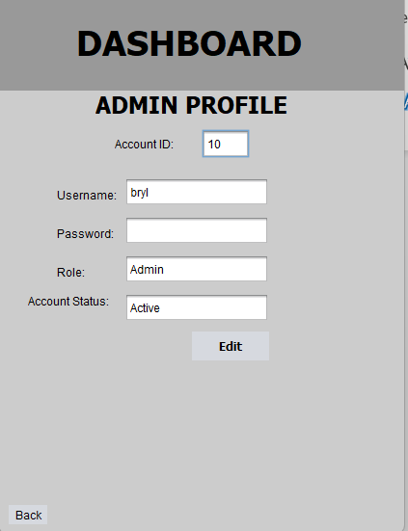
ADMIN PROFILE

When you click on the "Admin Profile" icon in the left sidebar, the system displays your personal administrative dashboard. This is a read-only view of your current credentials.

Features & Actions:

Information Display: A panel showing your stored personal data:

Username: Your login handle.

Role: Clearly shows "Admin".

Status: Your account status (should be "Active").

Administrative Controls:

Edit Profile Icon: Click this to launch the edit mode and change your profile details.

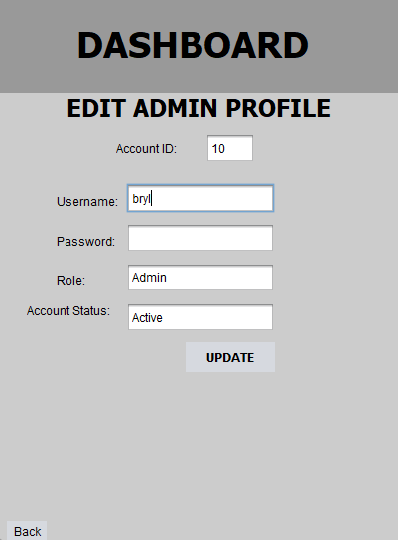
EDIT ADMIN PROFILE

Editing Profile Details:

1. Click the Edit Icon (the pencil/paper icon at the top right of the profile view).

2. The static text will change into editable input fields.

3. Update your information as needed:

· Username (must remain unique)

· Password (enter new password if changing)

4. Click "Save Changes" at the bottom to commit the new information to your account.

Note: You cannot change your own role or status. Contact another administrator if these need to be modified.

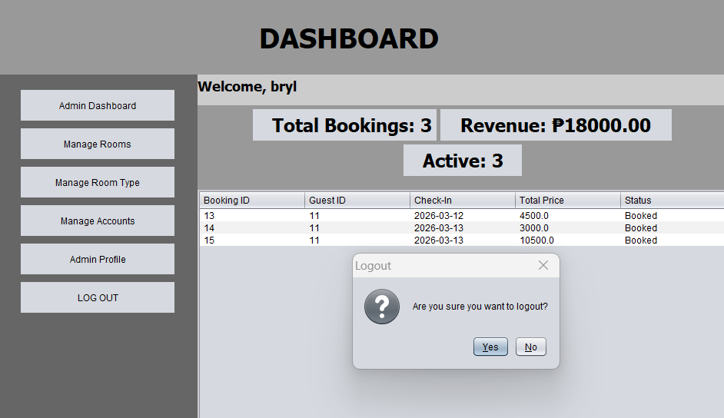
LOGGING OUT

Properly exiting the application ensures that your session is closed and your data remains secure.

Features & Actions:

Logout Trigger: Accessed via the "Log Out" button at the bottom of the left sidebar.

Confirmation Dialog: A confirmation box will appear asking: "Are you sure you want to logout?"

Yes Button: Click this to clear your session data and return to the Login screen.

No Button: Click this to cancel and remain logged in.

Security Note: Always log out when you finish using the system, especially on shared computers.

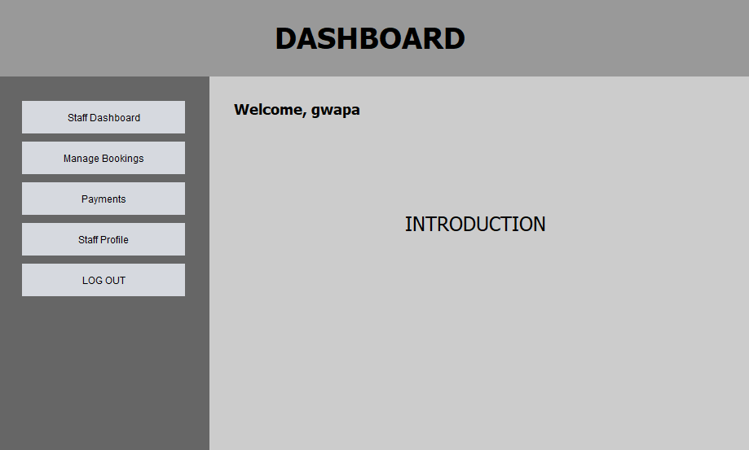
STAFF DASHBOARD

Upon successful login as a staff member, you will land on the Staff Dashboard. This is your central hub for managing daily hotel operations.

Features & Actions:

Staff Dashboard: Returns to the main welcome screen.

Manage Bookings: Handle all reservation operations.

Payments: Process guest payments.

Staff Profile: View and edit your personal account details.

Log Out: Safely exit the system.

Welcome Message: Displays "Welcome, [username]" prominently.

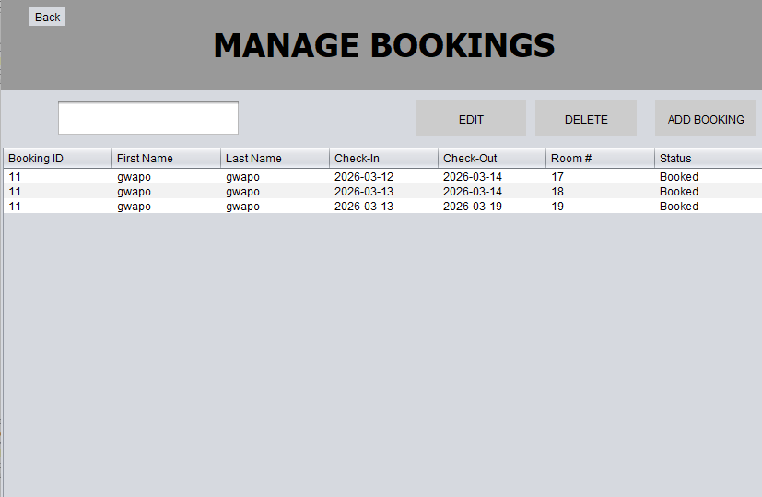
MANAGE BOOKINGS

When you click "Manage Bookings" from the sidebar, you will see the Booking Management interface. This is your control center for handling all hotel reservations.

Features & Actions:

Bookings Data Table: A comprehensive list displaying:

Booking ID: The unique identifier for each reservation.

Guest Name: The name of the guest (from accounts table).

Room Number: The assigned room.

Check-In Date: When the guest arrives.

Check-Out Date: When the guest departs.

Total Price: The complete cost of the stay (â‚±).

Booking Status: Current state (Booked, Cancelled, Completed).

Number of Guests: How many people are staying.

Management Buttons:

Add Booking: Opens a form to create a new reservation.

Edit Booking: Select a booking and click to modify its details.

Search: Filter bookings by guest name, booking ID, or date.

View Available Rooms: Check which rooms are free for specific dates.

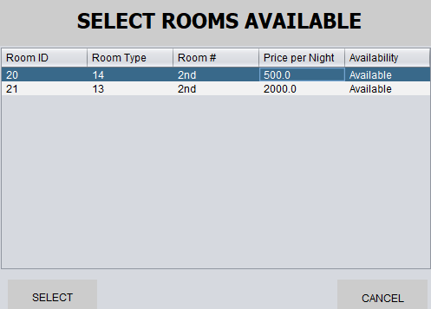
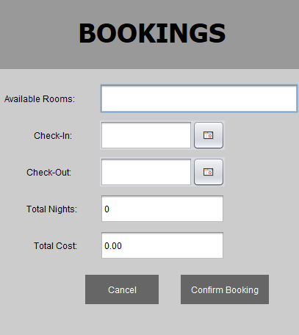
ADD BOOKING

When you click the "Add Booking" button, this form appears to create a new reservation.

Features & Actions:

Guest Selection:

Account ID Dropdown: Select the guest from registered users. Shows "ID - Name" format.

If the guest is not registered, they must create an account first.

Room Selection:

Available Room Clickable: Select from available rooms. Shows "Room Number - Type" format.

The system will display only rooms with "Available" status.

Booking Details:

Check-In Date: Use the calendar picker to select arrival date.

Check-Out Date: Use the calendar picker to select departure date.

Capacity: Enter the total number of people who stayed.

Price Calculation:

The system automatically calculates the total price based on:

- Room rate per night

- Number of nights (Check-out date - Check-in date)

Total Price: Displays the calculated amount.

Booking Status: Set initial status (typically "Booked").

Save Button: Click to create the reservation. The system will:

Validate that check-out is after check-in

Verify room availability for the selected dates

Update room status if needed

Generate a unique Booking ID

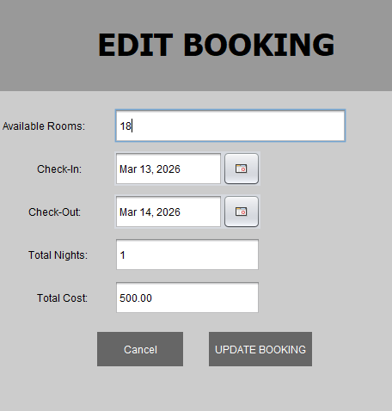
EDIT BOOKING

Select an existing booking and click "Edit" to modify reservation details.

Features & Actions:

Pre-filled Data: All current booking information is displayed.

Read-Only Booking ID: The Booking ID cannot be changed.

Modifiable Fields:

Change guest (if needed)

Reassign to different room (subject to availability)

Modify check-in/check-out dates

Update number of guests

Adjust booking status (Booked, Cancelled, Completed)

Price Recalculation: The system automatically updates the total price if dates or room are changed.

Update Button: Save changes and return to the bookings list.

Common Use Cases:

Extending a guest's stay

Changing room due to guest request

Updating booking status after check-out

Correcting booking errors

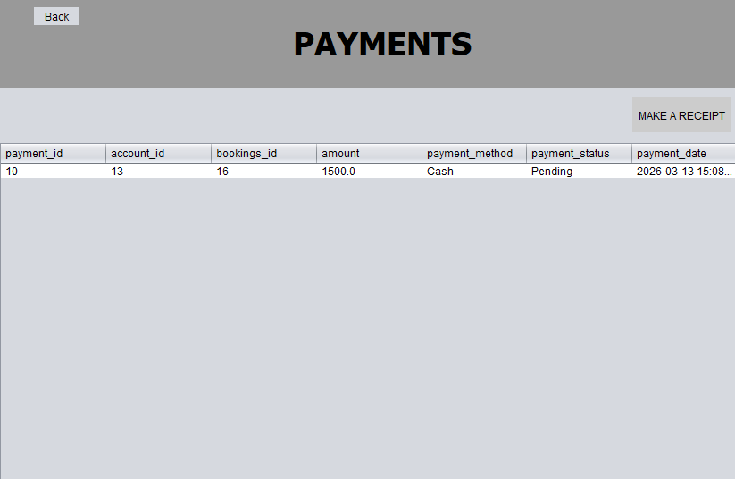
PAYMENTS

Processing Guest Payments

When you click "Payments" from the sidebar, you will see the Payment Management interface.

Features & Actions:

Payments Data Table: Displays all payment records:

Payment ID: Unique identifier for the transaction.

Booking ID: Associated reservation.

Payment Amount: The amount paid.

Payment Date: When the transaction occurred.

Payment Method: How payment was made (Cash, Card, Online).

Payment Status: Current state (Pending, Paid, Refunded).

Management Functions:

Process Payment: Select a booking and record payment details.

Update Status: Change payment status from Pending to Paid.

View Payment History: Filter by date, guest, or status.

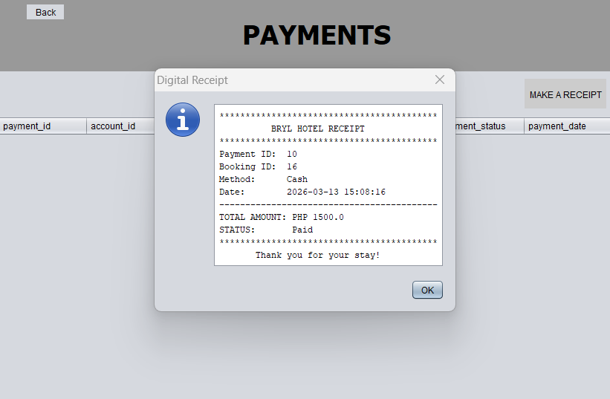
Make A Receipt: Create a payment receipt for the guest.

Payment Workflow:

1. Guest checks in or requests to pay

2. Staff selects the booking

3. Records payment amount and method

4. Updates status to "Paid"

5. System generates receipt

6. Guest receives confirmation

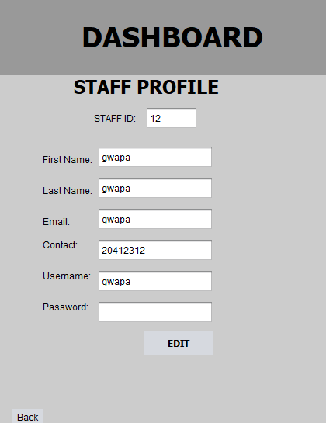
STAFF PROFILE

Viewing Your Profile

When you click on the "Staff Profile" icon in the left sidebar, the system displays your personal dashboard.

Features & Actions:

Information Display: Your stored personal data:

Full Name: Your complete registered name.

Username: Your login handle.

Email: Your contact email address.

Contact: Your phone number.

Role: Shows "Staff".

Status: Your account status (should be "Active").

Edit Profile Icon: Click to modify your personal information.

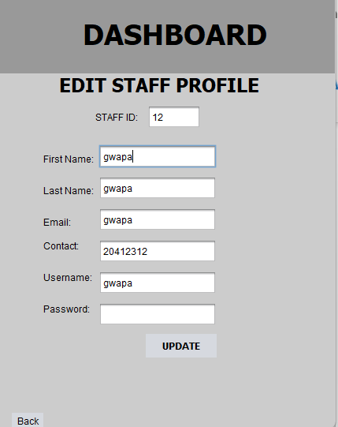
EDIT STAFF PROFILE

Editing Profile Details:

1. Click the Edit Icon at the top right of the profile view.

2. Editable fields will appear.

3. Update your information:

First Name & Last Name

Email address

Contact number

Username (must remain unique)

Password (if changing)

4. Click "Save Changes" to update your account.

Note: You cannot change your own role or status. Contact an administrator if these need modification.

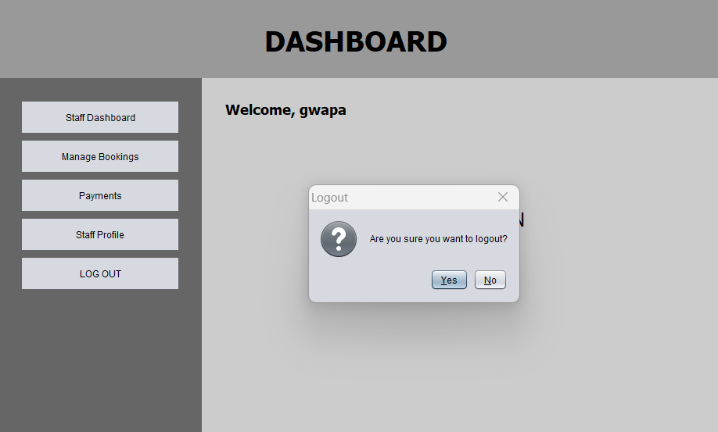
STAFF LOGOUT

Features & Actions:

Logout Button: Located at the bottom of the left sidebar.

Confirmation: System asks "Are you sure you want to logout?"

Yes: Clears session and returns to Login screen.

No: Cancels and keeps you logged in.

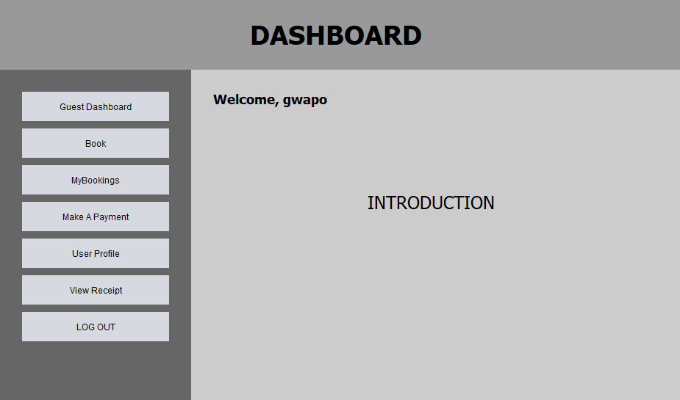
GUEST DASHBOARD

Viewing Guest Dashboard

Upon successful login as a guest, you will land on the Guest Dashboard. This is your personal hub for managing your hotel bookings.

Features & Actions:

Left Navigation Bar: Access guest features:

Guest Dashboard: Returns to the main welcome screen.

Book: Browse and reserve available rooms.

MyBookings: View your reservation history.

Make A Payment: Process payments for your bookings.

View Receipt: See and print your payment receipts.

User Profile: Manage your personal information.

Log Out: Safely exit the system.

Welcome Message: Displays "Welcome, [username]" prominently.

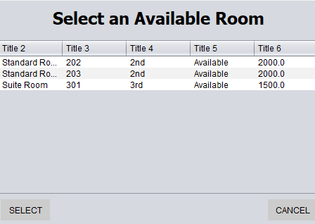
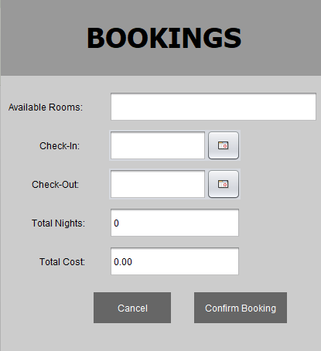
BROWSE ROOMS (BOOK)

When you click on "Book" in the sidebar, you can explore all available hotel rooms.

Features & Actions:

Available Room Gallery: Visual display of available rooms showing:

Room Number: The room identifier.

Room Type: Category (Single, Double, Suite, etc.).

Price: Nightly rate.

Floor: Location in the hotel.

Description: Brief overview of room features and amenities.

Status: Shows "Available" for bookable rooms.

Search Functionality: Use the search bar to find specific rooms by:

· Room number

· Room type

· Price range

· Floor

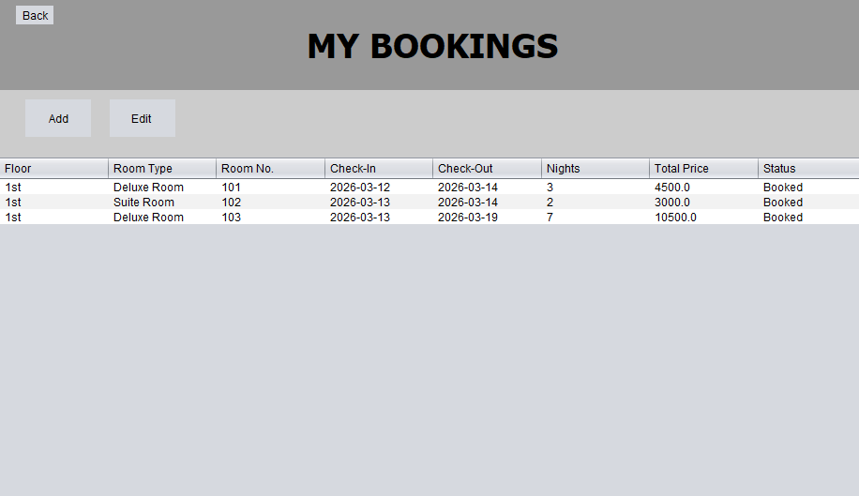
VIEW MY BOOKINGS

Clicking the "MyBookings" icon allows you to track the status of your current and past booking requests.

Features & Actions:

My Bookings Table: A summary of your reservations showing:

Booking ID: Your unique reservation number.

Room Number: Which room you booked.

Room Type: Category of your room.

Check-In Date: Your arrival date.

Check-Out Date: Your departure date.

Total Price: Complete cost of your stay (â‚±).

Booking Status: Current state:

- Booked: Reservation confirmed

- Cancelled: Reservation cancelled

- Completed: Stay finished

Number of Guests: How many people in your party.

Management Options:

Edit Booking: Click the edit icon to modify your reservation details.

Cancel Booking: Click to cancel your reservation (confirmation required).

View Details: Click on a booking row to see complete information.

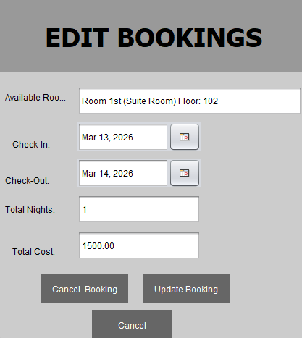
EDIT BOOKING

Clicking the edit icon at the MyBookings page will bring you to the booking modification form.

Features and Actions:

1. Pre-filled Information: Your current booking details are displayed.

2. Modifiable Fields:

· Check-In Date: Change your arrival date (subject to availability).

· Check-Out Date: Change your departure date.

3. Price Recalculation: The system automatically updates the total price based on your changes.

4. Update Button: Click to save your modifications.

Important Notes:

You can only edit bookings with "Booked" status

Date changes are subject to room availability

Price adjustments will be reflected in your payment

If you've already paid, contact staff for refund/adjustment

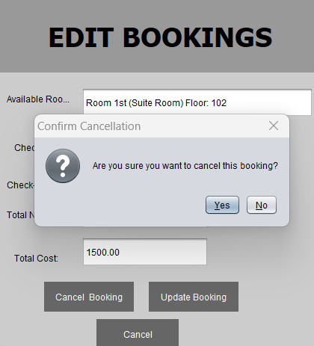
CANCEL BOOKING

Select a specific reservation from the MyBookings list and click "Cancel Booking."

Features & Actions:

Selection Required: You must highlight a booking row first.

Confirmation Prompt: A warning dialog appears asking: "Are you sure you want to cancel this reservation?"

Yes Button: Click to confirm cancellation.

- Booking status changes to "Cancelled"

- Room becomes available again

- If payment was made, contact staff for refund

No Button: Click to keep your reservation active.

Error Message: If no booking is selected, the system displays: "Please select a reservation to cancel."

Cancellation Policy Note: Check with hotel staff regarding refund policies for cancelled bookings.

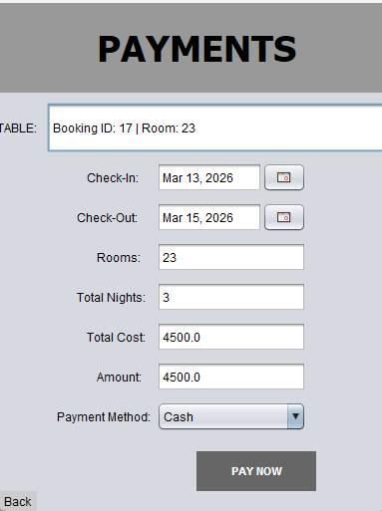
MAKE A PAYMEN

When you click "Make A Payment" from the sidebar, you can process payments for your bookings.

Features & Actions:

Booking Selection:

The system displays your bookings that require payment

Select the booking you want to pay for

Payment Information Display:

Booking ID: Your reservation number

Room Details: Room number and type

Total Amount Due: The amount you need to pay (â‚±)

Booking Dates: Check-in and check-out dates

Payment Method Selection:

· Cash: Pay at the front desk

· Card: Credit or debit card payment

· Online: Digital payment methods

Payment Processing:

1. Select your booking from the list

2. Choose payment method

3. Enter payment details (if required)

4. Confirm payment amount

5. Click "Process Payment" or "Submit"

Payment Confirmation:

Payment status updates to "Paid"

Payment ID is generated

Receipt becomes available

Booking is fully confirmed

Note: After successful payment, you can view and print your receipt from the "View Receipt" section.

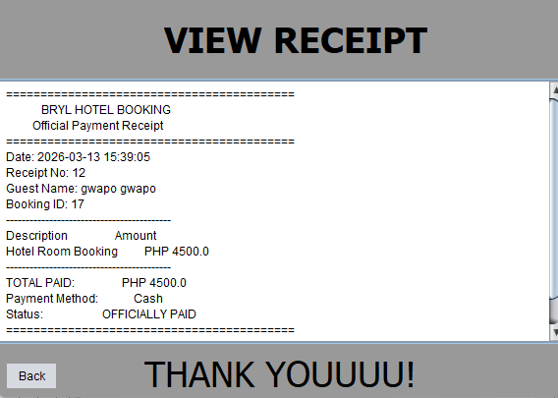
VIEW RECEIPT

Clicking "View Receipt" allows you to see and print your payment confirmation.

Features & Actions:

Receipt Display: Shows your latest paid receipt with:

Receipt/Payment ID: Unique transaction number

· Booking Information:

- Booking ID

- Room number and type

- Check-in and check-out dates

Guest Details:

- Your name

- Contact information

- Email address

Payment Details:

- Payment amount (â‚±)

- Payment date and time

- Payment method

- Payment status (Paid)

Print Receipt Button: Click to open the print dialog:

Important: Only receipts for completed payments (status: "Paid") will be displayed. If you don't see a receipt, ensure your payment has been processed successfully.

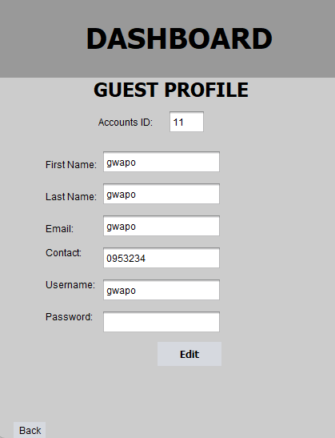
USER PROFILE

Viewing Your Profile

Clicking the "User Profile" icon displays your personal information. This section allows you to manage how you are identified within the system.

Features & Actions:

Information Display:

Full Name: Your first name and last name.

Username: Your login handle.

Email: Your registered contact email address.

Contact: Your phone number.

User Type: Shows "Guest".

Status: Your account status (should be "Active").

Address: Your registered address (if provided).

Edit Profile Icon: Click the pencil/edit icon at the top right to modify your information.

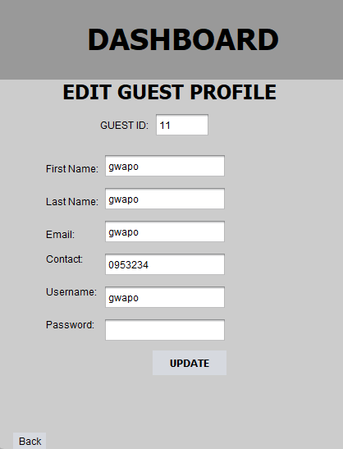
EDIT USER PROFILE

Editing Profile Details:

1. Click the Edit Icon (the pencil/paper icon at the top right).

2. The static text will change into editable input fields.

3. Update your information as needed:

· First Name & Last Name: Correct or update your name

· Email: Change your contact email

· Contact: Update your phone number

· Username: Modify your login name (must be unique)

· Password: Enter a new password if you want to change it

· Address: Update your residential address

4. Save Changes: Click the "Save Changes" button at the bottom to commit the new information to your account.

5. Confirmation: The system will display a success message and return you to the profile view.

Important: Keep your contact information up-to-date so the hotel can reach you regarding your bookings.

