|  |  |  |  |
| --- | --- | --- | --- |
|  |  |  |  |
|  | Classes | Dutch |  |
| SVM | Collision | Aanrijding |  |
| Aggressive and extreme physical exertion | Agressie en extreme lichamelijke inspanning |  |
| Other forms of contact with objects | Andere vormen van contact met voorwerpen |  |
| BHV medical deployment on location | BHV inzet op locatie |  |
| Hazardous material (fire or explosion) | Gevaarlijke stoffen, brand en explosies |  |
| Machine hand tools | Machines en handgereedschap |  |
| Fall (person or objects) | Vallen (van personen of voorwerpen) |  |

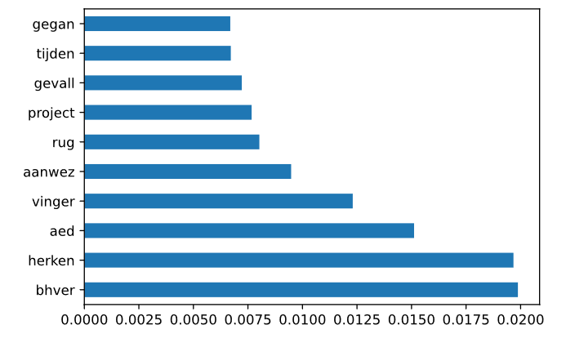

|  |  |  |  |
| --- | --- | --- | --- |
|  |  |  |  |
|  |  | Dutch |  |
| SVM | gone times case back present aed recognize bhver | gegan  tijden  gevall  rug  aanwez  aed  herken  bhver |  |