What Explains Seniority in the U.S. House of Representatives?
A journal-style research note using data from the 116th Congress (2019–2021)

Bryson Benford
Texas A&M University
March 2026

Abstract
Why do some members of the U.S. House remain in office for many terms while others leave quickly? This paper evaluates whether party affiliation helps explain variation in House seniority using a cross-sectional sample of representatives from the 116th Congress. The descriptive pattern suggests that Democrats served slightly longer on average than Republicans. However, a multivariate model tells a different story. Once district-level presidential vote share and ideological distance from the congressional median are included, the party coefficient is no longer statistically distinguishable from zero. District safety emerges as the clearest predictor of seniority, while ideological distance is negatively associated with tenure but does not meet conventional significance thresholds in the fully specified model. The central takeaway is modest but important: apparent party differences in congressional longevity seem to reflect underlying electoral conditions more than party label alone.

Keywords: Congress, incumbency, House of Representatives, seniority, district safety, ideology

Introduction
Seniority matters in Congress. Members who remain in office longer typically build stronger committee positions, gain procedural knowledge, and accumulate more influence over the legislative process. Yet tenure is unevenly distributed. Some representatives spend decades in the House, while others exit after only one or two terms. This paper asks a straightforward question: does party affiliation help explain why some House careers last longer than others?
The original expectation behind this project was that Democratic representatives would, on average, serve more terms than members of other parties. That expectation is plausible on descriptive grounds. Democrats are often elected from dense urban districts that lean consistently toward their party, and such districts may provide more insulation from electoral turnover. But descriptive differences can be misleading. A party gap in seniority may simply reflect differences in electoral context rather than an independent party effect.
To separate these possibilities, I estimate a regression model in which House seniority is explained by party, district safety, and ideological distance from the chamber median. The analysis shows that the raw party gap shrinks once those controls are added. In substantive terms, the findings suggest that structural electoral conditions matter more for congressional longevity than party label by itself.

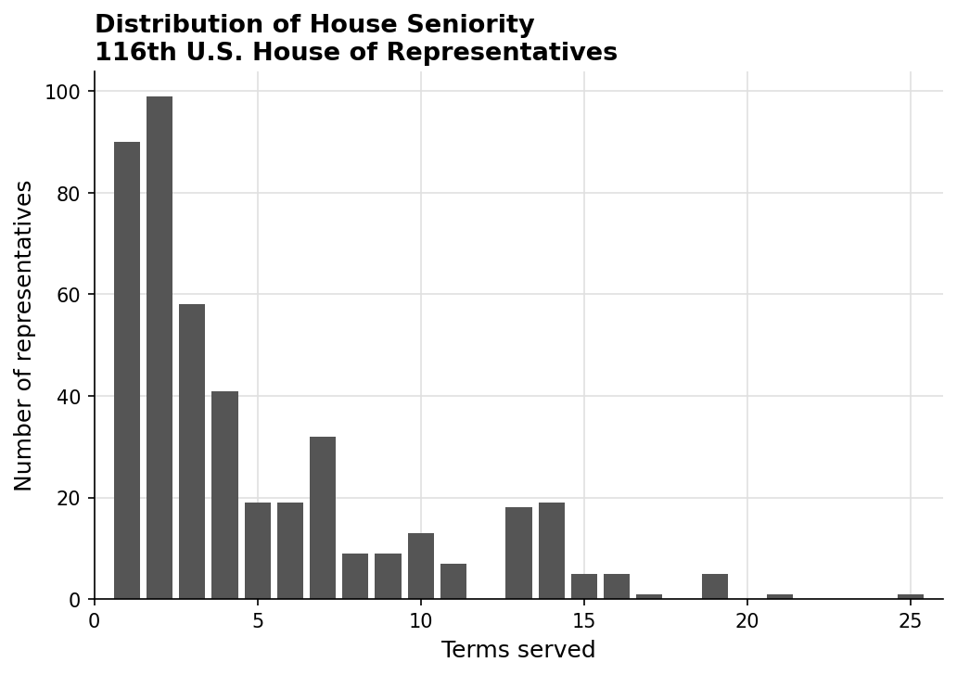
Figure 0. Distribution of House seniority in the 116th Congress. The distribution is right-skewed, with the largest share of members serving three terms or fewer.

Data and Research Design
The analysis uses member-level data for the 116th U.S. House of Representatives. The dependent variable is seniority, measured as the number of terms served. The key independent variable is party affiliation. The model also includes two controls. First, district safety is proxied with the incumbent party's share of the two-party presidential vote in the district (inc_pres_pct_2p). Second, ideological distance is measured with meddist, which captures how far a representative's ideological position is from the congressional median.
Because the dataset contains only one Independent and one Libertarian, the regression analysis is restricted to the two major parties. This avoids letting two single-observation categories distort inference. The descriptive figure still reports all party groups, but the multivariate model focuses on Democrats and Republicans, which is the defensible comparison in this dataset.
This is a cross-sectional observational design, so the estimates should be read as associations rather than causal effects. Even so, the model is useful for showing whether an apparent party gap survives after basic electoral and ideological controls are introduced.

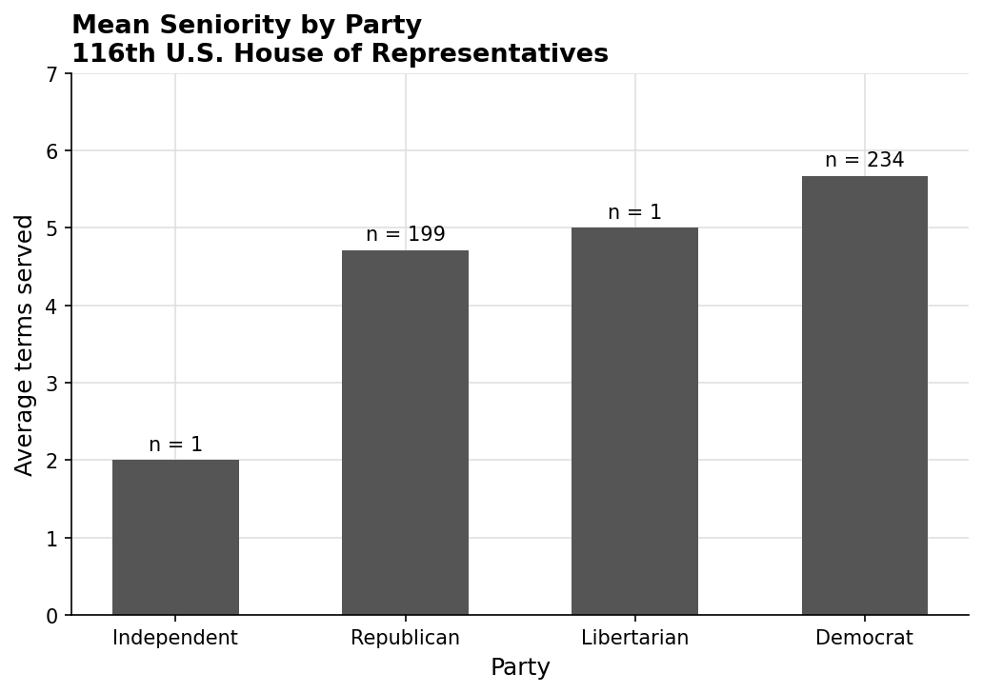
Figure 1. Mean seniority by party in the 116th House. The Independent and Libertarian categories each contain a single member, so those bars should be interpreted cautiously.

Descriptive Pattern
Figure 1 shows a simple party comparison. Democrats averaged 5.67 terms, compared with 4.71 terms for Republicans. On its face, that gap supports the original hypothesis. But the third-party categories illustrate why descriptive comparisons require caution: the Libertarian average is driven by a single case, Justin Amash, whose tenure was accumulated before his party switch. In other words, raw averages alone cannot tell us whether party is the main explanation for seniority.

Descriptive Statistics
Party | N | Mean seniority | Mean district safety | Mean meddist
Republican | 163 | 4.50 | 60.62 | 0.68
Democrat | 218 | 5.38 | 63.32 | 0.20
Table 1. Descriptive statistics for major-party representatives included in the regression model.

Regression Results
The multivariate model estimates House seniority as a function of party, district safety, and ideological distance. To make the presentation more defensible for a portfolio piece, the table reports heteroskedasticity-robust standard errors (HC3). The coefficient on Democrat is negative once controls are included, but it is small relative to its uncertainty and not statistically significant. By contrast, district safety is positive and precisely estimated: representatives from safer districts tend to accumulate more terms. Ideological distance is negative, which is directionally consistent with the idea that moderation may support longer careers, but the estimate does not reach the conventional 0.05 threshold.
Variable | Coefficient | Robust SE | p-value | 95% CI
Intercept | -0.751 | 1.817 | 0.679 | [-4.312, 2.809]
Democrat (ref. Republican) | -1.101 | 1.208 | 0.362 | [-3.468, 1.267]
District safety (inc_pres_pct_2p) | 0.125 | 0.029 | 0.000 | [0.067, 0.182]
Ideological distance (meddist) | -3.411 | 1.949 | 0.080 | [-7.231, 0.408]
Table 2. OLS model predicting House seniority among Democrats and Republicans (N = 381).

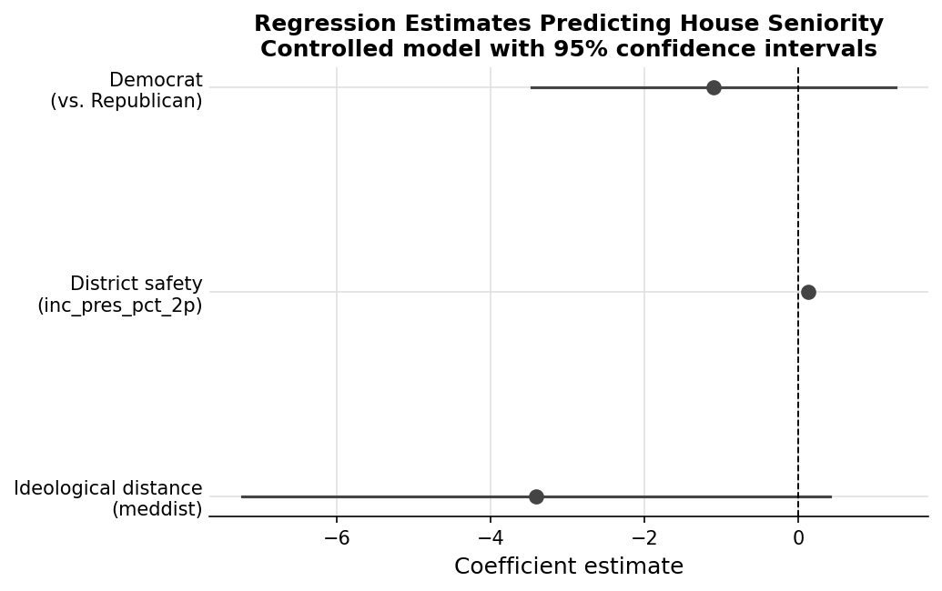
Figure 2. Coefficient plot for the fully specified regression model.

Discussion
The descriptive comparison and the regression model tell different stories. In the bivariate relationship, Democrats appear to have a modest seniority advantage. Once district safety and ideology are included, however, that advantage fades. The implication is that party matters less as an independent explanation of tenure than as a marker for the kinds of districts and ideological positions members occupy.
That conclusion is especially relevant for presenting this project in a professional setting. The strongest version of the analysis is not that one party is inherently better at keeping members in office. It is that electoral context structures congressional careers. Members from safer districts have more room to survive shocks, build seniority, and translate incumbency into durability. Party differences seem to operate largely through those underlying conditions.
The analysis also has limits. It uses one Congress, so it cannot capture how seniority evolves over time or how national waves reshape incumbency advantages. A fuller project would pool multiple Congresses or estimate a survival model of member exit. Even with those limits, this paper demonstrates a clear empirical workflow: start with a plausible hypothesis, test it with multivariate analysis, and revise the conclusion when the evidence points in a different direction.

Conclusion
This paper began with a simple expectation that Democratic representatives would serve longer in the House than other members. Descriptive evidence offered partial support for that idea, but the regression model did not. Once district safety and ideological distance are taken into account, party affiliation no longer provides a meaningful standalone explanation of congressional seniority. The broader lesson is that longevity in the House is shaped less by party label alone than by the political environment in which a representative competes.

Appendix: Reproducibility Note
A cleaned R script accompanies this paper. The script removes interactive commands, uses explicit package checks, restricts the multivariate analysis to the two major parties for defensible inference, computes HC3 robust standard errors, and exports publication-ready figures and tables. That version is designed to read more like professional analytical work than a classroom lab script.

