Bryson Webb
CSE 325 .NET
May 13, 2026
U02 Team Assignment
Summary:
During this group meeting we made our project name Momentum. We talked about what it will do as well. Momentum is an app that helps you keep track of your goals and habits in one place. You can set daily habits, build routines, track your progress, and stay motivated by seeing your streaks and consistency over time. It’s made to help you stay on top of the things you want to improve and make it easier to stay accountable every day.
Attendees:
Ami Hasley, Bryson Webb, Carolina Barion, Fernando Pinto, Daniel Nthengu
Repository:
https://github.com/ameliarose003/cse325-deadline-crushers
Screenshot:
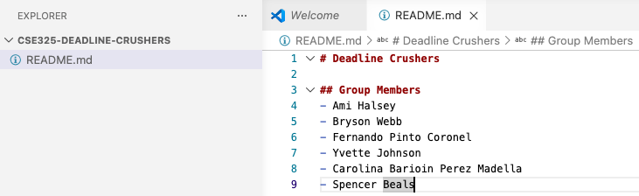
Project Proposal:
We thought of a couple different apps such as a financial app, fitness app and we ended up coming back with the Momentum application because you can truly tailor it to many different sectors.

