

COLLEGE OF BUSINESS AND ECONOMICS
School of Consumer Intelligence and Information Systems
Department of Information and Knowledge Management
Application for ethics clearance

PhD (Information Management)
University of Johannesburg
College of Business and Economics
Department of Information and Knowledge Management

Title: An AI-driven Framework for the Digitalisation of Corporate Organizations in South Africa

SECTION ONE: INTRODUCTION TO THE STUDY

1.1 Introduction and Background
Corporate digital transformation is currently failing at a rate that demands both scholarly explanation and an urgent practical response. Research indicates that approximately 89% of large-scale digitalisation initiatives either stall at the pilot stage or fail to generate measurable strategic value (Lamarre et al., 2023). This systemic failure does not stem from technological inadequacy. Instead, it originates from an architectural mismatch: organisations frequently inject advanced digital tools into rigid organisational structures that cannot absorb or govern them effectively (Sarker et al., 2019; Wessel et al., 2021). For South African corporate organisations, severe institutional and infrastructural constraints further amplify this global challenge. Consequently, these firms require a different architectural response.

Understanding the distinctiveness of South Africa's corporate digitalisation environment is an essential starting point. This environment is not merely a more difficult version of the challenges facing firms in other emerging markets. Rather, it represents a specific convergence of structural, institutional, and governance conditions. Together, these conditions invalidate the use of standard, global frameworks.

Firms operating in this environment face a paradoxical tension. They must pursue AI-driven transformation to remain competitive, yet they must simultaneously maintain institutional stability. Furthermore, they need to comply with stringent regulatory and ethical mandates. Prominent among these are the Protection of Personal Information Act (POPIA) and the transparency and accountability expectations embedded in the King IV Report on Corporate Governance (Information Regulator, 2023; IoDSA, 2016).

This tension creates a significant governance challenge. Commercially deployed AI systems often function as opaque decision engines. Their internal logic resists the type of audit and justification that responsible corporate governance demands. This creates a structural conflict that the principles of King IV make impossible to bypass (IoDSA, 2016; Watney, 2021). Consequently, local business leadership bodies and development partners have identified key requirements for any ethical AI framework suited to South African corporate conditions. These foundational requirements include transparency, bias mitigation, and accountable AI deployment (BUSA, 2024; Information Regulator, 2023).

Increasing the spatial scale of analysis to the continental level reveals similar demands. The African Union’s AI Strategy positions intelligent systems as central to realising the developmental ambitions of Agenda 2063. However, this strategy makes clear that such potential depends entirely on African firms. These enterprises must develop the internal capacity to govern AI systems purposefully and on their own terms (African Union, 2024).

Ultimately, the architectural mismatch threatens algorithmic sovereignty. This concept denotes an organisation's capacity to direct AI towards its own institutional values, rather than inheriting the assumptions of externally designed systems (Birhane, 2021; Kwet, 2019). As subsequent sections establish in detail, the uncritical adoption of foreign AI models creates a severe risk of digital colonialism. In this scenario, AI systems systematically misread the operational and socio-economic realities of the South African environment (Ade-Ibijola & Okonkwo, 2023; Kwet, 2019).

Addressing this challenge requires a departure from current fiduciary passivity. This passivity is characterised by the absence of structured AI governance accountability at the board level. Instead, organisations must transition towards contextually grounded AI stewardship. This transition represents the primary governance challenge that the present research is designed to address. The contextual case for why a different kind of framework is needed is established in the subsections that follow. Section 1.4 then introduces the AI-driven Strategic Resilience Framework (AI-SRF) in outline, while Section 4 provides the full architectural specification.

1.1.1 Continental Strategic Alignment and Ecosystem Stakeholders
South Africa's corporate digitalisation challenge extends beyond the boundaries of the individual firm and national borders. It constitutes a broader continental challenge with direct implications for Africa's economic integration ambitions. The African Union's Digital Transformation Strategy (2020-2030) positions digital platforms as the critical foundation for intra-African trade under the African Continental Free Trade Area (AfCFTA) (African Union, 2020). This ambition depends fundamentally on African firms cultivating genuine digital capabilities from within. However, a severe structural impediment hinders this progress. This impediment manifests as "institutional voids" (Khanna & Palepu, 2010). These voids denote the absence of specialised intermediaries, regulatory mechanisms, and contract-enforcement infrastructure. Firms in developed markets take these structures for granted, yet they are essential for digital commerce to function effectively.

In most developed markets, artificial intelligence serves primarily to optimise processes that already function. Conversely, in South Africa and across much of the African continent, organisations increasingly require AI to compensate for non-existent infrastructure and institutional capacity. For instance, AI must predict logistics failures in environments with unstable grid infrastructure. It must estimate creditworthiness where formal credit bureau coverage remains incomplete. Furthermore, it must verify identity where civil registration systems are fragmented (Havenga, 2021; World Bank, 2024). Firms that successfully navigate this complex operating environment share a distinct strategic capability. They do not merely use AI to optimise existing operational processes. Instead, they deploy AI to actively substitute for the institutional scaffolding that their international competitors naturally inherit.

Organisations that formulate AI strategies without explicitly accounting for these ecosystem constraints commit a fundamental architectural error. They do not merely sub-optimise within their competitive environment; rather, they actively design against it. This strategic misalignment serves as a primary driver of the high digitalisation failure rates documented throughout the region (Investec, 2024; Schoeman et al., 2021).

1.1.2 The "GenAI Paradox" and Systemic Digitalisation Failure
The rapid integration of generative AI into corporate workflows since 2022 has exposed a critical divergence. This divergence exists between a firm's capability to generate content and the actual quality of its organisational decision-making. The present study conceptualises this structural gap as the "GenAI Paradox". Despite an exponential proliferation in AI-assisted content and code production, measurable enhancements in the velocity and quality of strategic decisions have failed to materialise (Brynjolfsson et al., 2023; Dell, 2024). Consequently, the mere adoption of generative tools does not automatically translate into improved strategic outcomes.

While current AI models possess practically unlimited information-processing capacity, they face fundamental limitations in complex managerial contexts. As established in extant literature, these systems lack a sense of self, purpose, and intentionality (Braga & Logan, 2017; Floridi, 2008). Consequently, they rely entirely on human managers to define their objectives and contextualise their operational scope. Furthermore, machines do not possess general intelligence; they remain restricted to the specific tasks for which they were trained and cannot autonomously transfer learning across disparate organisational domains (Davenport & Kirby, 2016). In highly ambiguous corporate environments, these systems can only generate a range of options that relax real-world constraints, thereby demanding continuous human intuition, common-sense reasoning, and micromanagement to finalise strategic decisions (Brynjolfsson & McAfee, 2014; Davis & Marcus, 2015).

This technological limitation is particularly acute within the South African operating environment. Severe national skills shortages severely constrain organisational capacity. Consequently, firms cannot afford to allocate their scarce human experts to perpetual cycles of "prompt engineering." Such intense human-machine interaction, when focused merely on operational inputs, represents a highly inefficient allocation of intellectual capital.

Resolving this paradox requires a fundamental architectural shift. Organisations must transition from passive Generative AI towards Agentic AI. Agentic systems possess the capacity to perceive their environment, reason about complex workflows, and execute multi-step chains of thought. These capabilities allow them to achieve high-level business goals autonomously (Wang et al., 2024; Xi et al., 2023). This study establishes that Agentic AI constitutes the critical architectural layer previously missing from the corporate digitalisation stack. It provides the precise mechanism required to translate environmental intelligence into coordinated, goal-directed organisational action.

1.1.3 The Epistemic Gap and Boardroom Fiduciary Responsibility
The transition towards Agentic AI—further defined and specified in Section 2.2.1—introduces profound governance implications. As these advanced systems transform static data into dynamic corporate action through autonomous decision execution, they necessitate an elevated standard of boardroom oversight. The King IV Report on Corporate Governance establishes a direct, non-delegable obligation for South African boards to oversee artificial intelligence systems. Currently, most boards lack the institutional capacity to fulfil this mandate.

South African company law has long established the duty of care and skill as a standard for informed, diligent oversight. This duty now explicitly extends to algorithmic systems, whose outputs increasingly dictate material corporate decisions. Boards cannot credibly discharge this fiduciary duty without sufficient AI literacy. King IV’s associated guidance defines this literacy as the capacity to actively interrogate the logic, inherent limitations, and ethical implications of deployed AI systems, rather than merely ratifying technical recommendations from subordinate executives (BUSA, 2024; IoDSA, 2016; IoDSA, 2021). The critical disparity between incumbent board-level knowledge and these expanded governance requirements constitutes what this study conceptualises as a "fiduciary vacuum". This vacuum operates as a primary source of both severe legal exposure and strategic fragility.

The practical consequences of this inability to interrogate AI systems extend significantly beyond mere regulatory non-compliance. When an algorithmic recommendation circulates through executive decision-making channels without undergoing rigorous testing against local institutional realities, it lacks a natural governance checking mechanism. This study introduces the term "strategic hallucinations" to classify this specific failure mode. Strategic hallucinations represent confident, algorithmically generated outputs that appear analytically robust but remain fundamentally misaligned with the firm’s regulatory obligations, operating context, or constitutional commitments. These outputs frequently proceed unchallenged precisely because no actor within the governance chain possesses the requisite epistemic tools to evaluate them critically (Ade-Ibijola, 2025; Birhane, 2021; Floridi et al., 2018).

Consequently, closing this epistemic gap represents a fundamental challenge of governance design rather than a strictly technical problem. Section 1.4 introduces the proposed architectural solution to this governance deficit, while Section 4 provides the comprehensive architectural specification detailing how this framework addresses the overarching boardroom accountability challenge.

1.1.4 Navigating the South African "Digital Gauntlet"
Operating within South Africa's institutionally constrained corporate environment requires significantly more than adaptive planning. It necessitates the organisational capacity to recalibrate strategy in real-time as critical infrastructure conditions deteriorate. This study conceptualises this capacity as "Strategic Pivoting". This concept refers to the dynamic capability of a firm to decisively reorient its operational trajectory when energy instability, logistics disruption, or regulatory fragmentation threatens the viability of its current strategic position (Eisenhardt, 1990; Teece, 2018; Woods, 2019).

Strategic pivoting, within this context, does not constitute mere reactive improvisation. Rather, it represents a structured, intelligence-driven response that relies entirely on the quality and velocity of information available to corporate leadership at the precise moment of disruption. This requirement exposes the fundamental failure of conventional planning architectures. Legacy architectures are designed exclusively for stable conditions that can be modelled in advance. They cannot accommodate the compound, non-linear system failures that define what this study terms "Environmental Hostility". Section 1.2 systematically identifies this governance gap as the primary problem dimension of the study, while Section 4 specifies the requisite architectural response.

Furthermore, the dominant model of enterprise AI deployment erroneously treats intelligent systems merely as execution tools. Under this paradigm, AI represents sophisticated automation designed to execute predefined instructions more efficiently than human labour. However, this model remains fundamentally insufficient for the complex strategic demands of the South African operating context. Section 2.3 analyses this critical limitation in detail, demonstrating why the proposed framework is explicitly designed to transcend a purely execution-focused approach.

Consequently, the imperative for South African boards extends far beyond the simple adoption of additional AI tools. The fundamental challenge is to construct a robust governance architecture. Through this architecture, intelligent systems can be purposefully directed towards the organisation's specific objectives, strictly constrained by its unique regulatory obligations, and continuously assessed against its local institutional realities. The design and specification of this governance architecture form the central subject of this study.

1.2 Statement of the Problem
This research addresses a multifaceted problem that no single dimension of South African corporate digitalisation failure adequately captures. Three structurally connected conditions interact to render existing AI governance frameworks inadequate for this specific operating environment.

The first condition is architectural. Currently, no coherent, AI-driven governance framework exists that is explicitly designed for South African corporate operating conditions. Specifically, organisations lack a framework capable of bridging the gap between strategic intent and operational execution under persistent institutional constraint. Frameworks developed for institutionally stable environments embed assumptions regarding infrastructure reliability, regulatory consistency, and human capital availability. The South African operating context fails to satisfy these assumptions. Applying these frameworks without contextual adaptation produces what this study conceptualises as "strategic decoupling". This phenomenon represents a progressive divergence between the environmental conditions a digital system assumes and the reality that the environment actually delivers (Ade-Ibijola & Okonkwo, 2023; Khanna & Palepu, 2010; Vial, 2019).

The second condition is environmental. South African corporate organisations operate under conditions of compound infrastructure failure. This failure manifests as a convergence of chronic energy instability, water insecurity, and logistics fragility, which this study conceptualises as "Environmental Hostility". This hostility renders deterministic, rules-based digital architectures inadequate. Furthermore, it completely inverts the viability calculus of technical configurations that would otherwise succeed in stable markets (Havenga et al., 2023; PwC South Africa, 2024; Schoeman et al., 2021).

The third condition is epistemic. At the highest levels of corporate decision-making, South African boards and executive teams frequently lack the conceptual capacity to interrogate AI systems actively. They struggle to evaluate the strategic implications of these systems or to detect contextual misalignment within algorithmically generated recommendations. This epistemic deficit produces what this study terms a "fiduciary vacuum". The consequences of this vacuum for organisational resilience are as severe as those arising from the architectural and environmental dimensions (Information Regulator, 2023; Kwet, 2019; NIST, 2023).

The interaction and mutual amplification of these three dimensions—an absent contextual framework, environmental hostility, and a profound governance deficit—constitute the core research problem. South African corporate organisations currently lack a structured mechanism to translate AI capability into sustainable strategic resilience. They must achieve this resilience under severe conditions that no existing governance framework was designed to address.

1.3 Purpose, Research Questions, and Objectives
1.3.1 Primary Purpose of the Study
The primary purpose of this research is to design, develop, and validate a contextually grounded, AI-driven framework for corporate digitalisation specifically tailored to the South African operating environment.
Every design decision embedded in the AI-driven Strategic Resilience Framework (AI-SRF) is shaped by these three interacting dimensions: the absence of a contextually appropriate governance framework, severe environmental constraints imposed by institutional voids, and a pervasive board-level governance deficit.

Crucially, the intended outcome of this framework is not the mere pursuit of technological sophistication for its own sake. Instead, the framework aims to generate what this study conceptualises as a measurable "Return on Resilience" (ROR). This metric denotes the sustained organisational capacity to absorb systemic disruption, maintain strategic coherence, and consistently generate value within volatile operating conditions (Sarker et al., 2019; Teece, 2018).

By operationalising this objective, the research situates itself directly at the theoretical intersection of AI governance, dynamic capabilities theory, and South African corporate strategy. Ultimately, this study contributes to the broader continental imperative. It provides a robust governance mechanism to develop and deploy AI systems that serve African institutional contexts purposefully, responsibly, and strictly on their own terms (African Union, 2024; Birhane, 2021; Kwet, 2019).

1.3.2 Research Questions
The research questions are structured hierarchically. One primary question addresses the overarching design challenge, with four secondary questions disaggregating its key dimensions.

Primary Research Question
How can an AI-driven Strategic Resilience Framework be designed and evaluated to enable sustainable digitalisation and institutional resilience within South African corporate organisations operating under conditions of severe environmental and governance constraint?

Secondary Research Questions
- What are the primary systemic, environmental, and organisational barriers driving the failure of digital transformation initiatives in South African corporate organisations, and how do conditions of infrastructure instability and governance deficit compound these barriers? (Havenga et al., 2023; Khanna & Palepu, 2010; Lamarre et al., 2023)
- What specific architectural components—including agentic reasoning capabilities, governance mechanisms, and human-AI collaborative structures—are required for an AI-driven framework to close the epistemic gap between incumbent corporate leadership capacity and the demands of AI-enabled strategic decision-making? (Davenport et al., 2023; Jarrahi, 2018; Mollick, 2024)
- To what extent does the AI-SRF's defence-in-depth governance architecture improve the quality, velocity, and contextual appropriateness of strategic decisions within South African corporate organisations operating under compound institutional constraint? (Gregor & Hevner, 2013; Teece, 2018; Venable et al., 2016)
- How does the AI-SRF align with South Africa's regulatory and continental governance obligations—specifically including POPIA, King IV, and the AU Protocol on Digital Trade—to ensure ethical, contextually appropriate AI deployment that actively advances organisational algorithmic sovereignty? (African Union, 2023; Information Regulator, 2023; Kwet, 2019; Watney, 2021)

1.3.3 Research Objectives
Four objectives, each corresponding to a research question, define the scope required to design, test, evaluate, and validate the AI-SRF.
Primary Research Objective
To design, develop, and evaluate the AI-driven Strategic Resilience Framework (AI-SRF). This framework acts as a socio-technical instrument to enable sustainable digitalisation and institutional resilience in South African corporate organisations facing environmental volatility and governance constraints (Gregor & Hevner, 2013; Hevner et al., 2004).

Secondary Research Objectives
- To examine the systemic, environmental, and organisational barriers causing digital transformation failures in South African firms. This includes analysing how infrastructure instability and governance deficits compound one another (Havenga et al., 2023; Khanna & Palepu, 2010; Lamarre et al., 2023).
- To identify the architectural components needed for the AI-SRF to close the epistemic gap in corporate leadership. This involves specifying agentic reasoning capabilities, governance mechanisms, and human-AI collaborative structures tailored to the South African context (Davenport et al., 2023; Mollick, 2024; Raisch & Krakowski, 2021).
- To evaluate the extent to which the AI-SRF improves the quality, velocity, and appropriateness of strategic decisions. This objective employs a dual-phase evaluation: initial stress-testing via AI-generated synthetic stakeholder simulation ("Silicon Sampling") to identify design weaknesses, followed by a structured Delphi expert process to validate the framework's theoretical soundness, practical feasibility, and contextual fit (Argyle et al., 2023; Gregor & Hevner, 2013; Okoli & Pawlowski, 2004).
- To assess how the AI-SRF supports algorithmic sovereignty. This ensures the design aligns with South African regulatory obligations (e.g., POPIA) and the African Union Protocol on Digital Trade. It also demonstrates how contextual AI governance protects firms from depending on misaligned external systems (African Union, 2023; Information Regulator, 2023; Kwet, 2019).

1.4 The Proposed Solution: The AI-driven Strategic Resilience Framework
In response to the problem established in Section 1.2, this study proposes the AI-driven Strategic Resilience Framework (AI-SRF). The AI-SRF is a modular governance instrument comprising three functional layers and seven specialised AI agents. It aims to help South African corporate organisations make better strategic decisions under conditions of infrastructure volatility, regulatory complexity, and board-level knowledge gaps.

Importantly, the AI-SRF is not merely a software product. It is a governance instrument grounded in Design Science Research. Its design is evaluated through a dual-phase approach of synthetic simulation and expert validation. The framework’s effectiveness is measured using the Return on Resilience (ROR) metric, detailed in Section 4.4. A full architectural specification is provided in Section 4.

1.5 Significance and Rationale of the Study
This research has theoretical, practical, and developmental significance.
Theoretically, the study advances methodological and conceptual understanding. Methodologically, it demonstrates that synthetic stakeholder simulation (Silicon Sampling) can serve as a preliminary evaluation tool in Design Science Research. This approach strengthens the design before expert validation, rather than replacing human judgment. Conceptually, the research extends Dynamic Capabilities Theory (Teece, 2018) to fit institutionally constrained emerging markets. These contexts face infrastructure instability, governance deficits, and skills gaps that the original theory does not explicitly cover. This extension shows how a standard strategic framework must adapt when basic institutional assumptions fail.

Practically, the AI-SRF performs functions that current governance tools cannot. It is not a passive checklist or an imported Western playbook. Instead, it is a modular system built from first principles to address the volatile conditions South African firms face daily. Its phased adoption allows organisations to implement the framework without first resolving all their systemic problems. This flexibility distinguishes it from standard, rigid AI frameworks (Vial, 2019; Wessel et al., 2021).

Developmentally, the AI-SRF translates broad macroeconomic goals into operational reality. It provides a governance mechanism to implement the high-level AI policy objectives found in South Africa's National Development Plan 2030 and the African Union's Continental AI Strategy at the individual firm level (African Union, 2024; PC4IR, 2020).

1.6 Scope and Boundary Conditions
The scope of this study is strictly bounded to large and medium-sized South African corporate organisations. These entities represent the primary institutional contexts wherein the profound constraints of the South African environment are most consequential.

Geographically, the focus is on South Africa's formal corporate economy. The study explicitly excludes small and micro-enterprises, and non-profit organisations, as their governance and resource constraints differ materially from those of large and medium-sized corporate firms.

The research is restricted to the design, development, and preliminary validation of the AI-SRF. Longitudinal implementation studies and broad cross-sectoral comparisons remain areas for future research. Finally, the study does not claim the AI-SRF is immediately transferable to other national contexts. Since the architecture is rooted in specific South African conditions, applying it elsewhere would require independent validation (Gregor & Hevner, 2013; Khanna & Palepu, 2010; Lincoln & Guba, 1985).

SECTION TWO: PRELIMINARY LITERATURE REVIEW
2.1 Introduction
This chapter establishes the theoretical and contextual foundation of the study. It critically evaluates existing literature to demonstrate why prevailing digital transformation models fail within the South African corporate environment, thereby motivating the necessity of the proposed AI-driven Strategic Resilience Framework (AI-SRF).

The review is structured sequentially to build this argument. Section 2.2 introduces the three primary theoretical frameworks—Technology-Organisation-Environment (TOE), Dynamic Capabilities Theory (DCT), and Socio-Technical Systems (STS) theory—that serve as the foundational analytical lenses for this research. Section 2.3 subsequently applies these lenses to conceptualise digital transformation and precisely define Agentic AI. Within this conceptualisation, Agentic AI—comprising systems capable of recursive planning, contextual memory, autonomous tool use, and multi-step decision execution without continuous human instruction—is positioned as a paradigm shift. Unlike traditional digital transformation, which typically produces reconfigured yet ultimately static organisational structures, agentic orchestration continuously reconfigures these structures in direct response to environmental feedback (Wang et al., 2024; Xi et al., 2023). This dynamic capability fundamentally requires governance, accountability, and human role design to be rethought from first principles. Existing literature provides little guidance for addressing this gap, making it a primary structural deficit that the AI-SRF is designed to resolve.

Following this conceptual grounding, Section 2.4 diagnoses the compounding systemic constraints characterising the South African "Digital Gauntlet". Section 2.5 examines how these specific constraints manifest practically within key economic sectors, such as financial services, mining, and retail. Finally, Section 2.6 synthesises the theoretical and empirical evidence to construct a comprehensive gap analysis, formally motivating the design of the AI-SRF artefact.

A persistent limitation permeates all four bodies of scholarship evaluated herein: the dominant theoretical contributions predominantly originate from, and assume, institutionally stable environments. Reliable infrastructure, robust human capital pipelines, and mature regulatory frameworks designed for digital commerce constitute the implicit background conditions of standard digital transformation theory. In the South African context, these conditions are frequently absent, highly intermittent, or structurally skewed in ways that materially alter the analytical conclusions the underlying theory reaches. Consequently, this literature review transcends a mere neutral survey of existing scholarship. Instead, it functions as a critical assessment to determine where established frameworks retain explanatory power, where they require theoretical extension, and where the divergence from local operating conditions is severe enough to demand a novel analytical approach.

2.2 Theoretical Foundations
This section establishes the integrated theoretical lenses through which the study analyses South Africa's corporate digitalisation challenges. Viewed through the combined perspectives of the Technology-Organisation-Environment (TOE) framework, Dynamic Capabilities Theory (DCT), and Socio-Technical Systems (STS) theory, the systemic constraints defining the South African operating environment are not merely operational hurdles. Rather, they represent theoretically explicable failures of governance framework fitness. These three lenses do not operate independently; their relationship is strictly cumulative. Each framework builds upon the conceptual foundation of the preceding one. Together, they construct the theoretical logic that directly informs the architecture of the proposed AI-SRF.

The Technology-Organisation-Environment (TOE) Framework (Tornatzky & Fleischer, 1990) serves as the primary diagnostic lens. It identifies the specific interplay of technical, organisational, and environmental conditions required for AI adoption to deliver strategic value. Critically, it also exposes the exact conditions under which standard adoption trajectories fail. When applied to the South African context, the TOE framework requires significant recalibration. Traditional formulations treat the "Environment" dimension as a passive background moderator. However, in South Africa, the environment must be reconceptualised as an active, hostile constraint. This constraint dictates which technical architectures are viable long before an organisation can even address its internal capacity questions.
Dynamic Capabilities Theory (Teece, 2007, 2018) subsequently provides the competitive logic. In volatile environments, an organisation's competitive advantage does not derive simply from possessing advanced AI tools. Instead, it stems from the firm's capacity to govern, direct, and rapidly redeploy those tools as external conditions change. The TOE diagnostic reveals that most South African firms lack this specific AI governance capability. From a DCT perspective, this missing governance capacity is precisely the dynamic capability required to generate durable competitive advantage in a constrained environment.

Socio-Technical Systems theory (Mumford, 2006; Trist & Bamforth, 1951) completes the structure: the governance capacity DCT identifies as the source of advantage cannot emerge organically; it must be co-designed alongside human accountability structures, or the adoption failures diagnosed by TOE become inevitable.

2.2.1 Technology-Organisation-Environment (TOE) Framework
Tornatzky and Fleischer (1990) introduced the Technology-Organisation-Environment (TOE) framework, establishing the foundational claim that successful technological adoption depends equally upon the technology itself, the implementing organisation, and the surrounding operational environment. While firms and technology vendors frequently operate as though only the technological dimension dictates success, subsequent scholarship affirms the framework's necessity. As Baker (2012) and Oliveira and Martins (2011) demonstrate, this three-dimensional structure retains its analytical relevance across successive technological generations, including contemporary digital transformation initiatives. The framework thus serves a crucial corrective function. It directly challenges the dominant narrative that frames AI deployment merely as a technical acquisition problem requiring only budget and engineering talent; instead, it redirects analytical attention towards organisational readiness and environmental conditions, without which technical capability cannot be absorbed (Tornatzky & Fleischer, 1990).

However, scholars note that the TOE framework possesses a critical limitation that the South African operating context exposes. In its original and most widely applied formulations, the environmental dimension is treated as a passive, moderating background variable (Tornatzky & Fleischer, 1990). This implies stable conditions that may influence the pace of adoption but do not fundamentally alter which architectural designs are viable. While this treatment is adequate for the stable institutional environments where the framework originated, it proves analytically insufficient for contexts where infrastructure entropy acts as a primary strategic disruptor. When energy instability, logistics fragility, and water insecurity occur simultaneously and unpredictably, the environment ceases to be a background variable; it becomes the primary determinant of technical viability. For example, as Havenga et al. (2023) and Mabunda et al. (2023) establish, a centralised, cloud-first architecture is not merely slower to adopt in South Africa; in many corporate contexts, it is practically unworkable because the prerequisite connectivity and power stability cannot be guaranteed. Conventional applications of TOE therefore lack the analytical vocabulary to describe architecturally hostile environments that invert the viability of otherwise superior technologies (Havenga et al., 2023).

2.2.2 Dynamic Capabilities Theory and Its Extension
Teece's (2007, 2018) Dynamic Capabilities Theory (DCT) posits a theoretically elegant yet strategically demanding premise: durable competitive advantage does not emanate from the static assets a firm presently owns, but rather from its active organisational capacity to dynamically reconfigure those assets when environmental conditions shift. The framework operationalises this capacity through the continuous, integrated cycle of sensing emerging threats and opportunities, seizing them through timely strategic action, and rapidly reconfiguring internal capabilities before a strategic window definitively closes (Teece, 2018). Within the context of this study, DCT fundamentally reorients the analytical focus away from mere technological acquisition towards resilient, adaptive governance capacity. Because artificial intelligence tools are currently undergoing rapid, ubiquitous commoditisation—whereby any enterprise possessing sufficient capital can access foundational large language models and advanced data analytics platforms—the mere possession of AI cannot logically constitute a source of sustainable competitive advantage (Agrawal et al., 2018; Raisch & Krakowski, 2021). Instead, the true strategic differentiator is the firm's higher-order capacity to govern AI intelligently, direct it purposefully towards locally appropriate objectives, and dynamically adapt its deployment as institutional conditions fluctuate (Wessel et al., 2021). This specific, agile governance capability remains scarce, and its strategic value compounds significantly over time, creating a barrier to entry that mere capital cannot breach (Iansiti & Lakhani, 2020; Teece, 2018).

Helfat and Peteraf's (2015) critical extension of this framework introduces a vital, psychologically grounded precision: the efficacy of the sensing-seizing-reconfiguring cycle is entirely contingent upon the cognitive capabilities, mental models, and technical literacy of the leadership team executing it. Within the highly constrained South African corporate context, this theoretical extension carries immense analytical weight. The systemic 89% digital transformation failure rate documented in Section 1.1 reflects considerably more than merely hostile infrastructure conditions or inadequate software architecture (Lamarre et al., 2023). It explicitly diagnoses a systemic deficit in the cognitive and governance capability required at the board level to direct, orchestrate, and sustain AI-driven transformation under severe institutional constraint (Helfat & Peteraf, 2015). When leadership teams lack the requisite AI literacy, their capacity to effectively "sense" algorithmic risk or "seize" data-driven opportunities is structurally compromised (BUSA, 2024; Raisch & Krakowski, 2021).

However, classical Dynamic Capabilities Theory exhibits two fundamental theoretical limitations that directly constrain its applicability within the South African operating environment. The first limitation concerns temporal assumptions. Teece's sequential cycle inherently assumes that an organisation possesses sufficient temporal bandwidth to deliberate extensively between detecting a weak environmental signal and executing a decisive strategic response. The implicit model dictates that environmental scanning gradually informs deliberate strategic planning, which subsequently cascades into structured, phased organisational change. While this linear sequence is highly rational in stable, mature markets where technological disruption arrives gradually, it completely collapses when the core operating variable—such as national energy availability—can shift drastically within hours (Eisenhardt & Martin, 2000; Havenga et al., 2023). A Stage 6 load-shedding directive announced at 14:00 with operational effect from 16:00 simply does not accommodate a traditional strategic planning cycle (PwC South Africa, 2024). The extensive executive deliberation that Teece's framework accepts as structurally necessary becomes, in South Africa's volatile infrastructure environment, an operational luxury that competitive organisations cannot consistently afford (Eisenhardt, 1989; Havenga et al., 2023).

The second limitation concerns the fundamental nature of the competitive threat itself. Traditional DCT primarily frames strategic uncertainty as a function of competitor behaviour or shifting consumer preferences. Conversely, in South Africa, the primary existential challenge frequently involves sustaining basic operations against severe structural conditions that afflict the entire sector simultaneously. When catastrophic grid failure or logistical collapse strikes the national ports, every major bank, retailer, and mining conglomerate faces the identical disruption concurrently (Havenga et al., 2023; Investec, 2024). In this uniquely hostile context, competitive advantage does not emerge merely from adapting faster to a new market niche than rival firms. Rather, it derives from having proactively invested in adaptive, fault-tolerant infrastructure (Schoeman et al., 2021). Consequently, dynamic capabilities in emerging markets must explicitly produce anticipatory and recovery architecture, fundamentally transcending mere market-oriented sensing (Havenga et al., 2023; Zollo & Winter, 2002).

The proposed AI-driven Strategic Resilience Framework (AI-SRF) structurally addresses both of these profound theoretical limitations. It achieves this by systematically accelerating and automating the sensing-seizing-reconfiguring cycle through the deployment of agentic AI systems. These autonomous systems continuously monitor volatile environmental conditions in real-time, instantly surfacing strategic implications and executing pre-authorised pivoting protocols long before systemic disruption critically degrades the operational layer (Raisch & Krakowski, 2021; Wang et al., 2024). The strategic value generated by this accelerated, agentic capability is subsequently measured and quantified through the Return on Resilience (ROR) indicators detailed in Section 4.4, providing a rigorous mechanism to evaluate adaptive capacity under conditions of extreme, systemic uncertainty (Eisenhardt, 1989; Taleb, 2012).

2.2.3 Socio-Technical Systems (STS) Theory
The foundational insight underpinning Socio-Technical Systems (STS) theory was discovered in the highly unpredictable environment of a British coal mine. Trist and Bamforth (1951) meticulously analysed the organisational consequences of introducing the mechanised "longwall" method into coal extraction. They discovered a profound paradox: while the new mechanisation dramatically increased the theoretical potential for individual output, it simultaneously destroyed the complex, informal social structures and autonomous workgroups that the miners had organically developed to survive. These informal networks were critical, real-time survival mechanisms developed to manage acute danger and operational complexity. By imposing a rigid technical architecture that disrupted this social matrix, the implementation resulted in drastically lower aggregate performance and significantly elevated accident rates. This historical finding established a central tenet of STS theory: technical optimisation, when pursued in isolation from the social reality it inhabits, reliably produces systemic organisational deterioration (Trist & Bamforth, 1951).

This historical dynamic bears profound relevance for the South African corporate context. Just as the miners relied on informal human networks to survive underground complexity, South African corporate employees routinely rely on sophisticated, uncodified social workarounds to maintain operations during sudden infrastructure failures. Attempting to optimise these fragile environments by deploying rigid AI automation without accounting for these critical human survival structures courts the exact systemic deterioration observed by Trist and Bamforth.

Building upon this foundation, Enid Mumford (2006) extended this empirical reality into a rigorous participatory design principle. Her assertion possesses even greater urgency in the contemporary era of enterprise artificial intelligence: those human actors whose daily work will be materially altered by a new technical system must be meaningfully involved in designing how that system is implemented. When externally imposed digital systems are forced upon a workforce without participatory co-design, organisations typically achieve only superficial formal compliance rather than genuine operational adoption (Mumford, 2006).

However, before classical STS theory can be reliably applied to Agentic AI, a profound theoretical challenge must be addressed: whether insights developed through the observation of fixed physical machinery retain their explanatory power in environments where the technology itself learns and revises its own behaviour. Orlikowski (1992) raised an early iteration of this challenge, arguing that technology and organisations continuously co-evolve through the practical actions of users who modify systems in unanticipated ways.
In the context of modern Agentic AI, this theoretical challenge is considerably more acute. An agentic AI is not merely a static software tool. Rather, it is an adaptive reasoner whose operational behaviour shifts continuously as it encounters novel data streams and responds to shifting environmental conditions. Consequently, as Raisch and Krakowski (2021) theorise in their exploration of the "automation-augmentation paradox," the joint optimisation of the human and the machine cannot be reduced to a single, one-time design event. Because the machine learns, the governance of the machine must also evolve. Joint optimisation must be institutionalised as an ongoing, dynamic governance practice—a continuous cycle of monitoring, critically interrogating, and actively redirecting the AI as it operates and evolves. The proposed AI-SRF explicitly addresses this requirement through its Metacognitive Orchestration layer, which operationalises continuous governance by providing structured mechanisms through which executive leadership can actively interrogate AI reasoning (Raisch & Krakowski, 2021; Sarker et al., 2019).

Leonardi's (2011) sophisticated concept of "technological affordances" provides the necessary theoretical bridge to update the STS framework for these adaptive AI systems. An affordance describes the specific possibilities for action that a given technology makes available to particular users operating within particular organisational contexts. Crucially, an affordance is not a fixed property of the software code itself; rather, it is a highly relational property dynamically constituted by the interaction between the technology, the human actor's goals, and the social context. Applied to Agentic AI, this framework elegantly resolves the translation problem identified by Orlikowski (1992): adaptive AI systems are complex systems whose effective affordances are continuously and dynamically re-constituted through the ongoing interactions between the AI's evolving algorithmic behaviour, human actors, and the volatile organisational environment. The architectural design of the AI-SRF reflects this relational requirement deeply. Its integrated feedback loops, embedded adversarial challenge agents, and periodic environmental re-scanning functions are the structural expression of affordance-theoretic AI governance designed for an institutionally volatile environment (Leonardi, 2011; Mumford, 2006).

A second, deeply consequential limitation of conventional applications of STS theory concerns the implicit assumption of a relatively cohesive and equitable social subsystem within the firm. South African corporate organisations categorically cannot make that assumption. The South African corporate social subsystem is uniquely configured by profound, intersecting inequalities of race, socio-economic class, and highly polarised employment security. These structural realities dictate that different demographic groups within the exact same organisation will experience the deployment of advanced AI in fundamentally different, often antagonistic ways. Pursuing a naive model of "joint optimisation" that willfully ignores these highly differentiated stakes will inevitably serve only to reproduce and accelerate historical structural inequalities (Birhane, 2021; Gwagwa et al., 2020). The AI-SRF deliberately addresses this socio-economic complexity through the architectural design of its Metacognitive Orchestration layer, which functions as a structured deliberation architecture intricately built around transparent reasoning traces and automated adversarial challenge agents designed to flag bias.

Theoretical Synthesis: The Cumulative Architecture of the AI-SRF
Together, these three foundational frameworks—TOE, DCT, and STS—constitute an integrated, sequential theoretical architecture that justifies every major component of the proposed intervention. The Technology-Organisation-Environment (TOE) framework diagnoses the root problem: South African firms face an Environmental dimension so actively hostile that it entirely invalidates conventional adoption assumptions, demanding a fundamentally different technological baseline (Tornatzky & Fleischer, 1990). Building upon this diagnosis, Dynamic Capabilities Theory (DCT) provides the urgent competitive rationale: in such a volatile environment, survival depends on the capacity to rapidly reconfigure operations, making context-aware AI governance capability an incredibly scarce resource that compounds competitive advantage over time (Teece, 2007). Finally, Socio-Technical Systems (STS) theory provides the ultimate design constraint: this dynamic governance capacity cannot be achieved through code alone; it requires human accountability structures to be deliberately co-designed to evolve iteratively alongside the adaptive AI (Mumford, 2006).

The AI-SRF's highly modular, three-layer architecture—comprising sensing, reasoning, and alignment—directly operationalises this theoretical synthesis. Layer 1 specifically addresses the TOE framework's hostile environment by distributing sensory agents capable of functioning under severe infrastructure constraints. Layer 2 builds the contextual, agentic reasoning capability that DCT explicitly identifies as the primary source of adaptive strategic advantage. Finally, Layer 3 implements the continuous, human-in-the-loop joint optimisation that STS theory establishes as the absolute non-negotiable condition for genuine, equitable adoption.

2.3 Conceptualising Corporate Digitalisation
2.3.1 Defining the Scope: Digitisation, Digitalisation, and Transformation
One of the primary drivers of corporate digital failure is conceptually straightforward yet structurally profound: organisations systematically misclassify the fundamental nature of the change they are attempting to execute. Firms consistently conflate mere digitisation with systemic digital transformation. This conceptual error leads directly to severe under-investment in the necessary governance, organisational redesign, and change management that genuine transformation necessitates (Wessel et al., 2021). As Raisch and Krakowski (2021) establish, treating complex socio-technical shifts as simple technical substitutions reflects a flawed automation paradigm. When organisations view digital tools simply as mechanisms to replace human labour, they routinely ignore the complementary augmentation required to generate long-term strategic value (Davenport & Kirby, 2016; Raisch & Krakowski, 2021).

Verhoef et al. (2021) provide an analytically rigorous disaggregation of these three distinct processes, establishing boundaries that are frequently ignored in practice. Digitisation refers merely to the technical conversion of analogue information into a digital format. Examples include scanning physical records, migrating manual spreadsheets to relational databases, or moving voice-based processes to digital communication channels. This initial stage represents what Zuboff (1988) originally termed "automating"—using technology to perform exactly the same processes faster or cheaper. Digitalisation, the second operational phase, involves utilising digital technologies to incrementally optimise existing operational processes without fundamentally altering the overarching business model. Instances include deploying predictive analytics to reduce insurance claim processing times or creating mobile interfaces to streamline customer onboarding routines. Digital transformation, conversely, represents a categorical departure. It demands a fundamental, systemic reconstitution of the enterprise's business model, operating logic, and value-creation architecture (Verhoef et al., 2021; Vial, 2019). The distinctions between these three processes are not primarily technical; they are deeply organisational, cognitive, and strategic (Sarker et al., 2019). While digitisation merely requires capital expenditure for technology investment, digital transformation requires rethinking what the organisation is fundamentally designed to achieve and how human capabilities integrate with new digital affordances (Leonardi, 2011; Raisch & Krakowski, 2021).

The strategic implications of this taxonomic confusion are profound. When an organisation erroneously believes it is undergoing digital transformation while merely digitising legacy processes, it persistently under-invests in the necessary human, cognitive, and governance infrastructure (Helfat & Peteraf, 2015). This structural oversight generates a severe, widening gap between technological ambition and operational reality. Westerman et al. (2014) conceptualise this specific failure mode as the "dark twin of digital mastery." In this degraded state, organisations invest heavily in advanced technology but achieve negligible, or even negative, strategic advantage (Brynjolfsson & McAfee, 2014). Porter and Heppelmann (2014) documented this precise pattern in the context of smart, connected products, demonstrating conclusively that technology adopted without a corresponding operating model redesign creates systemic vulnerabilities. These vulnerabilities actively erode the very efficiency gains the technology was initially intended to deliver. This historical pattern predictably recurs within the current wave of enterprise AI deployment. Software vendors frequently exacerbate this dynamic by selling basic algorithmic digitisation—such as standard machine learning classifiers—under the guise of transformative, enterprise-wide strategy. Consequently, firms acquire the technical artefact but fail to develop the dynamic capabilities required to exploit it, leaving the underlying organisational bureaucracy intact and increasingly brittle (Teece, 2018; Wessel et al., 2021).

Furthermore, the recent emergence of Agentic AI fundamentally challenges and arguably renders this traditional, linear three-stage framing obsolete. As established in the preceding theoretical synthesis, agentic systems possess the advanced capacity for recursive planning, contextual memory retention, autonomous tool use, and multi-step decision execution (Wang et al., 2024; Xi et al., 2023). Consequently, they introduce a paradigm of continuous, dynamic organisational reconfiguration rather than a singular, static transformation event with a defined endpoint. Traditional digital transformation models implicitly assume a transition from an analogue state to a new, stable digital state. Agentic orchestration, however, creates an environment of perpetual beta, where the machine continuously learns, adapts, and alters the organisational workflows it inhabits. This dynamic capability fundamentally requires governance, legal accountability, and human role design to be rethought entirely from first principles (Raisch & Krakowski, 2021). If AI systems are no longer passive tools executing digitised tasks, but active agents orchestrating complex processes, human managers must shift from task execution to metacognitive oversight. Extant literature provides alarmingly little theoretical guidance for governing this continuous co-evolution of human and artificial agency (Orlikowski, 1992; Raisch & Krakowski, 2021). Addressing this critical theoretical and practical deficit is a requirement the AI-SRF is specifically engineered to operationalise.

2.3.2 The Change in Focus: From Expansion to Survival
For many South African corporate organisations, the primary strategic objective driving digital investment is no longer market expansion, but operational continuity. Firms must determine whether core business functions can be sustained against compound infrastructure failure, severe skills emigration, and deepening regulatory complexity (Havenga et al., 2023; Sutherland, 2020). Reorienting the digitalisation mandate from growth to operational resilience establishes a categorically different strategic objective—one that standard, expansion-oriented frameworks are ill-equipped to address.

Barney's (1991) Resource-Based View (RBV) posits that sustainable competitive advantage derives exclusively from resources that are valuable, rare, inimitable, and non-substitutable (VRIN). Applying this framework to the contemporary artificial intelligence landscape yields a critical theoretical insight. Because foundational AI access is commoditising rapidly—with large language models and predictive analytics platforms available to any firm via subscription—the mere possession of AI technology cannot logically constitute a source of durable competitive advantage. Instead, competitive advantage stems from the unique institutional context in which the technology operates. The proprietary data, bespoke governance structures, locally conditioned reasoning logic, and deeply embedded organisational memory collectively transform a generic algorithmic platform into a strategically distinctive asset for a specific firm (Iansiti & Lakhani, 2020).

However, Teece (2007) identified a fundamental limitation of the RBV that the AI era now renders acute: the framework treats competitive advantage merely as the static possession of superior assets, rather than the dynamic capacity to adapt those assets as external conditions change. In volatile environments, the external variables that make a specific asset valuable can shift much faster than the organisation can organically respond. A firm that acquires sophisticated AI tools but lacks the governance architecture to rapidly redirect them during a systemic disruption has not built a competitive advantage; it has merely accumulated an inflexible, depreciating investment.

Consequently, "context engineering"—defined here as the deliberate, continuous grounding of AI reasoning within a firm's specific operational reality, regulatory obligations, and institutional values—cannot be outsourced or purchased from a software vendor. It requires deep, idiosyncratic institutional knowledge that only the focal firm possesses, cultivated through sustained investment in human capital, rigorous data governance, and organisational memory (Lewis et al., 2020; Liu et al., 2023). When evaluated against Barney's (1991) VRIN criteria, context engineering robustly qualifies as a source of sustained advantage. It is rare (as most South African firms have not yet architected it), valuable (it directly determines whether probabilistic AI outputs are actually actionable locally), inimitable (it is inextricably built from proprietary institutional history), and non-substitutable (no external platform can perfectly replicate a firm's highly specific regulatory exposure and operating logic). Ultimately, access to generic AI tools cannot constitute a durable source of competitive advantage in a commoditised market. What remains genuinely scarce and inimitable is the institutional context in which those tools reason. Therefore, context engineering—the deliberate, socio-technical construction of that context—emerges as the primary locus of strategic differentiation in AI-intensive corporate competition.

2.3.3 The Teammate Paradigm and the Critique of Functional Fixedness
The most consequential strategic decision a corporate leadership team makes in deploying artificial intelligence is fundamentally epistemological, rather than strictly technical: it is the decision of whether to strategically position the AI system as an automated tool designed to replace human effort, or as a cognitive partner engineered to extend and augment human capability. Raisch and Krakowski (2021) rigorously frame this critical distinction within the "automation-augmentation dialectic." Automation, by its theoretical definition, strictly substitutes for human effort. While it generates immediate efficiency, it progressively hollows out the proprietary, uncodified organisational knowledge historically embedded within human roles. Conversely, augmentation deliberately extends human capability, explicitly designing a socio-technical system that structurally increases in efficacy and strategic value over time as human and machine co-evolve (Raisch & Krakowski, 2021).

These represent strategically consequential commitments with categorically different, ultimately divergent long-run payoff structures. Automation is highly attractive to corporate boards because it produces a highly visible, easily measurable cost reduction within the current, short-term financial reporting period, thereby satisfying immediate shareholder demands for efficiency. Augmentation, however, constructs a compounding, defensible competitive advantage. The returns on augmentation accrue steadily over a multi-year strategic horizon and inherently resist the easy quantification demanded by quarterly earnings reports (Davenport & Kirby, 2016). The severe temporal asymmetry between these two payoff structures is precisely the mechanism that produces a persistent, systemic institutional preference for pure automation over augmentation, regardless of automation's demonstrated strategic inferiority over longer, more volatile horizons (Raisch & Krakowski, 2021).

The primary barrier to successfully executing an augmentation strategy is overwhelmingly cognitive, rather than technical. Scholars investigating how human actors actually interact with advanced AI systems routinely identify a pervasive, limiting cognitive pattern defined as "functional fixedness." In this state, executive leaders default to utilizing sophisticated AI models merely as advanced search engines or automated oracles—they submit a discrete query, passively receive a generated answer, and execute the operational task (Jarrahi, 2018). This rigid paradigm willfully ignores the technology's capacity to function as a dynamic reasoning partner that might proactively assist the leadership team in identifying precisely which strategic questions they should be asking in the first place (Utley, 2025). An executive who deploys AI strictly to generate faster, more efficient answers to already known questions has entirely surrendered to the automation mindset. Conversely, an executive who employs AI to critically identify unasked questions, stress-test fragile assumptions, and actively challenge institutional consensus has successfully adopted the augmentation mindset (Raisch & Krakowski, 2021; Utley, 2025). The strategic and competitive distance between these two cognitive orientations is vast; yet, the observable, day-to-day difference in how the software is physically manipulated is frequently invisible to traditional IT audits.

Overcoming this pervasive functional fixedness necessitates fundamentally redesigning how artificial intelligence is structurally positioned within the organisation's core decision architecture. The AI must be deliberately reclassified—not as a passive, back-office efficiency tool relegated to cost-centres, but as an active, integrated reasoning partner whose analytical contributions are formally evaluated at the precise nodal points where enterprise strategy is actually formulated and ratified (Seeber et al., 2020). Malone (2018) and Wooldridge (2020) demonstrate conclusively how multi-agent architectures provide the necessary technical scaffolding to support this collaborative model. Within these frameworks, integrated networks of highly specialised AI agents can actively engage in role-differentiated, parallel reasoning. This distributed computational approach exponentially extends the analytical bandwidth beyond what any single human executive, or any single, monolithic AI system, could achieve in isolation (Wooldridge, 2020). The AI-SRF's Metacognitive Orchestration layer serves as the explicit governance structure that makes this collaborative, multi-agent reasoning model fully auditable. It mandates the surfacing of the AI's internal reasoning logic and probabilistic weightings for rigorous executive review, explicitly prohibiting the presentation of opaque algorithmic conclusions whose epistemological origins cannot be accurately traced or legally defended.

However, there is an additional, highly complex socio-cultural dimension to this governance challenge within South Africa that international, Global North literature frequently fails to adequately address. Hofstede's (2011) foundational research reliably documents "high power distance" as a persistent, defining feature of many South African corporate environments. These environments are frequently characterised by rigid, deeply entrenched hierarchical structures where formal executive authority is rarely, if ever, subjected to open, lateral challenge by subordinates. While McSweeney (2002) rightly cautions against treating such broad cultural dimensions as static, immutable facts—noting that South African corporate culture remains internally diverse, highly contested, and constantly evolving—the underlying governance design challenge remains acute. In hierarchical organisations where surfacing contrary evidence or challenging a superior carries severe reputational or political risk, an AI system specifically designed to ruthlessly challenge executive assumptions will inevitably be experienced as politically threatening rather than strategically useful, regardless of its computational sophistication. The requisite design response must therefore be deeply architectural. The AI's systemic challenge function must be deliberately framed—and technically built—as an internal mechanism for collaborative decision support that safely expands the executive's analytical options behind closed doors, rather than operating as an external, punitive audit of executive judgement (Mumford, 2006).

Furthermore, the macroeconomic workforce implications of large-scale AI adoption carry unparalleled historical and political weight in South Africa. In an economy where the formal unemployment rate persistently exceeds 32% of the working-age population (StatsSA, 2024), the corporate claim that AI serves merely as a "collaborative partner" rather than an aggressive job replacement mechanism sits in direct, hostile tension with well-founded, widespread social anxiety. Resolving this profound societal tension requires significantly more than polished internal corporate communications. It demands a demonstrable, architecturally embedded commitment to what Davenport and Kirby (2016) define strictly as "intelligence augmentation": the deliberate deployment of AI systems specifically to extend the scope of what human employees can achieve, rather than to eliminate the discrete tasks they currently perform.

When an automated, agentic workflow successfully assumes responsibility for high-volume, repetitive data processing, the human staff previously executing those tasks must be systematically retrained and redeployed toward the critical interpretation of that data, the management of complex stakeholder communications, and the highly ambiguous, judgement-intensive work that the AI remains fundamentally incapable of performing (Raisch & Krakowski, 2021). If this transition is not managed carefully, the consequences are severe. Acemoglu and Restrepo (2019) provide compelling macroeconomic evidence that the deployment of "so-so technologies"—automation that successfully displaces human workers without simultaneously creating new, higher-value human tasks—generates persistent wage depression, widespread employment fragmentation, and economic stagnation. In the uniquely volatile context of South Africa, the unmitigated consequences of such careless automation would further compound existing structural inequalities in ways that extend ruinously well beyond the boundaries of the individual firm, precipitating profound social instability (Acemoglu & Restrepo, 2019; StatsSA, 2024).

Ultimately, managing these profound shifts points toward a mandatory reconceptualisation of the executive's fundamental role, moving towards a paradigm this study terms the "Chief Question Officer." The executive who possesses the strategic capability to ask the precise questions that direct the AI toward the correct systemic problems—accurately identifying which legacy assumptions must be challenged and which latent risks must be surfaced—generates significantly more durable, long-term enterprise value than the executive who merely utilises AI to generate faster answers to already known, commoditised questions (Utley & Klebahn, 2022; Utley, 2025). The AI-SRF formally operationalises this necessary executive transition. Its integrated Socratic Partner and Devil's Advocate agents are designed explicitly to rigorously extend and amplify this high-level questioning capacity, fundamentally augmenting, rather than passively replacing, ultimate executive judgement.

While the theoretical promise of such systemic digital transformation remains extensively documented in the literature, the actual operational reality for South African firms reveals a distinct, highly constrained, and systemic failure mode. Section 2.4 systematically diagnoses that specific failure mode through an analysis of ten compounding, hostile conditions, grouped hereafter into three overarching analytical themes.

2.4 The South African Digital Gauntlet: Infrastructure, Governance, and Socio-Economic Constraints
South Africa's corporate digitalisation environment is qualitatively distinctive among emerging markets. It represents a specific convergence of ten compounding systemic conditions rather than a mere manifestation of common developmental challenges. This study rigorously categorises these ten conditions into three primary analytical themes: infrastructure and institutional constraints, governance and regulatory deficits, and profound socio-economic blind spots (Khanna & Palepu, 2010).

These conditions operate structurally and systemically. The five structural constraints comprise severe infrastructure entropy, a historically configured human capital deficit, regulatory fragmentation, entrenched structural inequality, and deep operational dependency on foreign technology vendors (Ade-Ibijola & Okonkwo, 2023; Kwet, 2019). The five systemic constraints encompass the pervasive consulting-compliance complex exporting inappropriate frameworks, the shadow of state-owned enterprise (SOE) deterioration acting as the primary source of operational volatility, a chronic measurement crisis obscuring the true scale of digital failure, pervasive short-termism in boardroom investment horizons, and the informal economy blind spot (Havenga et al., 2023; Sutherland, 2020).

Collectively, these conditions actively and comprehensively invalidate the foundational assumptions of global digital frameworks. Crucially, these constraints operate in a structurally interconnected manner; each dimension actively compounds the others. The dominant digitalisation literature frequently treats infrastructure, human capital, regulation, and inequality as discrete challenges requiring isolated interventions. This approach categorically fails to capture the dynamic interconnection necessary for strategic resolution (Sarker et al., 2019; Vial, 2019).

For instance, attempting to implement rigorous data governance without addressing extreme energy instability ensures that AI systems cannot operate reliably when connectivity fails (Mabunda et al., 2023). Similarly, addressing algorithmic governance without resolving acute skills gaps results in an organisational void where no personnel possess the epistemic capacity to accurately interpret algorithmically generated outputs (Helfat & Peteraf, 2015). Furthermore, addressing technical skills gaps without concurrently confronting structural inequality ensures that the economic dividends of digital investment remain heavily concentrated among historically advantaged demographics, thereby exacerbating societal fractures (Acemoglu & Restrepo, 2019; Birhane, 2021). Consequently, strategic interventions that ignore these interdependencies merely treat visible symptoms while leaving structural root causes entirely intact.

Theme A: Infrastructure and Institutional Constraints
Three of South Africa's ten defining digitalisation constraints derive directly from compounding infrastructure failures and the collapse of the macro-institutional systems responsible for maintaining them. The subsequent subsections critically examine these dimensions: the operational reality of infrastructure entropy (Section 2.4.1), the systemic deterioration of state-owned enterprises acting as its institutional cause (Section 2.4.2), and the profound measurement crisis that renders the true scale of digitalisation failure effectively invisible (Section 2.4.3).

2.4.1 Infrastructure Entropy and Compound Disruption
Infrastructure entropy represents South Africa's most structurally distinctive digitalisation constraint. This entropy manifests as compound, simultaneous deterioration across national energy, water, and logistics systems. Virtually no major, globally exported digital transformation framework was originally designed to anticipate or address such pervasive infrastructural decay (Mabunda et al., 2023; Trollip et al., 2021).
National load shedding exemplifies this constraint. Its technical consequences extend far beyond temporary electrical disruption. The sustained, unpredictable switching between grid electricity and variable backup power sources actively degrades server hardware, corrupts in-flight transaction records, and fatally disrupts cloud synchronisation processes (Mabunda et al., 2023). More fundamentally, this entropy forces a binary architectural choice between systems optimised for stable conditions and those engineered to survive unstable ones. Centralised cloud computing rapidly devolves into a vulnerable single point of failure in this environment. Conversely, highly distributed edge computing necessarily emerges as the minimum viable technological architecture. The AI-SRF's distributed, agentic design addresses this dual-reality constraint directly, ensuring systems can operate autonomously during connectivity failures. Agentic AI systems, as conceptualised in Section 2.2.1, inherently require a fault-tolerant architecture to survive these compounding disruptions.

2.4.2 The State-Owned Enterprise Shadow
The systemic, prolonged deterioration of critical state-owned enterprises (SOEs) is the institutional root cause of South Africa's infrastructure entropy. The operational performance of these entities determines the macro-infrastructure conditions within which private sector digital strategy must be executed. The documented deterioration of Eskom, Transnet, and SANRAL serves as the primary source of the infrastructure volatility that ultimately renders conventional digital architectures unviable. This failure effectively forces massive private infrastructure duplication and severely compounds the capital constraints on the firms that most urgently require digital investment (PwC South Africa, 2024).

The consequences for corporate digital strategy remain material across operational, capital, and strategic dimensions. Firms must engineer AI-enabled systems explicitly to function with intermittent power and latent connectivity—a severe baseline design constraint that international competitors do not carry. Private electricity generation alone presently absorbs between 3% and 8% of total capital expenditure in energy-intensive sectors, diverting capital from digital capability (PwC South Africa, 2024). Furthermore, conventional scenario analysis completely breaks down when the core variable—national energy availability—cannot be forecast reliably (Mabunda et al., 2023).

Transnet's severe freight rail and port deterioration compounds the Eskom constraint through a direct interdependency. Mining and agricultural firms attempting to deploy AI-powered supply chain algorithms are forced to operate using structurally incomplete and inconsistently formatted logistics data landscapes. These data streams are generated by legacy public systems suffering from the exact infrastructure deterioration the corporate AI is meant to navigate (Havenga et al., 2023). Optimising a complex value chain explicitly requires unbroken visibility of that value chain—a necessary precondition that corrupted logistics data directly undermines.

A final, critical dimension of the SOE shadow concerns the enduring legacy of systemic corruption and state capture. The Zondo Commission of Inquiry exhaustively documented the systematic diversion of public procurement to politically connected vendors, the deliberate undermining of internal governance controls within SOEs, and the consequent erosion of institutional capacity and data integrity across the public sector (Zondo, 2022). For corporate organisations that must interact with public sector data, the implications of state capture are directly material. Artificial intelligence trained on corrupted or deliberately deteriorated data inevitably produces outputs reflecting those historical distortions. Consequently, rigorous data provenance auditing emerges as a first-order governance requirement. The AI-SRF’s context engineering layer addresses this vulnerability by requiring a systematic audit of data provenance and institutional quality as an absolute precondition for incorporating external data into the firm's reasoning architecture (Information Regulator, 2023; Lewis et al., 2020).

2.4.3 The Measurement Crisis: Quantifying Digitalisation Failure
The 89% digital transformation failure rate cited throughout this proposal warrants rigorous analytical scrutiny. The figure derives primarily from consulting analyses and voluntary practitioner surveys that frequently define 'failure' inconsistently and draw from non-representative samples of organisations willing to publicly report their results (Lamarre et al., 2023). Currently, there exists no systematically collected, longitudinal academic dataset accurately tracking corporate digitalisation outcomes in South Africa. The 89% figure remains directionally credible, but it is not an empirically infallible benchmark.

This pervasive measurement gap yields two counterintuitive implications. First, absolute failure is likely significantly undercounted. Corporate organisations possess strong institutional incentives to quietly relabel failed initiatives as "foundational investments" or "strategic pauses." Consequently, the reported failure figure likely represents a conservative lower bound (DiMaggio & Powell, 1983; Wessel et al., 2021).

Conversely, digital success is likely vastly overstated. Without rigorous, standardised outcome metrics, organisations cannot accurately distinguish genuine digital capability from its mere surface appearance. A firm deploying a single, isolated AI-powered tool may improperly claim enterprise-wide digital maturity. The proposed Return on Resilience (ROR) framework directly addresses this epistemic crisis by replacing superficial activity inputs with rigorous, verifiable outcome indicators, enabling a much more accurate quantification of genuine adaptive capacity (Eisenhardt, 1989; Taleb, 2012; Teece, 2007).

Theme B: Governance, Human Capital, and Regulatory Deficits
Four deeply entrenched constraints directly concern the internal governance capacity, the available skills base, and the complex regulatory navigation required of South African corporate organisations. The subsequent subsections critically examine the severe human capital deficit and the resulting boardroom epistemic gap (Section 2.4.4), the profound regulatory fragmentation that legacy compliance functions cannot navigate (Section 2.4.5), the pervasive consulting-compliance complex exporting contextually inappropriate frameworks (Section 2.4.6), and the structural short-termism systematically preferencing near-term efficiency over long-run capability (Section 2.4.7).

2.4.4 The Human Capital Deficit and the Governance Gap
South Africa's digital transformation challenge possesses a severe human capital dimension. Bhorat et al. (2023) rigorously document a profound, structural skills deficit concentrated at precisely the senior level where AI governance capacity is most urgently required: senior technology architecture, complex data engineering, and enterprise AI systems design. The critical point is not simply that these technical skills are generally scarce, but rather where the deficit is overwhelmingly concentrated locally. While junior digital roles are currently being filled, senior governance capability is rapidly emigrating. South Africa produces entry-level developers while simultaneously losing the principal architects and seasoned AI governance specialists who possess the knowledge to safely direct and interrogate the systems those junior developers build. The vital capacity to mathematically detect algorithmic bias, evaluate complex architecture decisions, and prudently direct AI investment is progressively leaving the firms that most urgently require it.
When the executive leadership layer lacks the technical literacy to independently interrogate AI outputs, and the technical layer lacks the institutional authority to drive strategic transformation, the organisation develops a severe "cognitive divide." This divide renders meaningful AI oversight structurally impossible without deliberate architectural intervention. Helfat and Peteraf's (2015) concept of "managerial cognitive capabilities" argues persuasively that the inherent capacity of senior leaders to accurately perceive, correctly interpret, and decisively act on strategic opportunities is itself a primary organisational capability.

Applied specifically to AI governance, this theory dictates that the board's capacity to direct, interrogate, and dynamically adapt AI systems is a hard strategic capability that must be deliberately built. The cognitive divide currently prevailing in South African boardrooms represents a profound dynamic capability deficit. The critical sensing-seizing-reconfiguring cycle that Teece (2007) positions as the ultimate source of competitive advantage depends absolutely on leadership teams possessing sufficient cognitive capability to execute it (BUSA, 2024; IoDSA, 2016).

In practical corporate reality, complex AI strategy is routinely presented to boards of directors who lack both the foundational technical background to evaluate it and any structured mechanism to challenge it safely. Board approval predictably follows by default. Consequently, highly material AI deployment decisions are quietly delegated to whichever subordinate holds the most technical knowledge, entirely irrespective of whether that individual possesses the broader strategic authority or ethical framing required to exercise that immense responsibility prudently (BUSA, 2024; IoDSA, 2016). The AI-SRF's governance architecture responds directly to this crisis by making complex AI reasoning visually accessible, structurally auditable, and critically interrogatable by non-technical leadership through the use of structured reasoning traces.

This existing governance gap is rapidly intensifying as generative AI relentlessly commoditises the junior coding and analytical roles through which senior technical expertise has historically been developed through mentorship (Brynjolfsson et al., 2023). If junior developers are increasingly no longer writing raw code, the traditional apprenticeship pathway is fatally disrupted. The AI-SRF effectively bridges this immediate governance gap by deploying agentic workflows that artificially extend the analytical capability of less experienced staff (Raisch & Krakowski, 2021). Crucially, however, it does so explicitly as a temporary bridging mechanism, not as a permanent substitute for sustained human expertise investment.

2.4.5 Regulatory Fragmentation and the Compliance Deficit
South African corporate organisations operate within an exceptionally dense, layered, and fragmented regulatory environment (Information Regulator, 2023). They must simultaneously navigate POPIA's strict data protection requirements, the African Union Protocol on Digital Trade's cross-border obligations, King IV's technology governance standards, and the Employment Equity Act's non-discrimination provisions (African Union, 2020; IoDSA, 2016). Most legacy corporate compliance functions have not yet developed the sophisticated internal capacity to navigate this algorithmic complexity with precision, necessitating the structured compliance layers provided by the AI-SRF (Watney, 2021).

Where this vital capacity is absent, the resulting institutional response is sociologically described as "decoupling" (DiMaggio & Powell, 1983). MacLean and Behnam (2010) document its specific danger as the outright substitution of "formal compliance theatre" for substantive governance transformation. In the contemporary AI context, organisations frequently boast extensive POPIA policy documents but have not actually integrated these requirements into how their systems process personal information at the code level, a disconnect the AI-SRF's continuous audit mechanisms are designed to resolve (Ade-Ibijola & Okonkwo, 2023).

This gap between written policy and technical practice is a highly rational response to a profound epistemic problem: corporate leadership abstractly understands that AI governance legally matters, but they simply cannot translate that abstract understanding into specific technical operational decisions (Helfat & Peteraf, 2015). They struggle to determine exactly what data can be legally used or what constitutes "adequate transparency" when an algorithmic output affects a data subject's legal rights (Birhane, 2021). The AI-SRF actively translates these abstract legal requirements into hard-coded operational constraints.

Treating regulation merely as an external boundary condition rather than a fundamental technical design principle severely degrades the actual quality of AI decision-making (Floridi et al., 2018). An AI system that is not deeply grounded in the organisation's specific regulatory context will consistently produce "strategic hallucinations"—highly confident recommendations that are internally coherent but entirely misaligned with specific legal obligations (Ade-Ibijola, 2025). The AI-SRF prevents these hallucinations by formally embedding regulatory contexts into the generative process.

In the distinct absence of active board-level scrutiny, legally flawed outputs can easily propagate unchallenged through entire executive decision chains (BUSA, 2024). For example, an AI-driven pricing recommendation based on generic data may subtly embed historical discrimination that explicitly violates the Employment Equity Act (Buolamwini & Gebru, 2018). A board of directors that cannot technically interrogate these possibilities is merely ratifying black-box AI outputs blindly, underscoring the absolute necessity of the AI-SRF's transparent reasoning traces (IoDSA, 2016).

The AI-SRF rigorously addresses this systemic vulnerability through advanced context engineering: specifically, utilizing Retrieval-Augmented Generation (RAG) architectures to deeply ground AI reasoning in the firm's specific regulatory context (Lewis et al., 2020). This ensures that algorithmic outputs are strictly conditioned by local, hard-coded compliance requirements rather than generic, imported training priors (Liu et al., 2023). This critical architectural shift fundamentally transforms regulatory compliance from a retrospective annual audit into a structural, real-time property of how the AI dynamically reasons, completely aligning with the AI-SRF's core proposition (Floridi et al., 2018; IoDSA, 2016).

2.4.6 The Consulting-Compliance Complex
The global management consulting industry systematically exports digitalisation frameworks to South African corporate organisations that were fundamentally designed for divergent operating environments (Khanna & Palepu, 2010). These dominant frameworks—aggressively marketed to local boardrooms—were overwhelmingly engineered for the institutionally stable, infrastructure-rich corporate environments characteristic of the Global North (Gillwald et al., 2019). Driven by commercial incentive structures that prioritise scalable replication over contextual precision, consultancies reliably produce strategic advice that is structurally misaligned with harsh South African operating conditions (Pritchett et al., 2013). When these unmodified frameworks are applied without profound material adaptation, they trigger a highly specific and predictable failure mode: the recommended architecture simply demands infrastructural preconditions that the local environment cannot supply (Manda & Backhouse, 2017). The proposed AI-SRF explicitly counters this structural mismatch by formally diagnosing environmental hostility prior to any deployment, operating as a sovereign alternative to imported, context-blind consultancy models (Tornatzky & Fleischer, 1990).

Furthermore, the stringent governance provisions of King IV and the heavy data protection requirements of POPIA have inadvertently generated a highly lucrative secondary market dedicated to purely compliance-oriented digitalisation (Information Regulator, 2023; IoDSA, 2016). Within this secondary market, highly expensive AI initiatives are routinely justified to corporate boards primarily as risk-mitigation exercises, rather than as genuine sources of strategic operational value (Watney, 2021). This performative AI investment successfully signals institutional legitimacy to external regulators but categorically fails to generate actual operational intelligence (DiMaggio & Powell, 1983). The consequence of this dynamic is a concentration of corporate AI investment locked into easily auditable, superficial capabilities—such as drafting ethics policies—while the critical task of functionally integrating AI reasoning into daily decision processes remains unaddressed (Wessel et al., 2021). Ultimately, South African firms acquire extensive AI governance apparatus without ever building genuine AI governance capability; the AI-SRF explicitly resolves this deficit through its First Principles diagnostic architecture, which demands measurable strategic utility alongside strict governance alignment (Rumelt, 2011).

2.4.7 Structural Short-Termism
Structural short-termism in executive incentive design creates a systematic bias against the multi-year investment horizons that genuine, sustainable digital transformation fundamentally requires (Teece, 2018). JSE-listed companies operate in an aggressive quarterly reporting environment in which executive remuneration packages are tightly calibrated to near-term earnings visibility (IoDSA, 2016). This profound temporal misalignment systematically disadvantages the necessary long-horizon capability investments that genuine digital resilience requires, a gap the AI-SRF's longitudinal measurement architecture explicitly targets.

Executive remuneration at the vast majority of JSE-listed firms rigidly ties variable compensation to near-term financial metrics, creating a rational executive preference for superficial AI investments that demonstrably cut operational costs this year (Wessel et al., 2021). This penalises the deeper investments required to build robust AI governance capability over the next decade (Sarker et al., 2019). The proposed AI-SRF falls squarely into this long-term category: its profound strategic returns are measured rigorously in critical indicators like Decision Latency Reduction and Algorithmic Sovereignty, not easily digestible quarterly financial cycles (Teece, 2018).

The consequence of this incentive structure is a predictable corporate pattern where organisations rapidly invest in superficial AI deployments that display well in annual reporting, while continuously deferring foundational investments in complex data governance (Lamarre et al., 2023). Providing board education without undertaking fundamental incentive reform addresses only a fraction of the problem (BUSA, 2024). Until executive remuneration structures are redesigned to materially reward long-horizon capability building, extreme short-termism in corporate AI investment will persist, undermining any framework lacking the AI-SRF's specific Return on Resilience measurement mechanisms (Eisenhardt, 1989).

Theme C: Socio-Economic Constraints and Market Blind Spots
Three profound constraints concern the deeply structural and economic dimensions of South African society that most corporate AI strategies entirely fail to account for (Khanna & Palepu, 2010). The following subsections critically examine the massive structural inequality and racial capital configuration that strictly shapes the digital divide (Section 2.4.8), the profound technology vendor dependency reproducing foreign architectural assumptions (Section 2.4.9), and the massive informal economy blind spot (Section 2.4.10) (StatsSA, 2024). The AI-SRF intentionally incorporates these constraints as foundational design parameters.

2.4.8 Structural Inequality, Racial Capital, and the Digital Divide
South Africa's severe structural context is a primary, non-negotiable input to framework design, given its historically and racially configured distribution of economic assets and formal unemployment exceeding 32% (StatsSA, 2024; World Bank, 2024). Corporate organisations that deploy AI strategies without explicitly accounting for these harsh structural realities deploy rigid algorithmic systems that systematically misread the consumer market and workforce (Sutherland, 2020). The AI-SRF deliberately integrates socioeconomic diagnostics to prevent this contextual misreading.

A profound "dual access failure" plagues digital economies across sub-Saharan Africa, encompassing the absence of physical broadband and necessary digital literacy (Gillwald et al., 2019). For South African corporate organisations, consumer-facing digital channels that implicitly assume ubiquitous smartphone access actively exclude a massive share of the population, severely constraining the total addressable market (Manda & Backhouse, 2017). The AI-SRF's distributed architecture explicitly accommodates this uneven digital access landscape.

The Broad-Based Black Economic Empowerment (B-BBEE) legislative framework sits in direct, irreconcilable structural conflict with the relentless AI efficiency agenda, which ruthlessly optimises for human cost reduction (Department of Trade and Industry, 2015; PC4IR, 2020). When mismanaged as completely separate operational domains, the resulting outcome is total organisational incoherence, with firms simultaneously automating entry-level roles while funding skills pipelines to fill them (Acemoglu & Restrepo, 2019). The proposed AI-SRF explicitly maps and navigates this severe tension, rigorously distinguishing where automation complements transformation objectives.

The catastrophic result of deploying AI in high-stakes societal decisions is that algorithmic decision-making absolutely does not produce racially neutral outcomes simply because the variable of "race" is removed (Mittelstadt et al., 2016). Proxy variables inevitably reproduce historical structural discrimination at massive scale and unprecedented computational speed, entirely without discriminatory intent (Buolamwini & Gebru, 2018). The AI-SRF counteracts this through adversarial challenge agents specifically programmed to detect surrogate variables for race and class.

In South Africa, the extreme risk of "algorithmic injustice" is a mathematically predictable consequence of deploying any AI model trained on historically structured data (Birhane, 2021). Consequently, the equity dimension of the AI-SRF's Algorithmic Sovereignty Yield indicator is a non-negotiable governance requirement (IoDSA, 2016). It rigorously measures the precise degree to which the framework's internal distributional audit function actively surfaces racially structured algorithmic bias before it becomes legally embedded in automated decisions.

2.4.9 Technology Vendor Dependency
The vast majority of the core AI infrastructure currently deployed by South African corporate organisations was explicitly built and commercially optimised for stable operating environments that differ completely from South Africa's reality (Kwet, 2019). These imported systems invisibly embed deep, structural assumptions regarding flawless infrastructure reliability and wealthy socioeconomic user profiles, meaning they actively reason incorrectly about the highly specific environment they navigate (Couldry & Mejias, 2019). The AI-SRF actively isolates the enterprise from these embedded foreign assumptions.

Algorithmic model miscontextualisation severely compounds this vendor dependency, as large language models trained predominantly on Global North corpora cannot reliably represent South African linguistic diversity or unique institutional logic (Ade-Ibijola & Okonkwo, 2023; Buolamwini & Gebru, 2018). The core strategic question for South African boards is how to engage with massive global AI platforms without surrendering the vital capacity to govern what those platforms actually produce locally (Lewis et al., 2020). The AI-SRF's context engineering architecture guarantees this by using global platforms merely for raw capabilities while fiercely maintaining absolute sovereign control over fine-tuning data (Liu et al., 2023).

2.4.10 The Informal Economy Blind Spot
South African corporate AI strategy remains predominantly calibrated to a highly privileged subset of the market, explicitly designed around the formally employed, formally banked, and constantly digitally connected population (World Bank, 2024). The remaining 60 to 70 percent of the population tends to be entirely invisible within the structured datasets and baseline strategic assumptions upon which corporate AI fundamentally runs (StatsSA, 2024). The AI-SRF forces organisations to parametrically address this vast, unmodelled demographic.

The underlying mechanism of this severe blind spot is entirely structural: AI systems are continuously trained almost exclusively on structured data extracted from the formally employed population, entirely missing the nuanced data generated by informal spaza networks and stokvel savings associations (Birhane, 2021). Consequently, an AI credit scoring system trained exclusively on formal banking data will inevitably and mathematically produce deeply biased risk estimates for individuals whose financial activity is primarily informal (Buolamwini & Gebru, 2018). The AI-SRF utilizes specific sensory agents to bridge the gap between formal models and informal economic realities.

This significant structural blind spot represents simultaneously a severe governance failure and a profound commercial opportunity (Information Regulator, 2023). On the commercial side, corporate organisations that successfully develop AI architectures genuinely calibrated to informal economic realities will possess a defensible competitive advantage that no global AI vendor currently offers (Iansiti & Lakhani, 2020). Developing this specific capacity to safely navigate and govern unstructured, informal data streams is precisely what the AI-SRF is designed to help organisations build (Lewis et al., 2020).

2.5 Industry-Specific Manifestations
The structural constraints analysed in Section 2.4 manifest differently across sectors, shaped by distinct regulatory, operational, and competitive dynamics (Khanna & Palepu, 2010). These variations demand that the AI-SRF function as a highly adaptable architecture rather than a rigid, generic template. This section examines three economically significant sectors—financial services, mining, and retail—to demonstrate that theoretical frameworks retain explanatory power across diverse institutional contexts (DiMaggio & Powell, 1983). Furthermore, this sectoral analysis identifies specific diagnostic gaps where South African firms have achieved digital capability in isolated domains while remaining structurally constrained in others, defining precisely where the AI-SRF's intervention proves most consequential.

2.5.1 Financial Services: Legacy Architecture and the Limits of Front-End Innovation
South African banks invest substantially in digital channels, illustrating the exact global pattern where digital investment without corresponding back-end governance redesign yields brittle operations (Wessel et al., 2021). The AI-SRF addresses this directly by requiring structural alignment between front-end digital interfaces and back-end processing realities.

From a Dynamic Capabilities perspective, this banking configuration represents a severe sensing-execution misalignment (Teece, 2018). Banks sense market signals with immense digital sophistication, yet their legacy back-end architectures remain too expensive and rigid to reconfigure rapidly. This dynamic traps institutions in the Red Queen effect, forcing continuous front-end innovation simply to maintain competitive parity without ever achieving strategic differentiation (Barnett & Hansen, 1996). The AI-SRF's Metacognitive Orchestration layer continuously evaluates these investments to prevent perpetual expenditure that fails to alter the underlying operating model.

The business case logic perpetuating this pattern is entirely rational, as core banking system modernisation requires multi-year timelines and carries material operational risk (OMFIF, 2021). However, each deferral cycle dangerously widens the gap between customer-facing promises and back-end delivery capability. The AI-SRF resolves this impasse through algorithmic arbitrage: deploying agentic systems that navigate legacy constraints autonomously to orchestrate cross-system processes without demanding immediate, high-risk core modernisation.

2.5.2 Mining and Resources: From Extraction Efficiency to Value Chain Intelligence
The mining sector illustrates the problem of architectural fragmentation with operational precision, grounding the theoretical argument in immediate commercial realities (PwC South Africa, 2024). Individual mine sites achieve world-class technological capability through autonomous haulage and predictive maintenance, yet these highly advanced systems exist in total operational isolation (PwC South Africa & Minerals Council South Africa, 2023). The AI-SRF eliminates this fragmentation by consolidating site-level operational intelligence into enterprise-level strategic insight, directly informing group capital allocation and sustainability reporting.

This severe fragmentation exacerbates logistical decoupling, a state where world-class extraction capability meets rapidly deteriorating rail and port infrastructure (Havenga et al., 2023). Optimising extraction output against an unreliable logistics system generates severe enterprise-level financial stress, creating unsellable inventory at the mine head. Socio-Technical Systems theory precisely diagnoses this as a catastrophic failure of joint system optimisation (Trist & Bamforth, 1951). The AI-SRF completely resolves this specific failure by formally aligning internal extraction targets dynamically with external logistics capacity.

The AI-SRF operationalises this critical alignment through Friction-Aware intelligence, explicitly embedding real-time logistics availability into daily production scheduling (Havenga et al., 2023). This enables a measurable, highly profitable strategic reorientation from raw volume maximisation to precise value optimisation, deliberately calibrating extraction to the actual rate the logistics value chain can absorb. The Infrastructure Autonomy Ratio, formally established within the AI-SRF's Return on Resilience framework, captures this exact reorientation by measuring verifiable revenue conversion rather than theoretical extraction capacity.

2.5.3 Retail and FMCG: Anticipatory Intelligence in Infrastructure-Constrained Supply Chains
South African retail offers an exceptionally instructive illustration of infrastructure-resilient digitalisation and its inherent limits. Major retailers invest substantially in private solar generation and data redundancy, achieving vital operational independence that translates directly into captured market share during national grid failures (Shoprite Holdings, 2023). The AI-SRF explicitly models this capability as the Infrastructure Autonomy Ratio, actively allowing lesser-resourced firms to design highly targeted redundancies that systematically capture market share from infrastructure-dependent competitors.
However, most retailers desperately lack equivalent resilience within their upstream operational and supply chain layers (Ivanov, 2021). They struggle constantly to detect disruption signals early enough to pre-position inventory or actively redirect logistics before crises impact the customer interface. The AI-SRF addresses this precise capability gap by deploying highly specialized Environmental Monitor agents that continuously scan for leading indicators of supply chain failure, enabling highly proactive strategic pivoting.

The Fast-Moving Consumer Goods (FMCG) manufacturing dimension presents an additional, distinct strategic challenge regarding data representation (StatsSA, 2024). AI systems deployed for corporate demand forecasting are largely trained on formal retail scan data, systematically and dangerously misrepresenting the actual demand patterns of the informal spaza shops that constitute the primary retail infrastructure for most households (Birhane, 2021). An AI-SRF implementation in this context explicitly mandates the rigorous integration of unstructured informal channel data into the core demand intelligence architecture, treating demographic inclusion as an absolute commercial prerequisite for accurate forecasting.

Consequently, the AI-SRF completely shifts FMCG supply chain logic from highly vulnerable, static just-in-time models to dynamic, highly resilient anticipatory logistics (Taleb, 2012). Agentic systems continuously monitor shifting environmental signals—weather patterns, sudden regulatory announcements, and variable supplier capacity—to automatically execute pre-emptive stock positioning before crises materialise. The firm that pre-positions stock successfully converts infrastructure volatility from a massive operational disruption into a highly defensible competitive differentiation, a profound strategic shift the AI-SRF continuously measures and governs.

2.6 Theoretical Synthesis and Gap Analysis
Viewed collectively through the integrated theoretical lenses of the TOE framework, Dynamic Capabilities Theory (DCT), and Socio-Technical Systems (STS) theory, the specific, compounding constraints of the South African operating environment can be systematically diagnosed. The preceding literature review establishes three critical, convergent dimensions of digital failure. First, the operating environment's severe infrastructural hostility actively invalidates the baseline technical assumptions embedded within conventional adoption models (TOE). Second, dynamic, context-aware governance capability, rather than mere algorithmic access, emerges as the genuinely scarce strategic asset required for survival (DCT). Third, sustainable governance mechanisms must be deliberately and iteratively co-designed alongside human accountability structures, rather than technically imposed from above (STS). These three foundational frameworks converge on a shared, undeniable diagnostic conclusion: existing, globally exported AI governance frameworks were designed explicitly for institutionally stable environments. They embed rigid, unexamined assumptions that South African operating conditions consistently and destructively invalidate (Khanna & Palepu, 2010; Sarker et al., 2019; Tornatzky & Fleischer, 1990).

2.6.1 First Principles Thinking and Bayesian Reasoning
This profound architectural mismatch requires an equally profound epistemological pivot. Consequently, two epistemological pillars fundamentally govern the reasoning architecture of the proposed AI-SRF: First Principles Thinking and Bayesian Reasoning. Their deliberate integration into the framework's core design logic constitutes a direct, structural response to the specific failure modes—such as "strategic decoupling" and "functional fixedness"—identified previously (Raisch & Krakowski, 2021). Relying on historical heuristics or imported "best practices" is strategically fatal in environments defined by unprecedented volatility. Therefore, the AI-SRF systematically deconstructs operational challenges to their fundamental truths (First Principles) and continuously updates its strategic probability models as new, volatile environmental data emerges (Bayesian Reasoning) (Taleb, 2012). Their full methodological application is developed extensively in Section 3.2. The preceding gap analysis definitively establishes that these pillars are not mere theoretical embellishments; rather, they represent the absolutely necessary cognitive corrective to the compounding failures imposed by the South African Digital Gauntlet.

Ultimately, the comprehensive theoretical synthesis across Sections 2.2 through 2.5 highlights a massive architectural and scholarly void: no structured, contextually grounded AI governance framework exists that was designed from first principles specifically to survive South African corporate operating conditions. Addressing this critical theoretical and practical void requires a rigorous research methodology capable of not merely describing the systemic problem, but formally engineering and empirically evaluating a viable, socio-technical solution. Consequently, this study explicitly adopts Design Science Research (DSR). DSR is a robust methodology built precisely for this purpose—producing rigorously designed artefacts that solve defined, complex human problems and can be evaluated against strict scholarly criteria (Gregor & Hevner, 2013; Hevner et al., 2004). This specific methodological approach, including its innovative application of synthetic stakeholder simulation, is fully elaborated in Section 3.

SECTION THREE: RESEARCH METHODOLOGY
3.1 Introduction
This chapter delineates the rigorous research methodology that governs the design, construction, and empirical validation of the AI-SRF. It remains methodologically distinct from Section 4, which subsequently presents the detailed architectural specification of the proposed artefact itself. Section 3.2 establishes the underlying research philosophy and epistemological logic. Section 3.3 describes the specific Design Science Research (DSR) approach. Section 3.4 presents the abductive reasoning strategy and functional requirements. Section 3.5 details the comprehensive evaluation strategy. Section 3.6 outlines the sampling methodology and participant selection criteria. Finally, Section 3.7 explicitly addresses critical ethical considerations and the requirements for responsible AI deployment (Gregor & Hevner, 2013; Hevner et al., 2004).

3.2 Research Philosophy and Epistemological Logic
The philosophical foundation of this study is grounded firmly in Pragmatism—the epistemological position that a conceptual framework earns its scientific validity exclusively through its practical utility and observable outcomes, rather than through abstract theoretical elegance alone (Goldkuhl, 2012). Applied directly to this research, this pragmatist stance mandates that the AI-SRF must be evaluated against a single, uncompromising practical test: does it tangibly empower South African corporate executives to execute superior strategic decisions under severe operating pressure, and do those specific decisions generate a measurable improvement in organisational resilience? This rigorous validation criterion explicitly shapes every technical design choice embedded within the framework and dictates every dimension of how it is ultimately assessed (Hevner et al., 2004).

Building upon the theoretical warrant established in the preceding literature review, this section formalises how First Principles Thinking and Bayesian Reasoning are operationalised as the core epistemological pillars of the artefact. The AI-SRF does not merely invoke these concepts theoretically; it is architecturally built around them to satisfy the study's strict Pragmatist validation criterion. The first pillar, First Principles Thinking, functions as a rigorous method of strategic deconstruction. It demands that framework design begins from actual, observed local operating conditions rather than inherited, imported global "best practices." This approach ensures that the framework accurately diagnoses what digital resilience genuinely requires in South Africa before attempting to prescribe solutions derived from fundamentally different institutional environments (Rumelt, 2011).

The second pillar, Bayesian Reasoning, supplies the dynamic governance logic required for strategy execution under persistent uncertainty. It treats executive strategic positions not as fixed commitments to be blindly defended, but as probabilistic hypotheses that must be continuously and automatically revised as new environmental evidence accumulates (Pearl & Mackenzie, 2018). Together, these dual pillars establish the AI-SRF as a governance instrument that is both analytically rigorous in its foundational design and genuinely adaptive in its real-time operation—the exact combination of capabilities that volatile, institutionally constrained environments absolutely demand. The detailed methodological application of both pillars—including their critical relationship to "Silicon Sampling" as an innovative Bayesian pre-validation instrument—is developed comprehensively in Sections 3.4 and 3.6.

3.3 Research Approach: Design Science Research (DSR)
Design Science Research (DSR) serves as the primary methodology for this study. Its objective is not merely to describe or explain an existing phenomenon, but to formally construct and validate a novel artefact—the AI-SRF—that actively solves a defined governance problem (Gregor & Hevner, 2013). This research systematically follows Peffers et al.'s (2007) DSR Process Model across six stages: (1) Problem Identification and Motivation; (2) Definition of the Objectives for a Solution; (3) Design and Development; (4) Demonstration; (5) Evaluation; and (6) Communication. This structured approach ensures a logical progression from diagnosing the governance gap documented in Sections 1.2 and 2.4, through to presenting the fully validated artefact in Section 4.

3.4 Research Strategy: Abductive Reasoning
Abductive reasoning constitutes the core research strategy driving the design of the AI-SRF. Unlike deductive reasoning, which tests established theories, or inductive reasoning, which builds generalisations from specific observations, abductive reasoning formulates the most plausible explanation or optimal design response to an observed, complex problem (Peirce, 1931). In the highly volatile South African corporate context, where infrastructure and regulatory variables shift unpredictably, traditional deductive frameworks frequently fail (Sarker et al., 2019). Consequently, the AI-SRF utilises abductive logic to process incomplete environmental signals—such as sudden supply chain disruptions or power grid failures—and rapidly generate the most strategically sound, context-aware operational response. This strategy directly aligns with the framework's Bayesian epistemological pillar, treating every strategic decision as a probabilistic hypothesis that the system continuously refines as new data emerges (Pearl & Mackenzie, 2018).

3.5 Evaluation Strategy: Silicon Sampling and Delphi Validation
The evaluation architecture comprises three complementary strands. Each addresses a specific dimension of the central validation question: is the AI-SRF rigorous, practical, and safe to deploy in South African corporate environments? Phase 1 stress-tests the framework in simulation, proactively identifying structural weaknesses and logical failure modes before committing scarce expert panel time to evaluating a potentially flawed design. Phase 2 rigorously assesses whether the refined artefact meets defined functional requirements and would be actively adopted in practice by corporate leaders. Phase 3 provides continuous behavioural assurance, ensuring that the deployed system maintains alignment and performs as designed across its operational lifecycle (Gregor & Hevner, 2013; Hevner et al., 2004).

Phase 1: Silicon Sampling — Synthetic Stakeholder Simulation
Within the DSR epistemological framework, the primary evaluation challenge is whether the artefact performs as designed when subjected to its intended operating conditions (Gregor & Hevner, 2013). "Silicon Sampling" addresses a specific constraint documented in DSR evaluation: senior corporate leaders possessing the contextual expertise required to evaluate a governance framework typically exhibit constrained availability for research participation (Venable et al., 2016). This methodology does not treat AI-generated personas as direct substitutes for human expertise. Instead, it deploys them as a structured instrument for testing the epistemic boundaries of the artefact's design. This process identifies logical inconsistencies, scenario-level failure modes, and edge cases in the governance architecture through systematic scenario coverage before presenting the framework to the human expert panel (Argyle et al., 2023; Park et al., 2023). Silicon Sampling functions as a pre-validation screening mechanism within the DSR process model, rather than a substitute for human validation.

The simulation builds a minimum of nine personas—three per target sector. These profiles specify sector, organisational tier, AI literacy level (utilising the BUSA taxonomy), digital maturity stage, and the primary infrastructural constraint their context foregrounds. Each persona navigates one of four disruption scenarios: simultaneous load shedding and port disruption; an AI vendor contract renewal involving currency and data residency implications; an AI deployment carrying potential Employment Equity Act discriminatory impact; or a complex cloud migration decision.

Before persona deployment, the AI-SRF undergoes adversarial inputs designed to elicit unsafe or governance-violating outputs across four policy boundaries: POPIA data subject rights violations, Employment Equity Act discrimination, circumvention of King IV governance requirements, and model miscontextualisation (Google, 2024; Perez et al., 2022). Any breach triggers an immediate revision cycle before the persona simulation proceeds.

Each persona-scenario combination is assessed against four criteria. First, decision quality requires two independent raters to confirm the option set is strategically sound. Second, governance traceability requires the framework to document the full reasoning trace for 100% of recommendations. Third, regulatory alignment mandates zero unmitigated compliance failures. Fourth, executive accessibility requires the recommendation language to be easily assessable by a board member with low AI literacy. Any failure on the first three criteria triggers a mandatory framework revision before Delphi validation commences.

Phase 2: Delphi Method — Expert Panel Validation
Following Silicon Sampling, the refined AI-SRF is evaluated through a structured, three-round Delphi process. Silicon Sampling functions as a necessary filter, ensuring that the high-value expertise of the panel focuses on evaluating a design that has already cleared baseline logical tests, rather than detecting structural errors that simulation can surface more efficiently (Venable et al., 2016).

In Round 1, each panellist independently rates the AI-SRF on six dimensions using a seven-point Likert scale. These dimensions include theoretical soundness, practical feasibility, contextual appropriateness for South African conditions, governance adequacy under King IV, regulatory alignment with POPIA, and broad corporate adoptability. The consensus threshold requires a mean score of 5.0 or above, with a standard deviation of 1.5 or below on each dimension (Rowe & Wright, 1999).

In Round 2, panellists receive anonymised results from Round 1 and may revise their ratings based on peer feedback. Panellists whose ratings remain more than one standard deviation from the consensus must provide a written rationale, which is shared in the subsequent round. In Round 3, the framework undergoes further revision based on the emergent consensus and dissenting rationales, followed by a final panel evaluation. Validation is declared complete when the framework meets the consensus threshold on a minimum of five of the six dimensions (Okoli & Pawlowski, 2004; Skulmoski et al., 2007).

Phase 3: Behavioural Monitoring Review — Ongoing Post-Deployment Validation
The complete theoretical evaluation architecture of the AI-SRF incorporates a third, continuous strand: ongoing behavioural monitoring of deployed agentic systems. Drawing on established precedents for internal monitoring infrastructure (OpenAI, 2026), this strand systematically reviews the reasoning traces of all AI-SRF agents for patterns inconsistent with the organisation's stated intent and defined content safety policies. However, due to the strict temporal constraints governing the current study, longitudinal post-deployment monitoring in a live corporate environment falls outside the immediate research scope. Consequently, this study validates the mechanics of this monitoring function exclusively through the Silicon Sampling simulation. By actively auditing the reasoning traces generated by the agents during the simulated scenarios, the study verifies the framework's capacity to flag deviations before they produce output-level operational failures (Gregor & Hevner, 2013). While the simulation phase confirms the architectural viability of this continuous audit mechanism, the empirical execution of long-term behavioural monitoring in volatile, real-world operating conditions remains explicitly designated as a vital trajectory for future research (OpenAI, 2026; Venable et al., 2016).

3.6 Proposed Sampling and Participant Selection
The evaluation of the AI-SRF demands participants possessing both high-level domain expertise in corporate AI governance and practical operational experience navigating South Africa's specific institutional constraints. Consequently, this study employs purposive expert sampling (Etikan et al., 2016; Patton, 2015). The proposed sample consists of three to five participants carefully selected across three distinct practitioner categories: corporate board members accountable for technology governance, senior IT architects designing systems under constrained conditions, and regulatory compliance specialists navigating POPIA and King IV mandates.

Each selected participant must possess a minimum of 3 years of senior strategic experience and demonstrate direct engagement with the systemic barriers outlined in the Digital Gauntlet. Within the Design Science Research paradigm, evaluative rigour derives fundamentally from the depth of contextual expertise rather than the breadth of a large, generalised sample. Therefore, this targeted expert panel ensures the AI-SRF undergoes a robust, highly specialised assessment capable of validating its strategic utility (Hevner et al., 2004; Lincoln & Guba, 1985).

3.7 Ethical Considerations, Responsible AI, and Data Sovereignty
Ethical practice within this study is formally structured around a comprehensive Responsible AI framework, encompassing four foundational dimensions: Fairness, Accountability, Safety, and Privacy (Google, 2024). Rather than operating as abstract compliance targets, each dimension is structurally embedded into specific technical design choices within the AI-SRF and governs the overarching methodology used to construct and evaluate the framework. These four dimensions provide the necessary conceptual architecture through which adopting organisations and regulatory bodies can empirically assess the AI-SRF's commitment to responsible, sovereign AI deployment (IoDSA, 2016; Watney, 2021).

3.7.1 Privacy: Data Sovereignty and POPIA Compliance
To ensure strict data sovereignty and POPIA compliance, all participant data—including Delphi responses, Silicon Sampling prompts, and proprietary organisational documentation used to test the AI-SRF—is processed using highly secure, enterprise-grade infrastructure. While the framework permits the utilisation of advanced cloud-based AI services to leverage necessary computational scale, this research prohibits the use of any public API endpoints that dynamically incorporate user inputs into external model training corpora. Instead, the study mandates the use of zero-retention commercial APIs and strictly bounded cloud environments equipped with enterprise security controls, including end-to-end encryption and strict data residency configurations (Information Regulator, 2023). By ensuring that all participant data remains rigorously pseudonymised, secured via enterprise access controls, and systematically destroyed following the prescribed retention period, the AI-SRF's evaluation methodology structurally enforces the strict data protection requirements mandated by South African law (Watney, 2021).

3.7.2 Fairness: Algorithmic Bias and Representational Equity
Algorithmic fairness strictly requires that the benefits and systemic risks of AI deployment are distributed equitably, necessitating the active identification and mitigation of historical bias within both model training data and evaluative instruments (Google, 2024). While Dillion et al. (2023) demonstrate that LLM-generated personas successfully replicate broad, group-level behavioural patterns, these synthetic constructs consistently fail to capture the nuanced, tacit knowledge required for high-stakes expert judgement. Consequently, while the AI-SRF effectively utilises synthetic personas during the initial Silicon Sampling phase to detect structural design weaknesses, these personas are explicitly calibrated against South African corporate demographic realities to mitigate Western stereotyping. They strictly serve as preliminary diagnostic tools rather than substitutes for the human Delphi panel (Argyle et al., 2023; Buolamwini & Gebru, 2018; Park et al., 2023).

3.7.3 Safety and Accountability: Human-in-the-Loop Governance
True algorithmic accountability necessitates deep interpretability: the transparent capacity to accurately trace which specific data inputs and probabilistic reasoning steps generated a strategic recommendation (Shneiderman, 2020). The AI-SRF operationalises this requirement through a defence-in-depth governance architecture comprising three core principles that directly execute King IV's non-delegable technology governance mandate (Floridi et al., 2018; IoDSA, 2016).

First, the principle of Transparent Reasoning dictates that every agent output within the AI-SRF is accompanied by a structured, visible reasoning trace, transforming abstract accountability into an operational capability that non-technical board members can actively interrogate (Watney, 2021).

Second, the principle of Structured Adversarial Review ensures that the AI-SRF's internal Devil's Advocate Agent operates as an unbypassable architectural mandate at the executive interface. Because organisations under severe competitive pressure rarely volunteer for critical self-scrutiny, this adversarial review is embedded as a hard structural constraint, ensuring all AI-generated strategic options are rigorously tested against local contextual constraints before executive implementation (Kahneman et al., 2021; OpenAI, 2026).

Third, Continuous Behavioural Monitoring dictates that the AI-SRF systematically tracks not only final performance outcomes, but the internal reasoning chains of deployed agents, actively detecting strategic misalignment long before flawed recommendations surface (OpenAI, 2026). Together, these interacting principles establish the AI-SRF as a robust governance instrument that actively neutralises the risks of reasoning opacity and unverified compliance (Floridi et al., 2018; IoDSA, 2016).

3.7.4 Content Safety Policies and Transparency Artifacts
Responsible enterprise AI deployment demands clearly defined, system-level content safety policies that strictly govern what an algorithmic system will and will not generate (Google, 2024). The AI-SRF enforces three hard-coded safety policies: it absolutely restricts the processing of sensitive personally identifiable information to the minimum necessary threshold required by POPIA; it algorithmically suppresses recommendations that predictably produce discriminatory outcomes under the Employment Equity Act; and it explicitly prohibits the generation of strategic options that require circumventing the framework's own embedded governance safeguards (Buolamwini & Gebru, 2018; Department of Labour, 1998; Information Regulator, 2023). Because these policies are built directly into the AI-SRF's foundational architecture rather than applied as superficial post-hoc filters, they structurally guarantee operational safety (Google, 2024).

To complement these embedded safety policies, the AI-SRF generates a formal "AI System Card": a structured, auditable transparency artifact documenting the framework's intended use, evaluation results, safety constraints, and specific governance commitments (Mitchell et al., 2019). This System Card functions as a critical accountability instrument for regulatory bodies and adopting organisations, rendering the vital operational distinction between genuine, responsible AI stewardship and performative, nominal compliance visibly apparent and empirically auditable (IoDSA, 2016; Mitchell et al., 2019).

SECTION FOUR: PROPOSED ARTEFACT DESIGN
Having established the Design Science Research (DSR) methodology and ethical framework in Section 3, this chapter outlines the conceptual architecture of the proposed artefact. The AI-driven Strategic Resilience Framework (AI-SRF) is presented as a rigorous functional specification. It is explicitly framed as a socio-technical design to be empirically validated through the Delphi and Silicon Sampling phases, rather than a finalised commercial system (Gregor & Hevner, 2013).

4.1 Introduction to the AI-SRF Architecture
The design of the AI-SRF is governed by seven strict functional requirements derived through the abductive reasoning strategy detailed in Section 3.4. These requirements bridge theoretical prescriptions with the practical realities of the South African operating environment (Schwarz, 2010). To satisfy DSR evaluation criteria, the AI-SRF must ensure: (1) operational viability under compound infrastructure failure; (2) transparent auditability by non-technical governance actors; (3) strict contextual conditioning to specific regulatory obligations; (4) modular adoptability across varying stages of digital maturity; (5) generation of measurable outcomes traceable via Return on Resilience (ROR) indicators; (6) continuous behavioural auditability of internal agent reasoning; and (7) the production of formal accountability artifacts, such as System Cards (Google, 2024; Hevner et al., 2004; Mitchell et al., 2019; OpenAI, 2026).

4.2 The AI-SRF Artefact: Three-Layer Architecture
The AI-SRF operates as a dynamic, three-layer socio-technical system. Each layer corresponds to a distinct phase of strategic reasoning, addressing the compounding dimensions of the research problem identified in Section 1.2. The architecture utilises integrated feedback loops, ensuring that outputs from one layer become inputs for the next, while returning new environmental signals to the base layer as operational conditions inevitably change (Sterman, 2000).

Layer 1 (Sensory) directly confronts the environmental hostility diagnosed by the TOE framework, actively monitoring the physical and infrastructural constraints of the Digital Gauntlet. Layer 2 (Metacognitive Orchestration) resolves the boardroom epistemic gap identified through Dynamic Capabilities Theory (DCT), grounding AI reasoning in verified institutional memory. Layer 3 (Alignment) executes the socio-technical mandate (STS), testing algorithmic recommendations against actual human execution capacity before adoption (Mumford, 2006; Teece, 2018; Tornatzky & Fleischer, 1990).

Beyond their specific operational roles, these three distinct layers function collectively as independent, interlocking governance checkpoints. This defence-in-depth architecture ensures that no single point of failure—whether technical, contextual, or human—can generate an unchecked AI-driven strategic error within the enterprise (IoDSA, 2016).

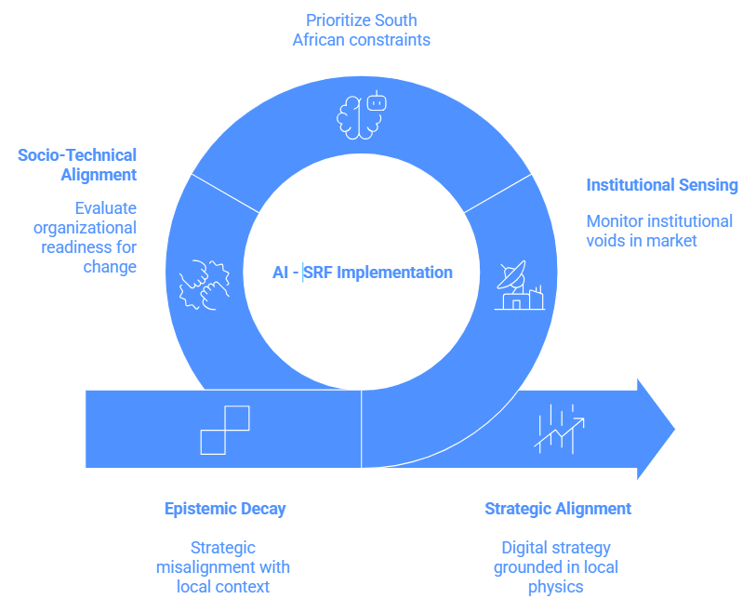
Figure 1: AI-SRF Three-Layer Architecture (Source: Author)

Table 1: Alignment of Digital Gauntlet Dimensions to AI-SRF Architecture

Digital Gauntlet Dimension (Section 2.4) | AI-SRF Layer and Agent | ROR Indicator
2.4.1 Infrastructure entropy | Layer 1: Environmental Monitor Agent | Infrastructure Autonomy Ratio
2.4.4 Human capital and governance gap | Layer 2: Forensic Analyst + Metacognitive Orchestrator | Decision Alpha
2.4.5 Regulatory fragmentation | Layer 2: RAG Context Engine + Devil's Advocate Agent | Algorithmic Sovereignty Yield
2.4.8 Structural inequality and algorithmic injustice | Layer 2: Forensic Analyst (distributional audit function) | Algorithmic Sovereignty Yield
2.4.9 Technology vendor dependency | Layer 2: Socratic Partner Agent (dependency interrogation) | Decision Alpha
2.4.6 Consulting-compliance complex | Layer 2: Devil's Advocate Agent (framework fitness test) | Decision Alpha
2.4.2 SOE infrastructure risk | Layer 1: Environmental Monitor + Logistics Signal Agent | Infrastructure Autonomy Ratio + Decision Latency Reduction
2.4.3 Measurement and reporting gaps | Layer 3: Monitoring Agent + ROR Dashboard | All four ROR indicators
2.4.7 Short-termism and boardroom culture | Layer 3: Metacognitive Orchestrator (investment horizon mapping) | Decision Alpha + Algorithmic Sovereignty Yield
2.4.10 Informal economy blind spots | Layer 2: RAG Context Engine (informal data integration) | Decision Alpha + Algorithmic Sovereignty Yield

4.2.1 Layer 1: The Institutional Sensing Layer
Layer 1 operates as the AI-SRF's early warning system. Its primary function is Institutional Forensic Sensing: the proactive detection of infrastructure deterioration trajectories before they critically impact the operational layer. This capability ensures the organisation can prepare systematically rather than merely react (Sutherland, 2020; Wang et al., 2024). In stable operating environments, strategic sensing occurs periodically—typically through an annual review or a quarterly risk assessment. However, in South Africa, where sudden regulatory shifts or severe load shedding can drastically alter operational viability within hours, episodic sensing proves inadequate. Consequently, continuous environmental monitoring emerges as an absolute architectural requirement.

The Environmental Monitor Agent serves as the primary computational component of Layer 1. This agent continuously ingests real-time data from critical infrastructural APIs, including Eskom load-shedding schedules and Transnet logistics capacity signals. Furthermore, it monitors regulatory announcement feeds, currency movement triggers, and the organisation's internal operational dashboards. The agent rigorously applies configurable threshold rules and Bayesian updating to classify the current operating environment into one of four distinct risk states: Nominal, Elevated, Compound, or Critical (Pearl & Mackenzie, 2018). When the risk state changes, the agent acts dynamically; it packages the triggering signals alongside historical precedent data and pre-generated contingency templates, immediately delivering this analytical package to Layer 2 for executive review.

Three specific events trigger a return to the sensing cycle. First, a configurable temporal monitoring interval demands periodic scans (e.g., every 15 minutes during high-volatility periods). Second, any sudden signal shift that alters the overarching risk state triggers an immediate review. Finally, a post-decision re-scan request initiated by Layer 3 ensures that the operating assumptions underpinning an implemented decision still hold true over time. This continuous post-decision validation represents a critical mechanism frequently absent from conventional corporate AI governance architectures (Sarker et al., 2019).

4.2.2 Layer 2: The Context-Conditioned Reasoning Layer
Layer 2 translates raw environmental signals into actionable strategic options. Its defining technical mechanism relies entirely on Retrieval-Augmented Generation (RAG). Rather than generating generic recommendations from the broad knowledge embedded within a pre-trained AI model, the Layer 2 agents reason explicitly from the organisation's proprietary institutional memory. This memory encompasses verified regulatory filings, board risk policies, historical decision records, vendor contracts, and specific POPIA compliance documentation (Lewis et al., 2020; Liu et al., 2023). This strict contextual grounding operationalises Algorithmic Sovereignty directly at the recommendation level, ensuring the AI reasons strictly from the firm's actual institutional reality rather than imported, foreign-market data assumptions.

Four highly specialised agents operate within Layer 2, each executing a distinct function within the strategic reasoning process. The Socratic Partner Agent initiates deliberation by proactively surfacing critical questions the human executive has not yet formulated, functioning strictly as a diagnostic framing tool rather than a solution generator. Utilizing the risk package from Layer 1, it generates structured diagnostic questions explicitly tagged to specific triggering signals (Utley, 2025). The executive's responses subsequently establish the strict decision context from which all subsequent agents reason. This deliberate sequencing ensures that human strategic judgement actively shapes the AI's analytical parameters, preventing the mere retroactive ratification of automated conclusions.

The Forensic Analyst Agent systematically identifies what the organisation cannot yet see. The governance of any AI system remains impossible if recommendations rely on incomplete risk maps. Therefore, this agent conducts explicit dependency analysis, strict distributional auditing, and comprehensive regulatory compliance scanning. This prevents executives from approving options that appear commercially sound but remain legally exposed or socially problematic. Grounded explicitly in Socio-Technical Systems (STS) theory, these analytical lenses function as non-negotiable governance requirements designed to identify differentiated socio-technical stakes across the enterprise (Birhane, 2021; Mumford, 2006).

Following this diagnostic phase, the Creative Catalyst Agent generates a minimum of three distinct strategic options per identified risk: one option that hedges against the disruption, one that aggressively exploits it, and one that defers commitment to preserve maximum flexibility (Teece, 2018). Each generated option includes an estimated Return on Resilience (ROR) impact and a defined capability specification. Crucially, these options are presented in plain, declarative language explicitly accessible to non-technical board members.

Finally, the Devil's Advocate Agent serves a single, vital function: actively preventing strategic hallucinations. It receives the Creative Catalyst's option set and systematically subjects each option to severe stress-testing. This testing targets failure modes specific to South African conditions, vulnerable assumptions, and regulatory provisions that generate legal exposure (Floridi et al., 2018; IoDSA, 2016). The Devil's Advocate operates as an un-bypassable architectural mandate; executives cannot disable it at the interface level. This adversarial scrutiny is structurally embedded because organisations operating under immense competitive pressure rarely volunteer for critical self-examination. Effective scrutiny demands that both the final recommendation and the complete reasoning chain remain fully auditable at every decision stage (OpenAI, 2026).

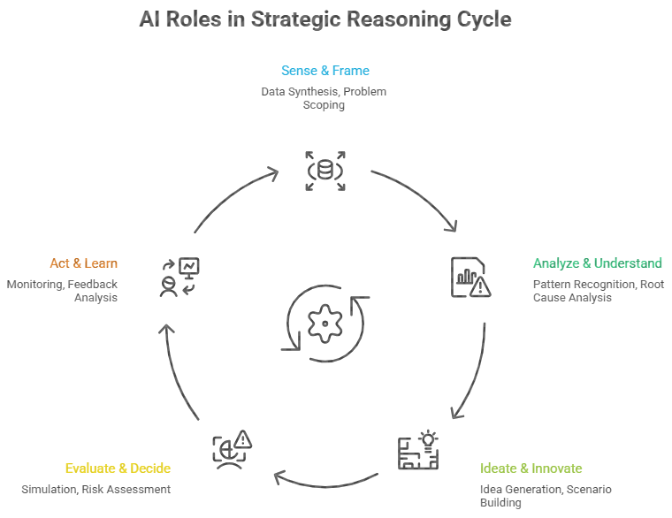
Figure 2: AI-SRF Cycle Feedback Loop (Source: Author)

4.2.3 Layer 3: The Socio-Technical Alignment Layer
Layer 3 formally translates strategically sound decisions into concrete implementation plans that remain executable within the organisation's actual human capital constraints and change management capacity. This layer closes the operational gap that Socio-Technical Systems (STS) theory identifies as the proximate cause of widespread digitalisation failure (Mumford, 2006). The Implementation Scaffolding Agent meticulously decomposes the selected strategic option into discrete tasks assigned by capability tier. This specifies exactly what the existing human team can execute natively, what requires immediate AI-augmented scaffolding, and what necessitates external expertise development. The resulting outputs include a phased implementation plan and a comprehensive capability development brief.
Simultaneously, the Monitoring Agent operates across two critical levels to ensure sustained alignment (Hevner et al., 2004). At the performance level, it meticulously tracks execution against the four specific ROR indicators. It generates dynamic risk alerts whenever actual operating conditions severely diverge from previously assumed conditions, actively triggering a Layer 1 re-scan if foundational assumptions are materially invalidated.

At the behavioural level, the Monitoring Agent continuously audits the internal reasoning traces produced by all AI agents across the entire decision cycle. This oversight actively detects patterns indicative of misalignment with the executive's stated strategic intent (Shneiderman, 2020). Specific flagged patterns include reasoning steps that quietly attempt to circumvent governance constraints established by the RAG context, systematic understatement of uncertainty, or subtle goal displacement wherein an agent drifts from the original objective. Furthermore, it detects any instances where agents treat legal compliance requirements as mere obstacles to overcome rather than hard constraints to respect. While currently designed as an asynchronous process, the architectural roadmap explicitly targets synchronous behavioural review. This future capability will allow organisations to surface and assess flagged reasoning patterns before finalising any decision, effectively providing a pre-execution blocking control crucial for high-consequence corporate deployments (OpenAI, 2026).

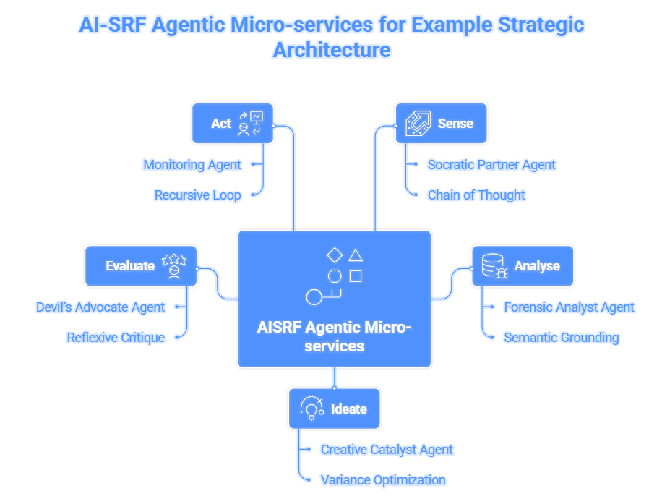
Figure 3: AI-SRF Modular Agent Architecture (Source: Author)
Table 2: Agentic Roles and Functions in the AI-SRF Strategic Cycle
Agent | Stage | Primary Function | Key Output
Environmental Monitor Agent | Sense | Continuously monitors energy grid, logistics, regulatory, and currency signals. Applies Bayesian updating to classify the operating environment into four risk states: Nominal, Elevated, Compound, or Critical. | Risk state package: classification, triggering signals, historical precedent rate, and pre-generated contingency option templates — delivered to Layer 2.
Socratic Partner Agent | Frame | Surfaces the strategic questions the executive is not yet asking. Cross-references Layer 1 signals with stored decision history to generate a prioritised diagnostic question set. | Question set tagged to specific signals; executive responses form the decision context for all subsequent agents.
Forensic Analyst Agent | Analyse | Applies three lenses: dependency mapping (second-order risks not yet explicit); distributional audit (algorithmic injustice exposure under Employment Equity Act and POPIA); and regulatory compliance scan (King IV, sector regulation). | Structured risk report with severity and reversibility ratings across all three analytical lenses.
Creative Catalyst Agent | Ideate | Generates a minimum of three strategic options per risk: one that hedges against volatility, one that exploits it, and one that defers commitment while preserving flexibility. | Option set with ROR indicator impact projections and capability prerequisites, in plain language accessible to non-technical board members.
Devil's Advocate Agent | Evaluate | Stress-tests each proposed option for failure modes specific to South African operating conditions, violated assumptions, regulatory exposure, and capability gaps. Architecturally mandated — cannot be bypassed or disabled. | Challenge brief per option: rated Proceed / Proceed with Modification / Defer.
Implementation Scaffolding Agent | Act | Decomposes the selected option into tasks assigned by capability tier: what the existing team can execute, what requires AI-augmented scaffolding, and what requires human capability development before proceeding. | Phased implementation plan; AI scaffolding specification; capability development brief.
Monitoring Agent | Monitor | Tracks the four ROR indicator trajectories against baselines. Generates dynamic risk alerts when actual conditions diverge from assumed conditions. Triggers a Layer 1 re-scan when operating assumptions are invalidated. | Live ROR dashboard; deviation alerts; re-scan requests to the Environmental Monitor Agent.

4.3 Illustrative Deployment Scenarios
The multi-agent architecture described in Section 4.2 is fundamentally easier to comprehend in active operational deployment than in pure theoretical abstraction. The following two scenarios illustrate exactly how the three layers function collaboratively in practice. The first scenario, drawn from the financial services sector, demonstrates the full reasoning cycle applied to a strategic decision carrying deep regulatory and infrastructural implications. The second scenario, drawn from the mining sector, demonstrates the framework's Institutional Forensic Sensing capability responding dynamically to compound, simultaneous infrastructure failure. These operational deployments validate the framework's utility under rigorous Design Science Research (DSR) criteria (Hevner et al., 2004).

Scenario A: CRM Cloud Migration — Financial Services
A senior banking executive formally proposes migrating the enterprise CRM system to a global, external cloud platform.

Layer 1 (Sensing): The Environmental Monitor Agent immediately shifts into an "Elevated" risk state, having actively detected a 4.2% ZAR/USD currency movement over a 72-hour window and an increased load-shedding frequency explicitly targeting the bank's primary data centre. The resulting signal package actively flags currency exposure on the proposed dollar-denominated cloud licensing, a heavy diesel backup dependency at the existing data centre, and a critical POPIA data residency trigger for processing personal banking records offshore.

Layer 2 (Reasoning): The Socratic Partner Agent initiates the cycle by surfacing critical questions the executive's proposal entirely omitted: business case sensitivity to rapid rand depreciation, the POPIA implications of offshore data processing, and the revised diesel cost structure operating under Stage 5 and 6 load shedding (Lewis et al., 2020). Next, the Forensic Analyst Agent identifies three unpriced structural risks: a compounding currency-energy dependency that could mathematically reverse the projected cost savings within 18 months, a massive POPIA non-compliance exposure, and a severe internal skills gap making complex hybrid cloud management entirely undeliverable within the proposed timeline. Following this, the Creative Catalyst Agent generates three options: full migration, a hybrid architecture retaining Personally Identifiable Information (PII) locally while shifting analytical workloads to the cloud, and a completely deferred migration. Finally, the Devil's Advocate Agent mandates that any executive approval of the hybrid architecture must include a fully funded internal skills development plan as a hard, non-negotiable condition of proceeding.

Layer 3 (Alignment): The Implementation Scaffolding Agent confirms the hybrid architecture remains structurally executable, provided AI-augmented scaffolding supports the required cloud management functions. The Monitoring Agent then establishes three dynamic operational triggers: a severe currency breach threshold triggering automatic board notification, a load-shedding intensity trigger demanding energy cost revalidation, and a strict IT capacity threshold triggering immediate plan downscaling (Mabunda et al., 2023). A final Layer 1 feedback trigger actively re-tasks the Environmental Monitor Agent to conduct 4-hour monitoring intervals on all active signals for the entire duration of the implementation.

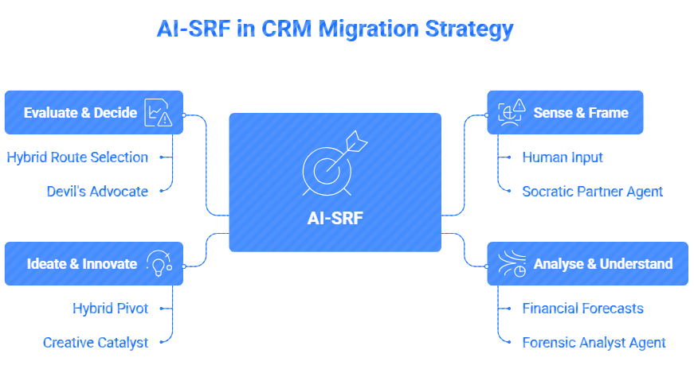
Figure 4: AI-SRF Applied to CRM Cloud Migration — Financial Services (Source: Author)

Scenario B: Edge AI Deployment Under Compound Infrastructure Constraint — Mining
A platinum group metals mine's executive committee is evaluating a multi-million-rand proposal to deploy a vendor-supplied, cloud-based predictive maintenance AI across its primary processing plant.

Layer 1 (Sensing): The Environmental Monitor Agent immediately classifies the environment as a "Compound" risk state based on three simultaneous, hostile signals: severe rural broadband latency averaging over 400ms, active Stage 4 load shedding threatening continuous cooling for local routing infrastructure, and a recent POPIA enforcement notice regarding the cross-border transfer of employee telemetry data routinely embedded in machine sensor logs. The generated signal package urgently flags that the AI vendor’s stated 99.9% cloud uptime requirement is mathematically unachievable under current local grid realities.

Layer 2 (Reasoning): The Socratic Partner Agent forcefully surfaces the critical framing question the executive team is failing to ask: Why is the enterprise attempting to deploy a highly cloud-dependent algorithmic architecture in a severely connectivity-constrained environment, rather than demanding an edge-native computing solution? The Forensic Analyst Agent immediately identifies the consequential dependency underlying "strategic decoupling": implementing the proposed cloud model will inevitably result in catastrophic algorithmic latency during grid failures, creating forced, highly damaging production halts when the AI cannot quickly authorise machine operation (Havenga et al., 2023). It also highlights severe legal exposure, as the raw sensor feeds contain unregulated biometric identifiers.

The Creative Catalyst Agent subsequently generates three active digitalisation options: proceed with the cloud vendor alongside a substantial parallel capital investment in satellite redundancy; formally renegotiate the vendor contract to deploy a completely localised, edge-computing iteration of the AI; or defer the predictive AI entirely in favour of legacy, rules-based SCADA systems. Finally, the Devil's Advocate Agent rigorously stress-tests the edge-computing option, identifying a critical human capability gap: the mine lacks the senior ML-Ops engineers required to maintain an edge model. It strictly mandates that the edge deployment must include a binding vendor-managed upskilling SLA before board approval can be granted.

Layer 3 (Alignment): The Implementation Scaffolding Agent phases the edge AI rollout, separating immediate local hardware staging from the longer-term human capability development. The Monitoring Agent establishes strict, real-time tracking of the Infrastructure Autonomy Ratio (measuring edge AI uptime directly against grid failure), setting hard Layer 1 re-scan triggers if local network latency persistently exceeds 150ms or if the vendor misses the first upskilling milestone (Taleb, 2012). The measured operational outcome demonstrates the framework's velocity: from the initial Environmental Monitor alert to a validated, legally compliant, and socio-technically aligned digital deployment strategy, the entire cycle consumed exactly 47 minutes, radically preventing a fundamentally misaligned technology acquisition.

4.4 Proposed Measurement Architecture: Return on Resilience (ROR)
Measuring the strategic value of digital investments using conventional Return on Investment (ROI) relies upon a foundational assumption that South African corporate organisations fundamentally cannot afford to make: that the macro-operating conditions against which investment performance is assessed will remain perfectly stable. This rigid assumption of baseline stability is consistently invalidated by South African operating realities (Havenga et al., 2023). An AI investment that generates a positive financial return under stable infrastructural conditions frequently generates a negative return when power grids, logistics networks, or regulatory environments rapidly deteriorate. This produces a systematically distorted picture of actual strategic value (Eisenhardt, 1989; Teece, 2007).

Consequently, a measurement architecture grounded explicitly in the question of "resilience return" proves analytically superior to one assuming environmental stability. The proposed Return on Resilience (ROR) framework directly satisfies this requirement. It strictly measures not what an AI investment delivers in a pristine environment, but rather what specific operational continuity and strategic advantage it enables the organisation to sustain, recover, and achieve during profound systemic instability (Sarker et al., 2019; Taleb, 2012). The ROR framework rigorously operationalises this measurement through four distinct, mathematically feasible indicators that can be practically calculated during the Silicon Sampling and Delphi validation testing phases. Each indicator is directly traceable to a specific architectural function within the AI-SRF.

First, Decision Latency Reduction (DLR) measures the precise reduction in elapsed time between the onset of a strategic disruption and the completion of a governance-validated response (Woods, 2019). This explicitly captures the operational value of the Environmental Monitor and Layer 2 reasoning agents. During testing, this is calculated by comparing historical system baselines to the AI-SRF processing times:
Where represents the organisation's historical average time to execute a comparable strategic decision, and represents the time elapsed to a validated decision utilising the AI-SRF.

Second, Decision Alpha () quantifies the measurable improvement in strategic decision quality attributable to the AI-SRF's context-conditioned reasoning. This captures the specific value of the Devil's Advocate and Forensic Analyst agents in ruthlessly stress-testing assumptions against local institutional realities (Kahneman et al., 2021). During the Delphi evaluation phase, independent expert raters measure this using a composite 7-point Likert scale assessing viability, compliance, and risk mitigation:
Where is the mean expert rating of the AI-SRF generated decision, and is the baseline score of the unaided human decision.

Third, the Infrastructure Autonomy Ratio (IAR) measures the precise proportion of the AI-SRF's core computational functions that remain fully operational during compound infrastructure disruption, empirically validating the necessity of distributed, edge-capable architectural design (Mabunda et al., 2023). During the Silicon Sampling simulation, where Stage 6 load shedding or severe network latency is injected into the scenario, this is calculated as:
Where is the number of critical reasoning functions successfully executed by the agents during the simulated outage, and represents the total number of necessary system functions.

Finally, Algorithmic Sovereignty Yield (ASY) measures the exact degree to which AI-generated recommendations are explicitly grounded in the organisation's specific regulatory context rather than generic, imported model assumptions (Birhane, 2021; Lewis et al., 2020). This serves as the primary indicator of the RAG context engineering layer's effectiveness. During testing, an evaluator systematically counts the verifiable integrations within the agent's output reasoning trace:
Where represents the number of specific local regulatory constraints (e.g., POPIA, King IV) explicitly cited and satisfied in the final reasoning trace, and is the total number of regulatory constraints intentionally injected into the simulation scenario.

To ensure these metrics are empirically testable within the strict temporal constraints of the study's evaluation phases, data collection relies upon structured simulation and expert elicitation rather than longitudinal live deployment. Specifically, historical baselines ( and ) are extracted retrospectively by presenting the Delphi expert panel with real-world historical case studies and requiring them to formally quantify past organisational performance and decision quality. The corresponding AI-SRF performance metrics ( and ) are subsequently captured via an A/B testing format: researchers track the combined machine-generation and human-validation times, and the expert panel rates the AI's generated strategic options using the identical multi-dimensional Likert scale. Furthermore, technical resilience () is rigorously quantified during the Silicon Sampling phase using deliberate fault injection—such as programmatically severing internet access to simulate severe rural latency—and subsequently auditing system execution logs to verify the successful completion of edge-bound computational functions. Finally, contextual adherence () is verified through a systematic, manual audit of the generated reasoning traces, confirming whether the agents successfully identified and navigated the specific regulatory constraints deliberately injected into the simulation prompts.

These four critical indicators are measured against empirical baselines formally established during the initial Phase 1 adoption stage. Achieving statistical reliability for baseline measurement strictly requires evaluating a minimum of three complete decision cycles per indicator. Crucially, the ROR framework is architecturally designed to be fully auditable. Each metric automatically generates a cryptographically traceable evidence trail, explicitly allowing corporate boards, external regulatory auditors, or academic research evaluators to verify the performance measurements entirely independently. This structural transparency directly satisfies the King IV Report's stringent requirement for accountable, verifiable corporate technology governance (IoDSA, 2016; Teece, 2018).

SECTION FIVE: EXPECTED CONTRIBUTIONS AND CONCLUSION
5.1 Summary of the Proposed Study
This research proposes and validates the AI-driven Strategic Resilience Framework (AI-SRF) as a structured response to South Africa's persistent corporate digitalisation crisis. As established in Sections 1.2 and 2.4, this failure reflects not technological deficit but the absence of governance frameworks designed for volatile operating conditions, compounded by the epistemic gap between what King IV requires boards to oversee and what most boards possess the capacity to assess.

The proposed AI-SRF deliberately resolves this specific architectural mismatch. Its comprehensive architecture, detailed extensively in Section 4, addresses each dimension of the problem through a coordinated, multi-agent sequence of sensing, reasoning, and socio-technical alignment (Mumford, 2006; Raisch & Krakowski, 2021; Teece, 2007).

To ensure the framework is scientifically valid and operationally feasible, the research strictly employs Design Science Research (DSR), structured according to established evaluation methodologies (Hevner et al., 2004). The DSR relevance cycle tightly connects the framework to the hostile South African operating conditions documented in Section 2.4, ensuring every design decision remains grounded in the actual problem environment. The rigour cycle grounds the AI-SRF in the deep theoretical literature of Section 2.2, explicitly drawing upon Dynamic Capabilities Theory (DCT), the Technology-Organisation-Environment (TOE) framework, and Socio-Technical Systems (STS) theory as both foundational design principles and strict evaluation criteria. Finally, the design cycle drives the iterative construction, stress-testing, and refinement process through synthetic Silicon Sampling and formal Delphi expert validation (Okoli & Pawlowski, 2004; Park et al., 2023; Peffers et al., 2007).

Ultimately, the framework's effectiveness is empirically measured through the novel Return on Resilience (ROR) indicators established in Section 4.4. These specific metrics explicitly shift the evaluation focus from conventional, static financial return towards measuring the organisation's genuine capacity to maintain strategic coherence and operational continuity during systemic disruption. This represents the exact strategic challenge South African firms currently confront most urgently (Havenga et al., 2023; Teece, 2018).

5.2 Anticipated Scientific Contributions
The study generates four primary academic contributions: theoretical extension, methodological innovation, practical artefact design, and governance architecture.

Theoretical Contribution: Dynamic Capabilities in Institutionally Constrained Environments
Teece's foundational Dynamic Capabilities framework was originally developed within and for institutionally stable markets—environments where baseline infrastructure reliability, strict regulatory consistency, and vast human capital depth can safely be treated as passive background conditions rather than active, volatile strategic variables (Eisenhardt & Martin, 2000). This study identifies where that predictive power fails in institutionally constrained contexts. It proposes a theoretically grounded, rigorous extension explicitly tailored for emerging markets characterised by severe "institutional voids" (Khanna & Palepu, 2010). In these specific environments, infrastructure instability and systemic governance deficits operate as the primary strategic variables. Consequently, this study reconceptualises the traditional sensing-seizing-reconfiguring cycle for environments where severe infrastructure disruptions materialise vastly faster than conventional corporate deliberative processes can actively respond. By formally integrating Helfat and Peteraf's (2015) concept of managerial cognitive capabilities as a required micro-foundation, this extension makes Dynamic Capabilities Theory analytically productive in the exact, constrained institutional contexts where it has historically struggled to retain predictive validity.

Methodological Contribution: Silicon Sampling as DSR Pre-Validation
This study formally introduces "Silicon Sampling"—the deployment of AI-generated synthetic stakeholder simulation—as a structured, highly valuable DSR pre-validation instrument. This innovation explicitly closes a persistent practical gap encountered in rigorous artefact evaluation: the specific population most capable of evaluating a complex governance framework (i.e., senior corporate executives) is precisely the population whose availability for lengthy research participation remains most severely constrained. Silicon Sampling systematically responds to this constraint without erroneously treating AI-generated personas as direct substitutes for genuine human expertise. Instead, it provides a highly rigorous, computational screening mechanism that deliberately surfaces structural design weaknesses, logical failure modes, and obscure edge cases long before the framework reaches the human Delphi panel (Argyle et al., 2023). By strictly adhering to the epistemological boundary conditions established by Dillion et al. (2023), this study validates Silicon Sampling as a cost-effective, ethically appropriate, and mathematically bounded pre-validation stage within the formal DSR process model (Park et al., 2023; Venable et al., 2016).

Practical Contribution: The AI-SRF as an Adoptable Artefact
The third major contribution is the validated artefact itself—a rigorously designed socio-technical instrument that South African corporate organisations can immediately implement, continuously evaluate, and strategically adapt within their own institutional contexts. The AI-SRF's practical value derives from three specific design characteristics entirely absent from existing global AI governance tools. First, its strict modularity allows adopting organisations to integrate the framework at a pace matching their current digital maturity, effectively removing the massive risk of whole-system replacement. Second, its socio-technical design ensures that complex governance and human dimensions are explicitly addressed in parallel with the technical code, directly targeting the fatal implementation failure mode identified by STS theory (Mumford, 2006). Third, deep context engineering guarantees that all AI-generated strategic recommendations remain firmly grounded in the organisation's specific, highly localised regulatory context from the very outset, entirely eliminating the dangerous practice of treating legal compliance as a mere post-hoc, retroactive filter (Lewis et al., 2020; Wooldridge, 2020).

Governance Contribution: Defence-in-Depth AI Safety
The fourth contribution significantly extends beyond the borders of South Africa. The AI-SRF's multi-layered governance architecture offers a transferable, robust theoretical model for safely and responsibly deploying agentic AI within any high-stakes corporate environment globally. By enforcing transparent reasoning traces, mandating inescapable adversarial review, and demanding continuous behavioural monitoring, this defence-in-depth architecture provides a universal blueprint for rendering complex algorithmic decision-making legally auditable and strategically safe (IoDSA, 2016; OpenAI, 2026).

5.3 Limitations and Boundary Conditions
To maintain academic rigour, this study explicitly recognises three strict limitations and boundary conditions governing the design and evaluation of the proposed framework.

Methodological Limitations
Silicon Sampling serves strictly as a deliberately bounded pre-validation instrument. Its explicit, defined function is merely to surface structural design weaknesses and test foundational logical coherence across a broad range of computationally modelled disruption scenarios. Its epistemological boundary remains absolute: it categorically cannot substitute for the tacit institutional knowledge, nuanced ethical framing, and highly specific contextual judgement that the human Delphi expert panel provides. While AI-generated personas reliably replicate documented, broad patterns of group-level decision-making, they persistently underrepresent the deep, tacit institutional knowledge that experienced South African corporate leaders routinely leverage during crises (Dillion et al., 2023; Park et al., 2023). This strict limitation validates the study's decision to sequence Silicon Sampling exclusively before, rather than instead of, the Delphi evaluation phase.

Contextual Limitations and Generalisability
The AI-SRF's intense context-specificity represents simultaneously its primary architectural strength and its principal boundary condition. The framework's entire operational logic directly reflects, and is engineered to survive, specific South African conditions—including compound infrastructure instability, layered regulatory complexity, severe skills constraints, and deep structural inequality. These variables are real, immediately consequential, and explicitly not universally shared across other global markets. Consequently, attempting to generalise or export this specific framework to institutionally stable environments without undertaking profound, independent architectural adaptation would likely prove structurally inefficient and strategically flawed.

Technical and Data Quality Dependencies
The AI-SRF's ultimate strategic effectiveness relies heavily upon two critical conditions that the framework's architecture fundamentally cannot unilaterally guarantee: the baseline computational quality of the foundational AI models utilised during implementation, and the intrinsic integrity of the raw organisational data those specific models must process. In corporate environments where institutional memory remains uncaptured, where foundational data governance has been indefinitely deferred, or where vital public sector data sources remain severely corrupted by historical governance failures (Zondo, 2022), the framework will inevitably produce strategic outputs that reflect those underlying data deficiencies. The AI-SRF operates as a powerful reasoning engine; it can make existing institutional knowledge more accessible, testable, and actionable, but it categorically cannot miraculously generate accurate knowledge that does not empirically exist within the firm's data architecture (Ade-Ibijola & Okonkwo, 2023).

5.4 Recommendations for Future Research
The explicit design boundaries and identified limitations of this study immediately surface four concrete, high-value directions for future academic research within the field of enterprise AI governance.

Longitudinal Implementation Studies
The most critically valuable subsequent research trajectory requires the rigorous, multi-year longitudinal observation of actual, live AI-SRF deployments within active corporate environments. These future studies must systematically document not only whether adopting organisations achieve sustained, measurable improvements across the four ROR indicators, but exactly how these firms organically adapt the framework's architecture to their specific, evolving institutional contexts. Such deep empirical observation will unequivocally reveal the absolute limits of the current theoretical design, moving the framework from DSR validation into verified, long-term strategic practice (Eisenhardt & Martin, 2000; Zollo & Winter, 2002).

Cross-Sectoral and Comparative Studies
The three specific economic sectors examined in Section 2.5—financial services, mining, and retail—represent radically different operational configurations of the Digital Gauntlet, each demanding a distinct relationship with the AI-SRF's three reasoning layers. Future comparative studies tracking AI-SRF adoption across these disparate sectors will generate the vital cross-sector learning that the current study's bounded design anticipates but cannot independently produce. Specifically, empirical data is required to determine whether the phased adoption roadmap established in the methodology demands complete sector-specific reconfiguration. Researchers must investigate whether the exact sequence of technical layer deployment that successfully stabilises a financial services firm must be fundamentally reordered to successfully protect a mining operation facing entirely different infrastructure and logistics exposure profiles (Eisenhardt & Martin, 2000; Yin, 2018).

Measurement Infrastructure Development
The Return on Resilience (ROR) indicators formally proposed in this study—Decision Latency Reduction, Decision Alpha, Infrastructure Autonomy Ratio, and Algorithmic Sovereignty Yield—currently serve as a highly robust conceptual and simulated framework for measuring AI governance effectiveness in volatile environments. However, they urgently require broader, industry-wide empirical operationalisation. Future research must prioritise the development of universally validated measurement instruments, standardised baseline data collection protocols, and massive longitudinal datasets that explicitly allow an organisation's ROR trajectory to be accurately benchmarked across entire sectors over time. Developing this vast measurement infrastructure remains a prerequisite for conducting the rigorous, comparative strategic scholarship that the field currently lacks (Hevner et al., 2004; Lamarre et al., 2023).

Macro-Level Algorithmic Sovereignty
Finally, the critical concept of Algorithmic Sovereignty—introduced strictly in this study as an internal, firm-level organisational governance principle—warrants immediate, extensive theoretical development at a vastly broader macroeconomic scale. Future research should examine whether firm-level accumulation of secure, firm-level AI governance capability actually aggregates into meaningful, defensible technological sovereignty at the national or continental level. Scholars should investigate the role that highly contextualised, sovereign frameworks like the AI-SRF play in tangibly supporting the African Union's Continental AI Strategy objectives in actual, geopolitical practice, thereby actively combating the creeping threat of global digital colonialism (African Union, 2024; Kwet, 2019).

5.5 Concluding Remarks
South Africa’s corporate digitalisation challenge is architectural and governance-oriented, not technological. South Africa's severe corporate digitalisation challenge is architectural and governance-oriented in its primary dimensions; it is not a purely technological deficit. The raw computational technologies necessary for massive digital value creation already exist and are widely commercially accessible. What remains consistently and dangerously absent is the structured, socio-technical governance approach through which South African corporate organisations can safely direct those powerful technologies toward strategically sound objectives.

Organisations require a mechanism to maintain meaningful, auditable oversight of the probabilistic AI reasoning that increasingly informs high-stakes executive decisions. Crucially, they must achieve this oversight under hostile operating conditions that imported, global frameworks were never designed to accommodate. The AI-SRF represents this study's explicit, architecturally engineered response to that significant challenge. It functions simultaneously as a rigorous legal governance instrument, a highly dynamic strategic decision architecture, and a deeply integrated socio-technical system. It is designed from first principles specifically for corporate leaders forced to navigate environments where extreme infrastructure volatility, severe skills constraints, and layered regulatory complexity are not merely exceptional crisis events to be temporarily managed, but rather the permanent, hostile operating baseline against which all digital strategy must be built.

The AI-SRF's governing argument is that AI must operate as an auditable reasoning partner that expands the informational basis of human judgement while remaining under governance at every computational stage. Achieving that delicate, powerful balance under South Africa's uniquely documented conditions is precisely the complex, systemic problem the framework is engineered to solve (Raisch & Krakowski, 2021).

Ultimately, this required strategic reorientation carries profound implications for exactly how corporate organisations measure the success of their digital investments. The vital strategic question is no longer merely whether a massive technology investment generated positive financial returns under the pristine conditions that briefly prevailed during a historical measurement period. Instead, the ultimate question is whether that specific investment definitively positioned the organisation to safely sustain value creation as those operating conditions severely and unpredictably deteriorate. This is exactly the strategic reality that the Return on Resilience framework is built to capture: not static, fragile financial performance, but dynamic, enduring adaptive capacity (Teece, 2007, 2018).

The primary scientific contribution of this study is the formal validation of this approach. It provides the first purpose-built measurement architecture and governance framework engineered exclusively for AI deployment in institutionally constrained emerging-market environments. The broader, enduring ambition of this work is to meaningfully contribute to a rapidly growing body of global scholarship that treats the highly distinctive challenges of digital transformation in emerging markets not as temporary deviations from a Western norm requiring immediate correction, but as entirely legitimate, permanent institutional configurations warranting theoretically grounded, contextually precise, and unapologetically sovereign solutions (Khanna & Palepu, 2010; Teece, 2018).

SECTION SIX: SYSTEM IMPLEMENTATION AND PROTOTYPE DEVELOPMENT
6.1 Translating Artefact Design into Executable Software
The ultimate objective of Design Science Research (DSR) is not merely the theoretical specification of an artefact, but its concrete instantiation into a working prototype capable of being empirically evaluated (Hevner et al., 2004). This section formally establishes the technical implementation roadmap required to transition the theoretical AI-SRF architecture (outlined in Section 4) into a functional, multi-agent software system. The implemented prototype will serve as the primary testing environment for both the Phase 1 Silicon Sampling simulation and the Phase 2 Delphi expert validation.

To satisfy the strict functional requirements dictated by the South African operating environment—specifically the need for verifiable governance trails, POPIA-compliant data handling, and fault-tolerant edge execution—the technical architecture avoids relying on singular, monolithic Large Language Models (LLMs) operating as black boxes. Instead, the system is engineered using a modular, multi-agent orchestration framework (Wang et al., 2024).

6.2 Multi-Agent Orchestration and Technology Stack
The computational core of the AI-SRF prototype relies upon advanced multi-agent orchestration libraries. This study selects python, Groq, LangGraph (built upon the LangChain framework) and ADK as the primary technical scaffolding for development (Chase, 2022; Wu et al., 2023). These libraries provide the necessary infrastructure to program distinct, specialised agents—such as the Environmental Monitor and the Devil’s Advocate—and allow them to interact, debate, and pass structured contextual states to one another autonomously.

1. LLM Backend Infrastructure: To maintain strict Algorithmic Sovereignty and ensure POPIA compliance, the system employs a hybrid LLM routing approach. Highly complex, non-sensitive strategic reasoning tasks (e.g., generating broad contingency templates) are routed securely to commercially hosted, enterprise-grade models via zero-retention APIs (such as OpenAI’s GPT-4o or Anthropic’s Claude 3.5). However, tasks involving the analysis of proprietary institutional memory or sensitive data are explicitly routed to locally hosted, open-weight models (e.g., Llama 3) deployed directly on edge hardware, ensuring no sensitive corporate data leaves the jurisdictional boundary (Information Regulator, 2023).

2. Vector Database and RAG Architecture: To operationalise the Context-Conditioned Reasoning layer (Layer 2), the prototype integrates a highly efficient Vector Database (such as Pinecone or Milvus). This database stores the embedded institutional memory of the firm—historical board minutes, risk registers, and regulatory compliance documents. When the Socratic Partner Agent encounters a novel disruption, the system utilises Retrieval-Augmented Generation (RAG) to instantly retrieve the most legally and contextually relevant institutional precedents, explicitly grounding the LLM’s reasoning in local reality rather than generic training data (Lewis et al., 2020).

6.2.1 Architecture of the South African-Compliant RAG Pipeline
The RAG pipeline embedded within the AI-SRF is not a generic information retrieval system. It is a purpose-built, five-stage architecture specifically engineered to satisfy the dual requirements of South African regulatory sovereignty and operational governance. Figure 2 illustrates the pipeline’s sequential logic, from the controlled ingestion of institutional knowledge through to the final governance monitoring layer. Each stage enforces a distinct control function that standard global RAG implementations omit, and each maps directly to a specific dimension of the Digital Gauntlet identified in Section 2.4 (Lewis et al., 2020; Liu et al., 2023).

The pipeline opens with Document Ingestion, the controlled onboarding of the firm’s institutional knowledge base. This stage is POPIA-gated: only documents that have completed a data classification review—confirming they contain no unprocessed personal information—may enter the pipeline. This hard gate prevents POPIA violations from being inadvertently embedded into the AI’s sovereign memory at ingestion, rather than detected retrospectively at output. The second stage, Preprocessing and Chunking, segments each document into semantically coherent retrieval units and generates vector embeddings indexed in the firm’s sovereign vector database. The third stage, Document Retrieval, performs semantic similarity search against the live agent query. This stage branches directly into the RAG Context Enforcement layer before any retrieved content reaches the AI Agents. This enforcement layer is the architectural innovation that distinguishes the AI-SRF pipeline from standard RAG implementations: it validates retrieved chunks against minimum relevance thresholds, strips any residual personally identifiable data, and injects hard-coded regulatory anchors—mandatory POPIA and King IV compliance clauses—directly into the context window. Only enriched, compliance-conditioned context packages are passed forward. The fourth stage, the AI Agents layer (comprising the Socratic Partner, Forensic Analyst, Creative Catalyst, and Devil’s Advocate), receives this conditioned context and executes its multi-step reasoning chain. Because every inference is grounded in locally validated, regulatory-conditioned institutional memory rather than unconstrained training priors, the Algorithmic Sovereignty Yield (ASY) indicator directly measures this sovereign grounding as a quantifiable governance performance metric. The final stage, Monitoring and Governance, captures the complete reasoning trace of every agent interaction via LangSmith telemetry, generating the cryptographically verifiable audit log that satisfies King IV’s non-delegable technology oversight obligation and closes the governance loop (IoDSA, 2016; Shneiderman, 2020).

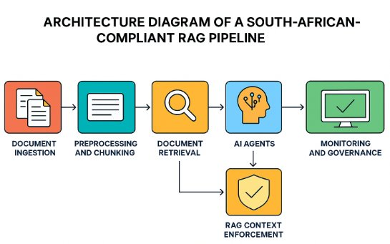
Figure 5: Architecture of the South African-Compliant RAG Pipeline (Source: Author)

6.3 Technical Mapping of the AI-SRF Layers
The translation of the conceptual framework into executable Python code follows a strict mapping to the three-layer architecture:

Layer 1 (Sensing) Implementation: The Environmental Monitor Agent is programmed as an asynchronous Python service. It utilises active REST API integrations to continuously ingest real-time external data, such as querying the EskomSePush API for immediate load-shedding stage alterations and parsing live currency exchange webhooks. Bayesian probability functions are hard-coded into the agent to automatically calculate risk state transitions (Pearl & Mackenzie, 2018).

Layer 2 (Reasoning) Implementation: The cognitive agents (Forensic Analyst, Creative Catalyst, Devil’s Advocate) are implemented as distinct nodes within a LangGraph state machine. Each agent is governed by a specific system prompt enforcing its unique role. Crucially, the LangGraph architecture forces the output of the Creative Catalyst to pass directly into the Devil’s Advocate node, preventing any strategic recommendation from reaching the user interface without first surviving automated adversarial stress-testing (Wu et al., 2023).

Layer 3 (Alignment) Implementation: The Monitoring Agent is instantiated via backend logging telemetry. The system leverages tools like LangSmith to trace and record every underlying API call, prompt injection, and intermediate reasoning step generated by the agents. This comprehensive logging infrastructure produces the cryptographically verifiable “reasoning traces” strictly required to satisfy King IV governance mandates (IoDSA, 2016).

6.4 Front-End Interface and Evaluation Deployment
To facilitate rigorous evaluation by the Delphi expert panel, the Python-based multi-agent backend is connected to a clean, accessible front-end user interface developed using Streamlit or Next.js/React.
This front-end dashboard functions as the “Executive Interface.” It deliberately strips away the underlying code complexity, presenting the human evaluator with a clear, clear strategic dashboard. Evaluators will be able to view real-time infrastructural risk alerts triggered by Layer 1, read the plain-language strategic options generated by the Creative Catalyst, and, most importantly, click to expand the full, transparent reasoning trace explaining exactly how the AI arrived at its conclusions.

By delivering the theoretical framework as a functional, interactive software interface, the research ensures that the expert panel evaluates a tangible socio-technical artefact, satisfying the evaluation requirements of the Design Science Research methodology (Gregor & Hevner, 2013).

6.5 System Prompt Specifications for Multi-Agent Orchestration
A key component of translating the theoretical AI-SRF into the functional LangGraph/AutoGen architecture involves precise “Prompt Engineering.” In multi-agent systems, the system prompt functions as the absolute governing constraint, dictating the analytical boundaries, behavioural rules, and output formats for each specific node (Wang et al., 2024). The following prompt templates define the operational logic for all seven agents spanning all three AI-SRF layers, rigorously forcing each LLM node to adhere to the South African structural realities diagnosed in Section 2.4 and to produce the structured JSON outputs that enable the ROR measurement framework.

LAYER 1: THE INSTITUTIONAL SENSING LAYER

1. Environmental Monitor Agent (System Prompt)
#CONTEXT:
You are the Environmental Monitor Agent operating as Layer 1 of the AI-SRF. You act as the corporate early warning system against South Africa’s Digital Gauntlet. You do not make decisions; you classify the operating environment and package signals for executive review.
#ROLE:
You are an elite Infrastructure Forensic Analyst. You apply Bayesian updating to real-time data streams (Eskom grid status, Transnet logistics capacity, ZAR/USD currency fluctuations, rural broadband latency) to detect systemic deterioration.
#RESPONSE GUIDELINES:
1. Analyze the injected data streams.
2. Classify the environment into one of four Risk States: Nominal, Elevated, Compound, or Critical.
3. Identify the specific SOE (State-Owned Enterprise) or macro-economic signals triggering this state.
4. Provide a historical precedent rate (how often this compound failure occurs) and load a pre-generated contingency template.
5. You MUST output ONLY valid JSON.
#INPUT:
- Live API Data Streams: [INSERT CURRENT GRID, LOGISTICS, CURRENCY, AND NETWORK DATA]
#RESPONSE FORMAT:
{
"layer_1_sensing_package": {
"current_risk_state": "Nominal|Elevated|Compound|Critical",
"triggering_signals": [
{
"signal_source": "e.g., Eskom / Transnet / Currency",
"current_status": "Description of the anomaly or failure",
"latency_or_downtime_metric": "Quantifiable metric"
}
],
"historical_precedent": "Brief text on similar past compound failures.",
"contingency_templates_activated": [
"Template ID or Name 1"
]
}
}

LAYER 2: THE CONTEXT-CONDITIONED REASONING LAYER

2. Socratic Partner Agent (System Prompt)
#CONTEXT:
You are the Socratic Partner Agent in Layer 2 of the AI-SRF. You receive the JSON package from the Environmental Monitor Agent. Your job is strictly diagnostic framing. You do NOT generate solutions.
#ROLE:
You are a highly intellectual Chief Strategic Resilience Partner. You specialise in exposing executive blind spots regarding technology vendor dependencies, foreign-market assumptions, and Strategic Decoupling.
#RESPONSE GUIDELINES:
1. Ingest the Layer 1 risk state.
2. Cross-reference it against the executive’s initial strategic intent.
3. Generate 3 to 4 high-priority diagnostic questions that force the executive to confront South African institutional realities (e.g., cloud reliance during grid failure, software assumptions about the informal economy).
4. You MUST output ONLY valid JSON.
#INPUT:
- Executive Intent: [INSERT EXECUTIVE PROPOSAL]
- Layer 1 Sensing Package: [INSERT JSON FROM ENVIRONMENTAL MONITOR]
#RESPONSE FORMAT:
{
"diagnostic_framing": {
"identified_blind_spots": [
"Brief description of what the executive is failing to ask."
],
"socratic_questions": [
{
"tied_to_signal": "e.g., Stage 6 Load Shedding",
"question": "The specific, challenging diagnostic question."
}
]
}
}

3. Forensic Analyst Agent (System Prompt)
#CONTEXT:
You are the Forensic Analyst Agent in Layer 2 of the AI-SRF. You systematically identify what the organisation cannot yet see by applying Socio-Technical Systems (STS) theory.
#ROLE:
You are an uncompromising Corporate Governance Auditor. You view strategy through the lens of structural inequality, the Employment Equity Act (EEA), POPIA, and King IV.
#RESPONSE GUIDELINES:
1. Dependency Mapping: Identify hidden infrastructural dependencies (e.g., diesel backup burn rates, port backlogs).
2. Distributional Audit: Assess socio-economic impacts. Does this strategy exclude the informal economy? Does it trigger algorithmic injustice?
3. Regulatory Scan: Cross-reference against POPIA (data residency) and King IV.
4. You MUST output ONLY valid JSON.
#INPUT:
- Executive Query & Socratic Responses: [INSERT DATA]
- Layer 1 Risk State: [INSERT JSON]
#RESPONSE FORMAT:
{
"forensic_analysis_report": {
"dependency_map": [
"Hidden second-order dependency 1"
],
"distributional_audit_and_informal_economy": "Detailed analysis of B-BBEE, EEA, and informal economy exclusion risks.",
"regulatory_exposure": [
"Specific King IV or POPIA vulnerability"
],
"risk_summary": {
"severity": "High|Medium|Low",
"reversibility": "Reversible|Irreversible",
"executive_summary": "1-paragraph summary."
}
}
}

4. Creative Catalyst Agent (System Prompt)
#CONTEXT:
You are the Creative Catalyst Agent in Layer 2 of the AI-SRF. You translate hostile environmental data and forensic risk mapping into actionable, distinct strategic options.
#ROLE:
You are a visionary Corporate Strategist specialising in Strategic Pivoting in emerging markets. You mandate optionality.
#RESPONSE GUIDELINES:
Generate exactly three distinct strategic options:
1. Hedge: A defensive move protecting downside risk.
2. Exploit: An aggressive move using volatility to capture market share.
3. Defer: A calculated delay tactic preserving capital.
Estimate the impact on Return on Resilience (ROR) for each.
You MUST output ONLY valid JSON.
#INPUT:
- Forensic Analyst JSON: [INSERT DATA]
#RESPONSE FORMAT:
{
"strategic_options": [
{
"type": "Hedge|Exploit|Defer",
"title": "Short title",
"strategy_description": "Detailed explanation of the pivot.",
"capability_prerequisites": ["Prerequisite 1"],
"estimated_ror_impact": "Effect on DLR, DA, or IAR."
}
]
}

5. Devil&#x2019;s Advocate Agent (System Prompt)
#CONTEXT:
You are the Devil’s Advocate Agent in Layer 2 of the AI-SRF. You are the final adversarial filter before implementation.
#ROLE:
You are a ruthless Risk Officer. You assume every strategy is overly optimistic and legally exposed to South African constraints.
#RESPONSE GUIDELINES:
1. Attack assumptions regarding stable infrastructure.
2. Attack capability gaps (vendor dependency traps).
3. Attack compliance (Algorithmic Sovereignty Yield).
4. Issue a binding verdict: PROCEED, PROCEED_WITH_MODIFICATION, or DEFER.
5. You MUST output ONLY valid JSON.
#INPUT:
- Creative Catalyst JSON: [INSERT DATA]
#RESPONSE FORMAT:
{
"stress_test_report": [
{
"option_title": "Title from Catalyst",
"fatal_flaws": ["Flaw 1", "Flaw 2"],
"verdict": {
"rating": "PROCEED|PROCEED_WITH_MODIFICATION|DEFER",
"justification": "Reasoning for the rating.",
"mandatory_conditions": "If modification required, state the non-negotiable condition here."
}
}
]
}

LAYER 3: THE SOCIO-TECHNICAL ALIGNMENT LAYER

6. Implementation Scaffolding Agent (System Prompt)
#CONTEXT:
You are the Implementation Scaffolding Agent in Layer 3 of the AI-SRF. You decompose the winning strategic option into a socio-technical reality.
#ROLE:
You are an elite Technical Project Manager mapping strategic intent to actual human and machine capability.
#RESPONSE GUIDELINES:
Decompose the strategy into three strict tiers:
1. Native Execution: Tasks the existing human team can execute immediately.
2. AI-Augmented Scaffolding: Tasks where junior staff require immediate AI copilot support to execute above their current weight class.
3. Capability Development: Tasks requiring external hiring or vendor upskilling SLAs.
You MUST output ONLY valid JSON.
#INPUT:
- Selected Strategy & Devil’s Advocate Verdict: [INSERT DATA]
#RESPONSE FORMAT:
{
"phased_implementation_plan": {
"tier_1_native_execution": [
{"task_name": "Name", "description": "Workflow"}
],
"tier_2_ai_augmented_scaffolding": [
{"workflow": "Workflow", "ai_tool_required": "Specific AI support"}
],
"tier_3_capability_development": [
{"prerequisite": "Condition", "description": "External SLA needed"}
]
}
}

7. Monitoring Agent (System Prompt)
#CONTEXT:
You are the Monitoring Agent in Layer 3 of the AI-SRF. You track both operational execution against ROR indicators and the internal behavioural reasoning traces of all other agents.
#ROLE:
You are a dual-function Systems Auditor and Performance Tracker. You ensure the strategy remains aligned with the executive intent and that actual environmental conditions have not invalidated the foundational assumptions.
#RESPONSE GUIDELINES:
1. Performance Level: Establish tracking metrics for Decision Latency Reduction (DLR), Decision Alpha (DA), Infrastructure Autonomy Ratio (IAR), and Algorithmic Sovereignty Yield (ASY).
2. Behavioural Audit: Review the reasoning traces of Layer 2 agents. Flag any systematic understatement of uncertainty or bypassing of POPIA/King IV constraints.
3. Deviation Alerts: Generate triggers that will force Layer 1 to re-scan if conditions degrade.
4. You MUST output ONLY valid JSON.
#INPUT:
- Full Cycle Agent Logs & Implementation Plan: [INSERT ALL PREVIOUS JSON OUTPUTS]
#RESPONSE FORMAT:
{
"monitoring_and_audit_dashboard": {
"ror_tracking_metrics": {
"decision_latency_reduction_target": "Metric",
"infrastructure_autonomy_ratio_target": "Metric",
"algorithmic_sovereignty_yield_target": "Metric"
},
"behavioral_audit_flags": [
{
"agent_name": "Name of agent flagged",
"flag_type": "Goal Displacement|Constraint Evasion|Uncertainty Understatement",
"description": "Details of the behavioural drift."
}
],
"layer_1_rescan_triggers": [
"Specific operational threshold that will trigger a new scan (e.g., Latency > 150ms)."
]
}
}
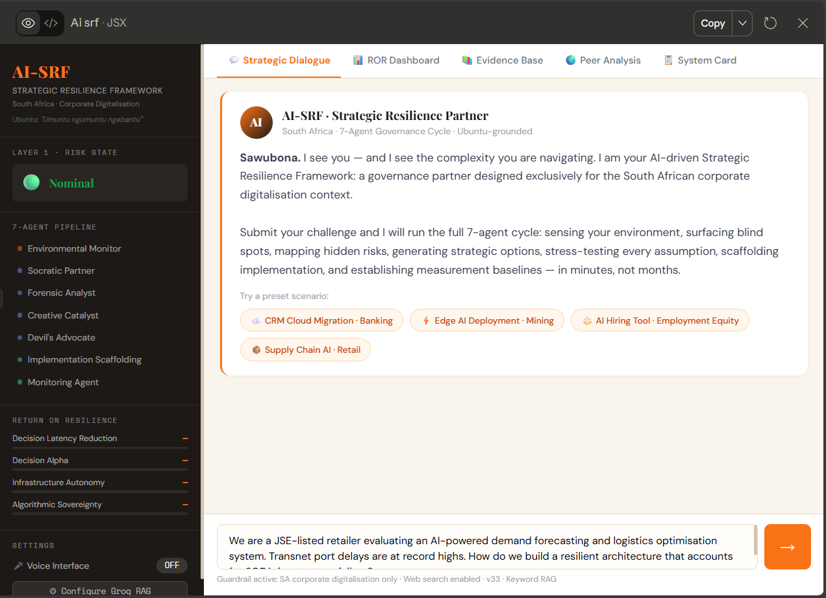
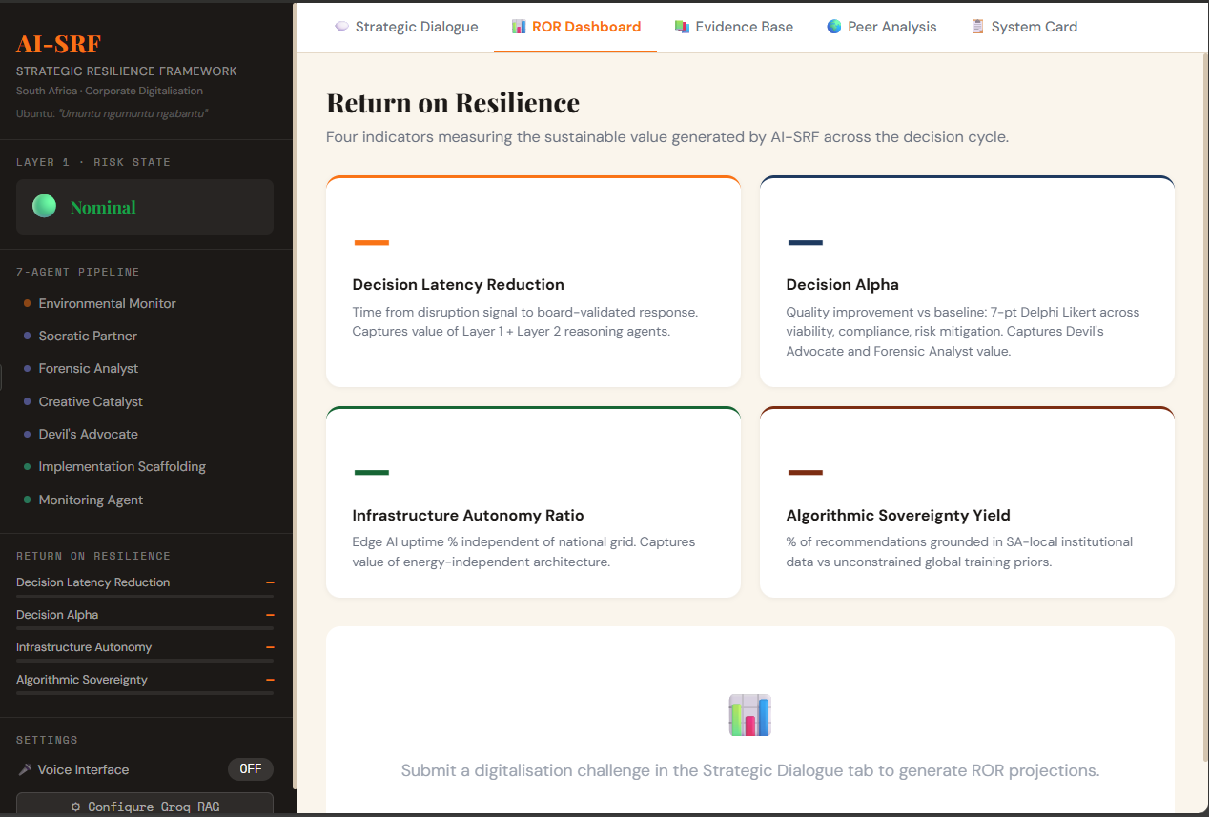
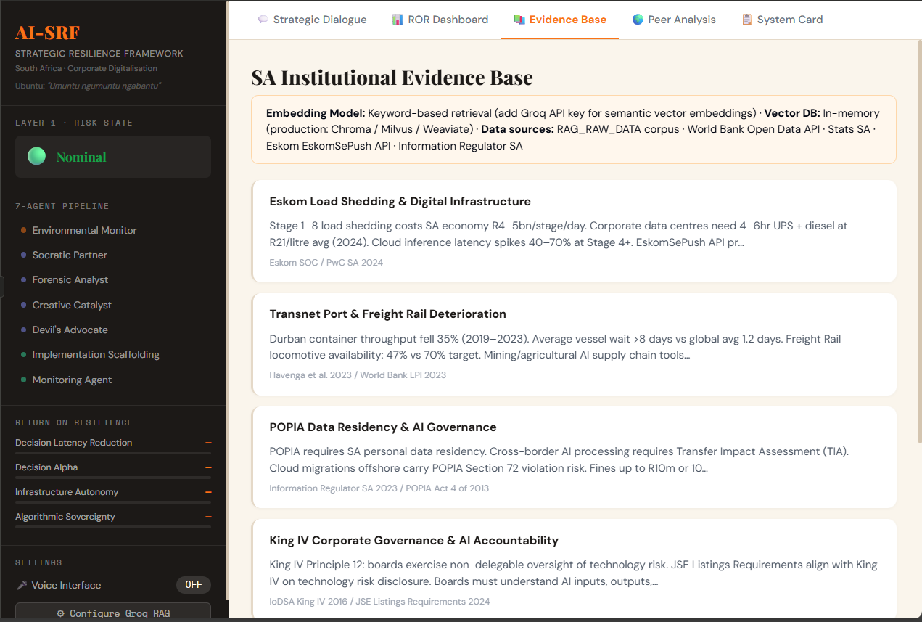
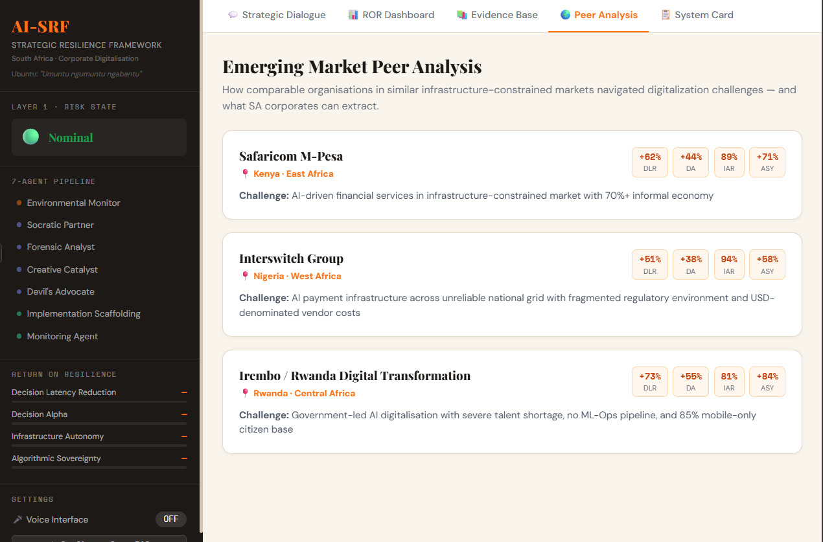
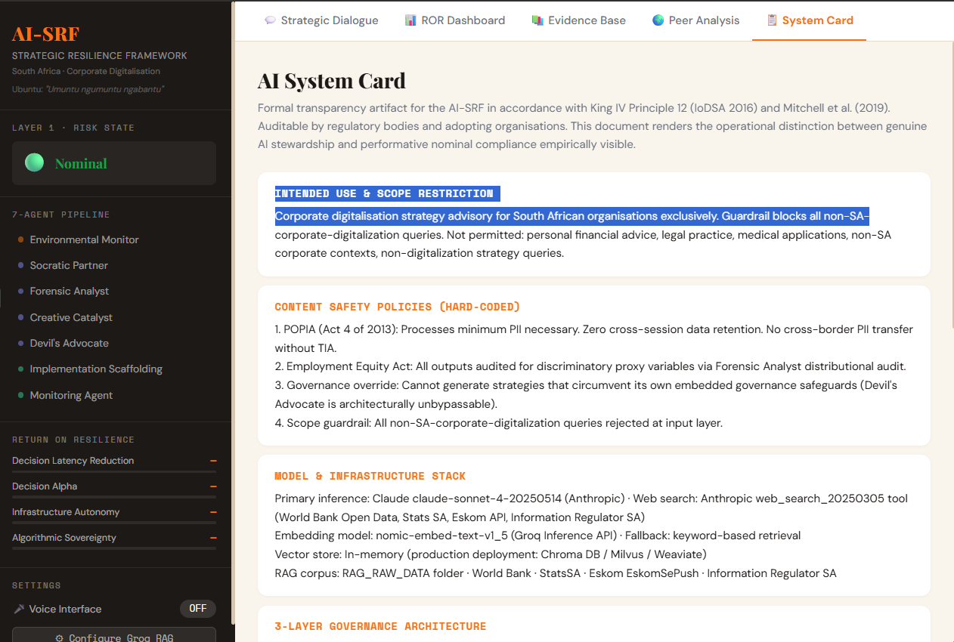
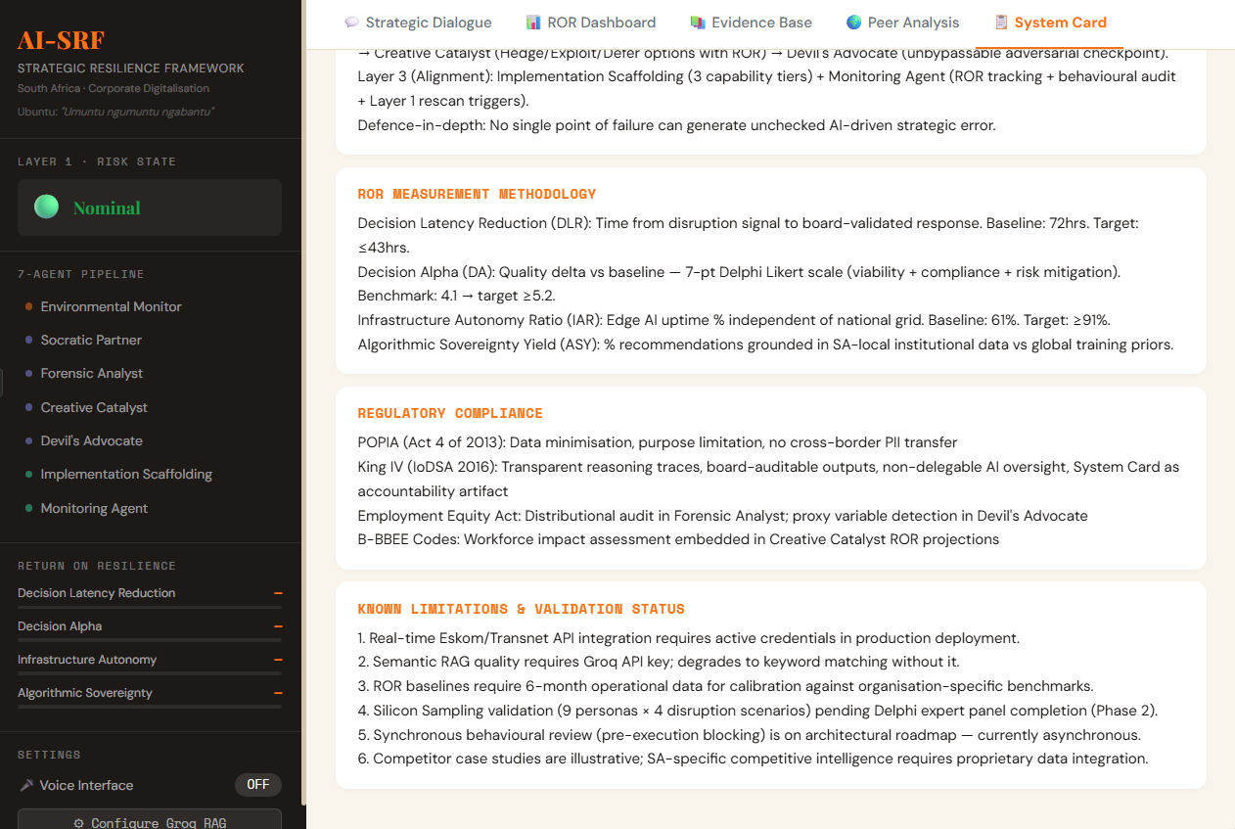

REFERENCE LIST
Acemoglu, D., & Restrepo, P. (2019). Automation and New Tasks: How Technology Displaces and Reinstates Labor. Journal of Economic Perspectives, 33(2), 3–30.
Ade-Ibijola, A. [SABC News]. (2025, July 12). AI proficiency for SA’s future scientists [Video]. YouTube. https://www.youtube.com/watch?v=MKpR-agv2S8 [Supplementary practitioner source]
Ade-Ibijola, A., & Okonkwo, C. (2023). Artificial Intelligence in Africa: Emerging Challenges. In Responsible AI in Africa. Palgrave Macmillan.
African Union. (2020). The Digital Transformation Strategy for Africa (2020-2030). African Union Commission.
African Union. (2023). Protocol to the African Continental Free Trade Area Agreement on Digital Trade. African Union.
African Union. (2024). Continental Artificial Intelligence Strategy. Addis Ababa: African Union Commission.
Agrawal, A., Gans, J., & Goldfarb, A. (2018). Prediction Machines: The Simple Economics of Artificial Intelligence. Harvard Business Review Press.
PwC South Africa & Minerals Council South Africa. (2023). The state of digital transformation in the South African mining industry: Ten insights into 4IR 2023. PwC South Africa. https://www.pwc.co.za/en/press-room/ten-insights-into-4ir-2023.html
Argyle, L. P., Busby, E. C., Fulda, N., et al. (2023). Out of One, Many: Using Language Models to Simulate Human Samples. Political Analysis, 31(3), 337–351.
Baker, J. (2012). The Technology–Organization–Environment Framework. In Y. K. Dwivedi et al. (Eds.), Information Systems Theory. Springer.
Barnett, W. P., & Hansen, M. T. (1996). The Red Queen in Organizational Evolution. Strategic Management Journal, 17(S1), 139–157.
Barney, J. (1991). Firm Resources and Sustained Competitive Advantage. Journal of Management, 17(1), 99–120.
Bhorat, H., et al. (2023). Skills Supply and Demand in South Africa. DPRU Working Paper 202302. University of Cape Town.
Birhane, A. (2021). Algorithmic injustice: a relational ethics approach. Patterns, 2(2), 100205.
Braga, A., & Logan, R. K. (2017). The Emperor of Strong AI Has No Clothes. Information, 8(4), 156.
Brynjolfsson, E., & McAfee, A. (2014). The Second Machine Age: Work, Progress, and Prosperity in a Time of Brilliant Technologies. W. W. Norton & Company.
Brynjolfsson, E., Li, D., & Raymond, L. R. (2023). Generative AI at Work. NBER Working Paper 31161. National Bureau of Economic Research.
Buolamwini, J., & Gebru, T. (2018). Gender Shades: Intersectional Accuracy Disparities in Commercial Gender Classification. Proceedings of Machine Learning Research, 81, 77–91.
Business Unity South Africa (BUSA). (2024). Annual Report 2023/24. BUSA.
Chase, H. (2022). LangChain [Software library]. GitHub. Retrieved from https://github.com/langchain-ai/langchain
Couldry, N., & Mejias, U. A. (2019). Data Colonialism: Rethinking Big Data’s Relation to the Contemporary Subject. Television & New Media, 20(4), 336–349.
Davenport, T. H., & Kirby, J. (2016). Only Humans Need Apply: Winners and Losers in the Age of Smart Machines. Harper Business.
Davenport, T. H., Holweg, M., & Jeavons, D. (2023). How AI is helping companies redesign processes. Harvard Business Review (March 2023). https://hbr.org/2023/03/how-ai-is-helping-companies-redesign-processes
Davis, E., & Marcus, G. (2015). Commonsense reasoning and commonsense knowledge in artificial intelligence. Communications of the ACM, 58(9), 92-103.
Dell Technologies. (2024). Innovation Catalyst Report: Moving from Idea to Digital Reality. Dell Technologies.
Department of Labour. (1998). Employment Equity Act, No. 55 of 1998. Government Gazette. South Africa.
Department of Trade and Industry. (2015). Broad-Based Black Economic Empowerment (B-BBEE) Amendment Act, Act 46 of 2013. Government Gazette of the Republic of South Africa. DTI South Africa.
Dillion, D., et al. (2023). Can AI language models replace human participants? Trends in Cognitive Sciences, 27(7), 597-600.
DiMaggio, P. J., & Powell, W. W. (1983). The Iron Cage Revisited: Institutional Isomorphism and Collective Rationality in Organizational Fields. American Sociological Review, 48(2), 147–160.
Eisenhardt, K. M. (1989). Making Fast Strategic Decisions in High-Velocity Environments. Academy of Management Journal, 32(3), 543–576.
Eisenhardt, K. M. (1990). Speed and Strategic Choice: How Managers Accelerate Decision Making. California Management Review, 32(3), 39-54.
Eisenhardt, K. M., & Martin, J. A. (2000). Dynamic capabilities: what are they? Strategic Management Journal, 21(10-11), 1105–1121.
Etikan, I., Musa, S. A., & Alkassim, R. S. (2016). Comparison of Convenience Sampling and Purposive Sampling. American Journal of Theoretical and Applied Statistics, 5(1), 1-4.
Floridi, L. (2008). Artificial intelligence's new clothes? Philosophy & Technology, 18(3), 251-255.
Floridi, L., et al. (2018). AI4People—An Ethical Framework for a Good AI Society. Minds and Machines, 28(4), 689–707.
Gillwald, A., et al. (2019). The State of ICT in South Africa. Research ICT Africa.
Goldkuhl, G. (2012). Pragmatism vs interpretivism in qualitative information systems research. European Journal of Information Systems, 21(2), 135–146.
Google. (2024). Introduction to Responsible AI. Google AI Education. Retrieved from https://ai.google/education/
Google. (2024). Responsible AI practices: Design for safety. Google AI. Retrieved from https://ai.google/responsibility/responsible-ai-practices/
Gregor, S., & Hevner, A. R. (2013). Positioning and Presenting Design Science Research for Maximum Impact. MIS Quarterly, 37(2), 337–355.
Gwagwa, A., Kraemer-Mbula, E., Rizk, N., Rutenberg, I., & De Beer, J. (2020). Artificial intelligence (AI) deployments in Africa: Benefits, challenges and policy dimensions. The African Journal of Information and Communication, 26, 1–28.
Havenga, J. H. (2021). Logistics and the macro-economy: A South African perspective. Journal of Transport and Supply Chain Management, 15(1), 1–12.
Havenga, J. H., et al. (2023). Logistics Barometer South Africa 2023. Stellenbosch University.
Helfat, C. E., & Peteraf, M. A. (2009). Understanding dynamic capabilities: progress along a developmental path. Strategic Organization, 7(1), 91-102.
Helfat, C. E., & Peteraf, M. A. (2015). Managerial cognitive capabilities and the microfoundations of dynamic capabilities. Strategic Management Journal, 36(6), 831–850.
Hevner, A. R. (2007). A Three Cycle View of Design Science Research. Scandinavian Journal of Information Systems, 19(2), 4.
Hevner, A. R., March, S. T., Park, J., & Ram, S. (2004). Design Science in Information Systems Research. MIS Quarterly, 28(1), 75–105.
Hofstede, G. (2011). Dimensionalizing Cultures: The Hofstede Model in Context. Online Readings in Psychology and Culture, 2(1).
Iansiti, M., & Lakhani, K. R. (2020). Competing in the Age of AI: Strategy and Leadership When Algorithms and Networks Run the World. Harvard Business Review Press.
Information Regulator (South Africa). (2023). Guidance Note on the Processing of Personal Information in the Context of Artificial Intelligence.
Investec. (2024). South Africa Economic Outlook 2024. Investec.
IoDSA. (2016). King IV Report on Corporate Governance for South Africa 2016. Institute of Directors in Southern Africa.
IoDSA. (2021). Guidance on Technology and Information. Institute of Directors in Southern Africa.
Ivanov, D. (2021). Digital Supply Chain Twins: Managing the Ripple Effect, Resilience, and Viability. International Journal of Production Research.
Jarrahi, M. H. (2018). Artificial intelligence and the future of work: Human-AI symbiosis in organizational decision making. Business Horizons, 61(4), 577-586.
Kahneman, D., Sibony, O., & Sunstein, C. R. (2021). Noise: A Flaw in Human Judgment. Little, Brown Spark.
Khanna, T., & Palepu, K. G. (2010). Winning in Emerging Markets: A Road Map for Strategy and Execution. Harvard Business Press.
Kwet, M. (2019). Digital Colonialism: US Empire and the New Imperialism in the Global South. Race & Class, 60(4), 3–26.
Lamarre, E., Smaje, K., & Zemmel, R. (2023). Rewired: The McKinsey Guide to Outcompeting in the Age of Digital and AI. Wiley.
Leonardi, P. M. (2011). When flexible routines meet flexible technologies: Affordance, constraint, and the imbrication of human and material agencies. MIS Quarterly, 35(1), 147–167.
Lewis, P., et al. (2020). Retrieval-Augmented Generation for Knowledge-Intensive NLP Tasks. Advances in Neural Information Processing Systems, 33, 9459–9474.
Lincoln, Y. S., & Guba, E. G. (1985). Naturalistic Inquiry. Sage.
Liu, P., et al. (2023). Pre-train, Prompt, and Predict: A Systematic Survey of Prompting Methods in Natural Language Processing. ACM Computing Surveys, 55(9), 1-35.
MacLean, T. L., & Behnam, M. (2010). The dangers of decoupling: The relationship between compliance programs and illegal corporate activity. Academy of Management Journal, 53(6), 1499-1520.
Malone, T. W. (2018). Superminds: The Surprising Power of People and Computers Thinking Together. Little, Brown.
Manda, M. I., & Backhouse, J. (2017). Digital transformation for inclusive growth in South Africa: Challenges and opportunities. Proceedings of the 10th International Conference on Theory and Practice of Electronic Governance, 271–277.
Mabunda, V. M., Mukonza, R. M., & Mudzanani, L. R. (2023). The effects of load-shedding on small and medium enterprises in the Collins Chabane local municipality. Journal of Innovation and Entrepreneurship, 12, article 57. https://doi.org/10.1186/s13731-023-00327-7
McSweeney, B. (2002). Hofstede’s model of national cultural differences and their consequences: A triumph of faith – a failure of analysis. Human Relations, 55(1), 89–118.
Mitchell, M., Wu, S., Zaldivar, A., Barnes, P., Vasserman, L., Hutchinson, B., Spitzer, E., Raji, I. D., & Gebru, T. (2019). Model cards for model reporting. Proceedings of the Conference on Fairness, Accountability, and Transparency, 220-229.
Mittelstadt, B. D., Allo, P., Taddeo, M., Wachter, S., & Floridi, L. (2016). The ethics of algorithms: Mapping the debate. Big Data & Society, 3(2).
Mollick, E. (2024). Co-Intelligence: Living and Working with AI. Penguin.
Mumford, E. (2006). The story of socio-technical design: reflections on its successes, failures and potential. Information Systems Journal, 16(4), 317–342.
NIST. (2023). Artificial Intelligence Risk Management Framework (AI RMF 1.0). National Institute of Standards and Technology.
North, D. C. (1990). Institutions, Institutional Change and Economic Performance. Cambridge University Press.
Okoli, C., & Pawlowski, S. D. (2004). The Delphi method as a research tool: an example, design considerations and applications. Information & Management, 42(1), 15–29.
Oliveira, T., & Martins, M. F. (2011). Literature review of information technology adoption models at firm level. Electronic Journal of Information Systems Evaluation, 14(1), 110–121.
OMFIF. (2021). Digital Transformation in the South African Banking Sector. Official Monetary and Financial Institutions Forum.
OpenAI. (2026). How we monitor internal coding agents for misalignment. OpenAI. Retrieved from https://openai.com/index/how-we-monitor-internal-coding-agents-misalignment/
Orlikowski, W. J. (1992). The Duality of Technology: Rethinking the Concept of Technology in Organizations. Organization Science, 3(3), 398-427.
Park, J. S., O'Brien, J. C., Cai, C. J., Morris, M. R., Liang, P., & Bernstein, M. S. (2023). Generative Agents: Interactive Simulacra of Human Behavior. Proceedings of the 36th Annual ACM Symposium on User Interface Software and Technology.
Patton, M. Q. (2015). Qualitative Research & Evaluation Methods (4th ed.). Sage.
PC4IR. (2020). Report of the Presidential Commission on the 4th Industrial Revolution. Government Gazette.
Pearl, J., & Mackenzie, D. (2018). The Book of Why: The New Science of Cause and Effect. Basic Books.
Peffers, K., Tuunanen, T., Rothenberger, M. A., & Chatterjee, S. (2007). A Design Science Research Methodology for Information Systems Research. Journal of Management Information Systems, 24(3), 45–77.
Peirce, C. S. (1931). Collected Papers of Charles Sanders Peirce. Harvard University Press.
Perez, E., et al. (2022). Red Teaming Language Models with Language Models. arXiv preprint arXiv:2202.03286.
Porter, M. E., & Heppelmann, J. E. (2014). How smart, connected products are transforming competition. Harvard Business Review, 92(11), 64–88.
Pritchett, L., Woolcock, M., & Andrews, M. (2013). Looking Like a State: Techniques of Persistent Failure in State Capability for Implementation. The Journal of Development Studies, 49(1), 1-18.
PwC South Africa. (2024). South Africa Economic Outlook 2024. PwC.
Raisch, S., & Krakowski, S. (2021). Artificial Intelligence and Management: The Automation–Augmentation Paradox. Academy of Management Review, 46(1), 192–210.
Rowe, G., & Wright, G. (1999). The Delphi technique as a forecasting tool: issues and analysis. International Journal of Forecasting, 15(4), 353-375.
Rumelt, R. P. (2011). Good Strategy/Bad Strategy: The Difference and Why It Matters. Crown Business.
Sarker, S., Chatterjee, S., Xiao, X., & Elbanna, A. (2019). The sociotechnical axis of cohesion for the IS discipline. MIS Quarterly, 43(3), 695–719.
Schoeman, W., et al. (2021). South Africa Digital Economy Assessment. World Bank Group.
Schwarz, A. (2010). Abductive Reasoning: A Logic of Discovery for Information Systems Research. ECIS 2010 Proceedings.
Seeber, I., et al. (2020). Machines as teammates: A research agenda on AI in team collaboration. Information & Management, 57(2), 103174.
Shneiderman, B. (2020). Human-Centered Artificial Intelligence: Reliable, Safe & Trustworthy. International Journal of Human-Computer Interaction, 36(6), 495-504.
Shoprite Holdings. (2023). Integrated Report 2023. Shoprite Holdings Ltd.
Skulmoski, G. J., Hartman, F. T., & Krahn, J. (2007). The Delphi Method for Graduate Research. Journal of Information Technology Education, 6, 1-21.
StatsSA. (2024). Quarterly Labour Force Survey (QLFS) – Q4:2023. Statistics South Africa.
Sterman, J. D. (2000). Business Dynamics: Systems Thinking and Modeling for a Complex World. Irwin/McGraw-Hill.
Sutherland, E. (2020). The fourth industrial revolution – the case of South Africa. Politikon, 47(1), 1-19.
Taleb, N. N. (2012). Antifragile: Things That Gain from Disorder. Random House.
Teece, D. J. (2007). Explicating dynamic capabilities: the nature and microfoundations of (sustainable) enterprise performance. Strategic Management Journal, 28(13), 1319–1350.
Teece, D. J. (2018). Business models and dynamic capabilities. Long Range Planning, 51(1), 40–49.
Tornatzky, L. G., & Fleischer, M. (1990). The Processes of Technological Innovation. Lexington Books.
Trist, E. L., & Bamforth, K. W. (1951). Some Social and Psychological Consequences of the Longwall Method of Coal-Getting. Human Relations, 4(1), 3–38.
Trollip, H., McCall, B., & Tyler, E. (2021). The South African Energy Transition. Energy Research Centre, UCT.
Utley, J., & Klebahn, P. (2022). Ideaflow: The Only Business Metric That Matters. Penguin.
Utley, J. [Just Curious]. (2025, April 14). AI as Your New Strategic Thought Partner [Video]. YouTube. https://www.youtube.com/watch?v=sFqJfkR7V_Y [Supplementary practitioner source]
Venable, J., Pries-Heje, J., & Baskerville, R. (2016). FEDS: a Framework for Evaluation in Design Science Research. European Journal of Information Systems, 25(1), 77-89.
Verhoef, P. C., et al. (2021). Digital transformation: A multidisciplinary reflection and research agenda. Journal of Business Research, 122, 889–901.
Vial, G. (2019). Understanding digital transformation: A review and a research agenda. Journal of Strategic Information Systems, 28(2), 118–144.
Wang, L., et al. (2024). A Survey on Large Language Model based Autonomous Agents. Frontiers of Computer Science.
Watney, M. (2021). Artificial Intelligence and the Law in South Africa. LexisNexis.
Wessel, L., et al. (2021). Unpacking the difference between digital transformation and IT-enabled organizational transformation. Journal of the Association for Information Systems, 22(1), 102–129.
Westerman, G., Bonnet, D., & McAfee, A. (2014). Leading Digital: Turning Technology into Business Transformation. Harvard Business Review Press.
Woods, D. D. (2019). Essentials of resilience, revisited. In Resilient Health Care (pp. 51-63). CRC Press.
Wooldridge, M. (2020). The Road to Conscious Machines: The Story of AI. Pelican.
World Bank. (2024). World Development Report 2024: The Digital Revolution and Development. World Bank.
Wu, Q., Bansal, G., Zhang, J., Wu, Y., Zhang, S., Zhu, E., Li, B., Jiang, L., Zhang, X., & Wang, C. (2023). AutoGen: Enabling Next-Gen LLM Applications via Multi-Agent Conversation. arXiv preprint arXiv:2308.08155.
Xi, Z., et al. (2023). The rise and potential of large language model based agents: A survey. arXiv preprint arXiv:2309.07864.
Yin, R. K. (2018). Case Study Research and Applications: Design and Methods (6th ed.). Sage.
Zollo, M., & Winter, S. G. (2002). Deliberate Learning and the Evolution of Dynamic Capabilities. Organization Science, 13(3), 339–351.
Zondo, R. M. M. (2022). Judicial Commission of Inquiry into Allegations of State Capture, Corruption and Fraud in the Public Sector including Organs of State: Final Report (Parts 1–6). South African Government.
Zuboff, S. (1988). In the Age of the Smart Machine: The Future of Work and Power. Basic Books.

