FEDERAL UNIVERSITY OF TECHNOLOGY OWERRI
P.M.B. 1526, OWERRI, IMO.

A TERM PAPER ON:
EVOLUTION OF RADAR

WRITTEN BY:
OGOKE CHIJIOKE

SUBMITTED TO:
ENGR. B.C. OKEKE

DEPARTMENT OF INFORMATION MANAGEMENT TECHNOLOGY.
SCHOOL OF MANAGEMENT TECHNOLOGY.

March 2019.

ABSTRACT
In recent years an abundance of technical papers and books have been written on several topics of radar signal processing. The detection of radar targets against ground and sea clutter is a problem of great interest in the radar community. The fusion of signals from different radar to improve detection performance is another relevant topic of research and application. These are two of several topics that have been extensively described in the technical literature. Needless to say that the consultation of technical references plays a key role in the daily work of researchers and engineers involved in the radar field. We collected almost 700 references in a single document to facilitate our work and the work of other colleagues of the radar community. The collection of references is by no means exhaustive; the period of screening mainly covers the last two decades.

TABLE OF CONTENT

- SECTION ONE
  - INTRODUCTION.

- SECTION TWO
  - FIRST MILITARY RADAR
  - EXPERIMENTS
  - HOW THE RADAR WORKS
2.3.1 ECHO AND DOPLER SHIFT
  - APPLICATIONS AND USES OF RADAR

- SECTION THREE
  - REFERENCES.

SECTION ONE

INTRODUCTION
Radar is an object detection system which uses radio waves to determine the range, altitude, direction, or speed of objects. It can be used to detect aircraft, ships, spacecraft, guided missiles, motor vehicles, weather formations, and terrain. The radar dish or antenna transmits pulses of radio waves or microwaves which bounce off any object in their path. The object returns a tiny part of the wave's energy to a dish or antenna which is usually located at the same site as the transmitter. The modern uses of radar are highly diverse, including air traffic control, radar astronomy, air-defense systems, anti missile systems; marine radars to locate landmarks and other ships; aircraft anti-collision systems; ocean surveillance systems, outer space surveillance and rendezvous systems; meteorological precipitation monitoring; altimetry and flight control systems; guided missile target locating systems; and ground-penetrating radar for geological observations. High tech radar systems are associated with digital signal processing and are capable of extracting useful information from very high noise levels.

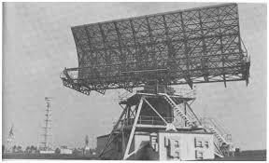
Fig. Early Radar
SECTION TWO

During the 1930s, efforts to use radio echoes for aircraft detection were initiated independently and almost simultaneously in eight countries that were concerned with the prevailing military situation and that already had practical experience with radio technology. The United States, Great Britain, Germany, France, the Soviet Union, Italy, the Netherlands, and Japan all began experimenting with radar within about two years of one another and embarked, with varying degrees of motivation and success, on its development for military purposes. Several of these countries had some form of operational radar equipment in military service at the start of World War II.
The first observation of the radar effect at the U.S. Naval Research Laboratory (NRL) in Washington, D.C., was made in 1922. NRL researchers positioned a radio transmitter on one shore of the Potomac River and a receiver on the other. A ship sailing on the river unexpectedly caused fluctuations in the intensity of the received signals when it passed between the transmitter and receiver. (Today such a configuration would be called bistatic radar.) In spite of the promising results of this experiment, U.S. Navy officials were unwilling to sponsor further work.
The principle of radar was “rediscovered” at NRL in 1930 when L.A. Hyland observed that an aircraft flying through the beam of a transmitting antenna caused a fluctuation in the received signal. Although Hyland and his associates at NRL were enthusiastic about the prospect of detecting targets by radio means and were eager to pursue its development in earnest, little interest was shown by higher authorities in the navy. Not until it was learned how to use a single antenna for both transmitting and receiving (now termed monostatic radar) was the value of radar for detecting and tracking aircraft and ships fully recognized. Such a system was demonstrated at sea on the battleship USS New York in early 1939.
The first radars developed by the U.S. Army were the SCR-268 (at a frequency of 205 MHz) for controlling antiaircraft gunfire and the SCR-270 (at a frequency of 100 MHz) for detecting aircraft. Both of these radars were available at the start of World War II, as was the navy’s CXAM shipboard surveillance radar (at a frequency of 200 MHz). It was an SCR-270, one of six available in Hawaii at the time, that detected the approach of Japanese warplanes toward Pearl Harbor, near Honolulu, on December 7, 1941; however, the significance of the radar observations was not appreciated until bombs began to fall.
Britain commenced radar research for aircraft detection in 1935. The British government encouraged engineers to proceed rapidly because it was quite concerned about the growing possibility of war. By September 1938 the first British radar system, the Chain Home, had gone into 24-hour operation, and it remained operational throughout the war. The Chain Home radars allowed Britain to deploy successfully its limited air defenses against the heavy German air attacks conducted during the early part of the war. They operated at about 30 MHz—in what is called the shortwave, or HF, band—which is actually quite a low frequency for radar. It might not have been the optimum solution, but the inventor of British radar, Sir Robert Watson-Watt, believed that something that worked and was available was better than an ideal solution that was only a promise or might arrive too late.
The Soviet Union also started working on radar during the 1930s. At the time of the German attack on their country in June 1941, the Soviets had developed several different types of radars and had in production an aircraft-detection radar that operated at 75 MHz (in the very-high-frequency [VHF] band). Their development and manufacture of radar equipment was disrupted by the German invasion, and the work had to be relocated.
At the beginning of World War II, Germany had progressed farther in the development of radar than any other country. The Germans employed radar on the ground and in the air for defense against Allied bombers. Radar was installed on a German pocket battleship as early as 1936. Radar development was halted by the Germans in late 1940 because they believed the war was almost over. The United States and Britain, however, accelerated their efforts. By the time the Germans realized their mistake, it was too late to catch up.
Except for some German radars that operated at 375 and 560 MHz, all of the successful radar systems developed prior to the start of World War II were in the VHF band, below about 200 MHz. The use of VHF posed several problems. First, VHF beamwidths are broad. (Narrow beamwidths yield greater accuracy, better resolution, and the exclusion of unwanted echoes from the ground or other clutter.) Second, the VHF portion of the electromagnetic spectrum does not permit the wide bandwidths required for the short pulses that allow for greater accuracy in range determination. Third, VHF is subject to atmospheric noise, which limits receiver sensitivity. In spite of these drawbacks, VHF represented the frontier of radio technology in the 1930s, and radar development at this frequency range constituted a genuine pioneering accomplishment. It was well understood by the early developers of radar that operation at even higher frequencies was desirable, particularly since narrow beamwidths could be achieved without excessively large antennas.

EXPERIMENTS
Serious developmental work on radar began in the 1930s, but the basic idea of radar had its origins in the classical experiments on electromagnetic radiation conducted by German physicist Heinrich Hertz during the late 1880s. Hertz set out to verify experimentally the earlier theoretical work of Scottish physicist James Clerk Maxwell. Maxwell had formulated the general equations of the electromagnetic field, determining that both light and radio waves are examples of electromagnetic waves governed by the same fundamental laws but having widely different frequencies. Maxwell’s work led to the conclusion that radio waves can be reflected from metallic objects and refracted by a dielectric medium, just as light waves can. Hertz demonstrated these properties in 1888, using radio waves at a wavelength of 66 cm (which corresponds to a frequency of about 455 MHz).
The potential utility of Hertz’s work as the basis for the detection of targets of practical interest did not go unnoticed at the time. In 1904 a patent for “an obstacle detector and ship navigation device,” based on the principles demonstrated by Hertz, was issued in several countries to Christian Hülsmeyer, a German engineer. Hülsmeyer built his invention and demonstrated it to the German navy but failed to arouse any interest. There was simply no economic, societal, or military need for radar until the early 1930s, when long-range military bombers capable of carrying large payloads were developed. This prompted the major countries of the world to look for a means with which to detect the approach of hostile aircraft.
Most of the countries that developed radar prior to World War II first experimented with other methods of aircraft detection. These included listening for the acoustic noise of aircraft engines and detecting the electrical noise from their ignition. Researchers also experimented with infrared sensors. None of these, however, proved effective.

HOW THE RADAR WORKS

The radio waves utilized by radar are created by a bit of equipment known as a magnetron. Radio waves are similar to light waves: they travel at an equivalent speed—but their waves are abundant longer} and have much lower frequencies. light waves have wavelengths of about five hundred nanometers (500 billionths of a meter, that is concerning 100–200 times dilutant than an individual's hair), whereas the radio waves utilized by radio detection and ranging usually vary from a couple of few centimeters to a meter—the length of a finger to the length of your arm—or roughly 1,000,000 times longer than light waves.
Both light and radio waves are part of the spectrum, which implies they are created from unsteady patterns of electrical and magnetic energy zapping through the air. The waves a magnetron produces are literally microwaves, almost like those generated by a microwave. The distinction is that the magnetron in a radar must send the waves several miles, rather than just some inches, thus it's a lot of larger and more powerful.
When people use radar, they are usually trying to accomplish one of three things:
- Detect the presence of an object at a distance - Usually the "something" is moving, like an airplane, but radar can also be used to detect stationary objects buried underground. In some cases, radar can identify an object as well; for example, it can identify the type of aircraft it has detected.
- Detect the speed of an object - This is the reason why police use radar.
- Map something - The space shuttle and orbiting satellites use something called Synthetic Aperture Radar to create detailed topographic maps of the surface of planets and moons.
Here's how radar works:
- Magnetron generates high-frequency radio waves.
- Duplexer switches magnetron through to antenna.
- Antenna acts as transmitter, sending narrow beam of radio waves through the air.
- Radio waves hit enemy airplane and reflect back.
- Antenna picks up reflected waves during a break between transmissions. Note that the same antenna acts as both transmitter and receiver, alternately sending out radio waves and receiving them.
- Duplexer switches antenna through to receiver unit.
- Computer in receiver unit processes reflected waves and draws them on a TV screen.
- Enemy plane shows up on TV radar display with any other nearby targets.

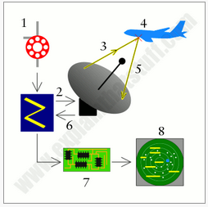
Fig. How radar works
USES AND APPLICATION OF RADAR
- Ship safety: Radar technology is also found in ships and other sea vessels to help in detecting other vessels in the sea when they are in need of help. The radar will provide the distance and probable location of the next ship and help in calling for help when they are in need
- Terrain avoidance: Military planes that fly low rely on terrain avoidance feature to help them avoid collision with high grounds such as mountains and also with other objects within the path of the airplane.
- Space vehicles: Radar has been used by space vehicles for the longest time now. Most space ships rely on radar for clocking and for landing on the moon.
- Satellite tracking: Some ground based radar are important in detecting satellites in space and also detecting other objects from the ground. This helps ground personnel in knowing how many satellites are in space and how many are actively relaying data.
- Non-contact measurement of speed and distance: One of the main uses of radar technology is the measurement of speed and distance. It can be used to independently calculate the speed and distance between two moving objects.
- Cemetery and grave location: Radar imaging services are used to detect areas that need to be used as grave sites. This is because they are able to detect objects that are beneath the earth surface and tell whether an area is conducive for use as a cemetery.
- Location of buried objects: Although not advanced, research is still being conducted on the possibility of using radar to detect objects or even bodies that are buried beneath the ground by criminals.
- Bedrock studies: Radar 3D imaging is important in the study of bedrocks underlying the earth’s surface. Geologists have been able to employ the use of radar technology to gather information regarding the structure of the rocks and the shifts in these structures.
- Border surveillance: Instead of having security personnel lined up at the border posting along borders, countries are now using radar technology to provide surveillance services along these borderlines and reporting of any intrusion if there is any.
- Cruise control: Modern cars are fitted with cruise control technology that allows the vehicle to cruise at a specific speed while sensing other potential objects on the road. When the vehicle senses an object on the road, it will automatically trigger an alarm and in some cases activate its braking system.

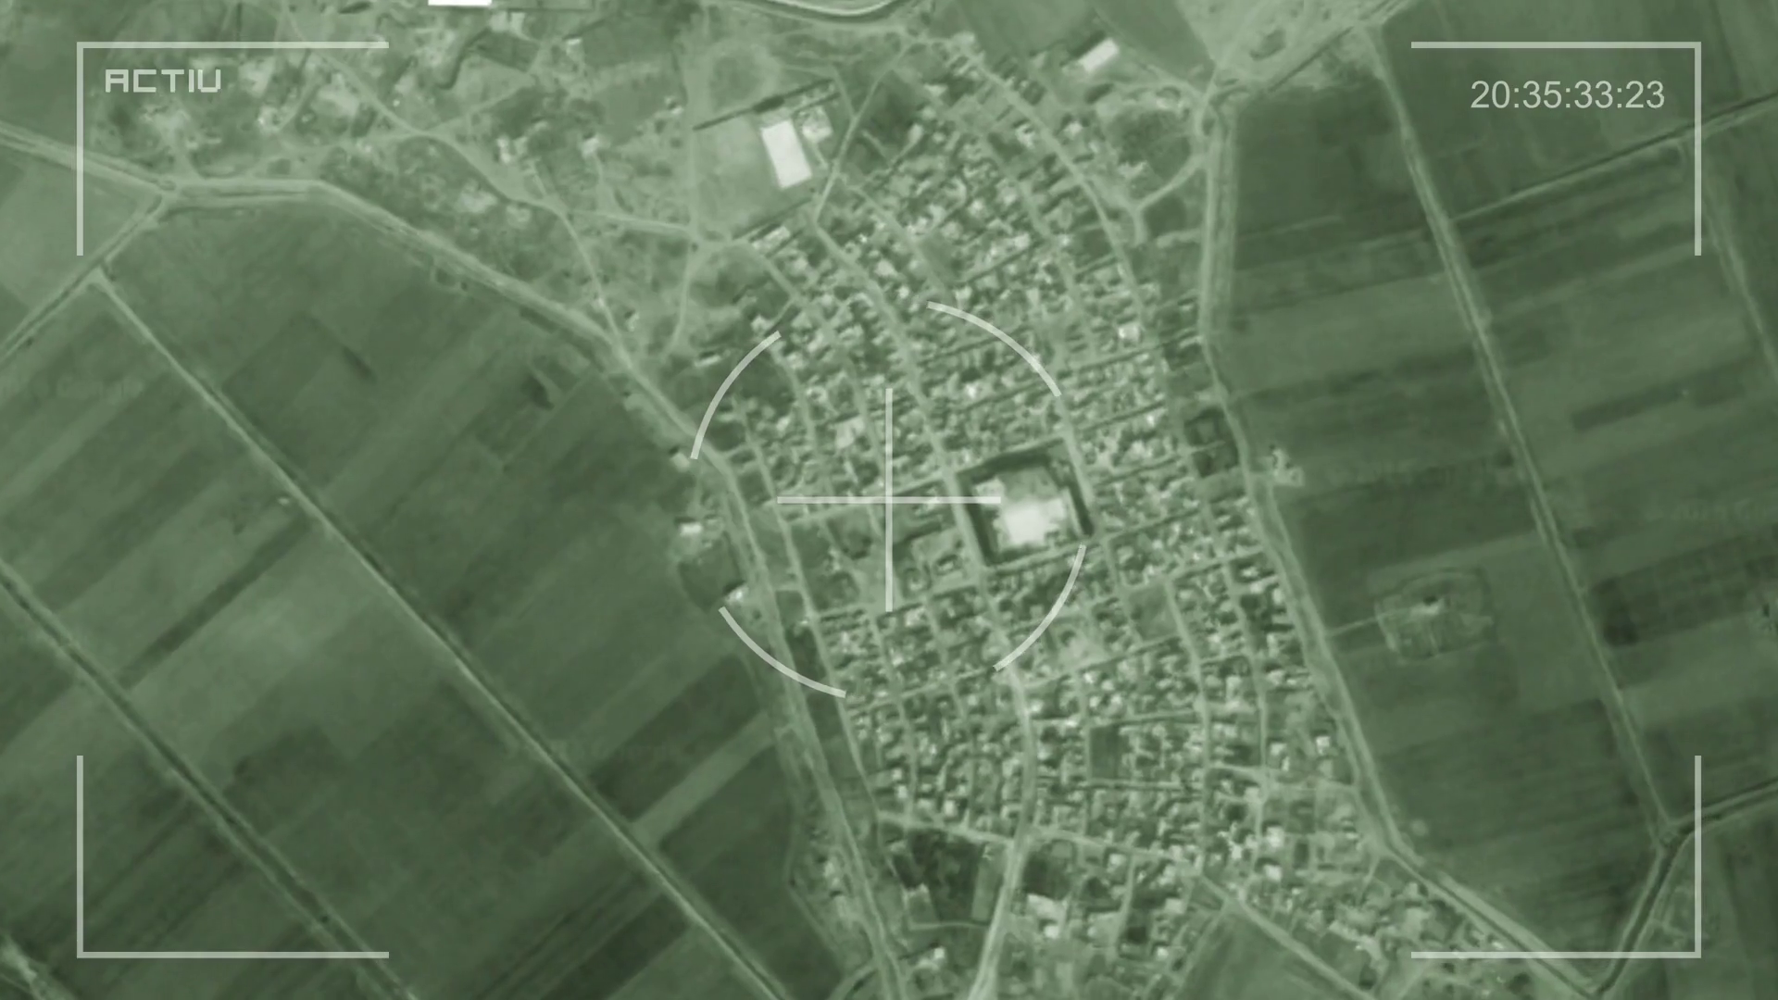
Fig. Radar used for military surveillance.

SECTION THREE

REFERENCES

- Novel Radar Techniques And Applications (Richards A. Klemm)
- Building Radar. Dobinson C. (25 march 2010)
- Radar. Zimmerman D. (15 May 2013).
- Principles of Modern Radar: Advanced Techniques. William A. Holm, Mark A. Richards, William L. Melvin.
- Fundamentals of radar [Mark A. Richards]
- Fundamentals of Radar Signal Processing, Second Edition (McGraw-Hill Professional Engineering) [Mark A. Richards]
- https://en.wikipedia.org/wiki/History_of_radar
- https://www.britannica.com/technology/radar/History-of-radar
- Principles Of Modern Radar: Volume 1 (Mark A. Richards)

