**DANE LOGOWANIA**

**nazwa.pl**

|  |  |
| --- | --- |
| Login: | **karol1396** |
| Hasło: | **BrzozowskiDomain16** |
| Nazwa domeny: | intellihomesystem.pl |



|  |  |
| --- | --- |
| Login: | **32085vQ** |
| Hasło: | **F72Truu3** |
| ID: | 32085 |
| E-mail: | brzozowski96@gmail.com |
| Usługa: | Aruba Cloud C00053718 |
| Panel zarządzania: | admin.dc3.arubacloud.pl |
| Login: | FPL-49676 |
| Hasło: | HrfoA213!h |



|  |  |
| --- | --- |
| Login: | **root** |
| Hasło: | **ProgServ@96** |
| Adres IP: | 89.40.126.110 |

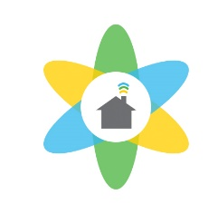

|  |  |
| --- | --- |
| Login: | **root** |
| Hasło: | **ZSKBoy@1996** |
| Login2:  Hasło2: | **karol**  **ZSKBoy@13** |
| Adres IP: | 10.5.0.101 |



|  |  |
| --- | --- |
| Login: | **root** |
| Hasło: | **brzoza96@Smart** |
| Login2: | **smart_home** |
| Hasło2: | **brzoza96@Base** |



|  |  |
| --- | --- |
| Login: | **IntelliHomeBrzozowski@gmail.com** |
| Hasło: | **SmartHome@96** |
| Usługa: | SMTP Server client |



|  |  |
| --- | --- |
| Login: | **admin** |
| Hasło: | **KAROL1396** |
| Adres IP:  Wi-Fi: | 10.5.0.100  IntelliHome |
| Hasło: | Brzoza@SMART16 |

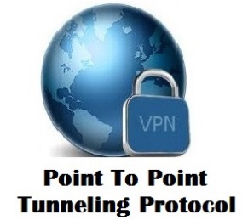

|  |  |
| --- | --- |
| Login: | **uservpn1** |
| Hasło: | **vpnBrzoza!96** |
| Adres IP (serwer): | 10.0.0.1 |
| Adres IP (client): | 10.0.0.100 |
| Usługa: | PTPPVPN tunnnel |



|  |  |  |
| --- | --- | --- |
| Login1: | **admin** | |
| Hasło1: | **homeCamera** | |
| Login2: | **user1** | |
| Hasło2: | **camera16** | |
| Login3: | **user2** | |
| Hasło3: | **camera16** | |
| Adres IP/Port: | | | 10.5.0.102:81 | |



|  |  |
| --- | --- |
| Login: | **intellihomebrzozowski@gmail.com** |
| Hasło: | **SmartHome16** |