Student Name: Ben Sottile
Class and Section CSC 210-02
Total Points (40 pts) __________________

Due: Refer to Blackboard (Late homework submission is not acceptable! You must turn in your own work in blackboard!)

Project: Calculating Future Investment Value

CS210 Introduction to Programming Principles
California Lutheran University

Problem Description:

Write a program that reads in investment amount, annual interest rate, and number of years, and displays the future investment value using the following formula:
and displays the future investment value using the following formula:

futureInvestmentValue =
investmentAmount * (1 + monthlyInterestRate)^{numberOfYears*12}

For example, if you enter amount 1000, annual interest rate 3.25%, and number of years 1, the future investment value is 1032.98.

Here is a sample run:

Test 1:
Enter investment amount: 1000
Enter annual interest rate: 4.25
Enter number of years: 1
Accumulated value is 1043.34

Test 2:
Enter investment amount: 5000
Enter annual interest rate: 1.25
Enter number of years: 2
Accumulated value is 5126.50

Test 3:
Enter investment amount: 3025.45
Enter annual interest rate: 3
Enter number of years: 5
Accumulated value is 3514.41

Submit the following items:
- Submit this world document with your answers before the due date.
- Zip your project and submit it before the due data.

- Analysis: (10 pts)
(Describe the program use cases. Write down the requirements for your code. Describe the stakeholders for your code. Describe what the SW should be able to do?)

- Scope/Objective:
Design a Software in JAVA that takes the investment amount, monthy interest rate, and number of years and gives the future value of that investment with interest rate.
- Use cases:
People who give loans and people who take them out who want to calculate how much interest they may pay.
Anyone who has bank account and wants to calculate the amount of interest they may acquire,
People in dept
People who own bonds
Anything that has interest payments.
If coded correctly it could also be coded to include depreciation and appreciation.
Requirements:
The Software shall be written in JAVA.
The Software shall include the scanner.util package
The Software shall ask the user to insert investment amount, annual interest rate, and number of years
The SW shall display Accumulated value as the result
The program will evaluate all input via a function to screen user input.
The SW shall not crash.
The SW shall throw back any invalid.
The SW shall not have any coding errors.
The SW shall be documented well.
The SW shall be readable.
The Software will include a decpriation as well as an appreciation option.
The SW shall be testable.

- Design: (10 pts)
(Describe the major steps for solving the problem. Flow charts, pseudocode, UML, Java Doc, Markdown all are acceptable.)

Pseudocode
Get Investment Value
Get Annual Interest Rate
Get Number of Years
Plug into Annual Interest Rate Equation
futureInvestmentValue = investmentAmount * ((100+annual Interest)/100)^{numberOfYears}
Print Future Value

Coding: (10 pts)
(Copy and Paste Source Code here. Format your code using Courier 10pts. Screen shot of your code is also acceptable.)
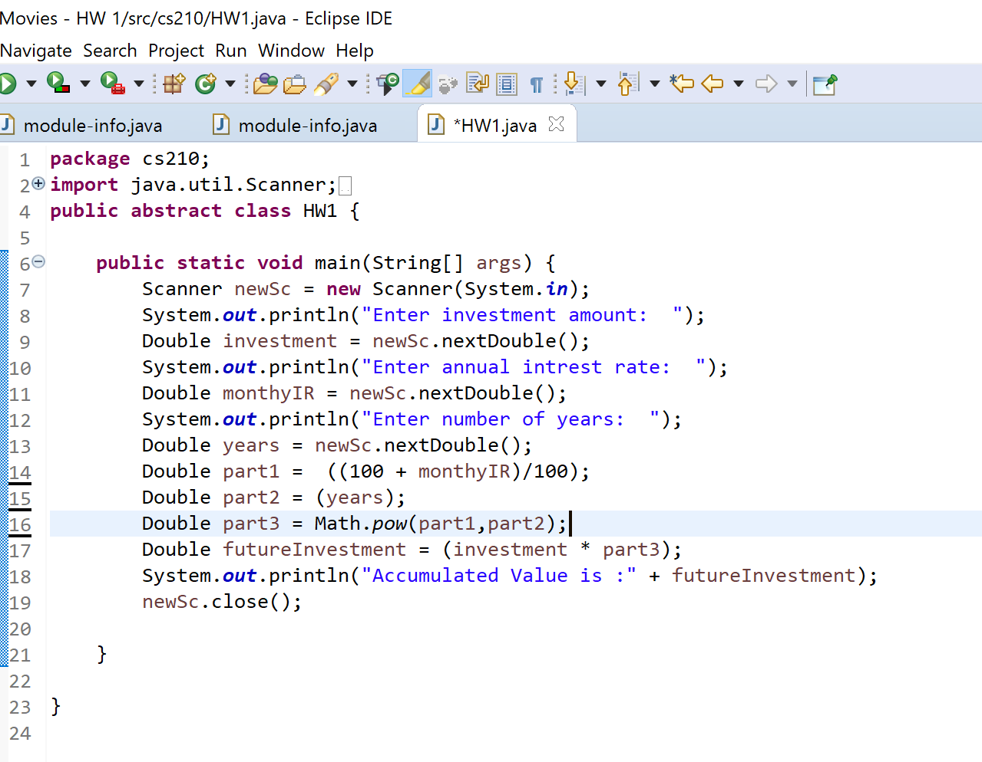

Testing: (10 pts)
(Describe how you test this program, and attach your results screen shots here. For this homework at least 3 test cases are required. Be clear in your results.)

