Arduino

Arduino has a built in Led at 13. The most basic programming that you can write is to run that led light. With the following code. Delays are variable which will determine the length and the pause between the blinks.

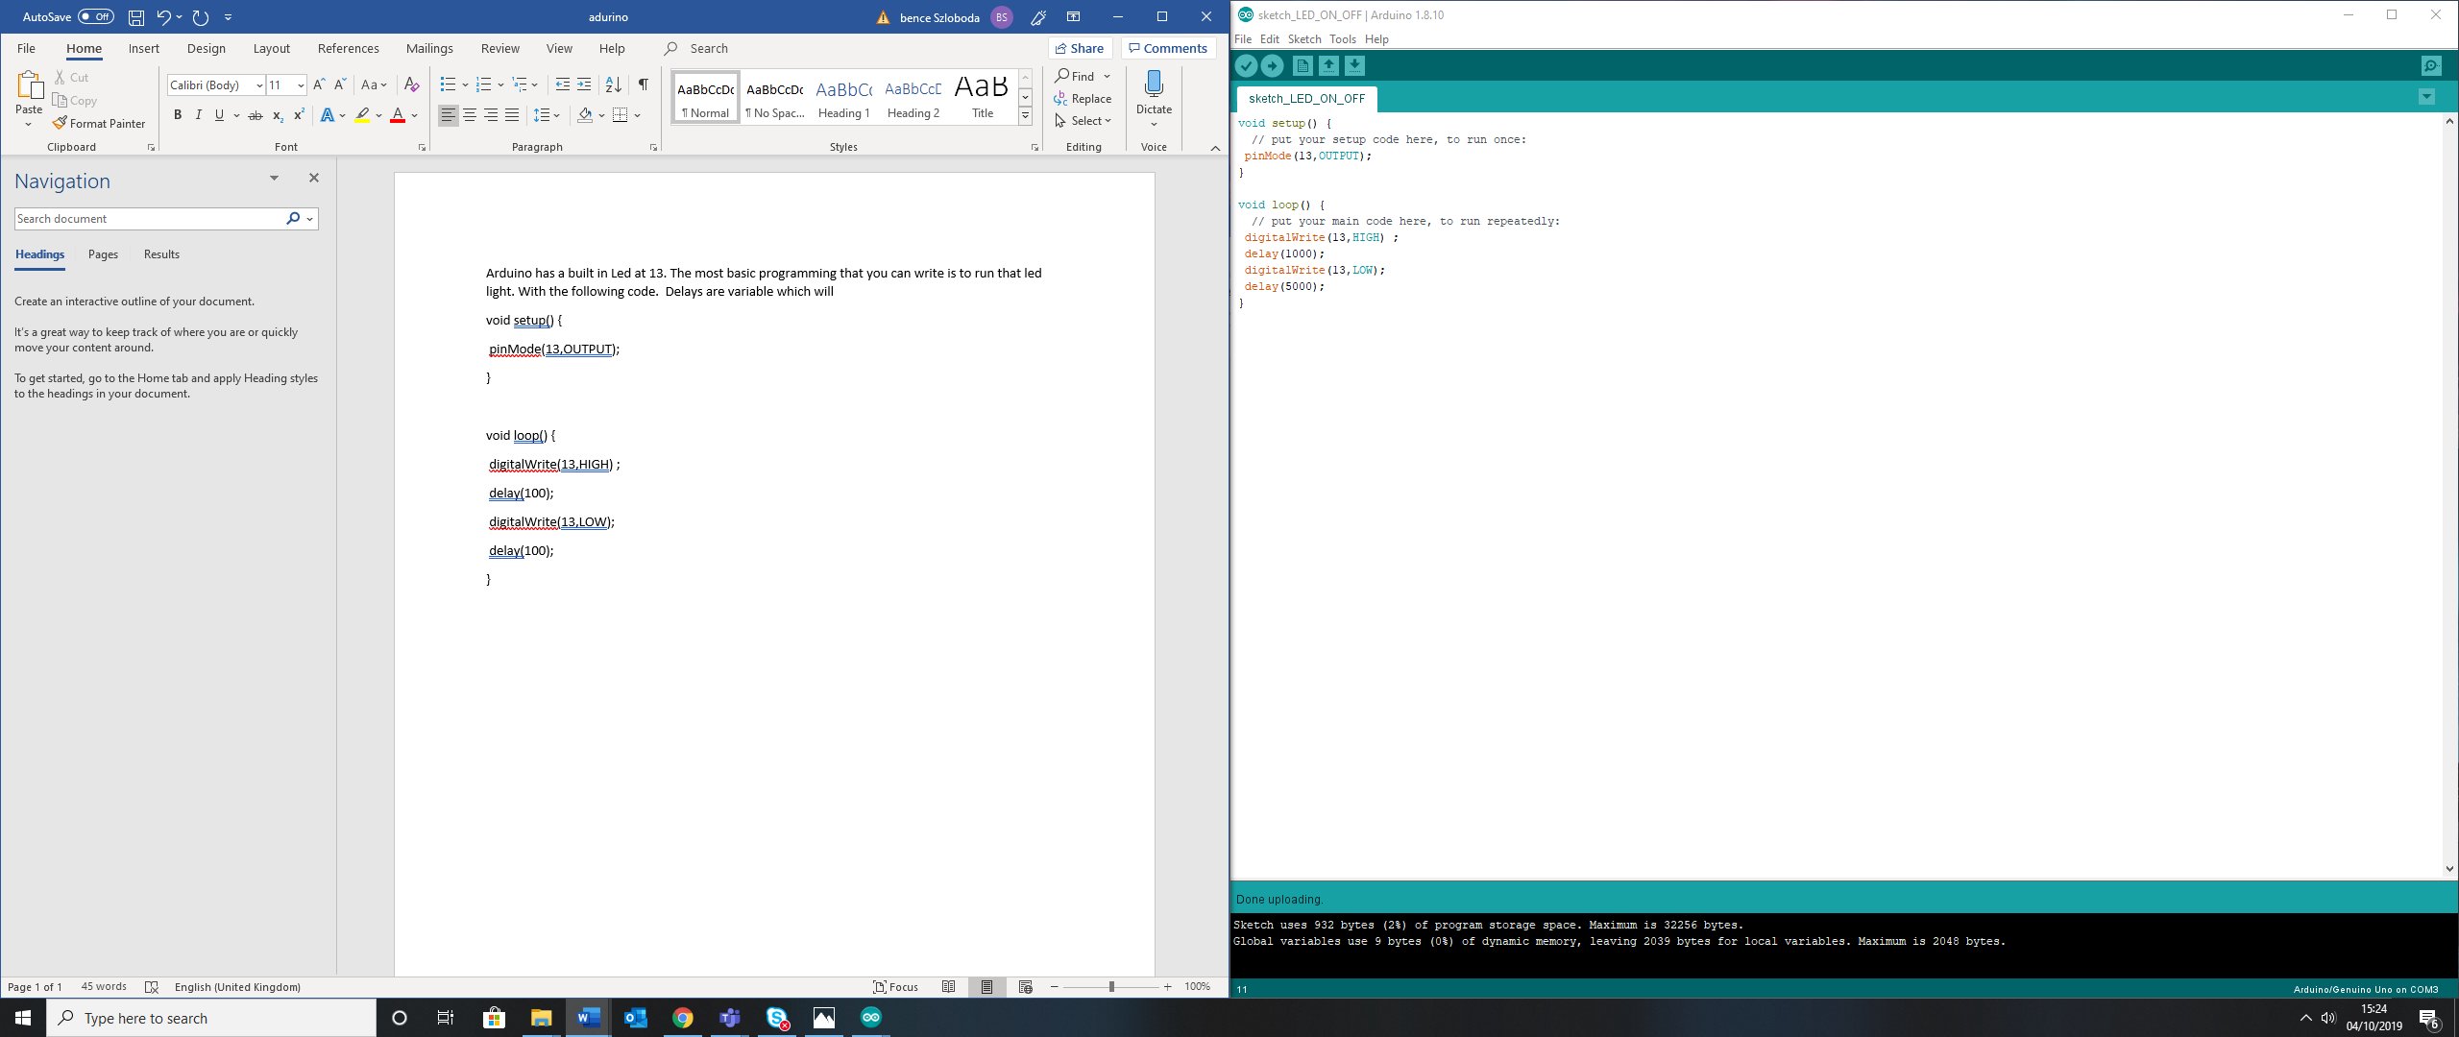

**Adding external LED**

Adding external LED(s) is possible by using a breadboard

LED has a short and a long pin, the short pin is connected to the ground. A resistor is important to be connected in series with a LED as its decreases the current so the LED will not burn out.

The Code will remain the same, however the pin reference has to be changed accordingly to where it is connected.

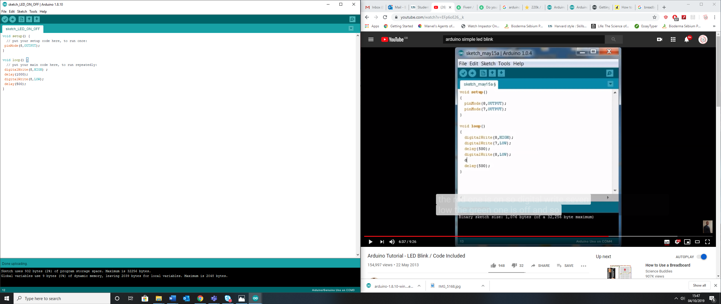

PICS

**Adding a second LED**

New pin needs to be initialized and added to the code. The following code will produce a blinking sequence between the two LEDs

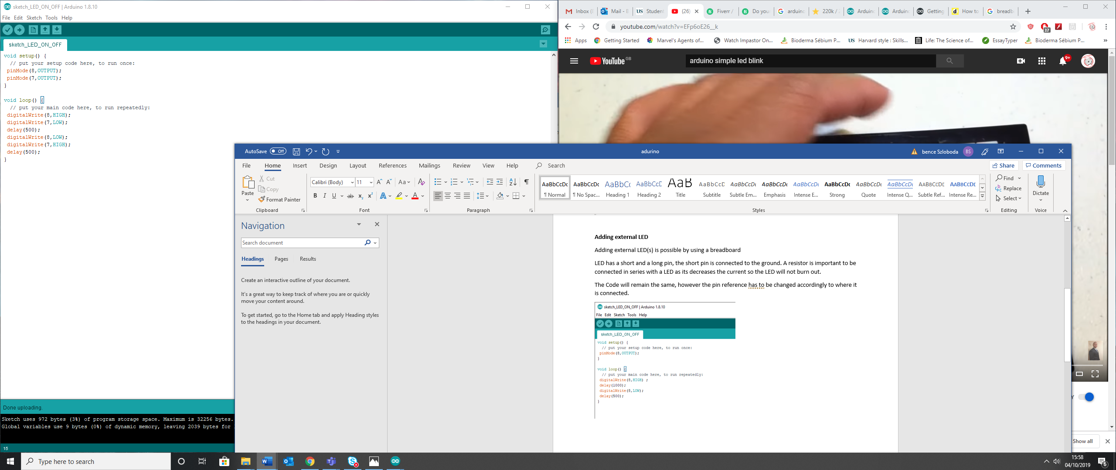

Pics

Adding Button

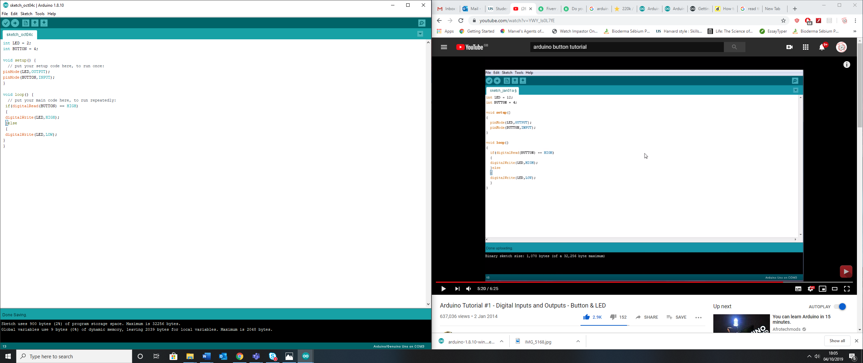

PICS

**Getting Serial Readings**

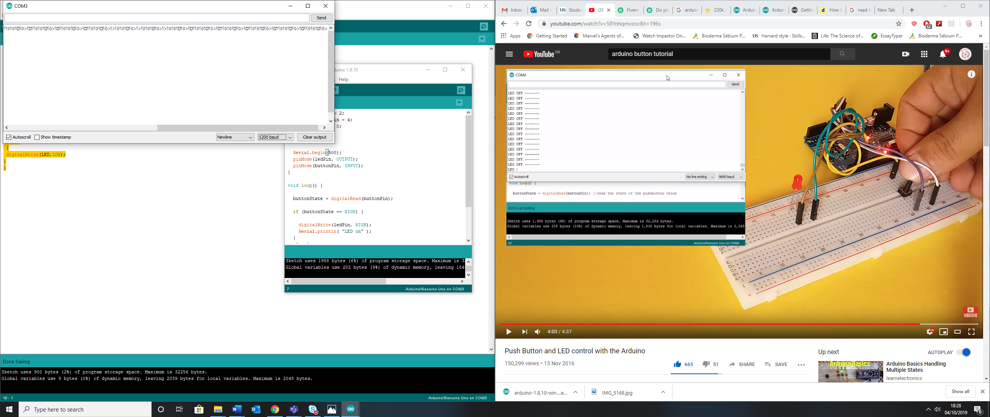

As I was getting Serial readings

When I changed to Serial.begin(9600) it was working

Having completed these tasks my next aim will be to learn about the potentiometer and variable resistance