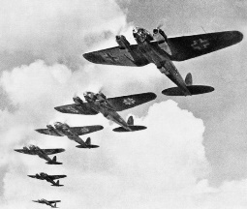 **CLASSIFICATION**

|  |  |
| --- | --- |
| **TRUE POSITIVE**  **2** | **FALSE NEGATIVE**  **1** |
| **FALSE POSITIVE**  **4** | **TRUE NEGATIVE**  **13** |

**Positive** **Negative**

**-**

**+**

**CONDITION**

 **Threshold 80**

 **CLASSIFICATION**

|  |  |
| --- | --- |
| **TRUE POSITIVE**  **3** | **FALSE NEGATIVE**  **0** |
| **FALSE POSITIVE**  **7** | **TRUE NEGATIVE**  **10** |

**Positive** **Negative**

 **Threshold 70**

**-**

**+**

**CONDITION**