SOFTWARE DESIGN SPECIFICATION
Salone Travel
Concierge Platform - SDS v1.0 - Part 2
Data Model, API Design and Business Logic - the operational blueprint that turns the architecture into an implementable schema, contract, and rulebook.

Document | Software Design Specification (SDS) - Part 2
Scope | Sections 3-5 - Data model, API design, business logic
Depends on | SDS Part 1 - Architecture (ADR-001 through ADR-005)
Product | Salone Travel Concierge Platform (MVP v1.0)
Author | Glen Ayienda
Version | 1.0 - Draft for review
Date | January 2026

About this document. Part 2 of the SDS specifies the platform's persistent state (the data model), its external contract (the API), and the rules that govern how state transitions happen (the business logic). It assumes the architectural foundations laid down in Part 1: a modular Node.js monolith over PostgreSQL, Prisma as the ORM, JWT-based authentication, and Stripe as the payments backbone.

Contents
3 Data Model 3
3.1 Design principles 3
3.2 Domain overview (Figure 6) 3
3.3 Type conventions and shared columns 6
3.4 Enumerations 6
3.5 Identity & auth tables 7
3.6 Catalog tables 9
3.7 Booking tables 11
3.8 Payment tables 13
3.9 Messaging tables 14
3.10 Moderation & audit tables 15
3.11 Indexes summary 16
3.12 Migrations policy 17
4 API Design 19
4.1 Design principles 19
4.2 Resource map (Figure 9) 19
4.3 Common conventions 22
4.4 Error model 23
4.5 Auth endpoints 24
4.6 Catalog endpoints 26
4.7 Booking endpoints 29
4.8 Payment endpoints 31
4.9 Review and moderation endpoints 32
4.10 Conversation endpoints 33
4.11 Admin endpoints 34
4.12 WebSocket event catalogue (Figure 10) 36
5 Business Logic 38
5.1 Booking state machine (Figure 7) 38
5.2 Provider verification workflow (Figure 8) 41
5.3 Concierge assignment rules 43
5.4 Review eligibility 43
5.5 Commission and money flow (Figure 11) 44
5.6 Cancellation and refund policy 46
5.7 Summary and next steps 47

3 Data Model

3.1 Design principles
Every schema choice in this section is measured against a small set of principles. When two principles conflict, the ADR for that decision (or a note in the table body) records which won and why.
- Money is stored as integers. All monetary values are stored in the smallest unit (cents) as int columns, never as decimal or float. Formatting for display is a presentation concern.
- Times are stored with time-zone. All timestamps use timestamptz. UTC in storage; conversion to local time is a presentation concern.
- Soft delete is the default for user-visible entities. Providers, services, destinations and reviews get a deleted_at column instead of physical DELETE, so historical bookings retain their references. Junk data (revoked sessions, consumed verification codes) is hard-deleted by a scheduled cleanup job.
- FKs use ON DELETE RESTRICT by default. Only weak references (audit metadata, denormalised snapshots) use ON DELETE SET NULL. Cascading deletes are avoided - they hide dependencies.
- Every mutable row has updated_at and version. updated_at supports the API's If-Modified-Since caching. version supports optimistic concurrency (see 5.1).
- Enums are Postgres enum types, not text. Constrained, indexed, cheap to compare. Migrations that add enum values are additive-only in production.
- JSONB for legitimately open-ended attributes only. emergency_contact, webhook payload, event metadata - never for anything that will be searched, joined, or aggregated. The moment a JSONB key is queried in more than one place it graduates to a column.

3.2 Domain overview (Figure 6)
The MVP data model comprises 18 tables organised across six loose domains. The domains are not hard partitions - relationships cross them freely - but they are useful for reasoning, for code organisation, and for permissions.
Domain | Tables
Identity & auth | users, refresh_sessions, email_verifications, traveler_profiles
Catalog | providers, services, provider_documents, destinations
Booking | bookings, booking_events
Payment | payments, refunds, webhook_events
Messaging | conversations, messages
Moderation & audit | reviews, audit_logs
Figure 6 (following page) shows the complete entity-relationship diagram. Its layout groups related tables into columns and colour-codes them by domain; cardinalities are shown on each relationship arrow.

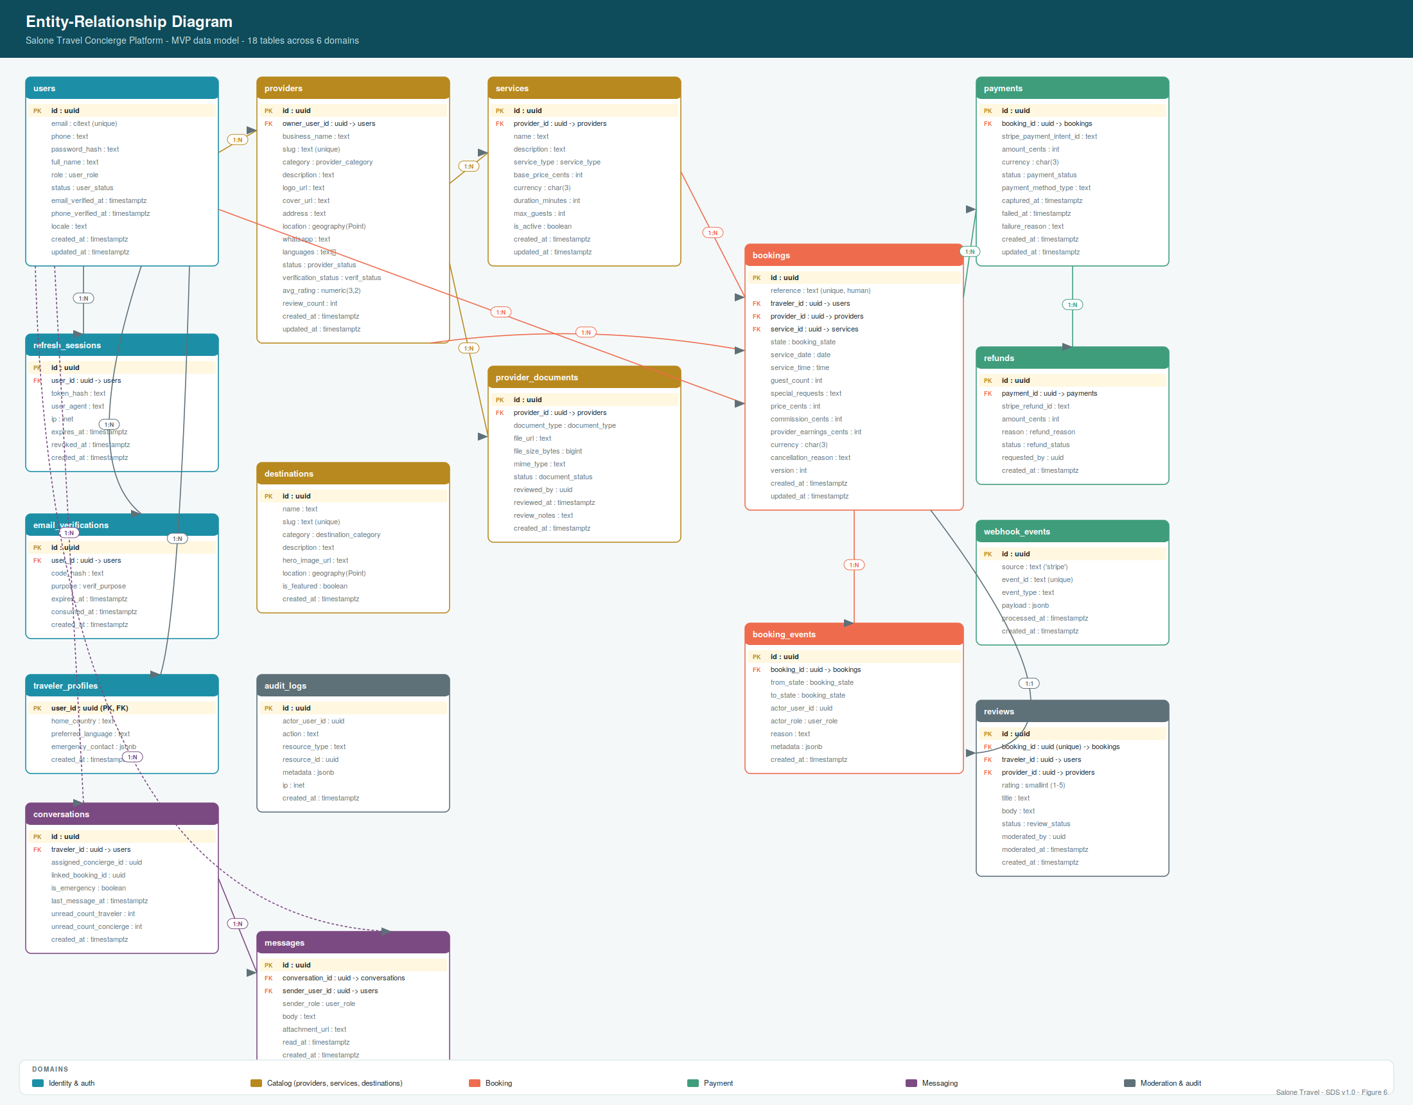
Figure 6 - Entity-relationship diagram: 18 tables across 6 domains.

3.3 Type conventions and shared columns
Every table in the schema follows these conventions unless a note explicitly says otherwise.
Convention | Rule
Primary keys | uuid v4 in the id column, generated by gen_random_uuid() (pgcrypto). No integer PKs - UUIDs prevent enumeration and simplify data merging.
Foreign keys | <referenced_table_singular>_id : uuid, NOT NULL unless the relationship is optional. Index every FK column.
Timestamps | created_at timestamptz NOT NULL DEFAULT now() on every row. updated_at timestamptz NOT NULL DEFAULT now() on any table where rows are mutated after creation; kept current by a Prisma middleware.
Version column | Every table whose rows are mutated after creation has version int NOT NULL DEFAULT 1 for optimistic concurrency (see 5.1).
Soft delete | Where required, deleted_at timestamptz NULL. Queries filter WHERE deleted_at IS NULL by default; a specific service-level flag exposes soft-deleted rows to admin queries.
Money columns | *_cents int NOT NULL (never NULL - if there's no amount, the column belongs on a different row or table).
Text vs varchar | text everywhere. varchar(n) is a legacy pattern that adds no safety in Postgres.
Emails | citext (case-insensitive text). Unique constraint applied at the database level, never enforced only in application code.
Phone numbers | text, stored in E.164 format (+232...). Validation at ingress (Zod); normalisation via libphonenumber-js before persist.
Slugs | text, unique, lowercase kebab-case, generated server-side from the display name.

3.4 Enumerations
Postgres enum types used throughout the schema. Enum members are documented here as source of truth; migrations that add members are one-line and non-blocking.
Enum | Members
user_role | 'traveler', 'provider', 'concierge', 'admin'
user_status | 'active', 'suspended'
verif_purpose | 'email_verify', 'password_reset', 'phone_verify'
provider_category | 'hotel', 'guest_house', 'tour_operator', 'guide', 'driver', 'car_rental', 'boat_operator', 'restaurant', 'event_organiser'
provider_status | 'draft', 'submitted', 'under_review', 'approved', 'listed', 'suspended', 'rejected'
verification_status | 'pending', 'verified', 'rejected'
destination_category | 'beach', 'wildlife', 'heritage', 'island', 'city', 'nature', 'culture'
service_type | 'accommodation', 'transfer', 'tour', 'rental', 'guide', 'meal', 'boat_trip', 'experience', 'event'
document_type | 'business_registration', 'tax_id', 'insurance', 'permit', 'id_document', 'other'
document_status | 'pending', 'approved', 'rejected'
booking_state | 'pending', 'accepted', 'awaiting_payment', 'paid', 'confirmed', 'in_progress', 'completed', 'declined', 'expired', 'payment_failed', 'cancelled_by_traveler', 'cancelled_by_provider', 'no_show'
payment_status | 'requires_payment_method', 'requires_action', 'processing', 'succeeded', 'failed', 'cancelled'
refund_reason | 'traveler_cancelled', 'provider_cancelled', 'no_show', 'service_failure', 'duplicate', 'other'
refund_status | 'pending', 'succeeded', 'failed'
review_status | 'pending_moderation', 'published', 'hidden'

3.5 Identity & auth tables

users
The root identity table. Every human or system principal that authenticates against the platform has a row here. Traveler-specific attributes live in traveler_profiles; provider-specific attributes live on providers.owner_user_id (a single user may own zero or one provider).
Column | Type | Notes
id | uuid | PK, gen_random_uuid()
email | citext | UNIQUE NOT NULL, indexed
phone | text | E.164 format, nullable, indexed
password_hash | text | Argon2id, never returned to clients
full_name | text | NOT NULL
role | user_role | NOT NULL, indexed
status | user_status | NOT NULL, default 'active'
email_verified_at | timestamptz | NULL until verified
phone_verified_at | timestamptz | NULL until verified
locale | text | IETF tag, default 'en-SL'
created_at | timestamptz | NOT NULL, default now()
updated_at | timestamptz | NOT NULL, default now()
version | int | NOT NULL, default 1
Constraints. UNIQUE(email), CHECK(email = lower(email)), CHECK(role IN valid enum members - enforced by type).
Indexes. idx_users_email_verified (email) WHERE deleted_at IS NULL; idx_users_role (role) for admin queries; idx_users_phone (phone) WHERE phone IS NOT NULL for lookup during SMS delivery.

refresh_sessions
Each successful login mints an access token (short-lived, stateless JWT, not stored) and a refresh token whose SHA-256 hash is stored here. A row exists per active login session. Rotation on refresh - the presented token is revoked and a new one is issued in the same transaction. Suspicious behaviour (mismatched user_agent, geographically improbable IP shift) triggers revocation of the whole user's sessions.
Column | Type | Notes
id | uuid | PK
user_id | uuid | FK -> users(id) ON DELETE CASCADE, indexed
token_hash | text | UNIQUE NOT NULL, sha256(refresh_token)
user_agent | text | captured at login
ip | inet | captured at login
expires_at | timestamptz | NOT NULL, default now()+30d
revoked_at | timestamptz | NULL until revoked; nightly cleanup deletes revoked+expired > 90d
created_at | timestamptz | NOT NULL

email_verifications
One row per outstanding verification code. Codes are 6-digit numeric, delivered by email or SMS, 15-minute expiry. Only the SHA-256 hash of the code is stored, so a database dump does not compromise pending flows. Consumed codes are kept for a short window (24h) for anti-abuse forensics, then deleted.
Column | Type | Notes
id | uuid | PK
user_id | uuid | FK -> users(id), indexed
code_hash | text | NOT NULL, sha256(code)
purpose | verif_purpose | NOT NULL, indexed
expires_at | timestamptz | NOT NULL
consumed_at | timestamptz | NULL until consumed; unique (user_id, purpose) WHERE consumed_at IS NULL
created_at | timestamptz | NOT NULL

traveler_profiles
Optional side-table for traveller-specific attributes. Uses a shared PK with users so the join is trivial (same UUID). Not created until the traveller fills in the first optional field; absence is fine.
Column | Type | Notes
user_id | uuid | PK, FK -> users(id) ON DELETE CASCADE
home_country | text | ISO 3166-1 alpha-2 (e.g. 'GB', 'US')
preferred_language | text | BCP-47 (e.g. 'en', 'fr', 'krio')
emergency_contact | jsonb | { name, relationship, phone } - accessed only by concierge in emergencies
created_at | timestamptz | NOT NULL

3.6 Catalog tables

providers
A verified local business listed on the marketplace. Row created in state 'draft' when the owner user upgrades to provider role, then walked through the verification state machine (5.2) until state='listed'. Ratings are denormalised (avg_rating, review_count) for fast list queries; kept in sync by a trigger on reviews.
Column | Type | Notes
id | uuid | PK
owner_user_id | uuid | UNIQUE, FK -> users(id) ON DELETE RESTRICT
business_name | text | NOT NULL
slug | text | UNIQUE NOT NULL, kebab-case, auto-derived from name
category | provider_category | NOT NULL, indexed
description | text
logo_url | text
cover_url | text
address | text
location | geography(Point,4326) | PostGIS; indexed with GIST for radius search
whatsapp | text | E.164
languages | text[] | BCP-47 tags
status | provider_status | NOT NULL, indexed
verification_status | verification_status | NOT NULL, default 'pending'
avg_rating | numeric(3,2) | 0.00-5.00, denormalised
review_count | int | NOT NULL default 0
deleted_at | timestamptz | soft delete
created_at | timestamptz | NOT NULL
updated_at | timestamptz | NOT NULL
version | int | NOT NULL default 1
Indexes. idx_providers_category_status_verif (category, status, verification_status) WHERE deleted_at IS NULL - covers the primary public-search path. idx_providers_slug (slug) UNIQUE. idx_providers_location GIST (location) - PostGIS radius search.

services
A specific bookable offering by a provider. Each row is a distinct service (e.g. 'Airport transfer - Aberdeen', 'City tour - half day'). Providers may have many; deleting a service they've had bookings on is not allowed - use is_active=false to withdraw it.
Column | Type | Notes
id | uuid | PK
provider_id | uuid | FK -> providers(id) ON DELETE RESTRICT, indexed
name | text | NOT NULL
description | text
service_type | service_type | NOT NULL, indexed
base_price_cents | int | NOT NULL, CHECK (base_price_cents >= 0)
currency | char(3) | NOT NULL, default 'USD', CHECK (currency = upper(currency))
duration_minutes | int | NULL for open-ended (accommodation)
max_guests | int | NOT NULL default 1
commission_rate | numeric(4,3) | NULL to inherit platform default (0.15); per-service override allowed
is_active | boolean | NOT NULL default true
deleted_at | timestamptz | soft delete
created_at | timestamptz | NOT NULL
updated_at | timestamptz | NOT NULL

provider_documents
Verification documents uploaded by a provider (business registration, tax ID, permits, ID). Files themselves live in object storage; only the URL and metadata are stored here. Admins review each document and set its status; a provider's overall verification cannot progress until all required documents are approved.
Column | Type | Notes
id | uuid | PK
provider_id | uuid | FK -> providers(id) ON DELETE CASCADE, indexed
document_type | document_type | NOT NULL
file_url | text | NOT NULL, signed URL to object storage
file_size_bytes | bigint | NOT NULL, CHECK (<= 10 MB)
mime_type | text | NOT NULL, CHECK (mime_type IN allowed list)
status | document_status | NOT NULL default 'pending', indexed
reviewed_by | uuid | FK -> users(id), NULL until reviewed
reviewed_at | timestamptz | NULL until reviewed
review_notes | text | admin's comment shown to provider on rejection
created_at | timestamptz | NOT NULL

destinations
Curated destination content - beaches, sanctuaries, heritage sites. Not connected to providers; the join with providers happens in application code (e.g. 'show me providers near this destination'). Admin-managed.
Column | Type | Notes
id | uuid | PK
name | text | NOT NULL
slug | text | UNIQUE NOT NULL
category | destination_category | NOT NULL, indexed
description | text
hero_image_url | text
location | geography(Point,4326) | PostGIS
is_featured | boolean | NOT NULL default false, indexed WHERE true
deleted_at | timestamptz | soft delete
created_at | timestamptz | NOT NULL

3.7 Booking tables

bookings
The central mutable entity of the platform. Every booking is created in state pending and walks the state machine described in 5.1. Money columns snapshot the pricing at request time so provider price changes do not retroactively alter existing bookings.
Column | Type | Notes
id | uuid | PK
reference | text | UNIQUE NOT NULL, human-readable (e.g. 'ST-8HQN2P'); 8-char base32, indexed
traveler_id | uuid | FK -> users(id) ON DELETE RESTRICT, indexed
provider_id | uuid | FK -> providers(id) ON DELETE RESTRICT, indexed
service_id | uuid | FK -> services(id) ON DELETE RESTRICT, indexed
state | booking_state | NOT NULL default 'pending', indexed
service_date | date | NOT NULL
service_time | time | NULL for open-ended
guest_count | int | NOT NULL default 1
special_requests | text
price_cents | int | NOT NULL - snapshot of services.base_price_cents * guests
commission_cents | int | NOT NULL - snapshot at creation
provider_earnings_cents | int | NOT NULL = price_cents - commission_cents
currency | char(3) | NOT NULL
cancellation_reason | text | NULL unless state is a cancelled variant
created_at | timestamptz | NOT NULL
updated_at | timestamptz | NOT NULL
version | int | NOT NULL default 1 - optimistic concurrency
Constraints. CHECK (guest_count > 0), CHECK (price_cents = commission_cents + provider_earnings_cents), CHECK (service_date >= created_at::date).
Indexes. idx_bookings_traveler_state (traveler_id, state, created_at DESC); idx_bookings_provider_state (provider_id, state, service_date); idx_bookings_state_service_date (state, service_date) for the scheduler's timed transitions; idx_bookings_reference UNIQUE (reference).

booking_events
Append-only audit log of every state transition. Every UPDATE to bookings.state must write a matching row here in the same transaction (enforced by a service-layer contract, not a trigger, so tests can control the behaviour). The event log is the source of truth for who did what to a booking and why.
Column | Type | Notes
id | uuid | PK
booking_id | uuid | FK -> bookings(id) ON DELETE CASCADE, indexed
from_state | booking_state | NULL for the initial 'pending' event
to_state | booking_state | NOT NULL
actor_user_id | uuid | FK -> users(id); NULL for system-initiated transitions (scheduler)
actor_role | user_role | NULL for system-initiated
reason | text | free-form; required for cancel/decline/reject
metadata | jsonb | transition-specific context (Stripe intent ID, refund ID, etc.)
created_at | timestamptz | NOT NULL

3.8 Payment tables

payments
A payment is the platform's local record of a Stripe PaymentIntent. Created when the booking transitions to awaiting_payment; updated by webhooks. A booking may have more than one payment row if a previous attempt failed and the traveller retried.
Column | Type | Notes
id | uuid | PK
booking_id | uuid | FK -> bookings(id) ON DELETE RESTRICT, indexed
stripe_payment_intent_id | text | UNIQUE NOT NULL
amount_cents | int | NOT NULL, mirrors PaymentIntent amount
currency | char(3) | NOT NULL
status | payment_status | NOT NULL, indexed
payment_method_type | text | 'card', 'link', etc. - Stripe classification
captured_at | timestamptz | set on succeeded
failed_at | timestamptz | set on failed
failure_reason | text | Stripe's failure code + message
created_at | timestamptz | NOT NULL
updated_at | timestamptz | NOT NULL

refunds
A refund is a mirror of a Stripe Refund object. Refunds are always attached to a specific payment, may be partial, and their status follows Stripe's - since Stripe may take minutes to settle a refund, the row is created in pending and then transitioned by the corresponding webhook.
Column | Type | Notes
id | uuid | PK
payment_id | uuid | FK -> payments(id) ON DELETE RESTRICT, indexed
stripe_refund_id | text | UNIQUE NOT NULL
amount_cents | int | NOT NULL
reason | refund_reason | NOT NULL
status | refund_status | NOT NULL, indexed
requested_by | uuid | FK -> users(id); who initiated
created_at | timestamptz | NOT NULL

webhook_events
Every inbound webhook (Stripe, in the MVP) is written here before any state change. The unique index on event_id makes replay safe - duplicate deliveries are no-ops. This table is the auditor's friend when reconciling money.
Column | Type | Notes
id | uuid | PK
source | text | NOT NULL, e.g. 'stripe'
event_id | text | NOT NULL, UNIQUE(source, event_id)
event_type | text | NOT NULL, e.g. 'payment_intent.succeeded'
payload | jsonb | NOT NULL - the raw webhook body
processed_at | timestamptz | NULL until handler completes; NULL rows are retried
created_at | timestamptz | NOT NULL

3.9 Messaging tables

conversations
One row per persistent chat thread between a traveller and the concierge team. A conversation belongs to exactly one traveller and, once claimed, has exactly one assigned concierge (though ownership can be reassigned). Unread counts are denormalised per participant so that inbox rendering is O(1) per conversation.
Column | Type | Notes
id | uuid | PK
traveler_id | uuid | FK -> users(id) ON DELETE CASCADE, indexed
assigned_concierge_id | uuid | FK -> users(id); NULL until assigned
linked_booking_id | uuid | FK -> bookings(id); optional context
is_emergency | boolean | NOT NULL default false, indexed WHERE true
last_message_at | timestamptz | denormalised, updated by trigger
unread_count_traveler | int | NOT NULL default 0
unread_count_concierge | int | NOT NULL default 0
created_at | timestamptz | NOT NULL

messages
An append-only stream of messages within a conversation. Ordered by created_at; message editing is out of scope for MVP. Attachments live in object storage and are referenced by URL.
Column | Type | Notes
id | uuid | PK
conversation_id | uuid | FK -> conversations(id) ON DELETE CASCADE, indexed
sender_user_id | uuid | FK -> users(id)
sender_role | user_role | denormalised for fast fan-out
body | text | NOT NULL, 1..4000 chars
attachment_url | text | NULL for text-only
read_at | timestamptz | NULL until any recipient reads
created_at | timestamptz | NOT NULL, indexed with conversation_id for ordered listing

3.10 Moderation & audit tables

reviews
One review per completed booking. Enforced by a UNIQUE constraint on booking_id; the traveller may edit their own review within 24 hours of creation, after which it is immutable. Moderation is manual in the MVP - reviews are visible immediately in state 'published' but an admin can hide any review at any time.
Column | Type | Notes
id | uuid | PK
booking_id | uuid | UNIQUE, FK -> bookings(id) ON DELETE RESTRICT
traveler_id | uuid | FK -> users(id), indexed
provider_id | uuid | FK -> providers(id), indexed
rating | smallint | NOT NULL, CHECK (rating BETWEEN 1 AND 5)
title | text | NULL for short reviews
body | text | NOT NULL, 10..2000 chars
status | review_status | NOT NULL default 'published', indexed
moderated_by | uuid | FK -> users(id), NULL if never moderated
moderated_at | timestamptz | NULL if never moderated
deleted_at | timestamptz | soft delete
created_at | timestamptz | NOT NULL
updated_at | timestamptz | NOT NULL

audit_logs
A generic audit trail for security-relevant actions - suspending a user, verifying a provider, refunding a payment, changing a role, and every failed login. Distinct from booking_events, which is the domain event log; audit_logs is the security event log.
Column | Type | Notes
id | uuid | PK
actor_user_id | uuid | FK -> users(id); NULL for anonymous events (failed login by unknown email)
action | text | NOT NULL, e.g. 'provider.approved', 'user.suspended', 'refund.issued'
resource_type | text | 'user', 'provider', 'booking', 'payment', ...
resource_id | uuid | the affected resource
metadata | jsonb | action-specific context
ip | inet | source IP
created_at | timestamptz | NOT NULL, indexed for time-window queries

3.11 Indexes summary
Consolidated view of every non-trivial index the schema requires. Simple UNIQUE and FK indexes are omitted; those are automatic. All indexes should be created in the same migration as the table they support.
Table | Index | Purpose
users | idx_users_role (role) | Admin list-by-role
users | idx_users_phone (phone) WHERE phone IS NOT NULL | Provider SMS lookup
refresh_sessions | idx_sessions_user_active (user_id) WHERE revoked_at IS NULL | List active sessions per user
providers | idx_providers_search (category, status, verification_status) WHERE deleted_at IS NULL | Primary public search
providers | idx_providers_location GIST (location) | Radius search near destination
services | idx_services_provider_active (provider_id) WHERE is_active | Provider profile page
provider_documents | idx_docs_provider_status (provider_id, status) | Verification review queue
destinations | idx_destinations_featured (is_featured) WHERE is_featured | Home-page carousel
bookings | idx_bookings_traveler_state (traveler_id, state, created_at DESC) | Traveler 'my bookings' listing
bookings | idx_bookings_provider_state (provider_id, state, service_date) | Provider 'incoming' + 'today' views
bookings | idx_bookings_state_service_date (state, service_date) | Scheduler's timed transitions
booking_events | idx_events_booking_created (booking_id, created_at) | Audit trail listing
payments | idx_payments_booking (booking_id) | Look up payments per booking
payments | idx_payments_stripe (stripe_payment_intent_id) UNIQUE | Webhook lookup
webhook_events | idx_webhook_unique (source, event_id) UNIQUE | Idempotent replay
webhook_events | idx_webhook_pending (processed_at) WHERE processed_at IS NULL | Retry sweep
conversations | idx_conv_traveler_recent (traveler_id, last_message_at DESC) | Traveler inbox
conversations | idx_conv_concierge_open (assigned_concierge_id, is_emergency, last_message_at DESC) | Concierge inbox
messages | idx_messages_conv_created (conversation_id, created_at DESC) | Chat scrollback
reviews | idx_reviews_provider_published (provider_id, status) WHERE status = 'published' | Provider public profile
audit_logs | idx_audit_created (created_at DESC) | Time-window audit queries
audit_logs | idx_audit_actor (actor_user_id, created_at DESC) | Per-user audit

3.12 Migrations policy
Schema evolution is managed by Prisma Migrate. Migrations are stored in the repository under prisma/migrations/, reviewed like any other code change, and run automatically on deploy.
- Additive-only in production. New columns, new tables, new indexes: always allowed. Adding a NOT NULL column requires either a DEFAULT or a two-phase migration (add nullable, backfill, add constraint).
- Destructive changes require an ADR. Dropping a column, renaming a column, changing a type, tightening a constraint - each requires a written decision recorded in the ADR register and, in production, a scheduled maintenance window.
- Enum values only grow. Removing an enum member requires (a) confirming no live rows use it and (b) a maintenance window; renaming is preferred.
- Indexes are created CONCURRENTLY. Creating an index on a busy table locks reads/writes; CONCURRENTLY avoids that at the cost of a longer creation time.
- Every migration is reviewable. CI runs prisma migrate diff against the deployed schema and posts the SQL to the pull request for a second pair of eyes.

4 API Design

4.1 Design principles
The API is the platform's stable contract with its four client applications and with any future integrator. It follows a set of conventions consistently so that clients can reason about behaviour without reading per-endpoint documentation for every call.
- Versioned. Every resource path lives under /v1/. A future breaking change is a v2 alongside v1, not a mutation of v1.
- Predictable resource shape. GET /v1/<resources> lists, GET /v1/<resources>/:id fetches one, POST /v1/<resources> creates, PATCH /v1/<resources>/:id partial-updates, DELETE /v1/<resources>/:id soft-deletes. Actions that do not fit CRUD are suffixed on the resource (POST /v1/bookings/:id/accept).
- JSON everywhere. application/json for request and response. Multipart is used only for direct file uploads (provider documents, message attachments).
- ISO 8601 for time, integers for money. No client should ever guess a time zone or a decimal place.
- Errors are structured and stable. Every failure returns the same envelope (see 4.4). Codes are strings, not HTTP status - HTTP status is the transport-level classification.
- Idempotency by header. Every non-idempotent endpoint (any POST or PATCH) accepts an Idempotency-Key header; the first request wins, subsequent identical retries return the cached response.
- Pagination is opaque cursor. Never page number + size (fragile under concurrent inserts); always ?cursor=<opaque> with a next cursor in the response envelope.
- Rate-limits are documented. Every endpoint class has a stated per-user and per-IP quota, returned in the X-RateLimit-* headers.

4.2 Resource map (Figure 9)
Figure 9 (following page) is the visual index of the entire API. Endpoints are grouped by resource; each row shows the HTTP method (colour-coded), the path, and a one-line purpose; the background of each row indicates the minimum role required to call it. This is the reference to keep alongside every subsequent code table in this section - the map catalogues what exists, the endpoint blocks below specify what each one does.

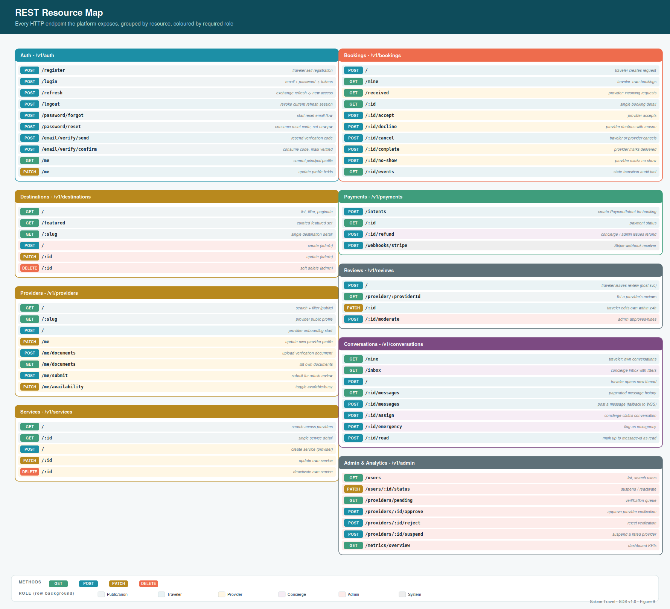
Figure 9 - REST resource map: every endpoint, grouped by resource, coloured by required role.

4.3 Common conventions

Request headers
Header | Purpose
Authorization: Bearer <jwt> | Access token, required on every non-public endpoint.
Idempotency-Key: <uuid> | Optional on all mutating endpoints; required on POST /payments/intents and POST /bookings. The server caches the response for 24 hours; retries with the same key return the cached response.
Accept-Language: <bcp47> | Preferred locale; falls back to user.locale, then 'en'.
X-Request-Id: <string> | Optional; if omitted, the server generates one. Always echoed in the response.

Response envelope
Every successful response uses this shape. Wrapping in data lets the same envelope carry pagination metadata without conflicting with the resource's own fields.
// Single resource
{
"data": { ... resource ... }
}
// Collection with pagination
{
"data": [ ... resources ... ],
"pagination": {
"nextCursor": "opaque-string-or-null",
"hasMore": true
}
}
// Empty (successful action with no body)
HTTP/1.1 204 No Content

Pagination
List endpoints accept two query parameters: ?cursor=<opaque> and ?limit=<int, 1..100, default 20>. The response includes pagination.nextCursor - opaque to the client - and pagination.hasMore. Clients paginate by re-issuing the same request with ?cursor set to the returned value.

Filtering and sorting
Filters are query parameters named after the field: ?status=confirmed, ?category=hotel. Sorting is ?sort=<field> for ascending, ?sort=-<field> for descending. Only fields whitelisted by the endpoint are accepted; anything else returns 422.

Rate limiting
Endpoint class | Per user | Per IP (unauth)
Auth (login, register, reset) | 10 / minute | 20 / minute
Read (GET *) | 300 / minute | 100 / minute
Write (POST, PATCH, DELETE) | 60 / minute | -
Payment intent creation | 20 / minute | -
Webhook (stripe) | - (bypassed after signature) | -
Every response includes: X-RateLimit-Limit, X-RateLimit-Remaining, X-RateLimit-Reset (Unix epoch seconds). A 429 response includes Retry-After.

4.4 Error model
A single, stable error envelope is returned for every failure. The HTTP status classifies the failure at the transport level; the code inside the body is the machine-readable identifier the client should switch on.
{
"error": {
"code": "BOOKING_NOT_ACCEPTED",
"message": "The booking must be in ACCEPTED state to create a payment intent.",
"requestId": "req_01HP...",
"details": { // optional; per-code shape
"currentState": "PENDING"
},
"fields": [ // present only for HTTP 422
{ "path": "guest_count", "code": "MIN_VALUE", "message": "must be >= 1" }
]
}
}

Status code map
HTTP | When | Example codes
400 | Malformed request (bad JSON, missing headers) | MALFORMED_JSON, MISSING_HEADER
401 | No credential or credential invalid | INVALID_TOKEN, EXPIRED_TOKEN
403 | Authenticated but not permitted | FORBIDDEN, ROLE_REQUIRED
404 | Resource does not exist (or not visible to caller) | NOT_FOUND
409 | State conflict - request is well-formed but cannot be applied | BOOKING_NOT_ACCEPTED, ALREADY_REVIEWED, VERSION_MISMATCH
422 | Validation failure - see fields array | VALIDATION_FAILED
429 | Rate limit exceeded | RATE_LIMITED
500 | Server error - see requestId in logs | INTERNAL_ERROR
502 | Upstream provider failure (Stripe, Twilio) | UPSTREAM_ERROR
503 | Service temporarily unavailable (maintenance, dependency down) | SERVICE_UNAVAILABLE

4.5 Auth endpoints
POST /v1/auth/register Traveler self-service registration.
Auth | Public
Request | { email, password, fullName, locale? }
Response | 201 Created -> { data: { user: { id, email, role, ... }, tokens: { accessToken, refreshToken } } }
Notes | Sends email verification code asynchronously; user can log in immediately but is marked emailVerified=false until verification. Password is Argon2id-hashed before persist. Email uniqueness is enforced at DB level; duplicate returns 409 with code EMAIL_TAKEN.

POST /v1/auth/login Exchange credentials for tokens.
Auth | Public
Request | { email, password }
Response | 200 OK -> { data: { user, tokens: { accessToken, refreshToken } } }
Notes | Failed attempts are audit-logged with source IP. After 5 failures in 15 minutes for the same email, subsequent attempts return 401 with code TOO_MANY_ATTEMPTS regardless of correctness. Access token TTL = 15 min; refresh token TTL = 30 days.

POST /v1/auth/refresh Exchange a refresh token for a new access token.
Auth | Public (bearer = refresh token)
Request | { refreshToken }
Response | 200 OK -> { data: { tokens: { accessToken, refreshToken } } }
Notes | Rotation: the presented refresh token is revoked and a new one is issued in the same transaction. If a revoked token is presented, ALL sessions for that user are revoked (indicates theft) and 401 REFRESH_REUSED is returned.

POST /v1/auth/logout Revoke the current refresh session.
Auth | Traveler+
Request | { refreshToken }
Response | 204 No Content
Notes | Only the specified session is revoked; other logins remain valid.

POST /v1/auth/password/forgot Start a password reset flow.
Auth | Public
Request | { email }
Response | 204 No Content
Notes | Always returns 204 regardless of whether the email exists, to prevent enumeration. If the email exists, a reset code is emailed; if not, no action is taken.

POST /v1/auth/password/reset Consume a reset code, set a new password.
Auth | Public
Request | { email, code, newPassword }
Response | 200 OK -> { data: { tokens: { accessToken, refreshToken } } }
Notes | Consumes the code (single-use). All existing refresh sessions for the user are revoked to invalidate any active theft.

POST /v1/auth/email/verify/send Resend an email-verification code.
Auth | Traveler+
Request | (no body)
Response | 204 No Content
Notes | Rate-limited to 1 request per minute per user. Idempotent - resends the same code if still valid, otherwise mints a new one.

POST /v1/auth/email/verify/confirm Consume a verification code.
Auth | Public
Request | { email, code }
Response | 204 No Content
Notes | Sets users.email_verified_at to now(). Idempotent - already-verified email returns 204 without side effects.

GET /v1/auth/me Fetch the current principal's profile.
Auth | Traveler+
Request | (no body)
Response | 200 OK -> { data: { id, email, fullName, role, ... traveler_profile fields ... } }
Notes | Cheap - reads from the request context populated by the JWT middleware, plus one JOIN for the profile.

PATCH /v1/auth/me Update the current principal's profile.
Auth | Traveler+
Request | { fullName?, phone?, locale?, homeCountry?, preferredLanguage?, emergencyContact? }
Response | 200 OK -> { data: { updated user } }
Notes | Only the whitelisted fields can be updated here; email changes go through a separate verify flow (not in MVP - contact admin).

4.6 Catalog endpoints
The catalog surface covers destinations, providers, provider documents and services. Public endpoints power the traveller's discovery experience; write endpoints power the provider dashboard; admin endpoints power the CMS.
GET /v1/destinations List destinations with filters and pagination.
Auth | Public
Request | ?category=<destination_category>&featured=<bool>&q=<search>&near=<lat,lng,km>&cursor=&limit=
Response | 200 OK -> { data: [ { id, slug, name, category, description, heroImageUrl, isFeatured, location } ], pagination }
Notes | Full-text search uses Postgres tsvector on (name, description); geo filter uses ST_DWithin on the PostGIS location column.

GET /v1/destinations/:slug Fetch a single destination by slug.
Auth | Public
Request | (none)
Response | 200 OK -> { data: { ... destination fields ..., nearbyProviders: [ ... top 5 within 10km, ranked by rating ... ] } }
Notes | 404 with code NOT_FOUND if slug does not exist or destination is soft-deleted.

POST /v1/destinations Create a destination.
Auth | Admin
Request | { name, category, description, heroImageUrl?, location: { lat, lng }, isFeatured? }
Response | 201 Created -> { data: { destination } }
Notes | Slug auto-generated from name; if collision, appends a short random suffix.

PATCH /v1/destinations/:id Update a destination.
Auth | Admin
Request | { any subset of createable fields }
Response | 200 OK -> { data: { updated destination } }

DELETE /v1/destinations/:id Soft-delete a destination.
Auth | Admin
Request | (none)
Response | 204 No Content
Notes | Sets deleted_at; existing bookings and provider links are unaffected.

GET /v1/providers Search providers.
Auth | Public
Request | ?category=&verified=<bool>&status=listed&q=&near=<lat,lng,km>&sort=<rating|created_at>&cursor=&limit=
Response | 200 OK -> { data: [ { id, slug, businessName, category, avgRating, reviewCount, logoUrl, location } ], pagination }
Notes | Default filter: status='listed' AND deleted_at IS NULL. Non-public callers (concierge, admin) can override with ?status=any.

GET /v1/providers/:slug Public provider profile.
Auth | Public
Request | (none)
Response | 200 OK -> { data: { provider fields, services: [ ... active services ... ], recentReviews: [ ... 5 latest published ... ] } }
Notes | Suspended or unverified providers return 404 to public callers; admins and the owner see the full record.

POST /v1/providers Traveller upgrades to provider role and creates a draft profile.
Auth | Traveler
Request | { businessName, category, description?, address?, whatsapp? }
Response | 201 Created -> { data: { provider, updatedUser: { role: 'provider' } } }
Notes | Atomic - the user's role changes and the draft provider row is created in one transaction. A user can own at most one provider (UNIQUE constraint on owner_user_id). Provider starts in state 'draft'.

PATCH /v1/providers/me Update the caller's own provider profile.
Auth | Provider
Request | { any updatable field }
Response | 200 OK -> { data: { updated provider } }

POST /v1/providers/me/documents Upload a verification document.
Auth | Provider
Request | multipart/form-data: file, documentType
Response | 201 Created -> { data: { document } }
Notes | File must be <=10 MB, one of {application/pdf, image/jpeg, image/png}. File is virus-scanned via a queue job before the document row transitions from 'pending'.

GET /v1/providers/me/documents List own uploaded documents.
Auth | Provider
Request | (none)
Response | 200 OK -> { data: [ { document } ] }

POST /v1/providers/me/submit Submit profile for admin review.
Auth | Provider
Request | (no body)
Response | 200 OK -> { data: { provider (state='submitted') } }
Notes | Preconditions: all required document types uploaded, business info fields non-empty. Missing prerequisites return 409 with code MISSING_PREREQUISITES and a details.missing array.

PATCH /v1/providers/me/availability Toggle available/busy state.
Auth | Provider
Request | { available: boolean }
Response | 200 OK -> { data: { provider } }
Notes | Only affects new booking requests; existing accepted bookings are unaffected. Providers set to 'busy' are hidden from public search.

GET /v1/services Search services across providers.
Auth | Public
Request | ?type=<service_type>&providerId=&maxPriceCents=&near=&cursor=&limit=
Response | 200 OK -> { data: [ { service } ], pagination }

GET /v1/services/:id Single service detail.
Auth | Public
Request | (none)
Response | 200 OK -> { data: { service, provider: { slug, businessName, avgRating } } }

POST /v1/services Provider creates a new service.
Auth | Provider
Request | { name, description?, serviceType, basePriceCents, currency?, durationMinutes?, maxGuests? }
Response | 201 Created -> { data: { service } }
Notes | Providers with verification_status != 'verified' cannot create services (returns 403 UNVERIFIED_PROVIDER).

PATCH /v1/services/:id Update an owned service.
Auth | Provider
Request | { any updatable field }
Response | 200 OK -> { data: { service } }
Notes | Price changes do not affect existing bookings (which snapshot price at creation). Returns 403 if caller does not own the service.

DELETE /v1/services/:id Withdraw a service (soft delete).
Auth | Provider
Request | (none)
Response | 204 No Content
Notes | Sets is_active=false AND deleted_at. Services with active bookings can still be soft-deleted; the bookings retain their reference and display 'discontinued'.

4.7 Booking endpoints
POST /v1/bookings Traveler creates a booking request.
Auth | Traveler (Idempotency-Key REQUIRED)
Request | { providerId, serviceId, serviceDate, serviceTime?, guestCount, specialRequests? }
Response | 201 Created -> { data: { booking (state='pending') } }
Notes | Snapshots price and commission at creation time. Rejects if the provider is not listed, the service is not active, or the service_date is in the past. Fires 'booking.notify_provider' job on success.

GET /v1/bookings/mine Traveler's own bookings.
Auth | Traveler
Request | ?state=&from=&to=&sort=-created_at&cursor=&limit=
Response | 200 OK -> { data: [ { booking, provider: {...}, service: {...} } ], pagination }

GET /v1/bookings/received Provider's incoming and current bookings.
Auth | Provider
Request | ?state=&from=&to=&sort=service_date&cursor=&limit=
Response | 200 OK -> { data: [ { booking, traveler: { fullName, phone } } ], pagination }
Notes | The traveler slice is limited to what the provider needs to fulfil the service. PII beyond that requires concierge escalation.

GET /v1/bookings/:id Single booking detail.
Auth | Traveler or Provider (must be a party)
Request | (none)
Response | 200 OK -> { data: { booking, provider, service, payments: [ ... ], review? } }
Notes | Callers who are not a party to the booking receive 404 (not 403, to avoid confirming existence).

POST /v1/bookings/:id/accept Provider accepts.
Auth | Provider
Request | (no body)
Response | 200 OK -> { data: { booking (state='accepted') } }
Notes | Precondition: state='pending'. Fires 'booking.notify_traveler_accepted' and 'payment.create_intent' jobs.

POST /v1/bookings/:id/decline Provider declines with a reason.
Auth | Provider
Request | { reason }
Response | 200 OK -> { data: { booking (state='declined') } }
Notes | Terminal. Fires 'booking.notify_traveler_declined' + 'booking.suggest_alternatives'.

POST /v1/bookings/:id/cancel Traveler or provider cancels.
Auth | Traveler or Provider (must be a party)
Request | { reason }
Response | 200 OK -> { data: { booking (state='cancelled_by_traveler' | 'cancelled_by_provider'), refund?: { ... if applicable ... } } }
Notes | Refund policy documented in 5.6. Full refund if provider cancels or traveller cancels >24h before service; partial or none otherwise.

POST /v1/bookings/:id/complete Provider marks the service delivered.
Auth | Provider
Request | (no body)
Response | 200 OK -> { data: { booking (state='completed') } }
Notes | Precondition: state in ('confirmed', 'in_progress'). Fires 'review.prompt_traveler' job (delayed 24h).

POST /v1/bookings/:id/no-show Provider marks traveler as no-show.
Auth | Provider
Request | { reason }
Response | 200 OK -> { data: { booking (state='no_show') } }
Notes | Terminal. Full commission still due to the platform; provider earnings are 50% of the service price (partial recovery for lost slot).

GET /v1/bookings/:id/events State transition audit trail.
Auth | Traveler or Provider (must be a party)
Request | (none)
Response | 200 OK -> { data: [ { fromState, toState, actorRole, reason, createdAt, metadata } ] }
Notes | Chronological; latest first.

4.8 Payment endpoints
POST /v1/payments/intents Create or fetch a PaymentIntent for a booking.
Auth | Traveler (Idempotency-Key REQUIRED)
Request | { bookingId }
Response | 201 Created -> { data: { paymentIntentId, clientSecret, amountCents, currency } }
Notes | Preconditions: booking state='accepted', caller is the traveller. Creates a Stripe PaymentIntent server-side, stores the local payments row, returns the client_secret for confirmation on the client via Stripe Elements. Booking transitions to 'awaiting_payment'.

GET /v1/payments/:id Payment status.
Auth | Traveler (owner)
Request | (none)
Response | 200 OK -> { data: { payment } }
Notes | Client polls this if it fails to receive the WebSocket booking:state_changed event.

POST /v1/payments/:id/refund Issue a refund.
Auth | Concierge or Admin
Request | { amountCents?, reason }
Response | 201 Created -> { data: { refund } }
Notes | amountCents omitted = full refund. Creates a Stripe Refund server-side; the local refunds row is created in status='pending' and transitions when Stripe delivers the webhook. All refunds are audit-logged with actor and reason.

POST /v1/payments/webhooks/stripe Stripe webhook receiver.
Auth | System (Stripe-Signature header)
Request | raw JSON as delivered by Stripe
Response | 204 No Content
Notes | Signature-verified using STRIPE_WEBHOOK_SECRET. Writes to webhook_events unconditionally (idempotent via UNIQUE(source, event_id)). Handled event types: payment_intent.succeeded, payment_intent.payment_failed, charge.refunded, charge.dispute.created. Unknown types are stored (for later handler additions) and 204 is returned so Stripe does not retry.

4.9 Review and moderation endpoints
POST /v1/reviews Traveler leaves a review for a completed booking.
Auth | Traveler
Request | { bookingId, rating (1-5), title?, body }
Response | 201 Created -> { data: { review } }
Notes | Preconditions: booking exists, state='completed', caller is the traveler, no existing review (UNIQUE bookingId). Publishes immediately; triggers avg_rating recompute on the provider.

GET /v1/reviews/provider/:providerId Public review list for a provider.
Auth | Public
Request | ?sort=-created_at&cursor=&limit=
Response | 200 OK -> { data: [ { rating, title, body, travelerName (first name only), createdAt } ], pagination }
Notes | Only published reviews returned to public callers.

PATCH /v1/reviews/:id Traveler edits own review within 24h.
Auth | Traveler (owner)
Request | { rating?, title?, body? }
Response | 200 OK -> { data: { review } }
Notes | Returns 409 EDIT_WINDOW_CLOSED if more than 24h have elapsed since creation.

POST /v1/reviews/:id/moderate Admin approves or hides a review.
Auth | Admin
Request | { action: 'publish' | 'hide', notes? }
Response | 200 OK -> { data: { review } }
Notes | Audit-logged with actor, action and notes. Hidden reviews are not shown publicly but remain visible to the owner and the provider.

4.10 Conversation endpoints
HTTP endpoints for conversations exist alongside the WebSocket surface (4.12). HTTP is used for opening a conversation, fetching history and administrative actions; live chat happens over WSS. The two are consistent - a message posted via HTTP fires the same server-to-client WSS event.
GET /v1/conversations/mine Traveler's own conversations.
Auth | Traveler
Request | ?cursor=&limit=
Response | 200 OK -> { data: [ { conversation, lastMessage: { preview } } ], pagination }

GET /v1/conversations/inbox Concierge inbox.
Auth | Concierge
Request | ?state=<unclaimed|mine|emergency|all>&cursor=&limit=
Response | 200 OK -> { data: [ { conversation, traveler: { fullName }, lastMessage: { preview } } ], pagination }
Notes | Default filter: 'mine' (assigned to the caller) + 'emergency' (any emergency, regardless of assignment).

POST /v1/conversations Traveler opens a new thread with the concierge team.
Auth | Traveler
Request | { linkedBookingId?, openingMessage? }
Response | 201 Created -> { data: { conversation, firstMessage? } }
Notes | If the traveler has an open conversation with no assigned concierge, returns that one instead of creating a new (409 CONVERSATION_ALREADY_OPEN with data.existingConversationId).

GET /v1/conversations/:id/messages Paginated message history.
Auth | Traveler or Concierge (must be a participant)
Request | ?before=<messageId>&limit=<int, default 50>
Response | 200 OK -> { data: [ { message } ], pagination }
Notes | Default order: newest first. Cursor is a message ID for stable pagination as new messages arrive.

POST /v1/conversations/:id/messages Post a message via HTTP fallback.
Auth | Traveler or Concierge (participant)
Request | { clientMessageId, body, attachmentUrl? }
Response | 201 Created -> { data: { message } }
Notes | Same persistence and fan-out as the WSS chat:send event. Provided for clients temporarily disconnected from WSS.

POST /v1/conversations/:id/assign Concierge claims an unassigned conversation.
Auth | Concierge
Request | (no body)
Response | 200 OK -> { data: { conversation } }
Notes | If already assigned to another concierge, returns 409 ALREADY_ASSIGNED (details includes assignedTo). Admins can force-reassign via a separate admin endpoint.

POST /v1/conversations/:id/emergency Flag as an emergency case.
Auth | Concierge
Request | { notes }
Response | 200 OK -> { data: { conversation } }
Notes | Fires 'emergency.notify_on_call' job that pages the on-call concierge and notifies platform admins. Audit-logged.

POST /v1/conversations/:id/read Mark messages up to a given ID as read.
Auth | Traveler or Concierge (participant)
Request | { upToMessageId }
Response | 204 No Content
Notes | Updates the participant's unread_count on the conversation.

4.11 Admin endpoints
GET /v1/admin/users List users.
Auth | Admin
Request | ?role=&status=&q=&cursor=&limit=
Response | 200 OK -> { data: [ { user (extended fields) } ], pagination }

PATCH /v1/admin/users/:id/status Suspend or reactivate a user.
Auth | Admin
Request | { status: 'active' | 'suspended', reason }
Response | 200 OK -> { data: { user } }
Notes | Suspension revokes all refresh sessions for the user (immediate logout on token expiry, within 15 minutes). Audit-logged.

GET /v1/admin/providers/pending Verification queue.
Auth | Admin
Request | ?cursor=&limit=
Response | 200 OK -> { data: [ { provider, documents: [ ... ] } ], pagination }
Notes | Filters providers in state ('submitted','under_review'), sorted by created_at ascending (oldest first).

POST /v1/admin/providers/:id/approve Approve verification.
Auth | Admin
Request | { notes? }
Response | 200 OK -> { data: { provider (state='listed', verification_status='verified') } }
Notes | Preconditions: provider state in ('submitted','under_review'), all required documents in status='approved'. Fires 'provider.notify_approved' job.

POST /v1/admin/providers/:id/reject Reject verification (terminal).
Auth | Admin
Request | { reason }
Response | 200 OK -> { data: { provider (state='rejected') } }
Notes | Different from request_changes - this is terminal. Owner user retains provider role but the profile is not listed and no further submissions are accepted (must contact support).

POST /v1/admin/providers/:id/suspend Suspend a listed provider.
Auth | Admin
Request | { reason }
Response | 200 OK -> { data: { provider (state='suspended') } }
Notes | Removes from public search; existing bookings continue. Reinstatement via a separate reinstate endpoint.

GET /v1/admin/metrics/overview Dashboard KPIs.
Auth | Admin
Request | ?window=<7d|30d|90d>
Response | 200 OK -> { data: { travelers: { registered, active }, providers: { listed, pending }, bookings: { count, gmv_cents }, revenue: { commission_cents }, series: { bookings_by_day, revenue_by_day } } }
Notes | Cached for 60 seconds to keep dashboard refresh cheap; window controls both point-in-time counts and the series length.

4.12 WebSocket event catalogue (Figure 10)
Figure 10 (following page) catalogues the events that flow bidirectionally between clients and the API over the /ws endpoint. Every event is documented with its direction, payload, and semantics. Clients receive events only for rooms they have joined - user rooms auto-join on connect, conversation rooms join on demand via chat:join. All handshakes and payloads carry the same JWT authentication used by the REST API.

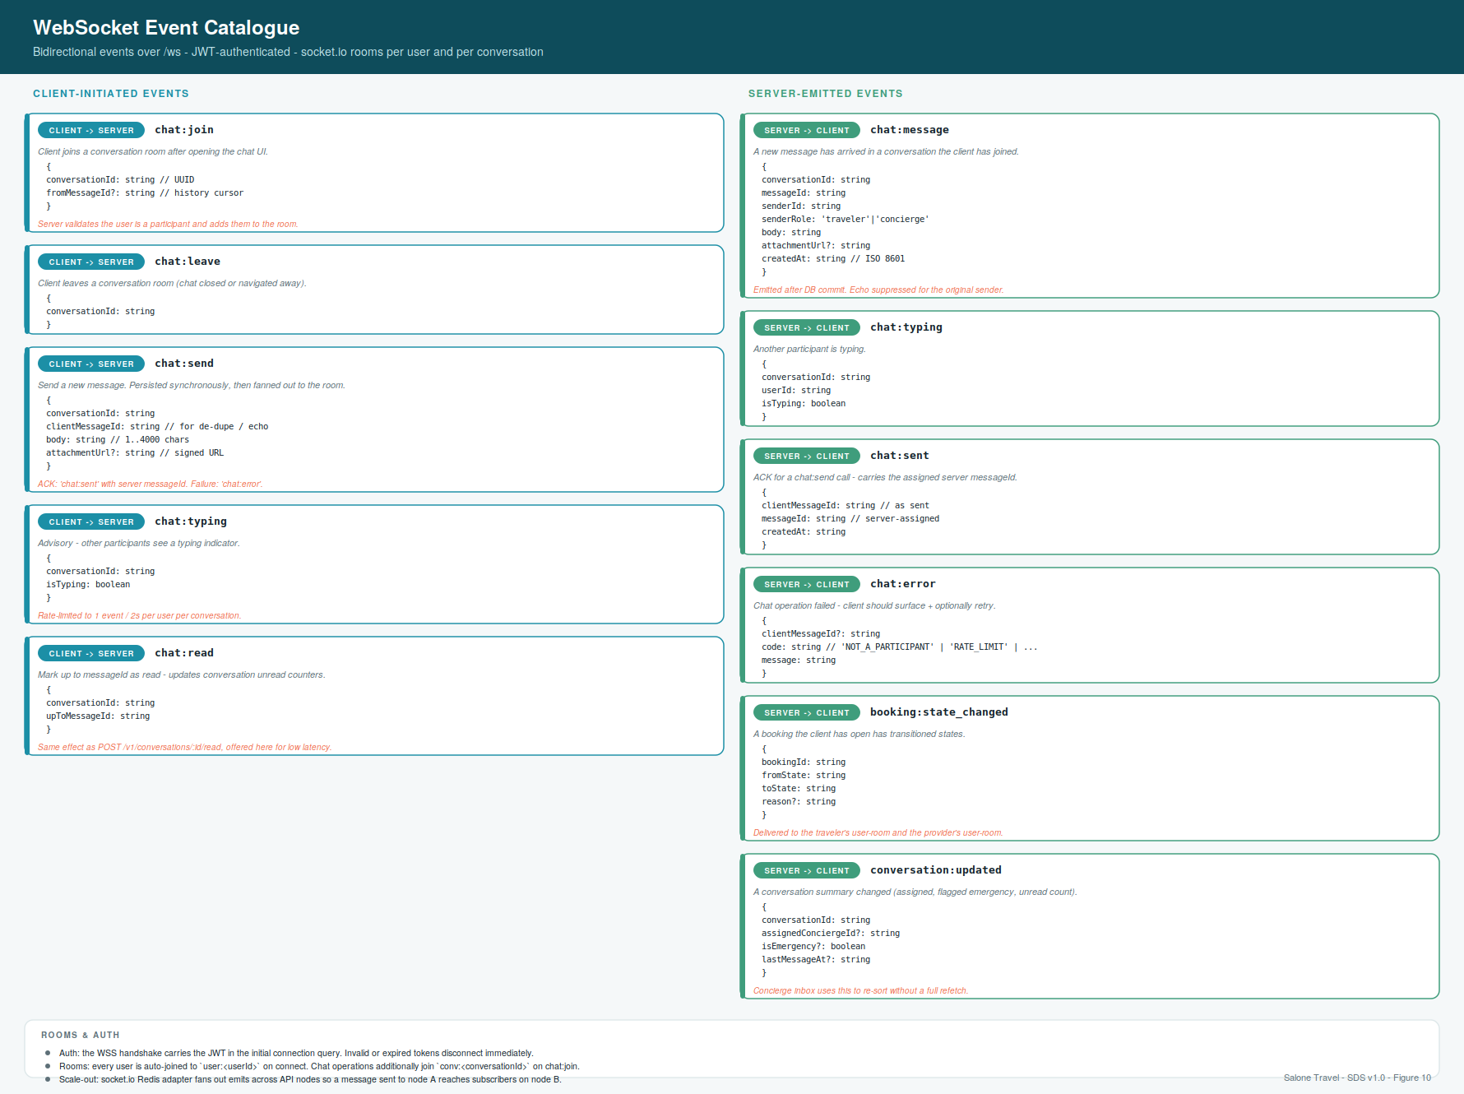
Figure 10 - WebSocket event catalogue: client-initiated events (left) and server-emitted events (right).

5 Business Logic
The rules that govern how state transitions happen - which actor is allowed to make which change, under which preconditions, with which side-effects. Where sections 3 and 4 defined the data and the surface, this section defines the behaviour. It is the specification a developer will read to know whether the code they are writing is correct.

5.1 Booking state machine (Figure 7)
Every booking traverses the state machine shown in Figure 7 (following page). States are colour-coded by category (awaiting action, money in flight, live, terminal success, terminal failure); terminal states have a double border and accept no further transitions. Every transition is atomic and audited.

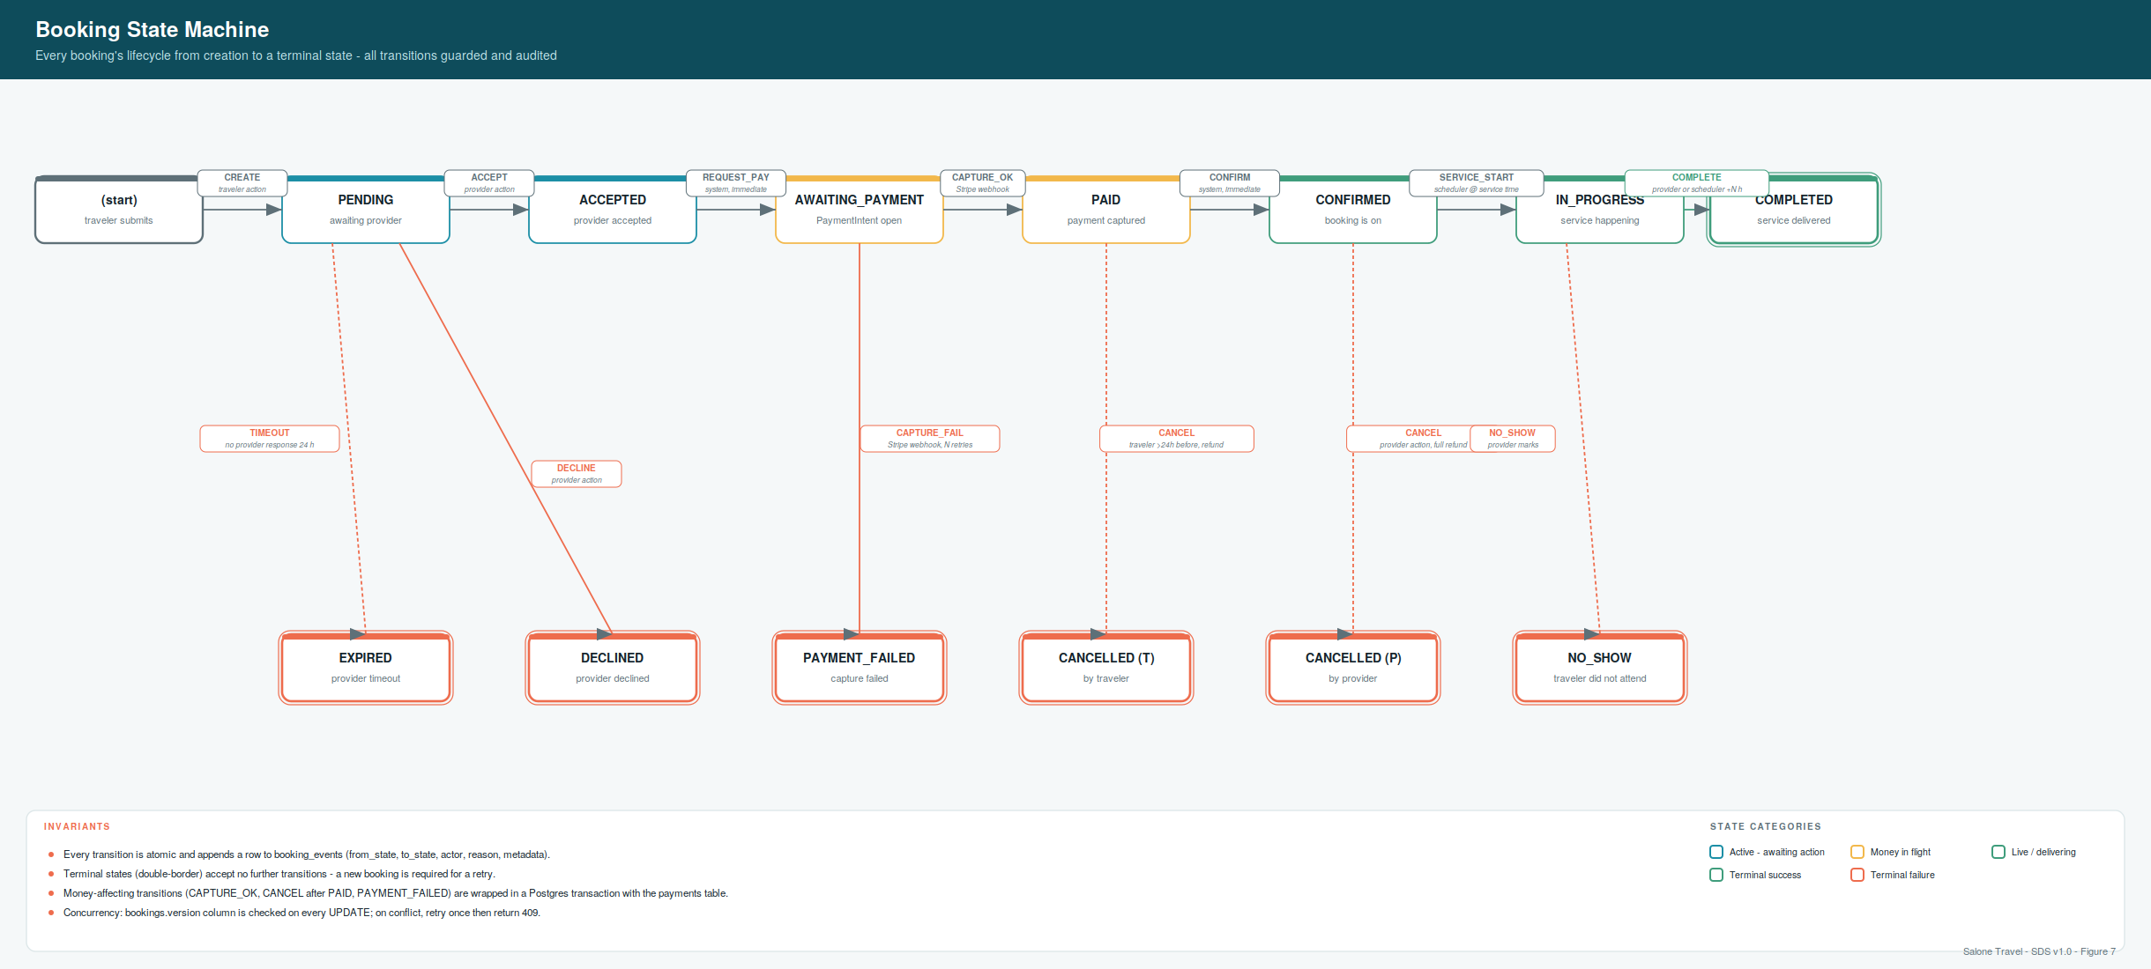
Figure 7 - Booking state machine: happy path (top row), terminal successes (COMPLETED), and terminal failures (bottom row).

Transition rules
Each transition below is expressed as a triple: the actor allowed to trigger it, the preconditions that must hold, and the side-effects the transition performs. Anything not listed is not allowed - a service method that attempts an unlisted transition returns 409 with code INVALID_TRANSITION.
Transition | Actor | Preconditions | Side-effects
CREATE -> pending | Traveler | Provider is listed; service is active; service_date >= today | Snapshot price + commission; enqueue booking.notify_provider
pending -> accepted | Provider | Caller owns the provider; state = pending | Enqueue booking.notify_traveler_accepted + payment.create_intent (via state -> awaiting_payment inside the same tx)
pending -> declined | Provider | Caller owns the provider; state = pending; reason provided | Enqueue booking.notify_traveler_declined + booking.suggest_alternatives; terminal
pending -> expired | System (scheduler) | state = pending AND created_at < now() - 24h | Enqueue booking.notify_traveler_expired; terminal
accepted -> awaiting_payment | System (same tx as accept) | state = accepted | Create Stripe PaymentIntent; insert payments row
awaiting_payment -> paid | System (Stripe webhook) | state = awaiting_payment AND event = payment_intent.succeeded | Update payments.status; enqueue receipt job
awaiting_payment -> payment_failed | System (webhook) | state = awaiting_payment AND event = payment_intent.payment_failed AND retries exhausted | Update payments.status; enqueue notify jobs; terminal
paid -> confirmed | System (same tx as paid) | state = paid | Immediate; no external side-effects
paid -> cancelled_by_traveler | Traveler | state = paid AND now() < service_date_time - 24h AND reason provided | Full refund via Stripe; refunds row inserted; terminal
confirmed -> in_progress | System (scheduler) | state = confirmed AND now() >= service_date_time | None
confirmed -> cancelled_by_provider | Provider | state = confirmed AND reason provided | Full refund via Stripe; terminal
in_progress -> completed | Provider or System | state = in_progress AND (provider action OR now() >= service_date_time + N h) | Enqueue review.prompt_traveler (delayed 24h); accrue provider earnings; terminal
in_progress -> no_show | Provider | state = in_progress AND reason provided | 50% provider earnings recovery; no refund to traveller; terminal

Concurrency and atomicity
Every transition executes inside a single Postgres transaction. The pseudocode below is the pattern used by every state-changing service method. It performs the guard, mutates the booking with an optimistic version check, appends the audit row, and enqueues side-effect jobs - all committed together, or all rolled back together.
async function transitionBooking(bookingId, event, actor, ctx) {
return prisma.$transaction(async (tx) => {
const booking = await tx.booking.findUniqueOrThrow({ where: { id: bookingId }});
guardTransition(booking.state, event, actor); // throws INVALID_TRANSITION
const nextState = computeNext(booking.state, event, ctx);
const updated = await tx.booking.updateMany({
where: { id: bookingId, version: booking.version }, // optimistic lock
data: { state: nextState, version: { increment: 1 }, updatedAt: new Date(), ...ctx.patch },
});
if (updated.count === 0) throw new ConflictError('VERSION_MISMATCH');
await tx.bookingEvent.create({ data: {
bookingId, fromState: booking.state, toState: nextState,
actorUserId: actor.userId, actorRole: actor.role, reason: ctx.reason, metadata: ctx.metadata,
}});
await ctx.enqueueJobs(tx); // outbox pattern
return getBooking(tx, bookingId);
});
}

5.2 Provider verification workflow (Figure 8)
A provider progresses through the verification state machine shown in Figure 8. The flow mirrors the booking flow's discipline: administrator-only transitions, structured audit trail, terminal states with double borders. Unlike bookings, verification is a one-time onboarding rather than a per-transaction lifecycle - most providers reach state='listed' and stay there.

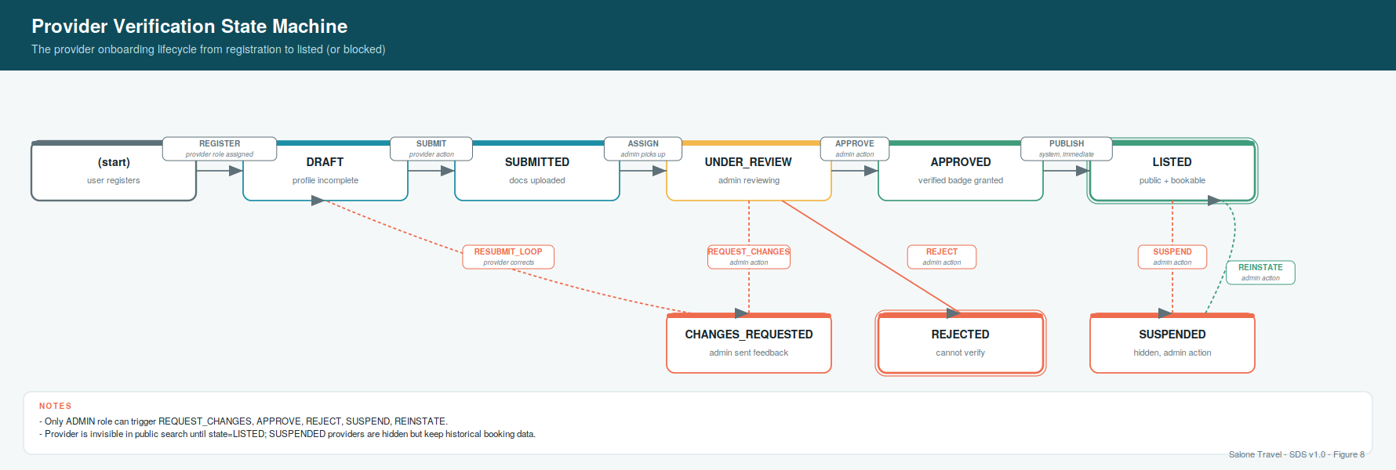
Figure 8 - Provider verification state machine.

Verification rules
- Required documents. business_registration, tax_id, id_document (of the primary contact). Optional: insurance, permit.
- Document review. Each uploaded document is reviewed independently. A document rejection does not fail the whole verification - it returns the provider to state='changes_requested' with review notes on the specific document(s).
- Approval preconditions. All required documents in status='approved'; provider profile has non-empty businessName, category, address, at least one active service.
- Rejection is terminal. REJECT (as opposed to REQUEST_CHANGES) is used only for irrecoverable cases (fraud, missing legal standing). The affected user retains their provider role but cannot resubmit; support contact is required.
- Suspension is reversible. A LISTED provider can be moved to SUSPENDED at any time by admin action; the same actor role can reinstate. Existing bookings continue during suspension - only new booking requests are blocked.
- Ratings are frozen during suspension. avg_rating and review_count do not update while suspended, to prevent gaming.

5.3 Concierge assignment rules
Concierge conversations follow a claim model rather than automatic round-robin routing. The MVP assumes a small enough concierge team that human judgement outperforms an algorithm; this decision is revisited in Phase 2 once volume warrants it.

Assignment lifecycle
- Unclaimed by default. New conversations have assigned_concierge_id = NULL. They appear in every concierge's 'Unclaimed' inbox filter.
- Self-claim to work. Any concierge may claim any unclaimed conversation via POST /v1/conversations/:id/assign. First-write wins - concurrent claims fail with 409 ALREADY_ASSIGNED.
- Reassignment. Only admins can reassign a claimed conversation (concierges cannot steal from each other). The endpoint is POST /v1/admin/conversations/:id/assign.
- Release. A concierge can release a claimed conversation back to the unclaimed pool via POST /v1/conversations/:id/release (adds a system message to the thread explaining the handover).

Emergency handling
An emergency is any conversation that a concierge flags via POST /v1/conversations/:id/emergency. The flag has three effects: (1) the conversation appears in every concierge's Emergency filter regardless of assignment, (2) the on-call concierge is paged (SMS + WhatsApp), (3) platform admins receive a notification. Emergencies stay flagged until explicitly resolved by the assigned concierge or an admin (a Resolve endpoint clears is_emergency and adds a system message).

5.4 Review eligibility
Only travellers who have actually consumed a service may review it. The rules below encode this in a way that is auditable and manipulation-resistant.
Rule | Rationale
Exactly one review per booking (UNIQUE constraint on booking_id) | Prevents duplicate reviews for the same experience.
Review may be created only after booking.state = completed | Prevents pre-service reviews or reviews for cancelled bookings.
Review may be created only by the traveler on the booking (RBAC + FK check) | Prevents third-party review injection.
Review may be edited only within 24h of creation | Discourages retaliation after a dispute; matches common industry policy.
Review body: 10..2000 characters | Filters out zero-effort text; the upper bound keeps rendering predictable.
Reviews are published immediately (status='published') and moderated retrospectively | Faster feedback for travellers; hidden reviews remain visible to owner and provider for appeal purposes.
Denormalised avg_rating and review_count recomputed by a trigger on reviews INSERT/UPDATE | Fast provider list rendering without JOIN or aggregate query on every request.

5.5 Commission and money flow (Figure 11)
Figure 11 (following page) traces the money for a $100 booking end-to-end. The MVP takes a simple approach: the platform collects the full amount, retains the commission, accrues the provider's earnings as a liability, and settles with providers manually on a weekly cadence. Automated payouts via Stripe Connect are a Phase 2 upgrade explicitly noted in the figure.

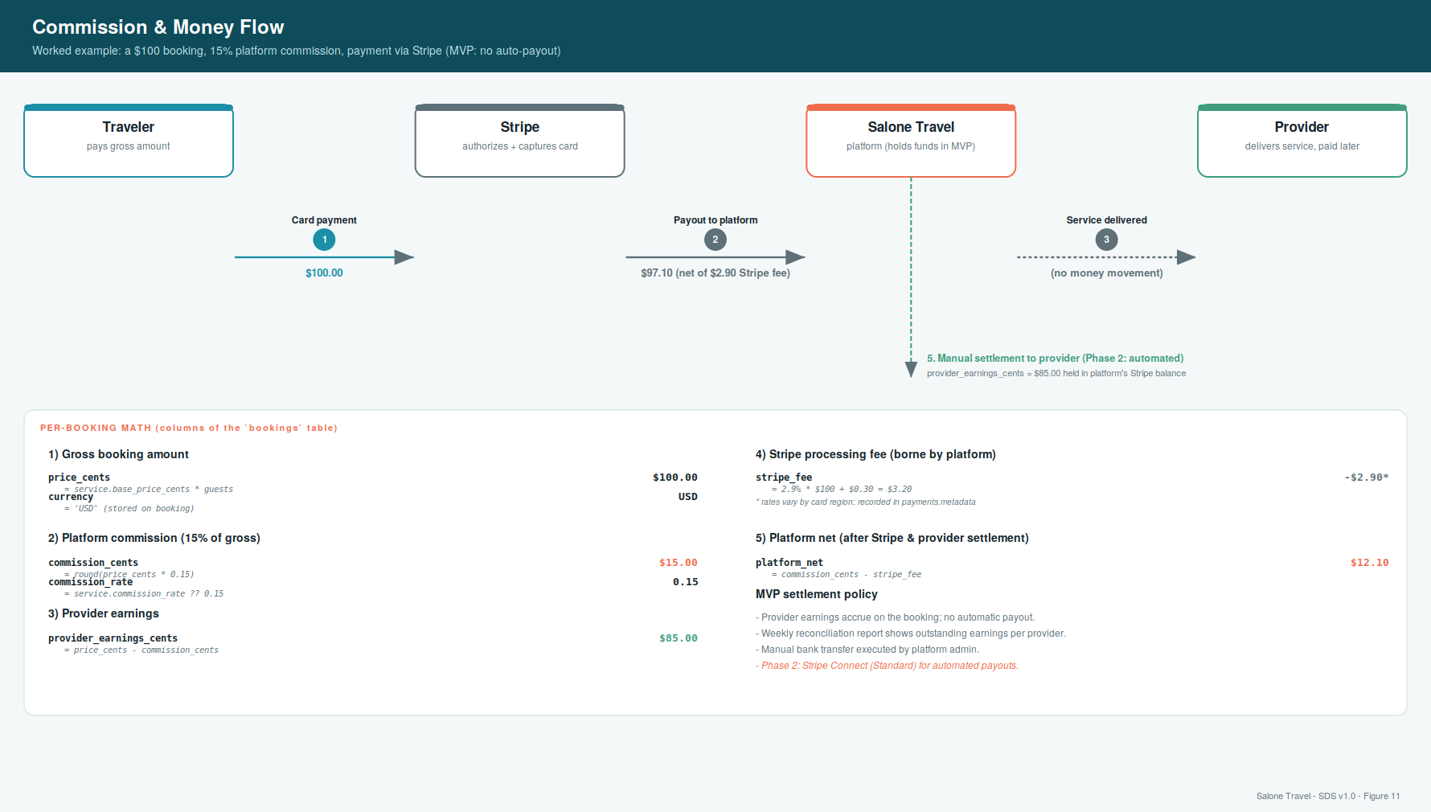
Figure 11 - Commission and money flow: a $100 booking, 15% commission, MVP settlement policy.

Commission calculation
Commission is snapshotted onto the booking at creation time so that platform-wide rate changes do not retroactively rebate or charge existing bookings. The default rate is 15%; per-service overrides are permitted via services.commission_rate.
// executed in the same transaction as booking creation
const rate = service.commission_rate ?? PLATFORM_DEFAULT_COMMISSION; // 0.15
const price = service.base_price_cents * booking.guest_count;
const commission = Math.round(price * rate);
const providerEarnings = price - commission;
await tx.booking.create({ data: {
...bookingInput,
price_cents: price,
commission_cents: commission,
provider_earnings_cents: providerEarnings,
currency: service.currency,
}});

Reconciliation
A nightly job produces a per-provider reconciliation report: outstanding accrued earnings, minus any prior settlements, minus any refunds that reduced accrued earnings. The report is emailed to platform admins and used to prepare weekly manual bank transfers. Every settlement is recorded in an admin action, audit-logged for regulatory traceability.

5.6 Cancellation and refund policy
Cancellation rules balance three interests: the traveller's flexibility, the provider's protection against last-minute drops, and the platform's operational simplicity.
Scenario | Refund to traveller | Provider earnings
Traveler cancels > 24h before service | 100% (via Stripe refund) | 0
Traveler cancels <= 24h before service | 0 | 100% of provider_earnings_cents (traveler bears loss)
Provider cancels (any time) | 100% | 0
Provider declines (before payment) | N/A (no payment yet) | 0
Provider marks no-show | 0 | 50% of provider_earnings_cents (partial slot recovery)
Payment fails after N Stripe retries | N/A (no capture) | 0; booking terminates in payment_failed
Concierge-issued goodwill refund | 1..100% (concierge discretion) | Reduced pro rata; audit-logged
Every refund creates a refunds row in status='pending' and a booking_events row noting the reason and the requesting actor. When the corresponding Stripe webhook arrives, the refunds row transitions to succeeded (or failed). Only after that transition does the refund appear as settled in reconciliation reports.

5.7 Summary and next steps
This document has specified the platform's persistent state (18 tables across six domains, with typed columns, foreign keys, indexes and enums), its external contract (a versioned REST API of ~60 endpoints, plus a WebSocket surface of five client-initiated and six server-emitted events, and a stable error model), and its behaviour (a strict booking state machine, a provider verification workflow, concierge assignment and emergency rules, review eligibility, commission calculation, and cancellation/refund policy). Every state change is atomic; every non-trivial action leaves an audit trail.

What Part 3 will add
- Section 6 - Sequence diagrams. End-to-end flows for register/login, request-to-book, payment capture, concierge chat, provider verification and emergency escalation - showing every actor, every message, and every state transition together on one page each.
- Section 7 - Payment integration. The full Stripe topology: PaymentIntents lifecycle, webhook processing and idempotency, refund handling, SCA/3DS considerations, PCI scope reduction, currency handling, and the Phase-2 Connect migration.
- Section 8 - Security architecture. Authentication and authorisation matrix, input validation, rate limiting, secrets management, data classification (PII/PCI), transport security, a STRIDE threat model, and audit logging as a first-class subsystem.
Approval requested
Before proceeding to Part 3, please confirm the data-model shape (particularly the booking snapshot columns and the commission model in 5.5), the API surface (particularly the /me pattern for provider self-service and the actions-on-resources pattern for bookings), and the transition rules in 5.1. Comments and challenges are cheapest now, before code starts to depend on these choices.

