ReqID_00001

Title: User Login page for autorization

Descrption:

User can log the appllication with login page.it is having user id and password fields .

User id passwrod provided by admin .

Password field accespts encryption data.

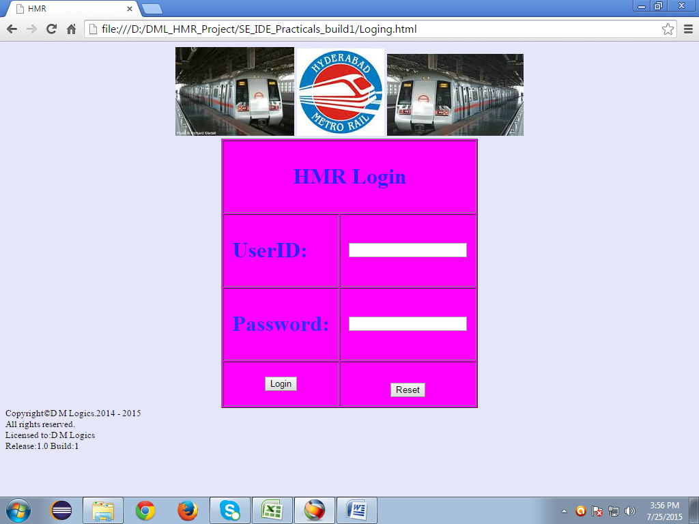

Test instruction:

Navigation: Enter URL

1.Login button works with valid values of useid and password

2.login button prompts for invalid values

3.Reset button resets values in fields