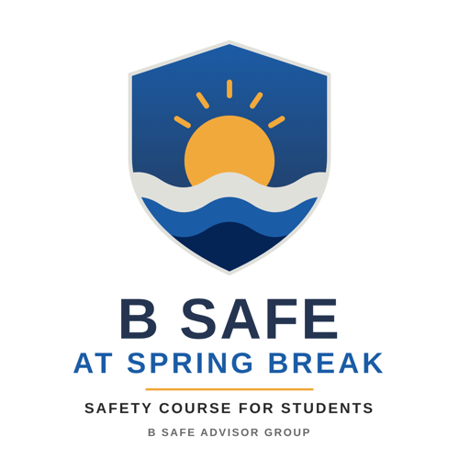 | B Safe at Spring Break  Parent’s Predeparture Checklist  Complete each item before your student leaves. Check the box when it is done.

☐ | 1. Contact information and agreed ways to communicate  Record your student’s contact information and the ways you will reach each other, such as phone, text, email, and a messaging app like WhatsApp or Signal.  Student’s cell phone: Text number:  Email:  Messaging apps: ☐ WhatsApp ☐ Signal ☐ Other:  Username or number for each app:  First choice, then backups, in order:  Student’s mobile service overseas  Decide before departure how, or if, your student will have mobile phone service overseas. Options include an international plan with the current carrier or a local eSIM added to the phone on arrival.  ☐ International plan ☐ Local eSIM on arrival  ☐ Other:  Carrier or eSIM provider, and plan details:
☐ | 2. A copy of your student’s passport photo page and visa (if required for entry)  Visa required for entry? ☐ Yes ☐ No ☐ Not sure  Where the original passport will be kept (room safe or carried):
☐ | 3. Daily check-in time and plan  Agree on a daily check-in. It can be a text message or a call at specific times.  Check-in time: Method:  What counts as a missed check-in:  If a check-in is missed, call first:  Then call the buddy and the hotel after (number of hours):  Family scam-call code word:  Group distress code word (my student shares it with the group):
☐ | 4. Insurance cards and 24-hour contact lines  Copies of your student’s insurance cards for medical care insurance and medical evacuation insurance, plus the 24-hour number for each provider.  Medical care insurance provider and policy number:  24-hour number:  Medical evacuation insurance provider and policy number:  24-hour number:
☐ | 5. Names and contact information for everyone in the group  List everyone in your student’s group, starting with the buddy.  Name: Phone or app:  Name: Phone or app:  Name: Phone or app:  Name: Phone or app:  Name: Phone or app:
☐ | 6. Hotel and lodging information  Hotel or lodging name:  Address:  Hotel phone: Reservation number(s):  Name of the reservation holder:
☐ | 7. Smart Traveler Enrollment Program (STEP)  Ensure your student is enrolled in the State Department’s Smart Traveler Enrollment Program (STEP).
☐ | 8. US Embassy or Consulate contact information  Embassy or Consulate:  Phone: Point of contact:  Email or address:  US Overseas Citizens Services: 1-888-407-4747 (from the US and Canada) or +1-202-501-4444 (from elsewhere).
☐ | 9. Phone, account, and weather safeguards  Confirm each of these with your student before departure.  ☐ Find My (or the Android equivalent) is turned on and updated, and my student can log in to it from another device  ☐ My student has checked that the recovery email, phone number, and recovery codes are current for email accounts  ☐ My student has saved weather.gov (National Weather Service) and nhc.noaa.gov (National Hurricane Center) on a phone  ☐ My student knows that 9-1-1 is not universal and has saved the local emergency numbers for the destination
Keep a copy with you and give a copy to your student.

