

**A. D. PATEL INSTITUTE OF TECHNOLOGY** **KARAMSAD 001**

**(ID: C-176)**

**TEAM ID: SGH001052**

**PROBLEM STATEMENT ID:- SGH068**

**Submitted By:**

|  |  |  |
| --- | --- | --- |
| **SR NO.** | **NAME OF STUDENT** | **ENROLLMENT NUMBER** |
| 1 | DIVYA CHHABARIA | 170010107007 |
| 2 | PRIYANSHI SODANI | 170010107045 |
| 3 | DEEP BODA | 170010107003 |
| 4 | VAIKUNTH DESAI | 170010107009 |
| 5 | DAKSH PATEL | 180013107009 |
| 6 | NAYANKUMAR SORATHIYA | 170010107061 |
| 7 | KRUNAL BARAD | 180013107002 |
| 8 | PARTH SABHADIYA | 170010107052 |

# Index

1. Abstract
2. Literature Review/Existing Innovation-technology to address related to your problem
3. What would be your approach to solve the problem
4. Flow Diagram : 1
5. Flow Diagram : 2
6. Tools and technologies to be used to solve the problems
7. Challenges/Risk in implementing your Final prototype
8. Possible outcome of your work
9. Work Done Till Date
10. Web Portal
11. Health Card

**Abstract**

The main problem in today's date is we are not having any centralized medical database of individual person and because of that it is impossible to take proper precaution for prevention of any viral disease in the city. Also, if someone mets with an accident and is taken immediately to hospital and that patient is having some disease or is allergic from some chemical, so without refering to patient's past medical history, providing diagonsis is quite risky.

So there will be common website, from where people can generate their health cards containing unique health card number by providing necessary medical details and also they are provided with unique login ID and password, so they can view their records anytime for reference. Doctors, Chemists and Lab technicians need to generate their unique login ID and passwords by registering in website. As any patient visits the hospital, Doctor needs to login into their accounts and then search the unique health card number of patient to view and edit his past medical record. Chemists login into their own accounts and by searching that unique health card number of patient, they can view the prescription given by doctor. If there is any report like X-Ray or CT Scan, it will be uploaded by Lab-Technician. Hence, all the health related day to day data can be analysed by using AI and ML mechanism to retrieve the health trends of different state, city and area and necessary precautions can be taken. Gradually this leads to decrease death ratio of people because of unknown data of past, Also as it gives very potential analytics so this will reduce the threat of spreading many unwanted viral disease in society as everything is recorded online so on time we can get idea about such threats.

**Literature Review/Existing Innovation-technology to address related to your problem**

This kind of website is available which only manages the details of patient confined to a single hospital. By our project, it can be accessed by any other hospital or even patient can see his medical records. Also, any graph is generated by analysing all the health related day to day data using AI and ML mechanism to retrieve the health trends of different state, city and area, so that necessary precautions can be taken and stop the viral disease to spread across the city. As data will be stored online so there is no need to store offline reports and prescriptions.

**What would be your approach to solve the problem**

A website from where people can generate their health cards using (Pegasus PCP P1 Double Side ID Card Printer) containing unique health card number by providing necessary medical details and also they are provided with unique login ID and password, so they can view their records anytime for reference.

Doctors, Chemists and Lab technicians need to generate their unique login ID and passwords by registering in website and all this database is maintained by XAMPP(My SQL). As any patient visits the hospital, Doctor needs to login into their accounts and then search the unique health card number of patient to view and edit his past medical record.

Chemists login into their own accounts and by searching that unique health card number of patient, they can view the prescription given by doctor.

If there is any report like X-Ray or CT Scan, it will be uploaded by Lab-Technician.

Hence, all the health related day to day data can be analysed by using AI and ML mechanism to retrieve the health trends of different state, city and area and necessary precautions can be taken. Zabbix open source monitoring tool will be used for network traffic.

**FLOW DIAGRAM : 1**

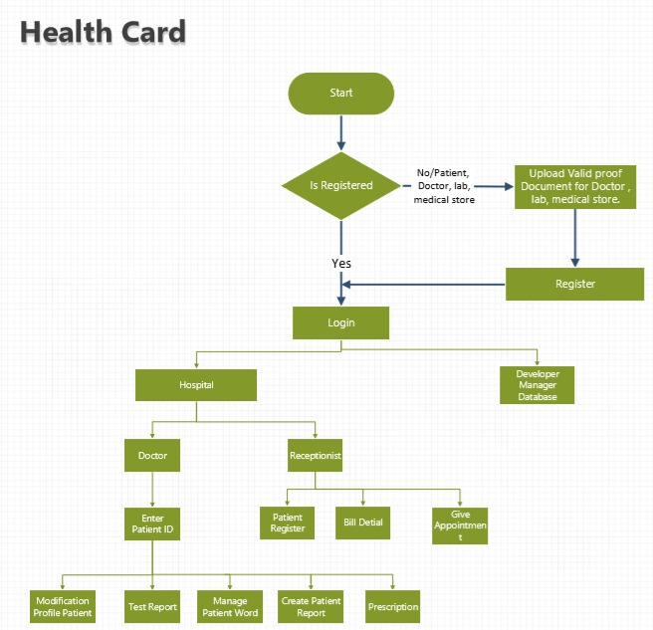

**FLOW DIAGRAM : 2**

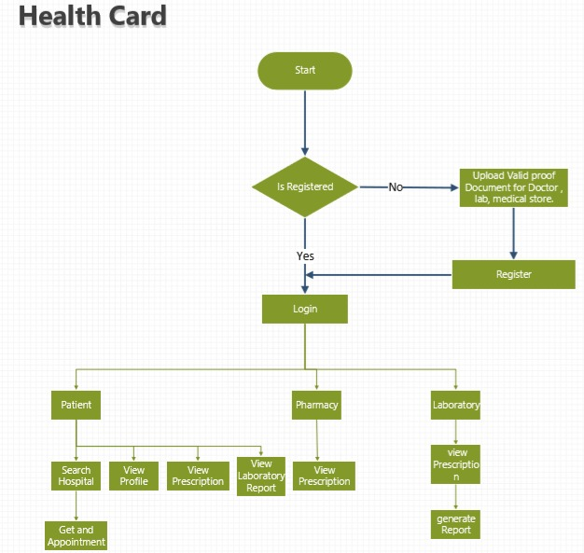

**Tools and technologies to be used to solve the problems**

1)Php as a microservice for collecting data from people.

2)XAMPP(My SQL) database for database management system.

3)Zabbix open source monitoring tool for network traffic track.

4)ML mechanism to retrieve the health trends of different state, city and area

**For Website Development**

**Front end**

1)HTML css JavaScript

2)Front end Frameworks and state

3)UI/CSS Framework

4)HTML JSON, API`s

**Back end**

1) Server side language

2) Server side framework

3) Database SQL, XAMPP

4) Security

**Challenges/Risk in implementing your Final prototype**

We might face the heavy traffic on server/website which maintains human health records when multiple users are linking to

database at the same instance which may leads to crash or collision. This can be deal by:-

1)Create a performance benchmark of website.

2)Assess the minor Increase in Traffic.

3)Monitor site activity.

4)Proxy server

5)Getting your website ready for traffic spikes.

6)Upgrade web hosting.

7)Use a Content Delivery Network (CDN).

Another challenge of this project is to create a graph based report using Machine learning with less data as we need to stop the viral disease to spread across the city.

**Possible outcome of your work**

As the Data is stored online and is centralized, Doctor can keep record of every patient's health and Patient can manage all cases of his/her lifetime. Concern authorities can analyse the data and take appropriate action from stored data. One can easily understand past doctor's treatment and thus patient will get accurate treatment. Also, all the health related day to day data can be analysed by using AI and ML mechanism to retrieve the health trends of different state, city and area and necessary precautions can be taken. Gradually this leads to decrease death ratio of people because of unknown past medical data. Also as it gives very potential analytics so this will reduce the threat of spreading many unwanted viral disease in society as everything is recorded online so on time we can get idea about such threats.

**Work Done Till Date**

User interface of website is completed.

Chatbot is integrated into website using Artificial Intelligence which helps patient to recommend medicines.

Database of website is completed.

**WEB PORTAL**

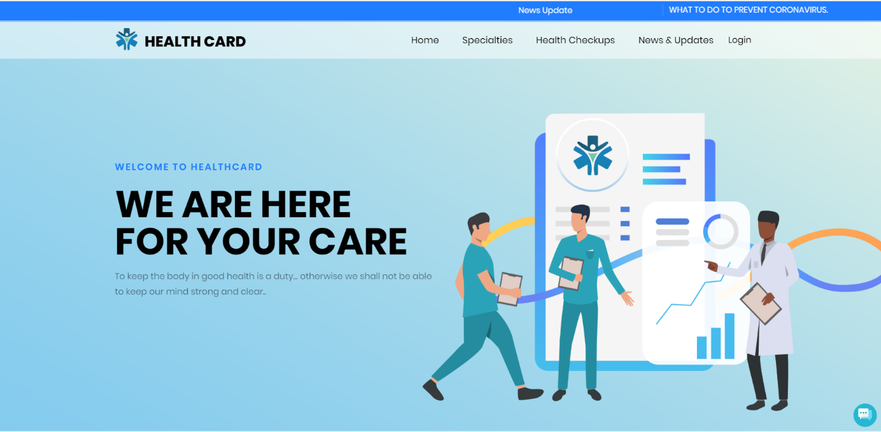

**HEALTH CARD**

