**GITHUB Account Creation and Access management**

Log in GitHub account <https://github.com/>

If you don’t have please create one account.

Create New Repository

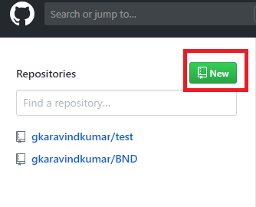

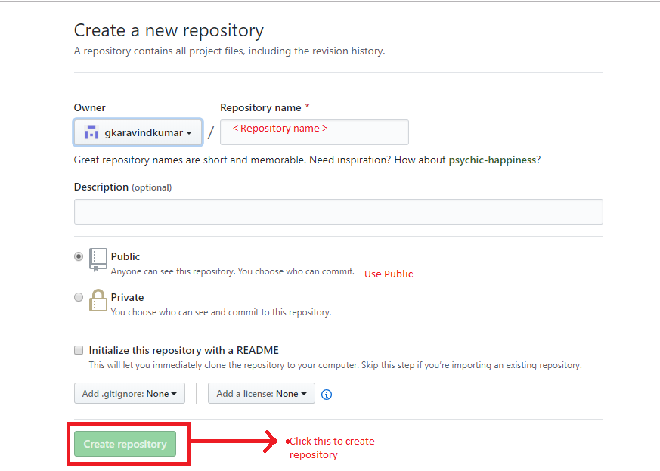

* Create a SSH keys using keygen

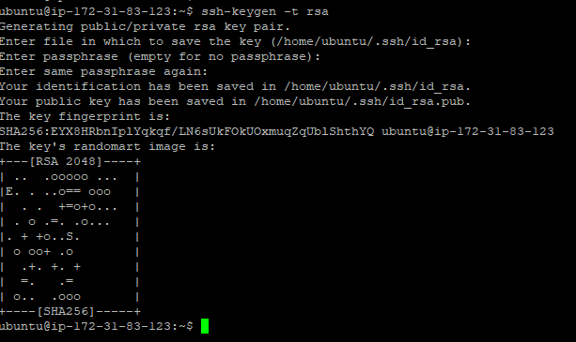

Copy the public Key and paste it in deploy keys **id_rsa.pub**



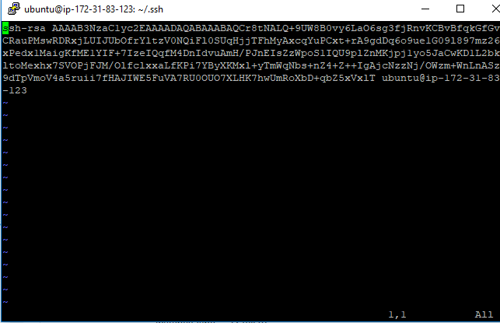

* Open the repo > Add some codes or html files.
* Click Settings > and Click Deploy keys to add public key of the server.

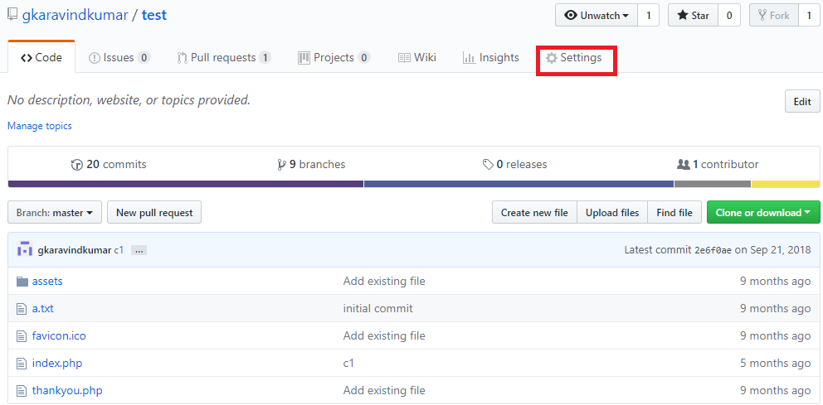

* Added deploy key we created (Add Public key of server where you going to take clone)

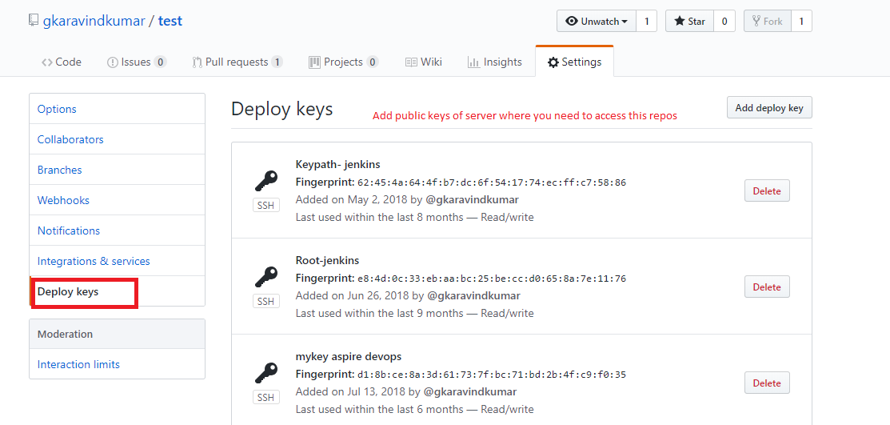

Now go to the server check you have added the ssh public key added to GIT

Check the git ssh url of the repo

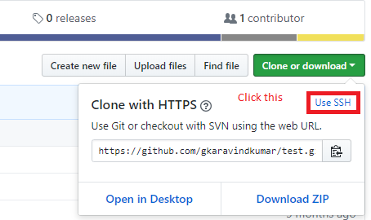 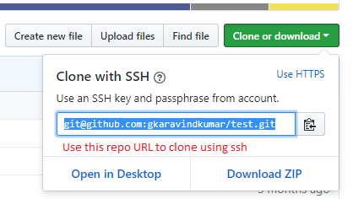

use below format to clone the repo

git clone [git@github.com:gkaravindkumar/test.git](mailto:git@github.com:gkaravindkumar/test.git)

you can able to clone the repo.

**Clone the Repo in linux server**

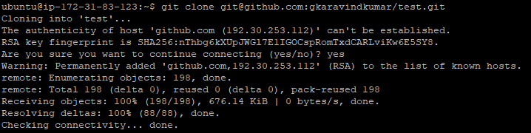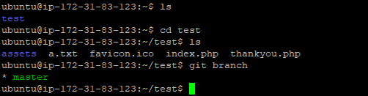

----------You Have done---------------