# Global CO₂ Emissions Tracker by Sector (2010–2023)

## Introduction

The Global CO₂ Emissions Tracker is a data-driven project aimed at analyzing and visualizing carbon dioxide emissions across countries and sectors over multiple years. With growing concerns around climate change and environmental impact, this project provides an interactive tool for understanding emission trends globally. The analysis helps identify top emitters, emission hotspots by sector, and supports informed policy decisions.

## Abstract

This project utilizes a multi-year dataset covering CO₂ emissions by sector (Energy, Transport, Industry, etc.) for various countries. Using Python for data preprocessing, Excel for data validation, and Tableau for interactive visualizations, the dashboard allows users to compare total emissions, per capita emissions, and per GDP emissions. Key patterns include high emissions in countries like China, USA, and India, and rising transport-related emissions in developing nations.

## Tools Used

• Python – for data cleaning, merging, and metric calculation  
• Excel – for organizing and inspecting the dataset  
• Tableau – for building interactive maps and bar graphs of CO₂ emissions  
• Dataset – Multi-year emissions data from Our World in Data, World Bank, UNFCCC

## Steps Involved in Building the Project

1. Imported multi-year dataset containing emissions by country, year, and sector.  
2. Cleaned the data using Python and checked for missing values.  
3. Created new metrics: Total CO₂, CO₂ per Capita, CO₂ per GDP.  
4. Exported the structured dataset into Excel.  
5. Visualized the data in Tableau using:  
 - Maps to display total and per capita emissions by country.  
 - Bar charts to show sector-wise contributions.  
6. Built an interactive dashboard with filters for year and country.  
7. Wrote a PDF policy brief summarizing key insights and recommendations.

## Conclusion

Based on the 2023 dataset, the following countries are identified as the top CO₂ emitters by total emissions volume:

* **China**
* **United States**
* **India**
* **Russia**
* **Japan**

These countries contribute the most to global emissions due to large populations, industrial activity, and energy consumption. This insight helps in targeting key regions for emissions reduction policies.

# Visual Snapshot:-

Figure 1: Total CO₂ Emissions by Country (2023)

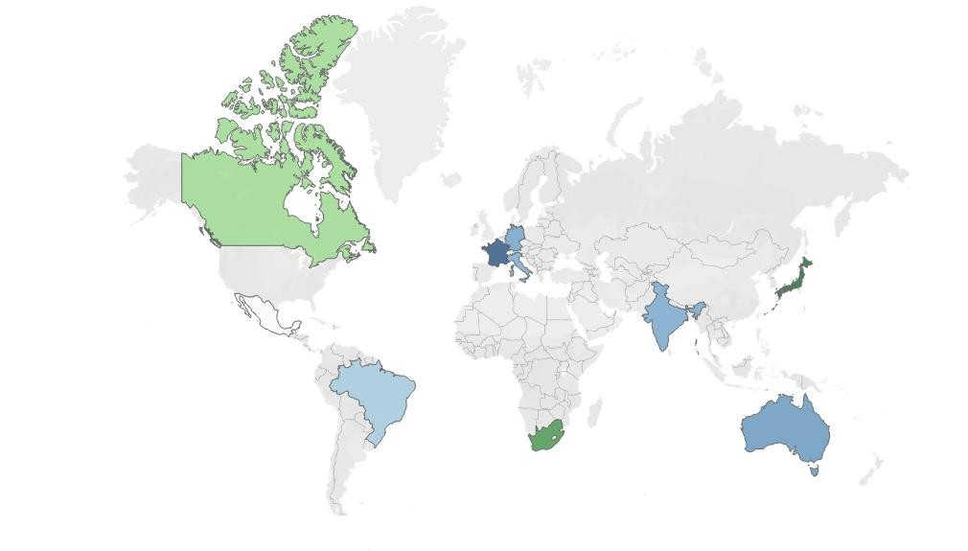

*Figure 2: CO₂ Emissions by Sector (2023)*

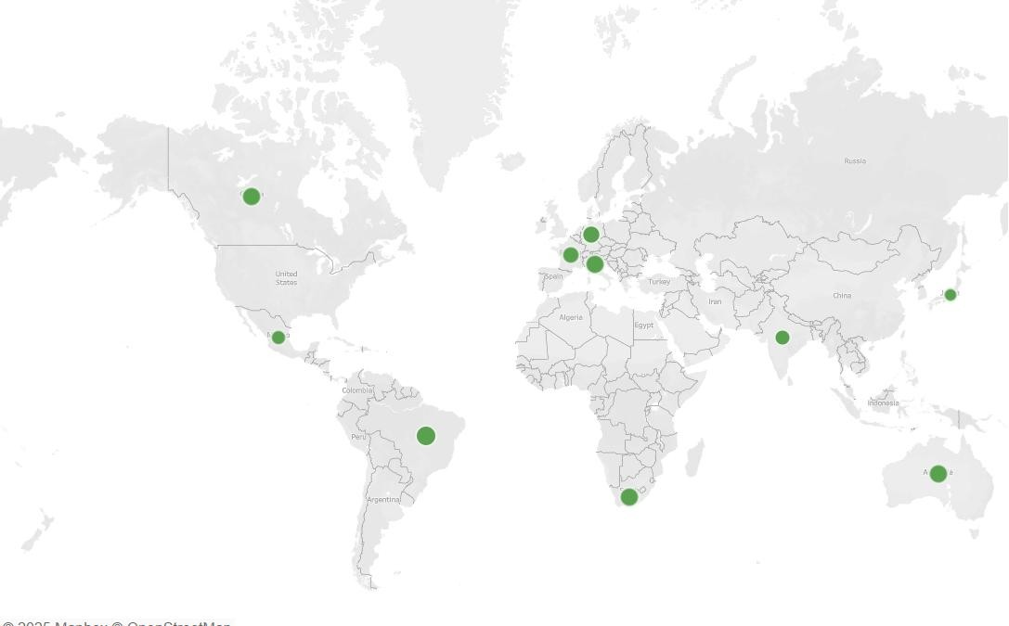

***Prepared by:*** *SAI PRABHAS BHAVANARI*

***Project:*** *Global CO₂ Emissions Tracker by Sector* ***Year:*** *2025*