**ENPM 809T – Autonomous Robotics**

**HW 4**

Bala Murali Manoghar Sai Sudhakar

116150712

**Video Link**

Video File Link - <https://youtu.be/WRG9RSwpvds>

**Sonar Distance Check**

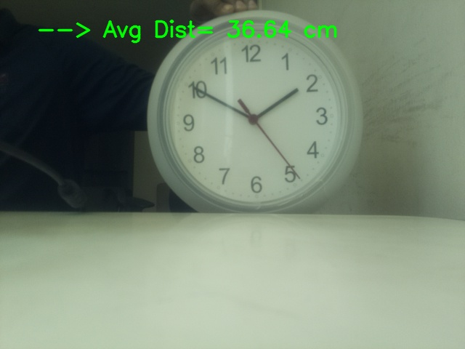

**Analysis of hardware perfomance**

