Rama Prashanth Ramasamy Vijayakumar

116428941

**Teleoperation Video**

<https://youtu.be/b917Zo27y54>

**In-Class Exercise**

**PWM Calculation**

$$v_{th}=3 V \\ v_{max}=5 V$$

$$v_{operating}=v_{max}-v_{th} \\ v_{operating}=2 V$$

**Forward Rotation**

$$v_{forward}=30 \% of full speed \\ v_{forward}=30\% of v_{operating}+v_{th} \\ v_{forward}=\left(0.3×2\right)+v_{th} \\ =0.6+3 \\ =3.6 V \\ Duty cycle=\frac{3.6}{5}×100 \\ =72 \% \\ t_{on}=72 \% of 1 ms \\ =0.72 ms \\ t_{off}=1-0.72 \\ =0.28 ms$$

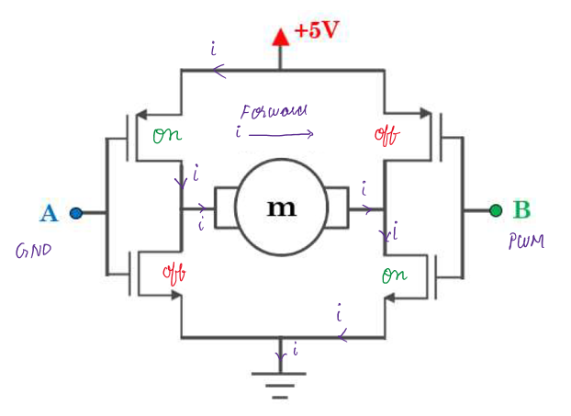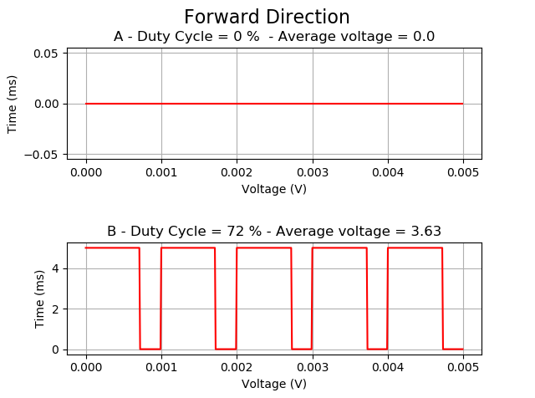

**Reverse Rotation**

$$v_{reverse}=70 \% of full speed \\ v_{reverse}=70\% of v_{operating}+v_{th} \\ v_{reverse}=\left(0.7×2\right)+v_{th} \\ =1.4+3 \\ =4.4 V \\ Duty cycle=\frac{4.4}{5}×100 \\ =88 \% \\ t_{on}=88 \% of 1 ms \\ =0.88 ms \\ t_{off}=1-0.88 \\ =0.12 ms$$

