**ENPM 809T Autonomous Robotics  
Assignment 7**

**Team:**

Bala Murali Manoghar Sai Sudhakar (116150712)

Rama Prashanth Ramasamy Vijayakumar (116428941)

**Email ID :**

[grandclassifiedteam@gmail.com](mailto:grandclassifiedteam@gmail.com)

**YouTube Video Link for Encoder Testing:**

<https://youtu.be/HOB3eL4HSM0>

**Plots:**

Encoder Reading for 180 Deg wheel rotation using PWM

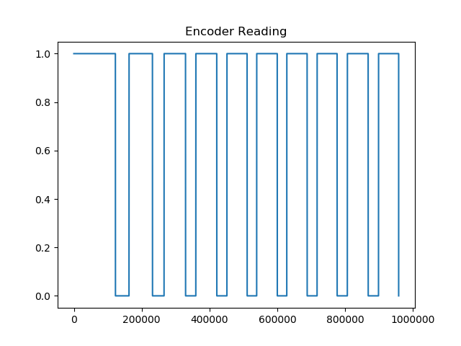

Left and right encoder reading for both rotating right-side wheels only

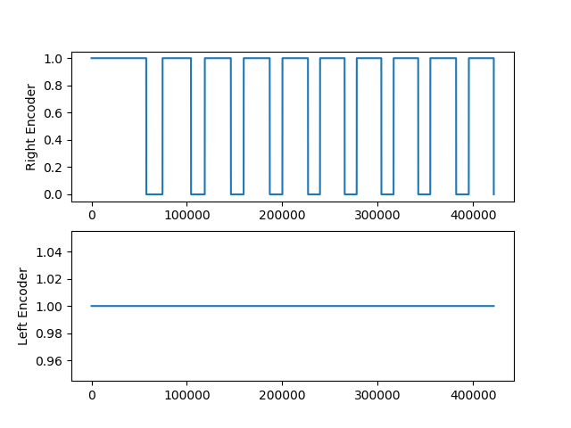

Left and right encoder reading for both rotating right and left side wheels

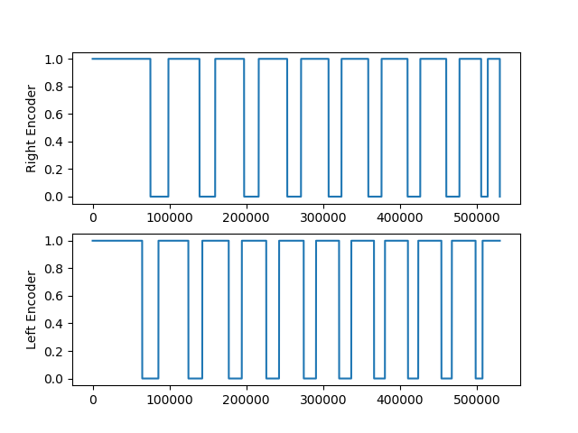

Encoder Reading for Forward

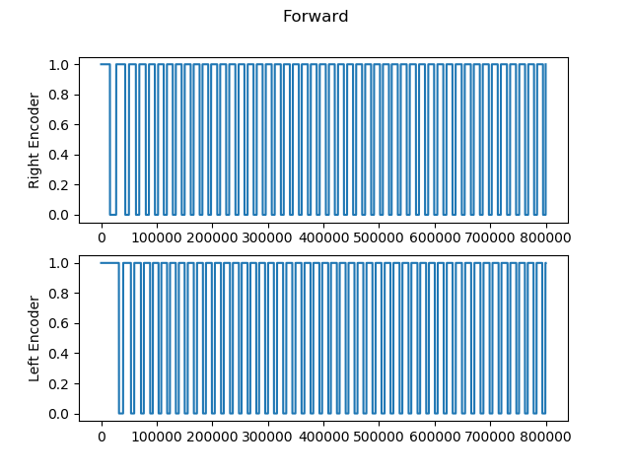

Encoder Reading for Reverse

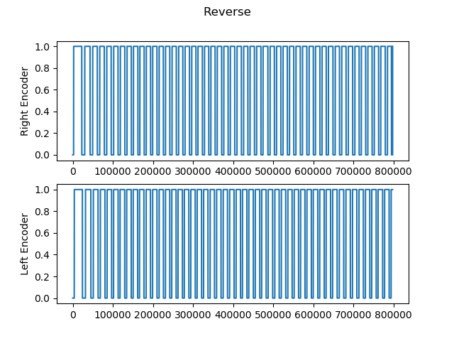

Encoder Reading for Pivot Right

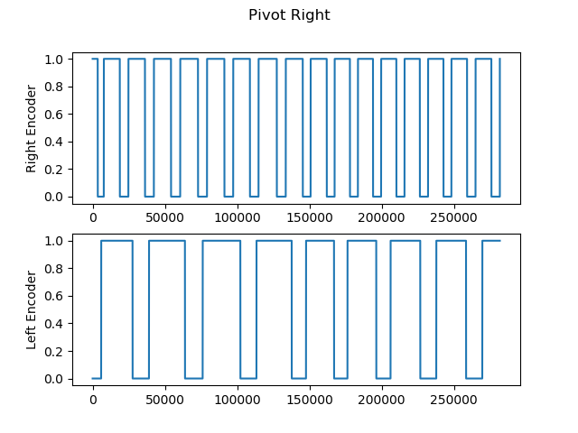

Encoder Reading for Pivot Left

