CMSC 818B HW 2

**Gaussian Process**

Gaussian process is a linear predictor which requires a kernel function. Alternatively, gaussian process can be described as a linear combination of co-variance functions. In Gaussian process we consider the co-variance function doesn’t depend on the function instead it depends only on the position if inputs or observations.

**Objective**

Function to be learnt: $\sin\left(3x\right)$ (with noisy observations)

**Implementation**

1. Read observation data from file (training set)
2. Read test data form file (test set)
3. Generate truth values for test set (sine(3x))
4. Use different kernel to fit model to data
5. Compute mean squared error between ground truth and model predicted value

**Kernel functions used**

|  |  |  |  |  |
| --- | --- | --- | --- | --- |
|  | **Kernel** | **Hyper Parameters** | **Reason for choosing Kernel** | **MSE** |
| 1 | Squared Exponential Kernel + Constant Kernel | $l_{se}$– Length Scale $σ_{se}$ – Variance $σ_{c}$ - error | Observed data has error and the error also has to be modelled | 0.0732 |
| 2 | Square Exponential Kernel + Radial Basis Kernel | $l_{se}$– Length Scale $σ_{se}$ – Variance $l_{rbf}$ - length scale | Observed data has noise and the noise is assumed to be gaussian | 0.0459 |
| 3 | Rational Quadratic + Radial Basis Kernel | $l_{rq}$– Length Scale $σ_{rq}$ – Variance $α_{rq}$ - weight factor $l_{rbf}$ - length scale | Observed data has noise and the noise level may not be constant throughout the data | 0.0459 |
| 4 | Exp-Sine-Squared kernel + Radial Basis Kernel | $l_{ess}$– Length Scale $p_{ess}$ – Periodicity $l_{rbf}$ - length scale | Since we already know that the function to be learnt is sine wave, which is periodic, periodic kernel is used along with RBF to model gaussian noise. Since we know the properties of the function to be learnt we can tailor the kernel function and get minimum error | 0.0011 |

**Final Model**

**Kernel 1**

0.733**2 * RBF(length_scale=0.481) + 0.0316**2

Mean Squared Error : 0.07321081199043417

**Kernel 2**

0.0316**2 * RBF(length_scale=100) + RBF(length_scale=0.561)

Mean Squared Error : 0.045965971922398756

**Kernel 3**

0.0316**2 * RationalQuadratic(alpha=0.000707, length_scale=25) + RBF(length_scale=0.561)

Mean Squared Error : 0.04596593768269977

**Kernel 4**

3.11**2 * ExpSineSquared(length_scale=6.09, periodicity=2.09) + RBF(length_scale=100)

Mean Squared Error : 0.0011681031664022967

**Plots**

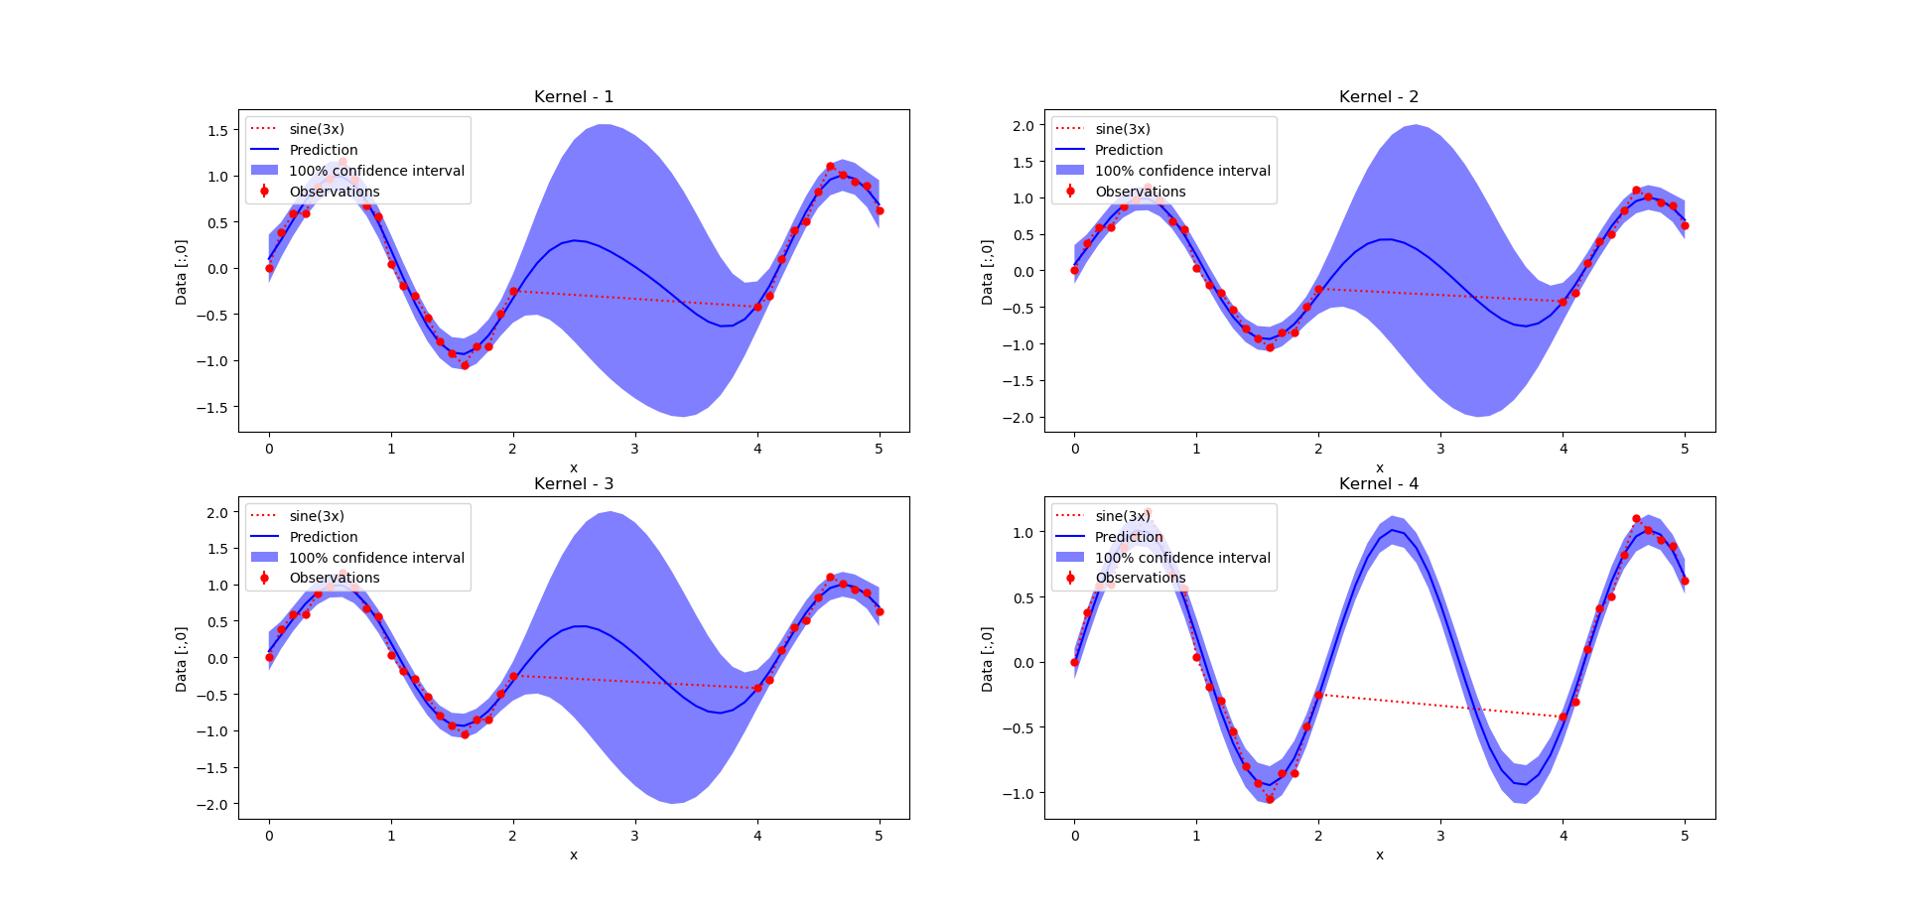

**Objective**

Given: Combined Cycle Power Plant Data Set

X = [T, AP , RH, V]

Y = [PE]

To predict: PE for test data

**Implementation**

1. Read observation data from file (training set)
2. Read test data form file (test set)
3. Read ground truth data for test set form solution file
4. Use different kernel to fit model to data
5. Compute mean squared error between ground truth and model predicted value

**Kernel functions used**

|  |  |  |  |  |
| --- | --- | --- | --- | --- |
|  | **Kernel** | **Hyper Parameters** | **Reason for choosing Kernel** | **MSE** |
| 1 | Squared Exponential Kernel (1 Dimensional) + Constant Kernel | $l_{se}$– Length Scale $σ_{se}$ – Variance $σ_{c}$ - error | Observed data has error and the error also has to be modelled | 274.1088 |
| 2 | Square Exponential Kernel (4 Dimensional) + Radial Basis Kernel | ${4 × l}_{se}$– Length Scale (one for each dimension) $σ_{se}$ – Variance $l_{rbf}$ - length scale | Observed data is in 4 dimensions and the noise is assumed to be gaussian | 29.2136 |
| 3 | Rational Quadratic + Radial Basis Kernel | $l_{rq}$– Length Scale $σ_{rq}$ – Variance $α_{rq}$ - weight factor $l_{rbf}$ - length scale | Observed data has noise and the noise level may not be constant throughout the data | 11.9522 |
| 4 | Exp-Sine-Squared kernel + Radial Basis Kernel | $l_{ess}$– Length Scale $p_{ess}$ – Periodicity $l_{rbf}$ - length scale | The data might have small ripples throughout the length (since electrical energy is to be predicted, it might fluctuate depending on load and this might give rise to ripples) with some gaussian noise similar to the graph shown below.  Image result for atmospheric concentration | NA |

**Final Model**

**Kernel 1**

17.1**2 * RBF(length_scale=0.0122) + 31.6**2

Mean Squared Error : 274.1088810454674

**Kernel 2**

31.6**2 * RBF(length_scale=88) * RBF(length_scale=86.8) * RBF(length_scale=59) * RBF(length_scale=5.09) + RBF(length_scale=0.0374)

Mean Squared Error : 29.213600832990878

**Kernel 3**

31.6**2 * RationalQuadratic(alpha=0.00319, length_scale=2.85) + RBF(length_scale=0.0277)

Mean Squared Error : 11.952289870308482

**Plots**

Plotting 1st dimension against prediction

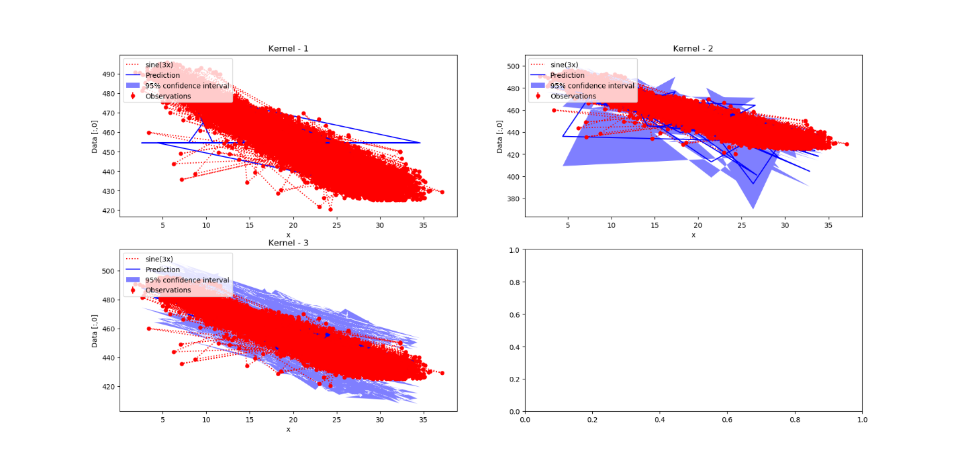

**References**

1. <https://scikit-learn.org/stable/modules/gaussian_process.html#exp-sine-squared-kernel>
2. <https://scikit-learn.org/stable/auto_examples/gaussian_process/plot_gpr_noisy_targets.html>
3. <https://scikit-learn.org/stable/modules/gaussian_process.html#gpr-examples>
4. <https://www.cs.toronto.edu/~duvenaud/cookbook/>