8 bits = byte

2^10 = 1 kilo = roughly 1,000

2^20 = 1 mega = roughly 1,000,000

2^30 = 1 giga = roughly 1,000,000,000

----------------------------------

Overflow in binary addition:

🡪Add number that is out of range of number of numbers

-----------------------------------

To negate a number:

- flip all bits

- add one

-----------------------------------

Not = flips input

Buf = input is output

-----------------------------------

N –Transistor: if low Voltage (0) then N disconnects and renders 0

If 1 high Voltage (1) then N connects and renders 1

P-Transistor: If high voltage (0) then P connects rendering 1

If low voltage (1) then P disconnects rendering 0

------------------------------------

inverter adds a bar over letter

------------------------------------

Demorgans Law:

You can convert an or gate with an inverter on the right side or two inverters on the left side and change it to an and gate with two inverters on left and one inverter on right side

Bubble Rules:

* Begin at output then work towards input
* Push bubbles on final output back
* Draw gates in form so bubbles cancel

Circuit schematics Rules:

* Inputs on right(or top) outputs on right(or bottom)
* Gates flow left to right
* Straight wires are best

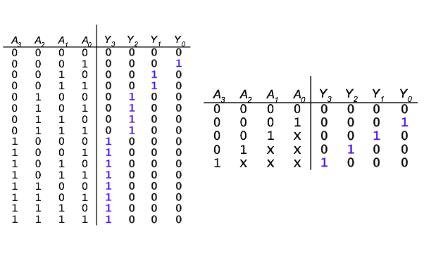

\*\*right is shorthand for left side

Use a K chart in order to figure out how the circuit works